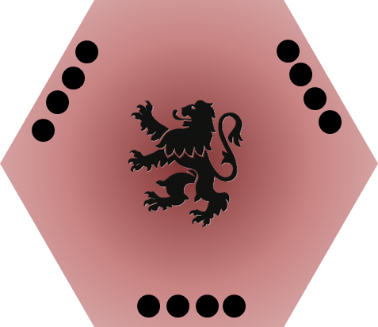
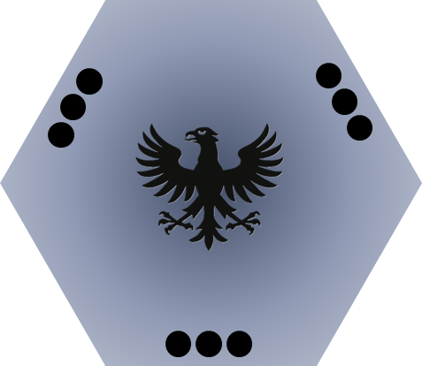
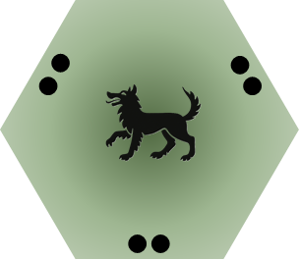
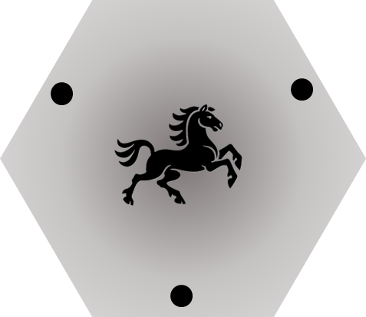

 |  | 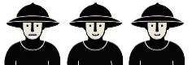 | 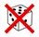 |  | 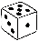
 |  |  |  |  | 1 | 2 | 3 | 4 | 5 | 6
 |  | # | 1 |  | 1 | 1 | 2 | 2 | 3 | 3 | +1 T1
 |  | Donjon # | 1 |  | 2 | 2 | 2 | 3 | 3 | 3 | +1 T1
 |  | 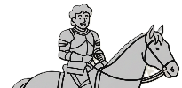
 |  |  |  |  | 1 | 2 | 3 | 4 | 5 | 6
 |  | # | 1 |  | 3 | 3 | 2 | 2 | 1 | 1
 |  | 
 |  |  |  |  | 1 | 2 | 3 | 4 | 5 | 6
 |  |  | NOK |  | NOK | NOK | NOK | OK | OK | OK
 |  | 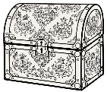
 |  |  |  |  | 1 | 2 | 3 | 4 | 5 | 6
 |  |  | NOK |  | OK | NOK | NOK | NOK | NOK | NOK

