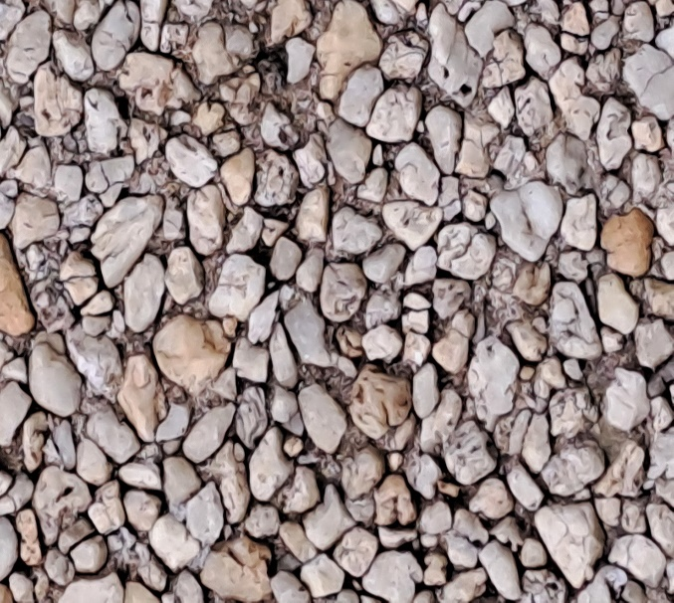

1

1

1



1

1

1



1

1

1



1

1

1



1

1

1



1

1

1