
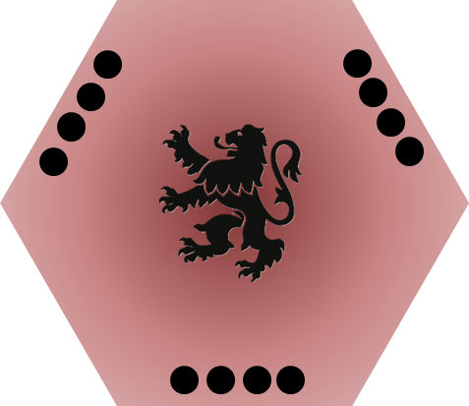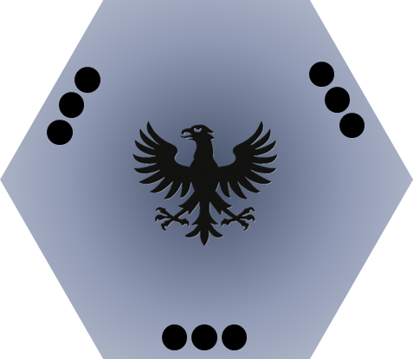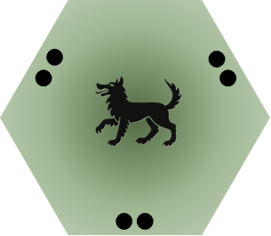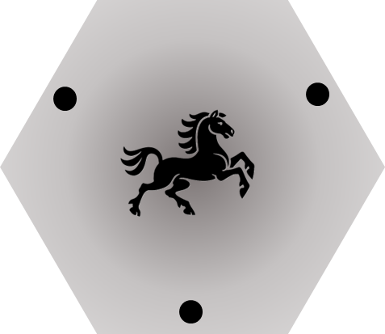

 |  | Command Tile
 |  | 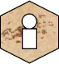 | Baron | 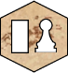 | Keep +  Knight | 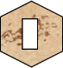 | Keep
Troop Orders | Concentrate |  |  |  |  | 
 | Disperse |  |  |  |  | 
 | Recruit |  |  |  |  | 
 | Build |  |  |  |  | 

Resolution | Maneuver | Tile |  | Discard | Supply
 | Build Keep | 3 troops |  | 3 troops | --
 | Destroy Keep | 3 troops |  | -- | 3 troops
 | Capture Keep | 9 troops |  | 3 troops | 6 troops

