Land of Barons
- Introduction
In The Land of Barons, you play as a Liege Lord engaged in the conquest of fractured provinces. Across a domain that takes shape with every battle, your orders are driven by the strategic management of your cards.
Your Lords — your Baron and his Liege Knights — roam the land to manage your army's logistics: they recruit Troops, move your battalions, and order the construction of Keeps, the pillars of your conquest.
Troop maneuvers can spark decisive battles, while the strategic placement of your Knights allows you to lock down enemy positions and restrict your rivals' orders.
Who will emerge as the most powerful Baron? Are you ready for an epic adventure where strategy, tactics, and risk-taking collide?
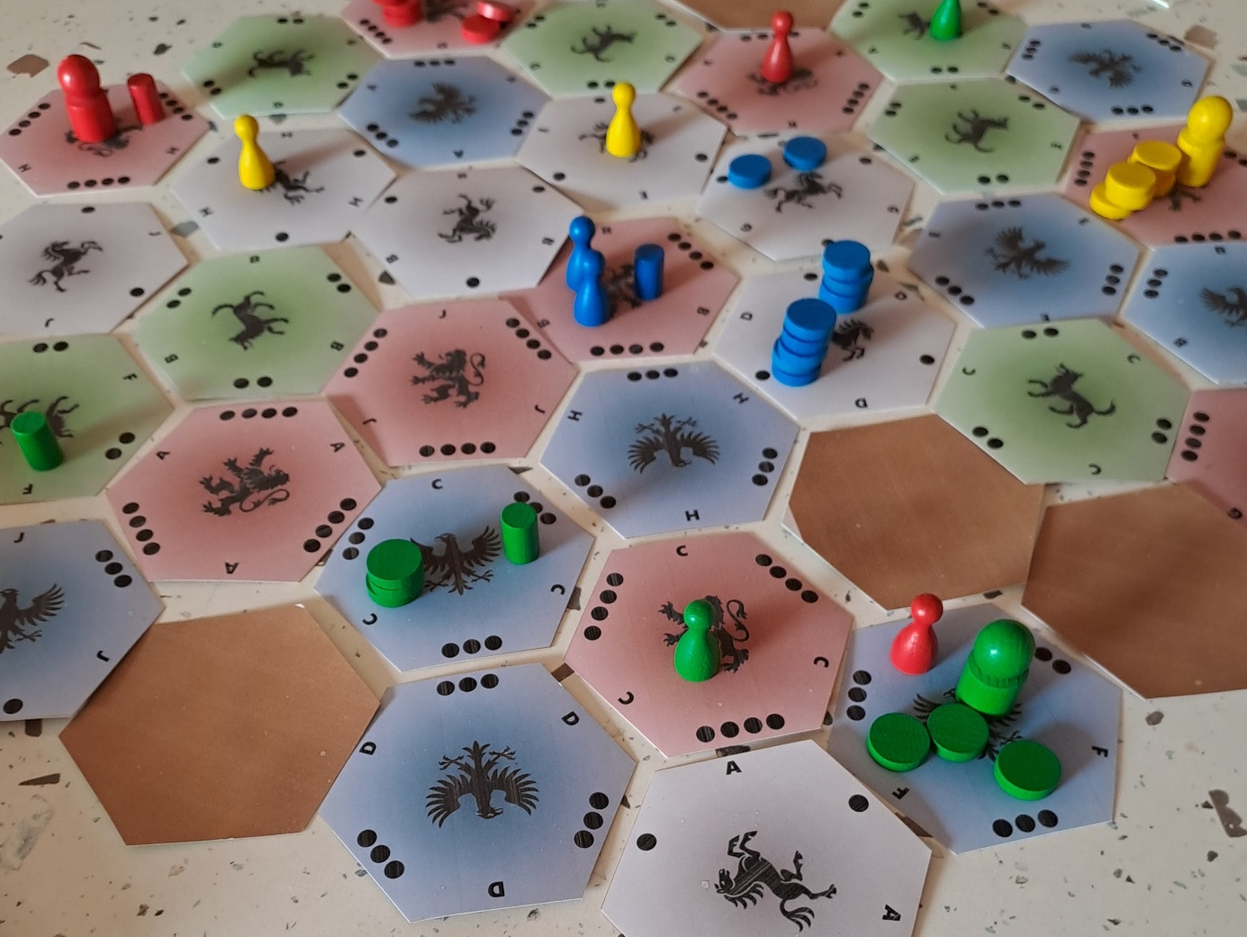
- General Information
Number of Players |  | 2 to 4 |  |  | Genre |  |  | Mechanics
Age |  | 10 |  |  | Conquest |  |  | Area Control
Duration |  | 60 minutes |  |  | Tactical |  |  | Chain of Command
Experience Level |  | Intermediate Players |  |  | Logistics |  |  | Hand Management

The Land of Barons, Game rules for 2 to 4 players.
Copyright (C) 2023 lucas.borboleta@free.fr ; licence Creative Commons BY-NC-SA
- Components
- 37 Hexagonal Tiles: Double-sided. Front: Lands worth 1, 2, 3, or 4 points. Back: Impassable Mountains (solid brown face). Each tile is identifiable on the front by a color, a crest, and a letter, distributed as follows:
  - 10 Red 4-point Tiles (Lion crest)
  - 9 Blue 3-point Tiles (Eagle crest)
  - 9 Green 2-point Tiles (Wolf crest)
  - 9 Grey 1-point Tiles (Horse crest)
- 37 Position Cards: Matching the colors, letters, and crests of the Tiles.
- 4 Prestige Cubes: 1 white cube for the Free City and 3 wooden cubes for the Trading Cities.
- 1 Score Track
- Player Materials (x4 sets):
- 1 Large Baron Pawn
- 4 Small Knight Pawns
- 30 Troop Tokens
- 10 Small Cylindrical Keeps
- 1 Deck of 42 Action cards plus 3 Event cards
- Goal of the Game – Game End – Winner
  - Goal of the Game
Your goal is to accumulate the most points by asserting your dominance through the construction of Keeps. Your total score is the sum of three types of gains:
- Land Points: The value of each Tile where you own a Keep.
- Prestige Points: Bonuses granted if your Keeps occupy Tiles containing the Free City or Trading Cities.
- Diversity Points: A bonus rewarding the variety of crests (Land colors) you have conquered.
Land Points |  |  | Prestige Points |  |  | Diversity Points
Grey Land (Horse) | 1 point |  | Trading City | 2 points |  | 2 colors | 2 points
Green Land (Wolf) | 2 points |  | Free City | 4 points |  | 3 colors | 3 points
Blue Land (Eagle) | 3 points |  |  |  |  | 4 colors | 4 points
Red Land (Lion) | 4 points

Important Note: The score track monitors scores in real-time. Update it at the end of each player's turn whenever Keeps are built or destroyed. No points are permanent: scores depend solely on the current state of the board. If a Keep is removed, all associated gains are instantly lost: Land Points, Prestige Points, and even the Diversity bonus, which must be recalculated based on your remaining Land colors.

  - Game End
The game ends immediately at the end of the active player's turn if any of the following three conditions are met:
- Supremacy: The active player reaches or exceeds the Critical Point Threshold. Their influence is so great that their rivals have no choice but to bend the knee.
- Exhaustion: The active player has 5 or fewer Troops remaining (total on the board and in their supply). Too much blood has been shed, and the heralds sound the end of the conflict.
- Desolation: There are 5 or more Event cards in the Calamity Zone. The kingdom, ravaged by repeated plagues, collapses: the time for conquest is over; the time for survival has begun.
Critical Thresholds
Configuration | Supremacy | Exhaustion | Desolation
2-Player Game | 18 points | 5 Troops | 5 Cards
3-Player Game | 14 points | 5 Troops | 5 Cards
4-Player Game | 12 points | 5 Troops | 5 Cards

  - Determining the Winner
Once the end of the game is triggered, the player with the highest score wins. In the event of a tie, the following tie-breakers are used in order:
- Most Keeps on the board.
- Most Troops available (total on the board and in the supply).
- If the tie persists, the players share the victory!
  - Scoring Examples

Conquests | Land Points | Prestige | Diversity | Total
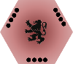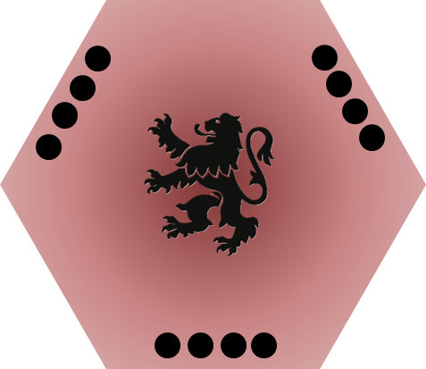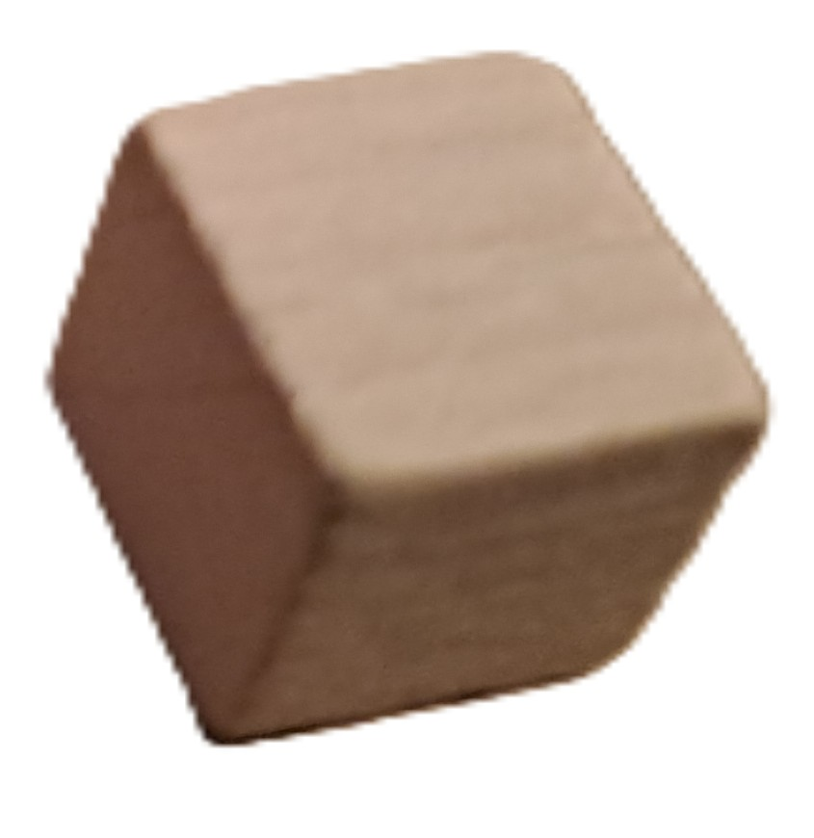 | 4+4+4+4 = 16 | 4 | 0 | 20
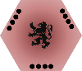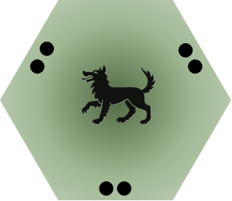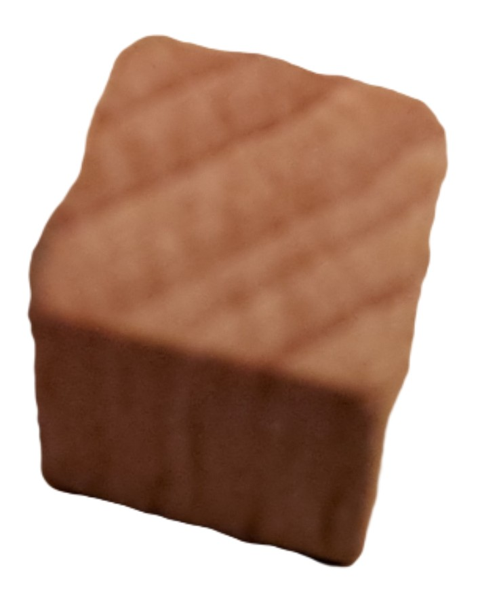 | 4+4+3+3 = 14 | 2+2=4 | 2 | 18
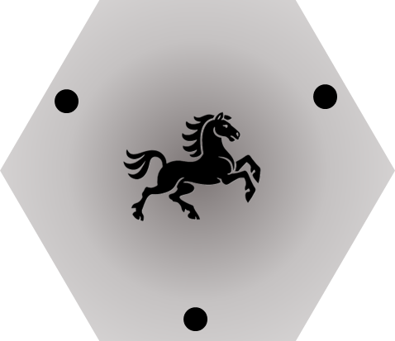 | 4+4+3+2+1 + 1 = 15 | 0 | 4 | 19
 | 4+3+3+2+2 =14 | 2 | 3 | 19

- Setup
  - Shaping the Terrain
- The Board – Shuffle the Tiles and arrange them with the "crest" side visible following the hexagonal pattern below (a large hexagon with 4 tiles per side).

- Special Positions – Shuffle the 37 Position cards. For each step below, announce the element, draw a card, and place the element on the corresponding Tile:
- Mountains: Draw 4 cards. Flip the designated Tiles to their brown side (crests hidden). Important: Permanently remove these 4 cards from the game.
- Free City: Draw 1 card and place the white cube on the designated Tile.
- Trading Cities: Draw 3 cards and place the wooden cubes on the designated Tiles.
  - Initial Deployment
Before players choose their sides, draw the starting Positions for each color in play:
- One Tile for the Baron.
- One Tile for the first Knight.
- One Tile for the second Knight.
Important: Once these Positions are established, reshuffle all Position cards (except for the 4 Mountains) to form the Position Deck.
Vigilance (Blocking and Balance)
- Accessibility: If a Baron, a Knight, the Free City, or a Trading City is isolated from the rest of the board by Mountains, redraw its Position card.
- Connectivity: If the terrain is too fragmented or if Tile colors are too clustered (creating unbalanced zones), players are encouraged to perform a full reshuffle of the board.
  - Preparation of the Liege Lords
- Turn Order – Play proceeds clockwise. To determine the first player, each player draws one Position card. The first player is the one with the lowest-ranked card based on the following hierarchy:
  - Crest Value: Horse (1) < Wolf (2) < Eagle (3) < Lion (4).
  - Letter: A < B < C < D...
Example: A Wolf card (2) wins over a Lion card (4). Between two Wolf cards, Wolf A wins over Wolf B.
- Choosing Colors – Starting with the last player and moving counter-clockwise, each player chooses a color and collects their materials.
- Supply Setup – Each player places the following in front of them:
  - Their Liege Knights (2 in the supply; the other 2 already on the board).
  - 10 Keeps and 30 Troops.
- The Deck – Set aside the 3 brown Event cards (Calamities); they are not included in the first deck cycle. Shuffle your 42 remaining Action cards to form your face-down draw deck.
- The Barons' Oath (Simultaneous Mulligan) – Before the first player opens hostilities, all players proceed simultaneously:
  - Draw an initial hand of 6 cards.
  - Decision: If you are unsatisfied with your hand, you may take a single free Mulligan.
  - Procedure: Return your 6 cards to your deck, reshuffle, and draw your final hand of 6 cards. Once all Lords have sworn an oath upon their hand, the conquest begins!
  - Table Layout
- Cemetery: Designate a shared space (e.g., the box lid) for all Troops permanently leaving the game (due to combat, construction, or events).
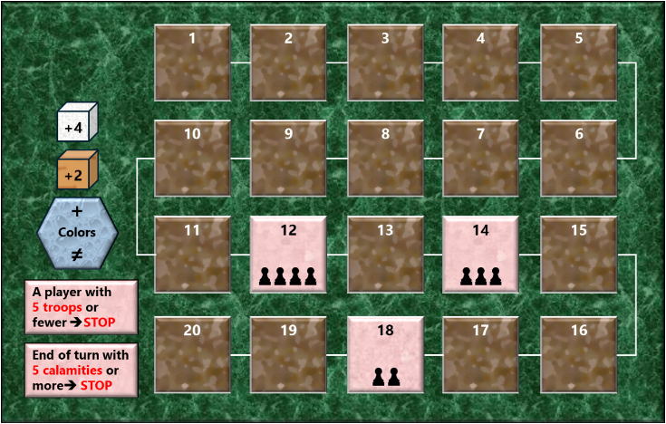
- Calamity Zone: Reserve a central area for Event cards (Calamities). Once resolved, they remain face-up here, marking the progression toward the Time of Survival.
- Score Track: Place the track where everyone can see it. Each player places one Keep in front of the "1" space to mark their starting influence.

The conquest begins! The first player opens hostilities, followed by the other players in clockwise order.
Below is the table layout diagram for a 2-player game

Score Track
P1 Supply
P1 Action Deck
P1 Discard Pile
P2 Supply
P2 Action Deck
P2 Discard Pile
Cemetery
Position Deck
Calamity Zone
- Turn Sequence
On your turn, you must choose one of the following two options:
Option A — Take Action
- Plan – Choose 1 to 3 Action cards from your hand. The total cost of these cards must not exceed 3 credits (indicated at the bottom left of each card). Example: Playing 2 cards with costs of 1 and 2 credits ($1+2 3$).
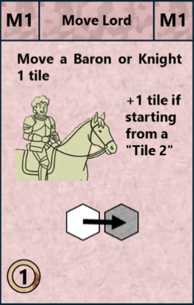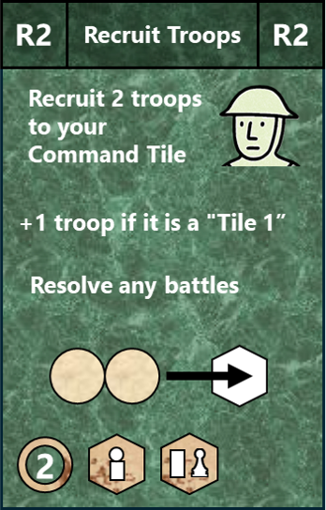
- Act – Resolve the effects of your chosen cards according to these rules:
  - Free Order: You choose the sequence in which your cards are resolved.
  - Independence: Each card must be fully resolved before moving to the next. A card may alter the state of the board (movement, recruitment, combat) and thus influence the conditions for the following card.
  - Discard: Once played, place them face-up in your personal Discard Pile.

- Reinforce – Refill your hand until you have 6 Action cards:
- If there are Event cards in your deck, you must draw your cards one by one.
- If you draw an Event card, reveal it and resolve it immediately.
- Then, place the Event card in the Calamity Zone (it does not go to your discard pile or back into your deck).
- Update (End of Turn)
- Update the Score Track based on the final state of the board.
- Check if any threshold for Supremacy (points), Exhaustion (5 troops or fewer), or Desolation (5 events or more) has been reached. If so, the game ends immediately.
Option B — Replan
If you choose not to play any Action cards:
- Purge: Discard between 1 and 6 cards from your hand into your personal Discard Pile.
- Renew –Refill your hand until you have 6 Action cards:
  - As with Option A, reveal and resolve immediately any drawn Event card, then continue drawing until your hand is full.
- Update (End of Turn) – As with Option A, update the Score Track and check for game-end conditions (Supremacy, Exhaustion, or Desolation). Even if you didn't act, some Events triggered during the draw may have altered the state of the board.
- Managing the Deck and Discard Pile
- Transparency: Your opponents may ask to examine the cards you have just discarded during your turn. Once the examination is complete, only the top card of the pile remains visible.
- Confidentiality: Aside from this immediate consultation, the contents of the discard piles are secret. No player may browse their own discard pile or that of a rival.
- Deck Cycling (Reshuffling): As soon as your deck is exhausted and you still need to draw cards to refill your hand:
  - First, draw any remaining cards from the deck (if any).
  - Retrieve your 3 brown Event cards that were set aside at the start of the game.
  - Shuffle them together with your entire discard pile.
  - This forms your new deck; proceed to finish refilling your hand.
Note: Event cards only enter your deck starting with this first reshuffle (the second cycle).

- Action Card Effects
Action cards are divided into three types, identified by their background color, as shown in the figure below:
- Pink Background: Lord Actions (Baron or Knight).
- Green Background: Troop Actions.
- Grey Background: Hand Actions.
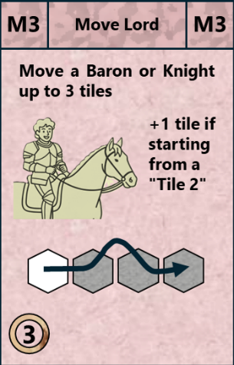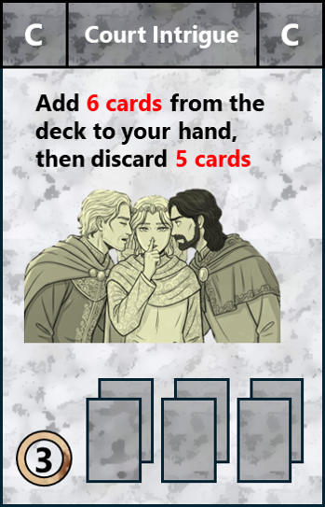
The following table provides a summary of the 42 Action cards. For each card, its name, type (via background color), cost, and quantity are listed.
Action Card | Credits | Quantity | Groups
Move Lord 3 | 3 | 4 | 15 |  |  | 42
Move Lord 2 | 2 | 5
Move Lord 1 | 1 | 6
Recruit Troops 3 | 3 | 2 | 9 | 17 | 23
Recruit Troops 2 | 2 | 3
Recruit Troops 1 | 1 | 4
Concentrate Troops | 1 | 3 | 8
Disperse Troops | 1 | 5
Build Keep | 3 | 6 | 6 | 6
Long Ride | 3 | 1 | 4
Recruit Knight | 3 | 1
Exile Knight | 3 | 1
Court Intrigue | 3 | 1

Action cards are described in detail by type in the following sections.

  - Lord Action Cards
Below are the effects of Action cards played on a Lord.
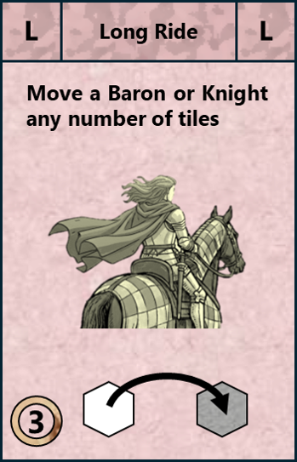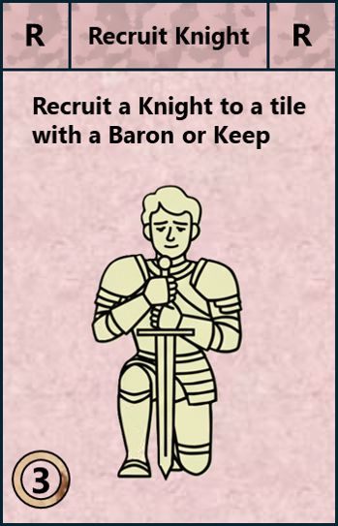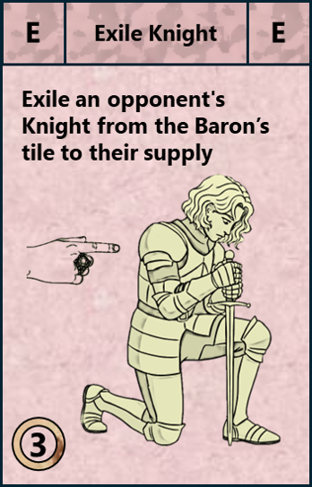
- Move Lord 3 – Move one Lord (Baron or Knight) up to 3 Tiles. The movement does not have to be in a straight line.
- Bonus: If your Lord starts their movement on a 2-point Tile (Wolf), they gain +1 Movement (representing a lush green land where they can regain their strength).
- Constraints:
  - Neither a Baron nor a Knight may cross or occupy a Mountain Tile.
  - A Knight has no other crossing or occupation constraints.
  - A Baron may not cross or occupy a Tile occupied by an enemy Baron or an enemy Keep.
  - A Baron may cross or occupy a Tile occupied by allied or enemy Troops and Knights.
- Move Lord 2 – Identical to "Move Lord 3," but with a maximum distance of 2 Tiles (plus any potential terrain bonus).
- Move Lord 1 – Identical to "Move Lord 3," but with a maximum distance of 1 Tile (plus any potential terrain bonus).
- Long Ride (Rare) – Choose one Lord (Baron or Knight) currently on the board and move them directly to any Tile of your choice, respecting the occupation restrictions listed under "Move Lord 3."
- Recruit Knight (Rare) – If you have a Knight remaining in your supply, place that Knight directly onto a Tile occupied by your Baron or one of your Keeps.
- Exile Knight (Rare) – If an enemy Knight is present on the same Tile as your Baron, that Knight is sent back to the opponent's supply. If multiple enemy Knights are on your Baron's Tile, this effect only applies to one of them.

  - Combat – Control – Command
Before describing the Troop Action cards in §8.3, three key mechanics must be detailed:
- Clash Resolution: Resolving "Troops vs. Troops" and "Troops vs. Keep" encounters.
- Knight Control: How Knights lock down a Tile.
- Troop Command: Issuing orders to Troops from a Tile.
    - Clash Resolution
Clashes occur in the following situations. Resolving each clash is mandatory and immediate.
The Vanguard Rule – When performing a Concentrate or Disperse action, you may freely organize your engaged Troops into multiple Assaults. For each Assault, only the specific number of Troops required to resolve the combat—the Vanguard—is used.
- Troop Clash – On a Tile occupied by enemy Troops, the arrival of one or more of your Troops triggers a clash:
Resolution
Supply
Cemetery
Clash
  - The principle is: 1 Troop versus 1 Troop.
  - Your Troop is the attacker. It is returned to your Supply.
  - The enemy Troop is the one being attacked. It is sent to the Cemetery.
  - Resolving Troop Clashes takes priority over Keep Clashes (see Keep Destruction or Capture).
- Keep Destruction – On a Tile occupied by an enemy Keep, the presence of your Troops may trigger a clash:
Resolution

Supply
Clash

Supply
X 3
X 3
  - The principle is: 3 Troops versus 1 Keep.
  - The presence of your 3 attacking Troops triggers the clash. Having only 1 or 2 attacking Troops triggers nothing. The arrival of the 3rd Troop is what initiates the combat.
  - The enemy Keep is destroyed and returned to its owner’s Supply.
  - Your 3 attacking Troops are returned to your Supply.
- Keep Capture – This is a powerful variation of "Keep Destruction»:
Resolution
Supply
Clash
Supply
Cemetery
X 3
X 6
X 9
  - The principle is: 9 Troops versus 1 Keep + 1 Keep.
  - The presence of 9 attacking Troops triggers the clash. The presence of 1 or 2 attacking Troops triggers nothing. The arrival of the subsequent Troops triggers the clash.
  - The enemy Keep is destroyed and returned to its owner’s Supply.
  - You immediately build a Keep of your own color on the Tile.
  - 3 attacking Troops are sent to the Cemetery.
  - 6 attacking Troops are returned to your Supply.
The Rearguard Rule – If you move more Troops than necessary for a clash, the remaining units form the Rearguard. Their behavior depends on the action being performed:
- Concentration: The Rearguard continues its movement toward the Command Tile.
- Dispersion: The Rearguard must stop on the Tile where the clash occurred.
    - Controlling a Tile
A Tile is considered controlled by a color if that color has strictly more Knights on the Tile than any other individual enemy color.
- Ties or Absence: If no color has a majority, or if there are no Knights present, the Tile is considered uncontrolled.
- Note: Barons, Troops, and Keeps never factor into the calculation for controlling a Tile; only Knights are taken into account.

- Examples of Tile Control:
  - 1 Red Knight: Controlled by the Red side.
  - 2 Red vs. 2 Blue: Tie no control.
  - 3 Red vs. 2 Blue vs. 2 Green: Red majority controlled by the Red side.
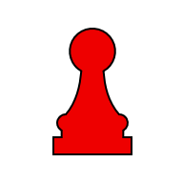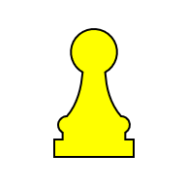
Controlled by Red
Controlled by Red

No Control
    - Command Tile
To play any Troop Action card, you must designate a Command Tile. There are three types of Command Tiles, each offering different capabilities:
 | Baron | A Tile with your Baron can: Recruit, Build, Concentrate, and Disperse.
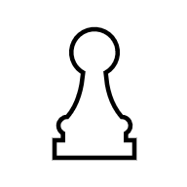 | Keep + Knight | A Tile with one of your Keeps and one of your Knights can: Recruit, Concentrate, and Disperse.
 | Keep | A Tile with only one of your Keeps can: Concentrate and Disperse.

Knight Control Restrictions:
- You cannot designate a Command Tile if it is controlled (see §8.2.2) by enemy Knights. Your Command Tile must be either uncontrolled or controlled by your own Knights.
- A "Keep + Knight" Command Tile loses some of its capabilities if enemy Knights are present and your Knights do not hold a majority (i.e., a tie, see §8.2.2). In this situation, your Knights are considered engaged in a standoff and cannot recruit Troops.

Blue Baron Command Tiles
Blue Keep + Knight
Command Tile
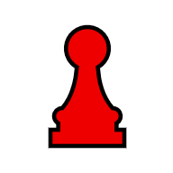
Tiles Controlled by Red
Blue Keep Command Tile
  - Troop Action Cards
Now that you are familiar with the mechanics of clashes, Tile control, and Command Tiles (see §8.2), you are ready to explore the effects of Troop Action cards.
The authorized Command Tiles for each card are indicated by hexagonal icons at the bottom of the Action card (see figure below).
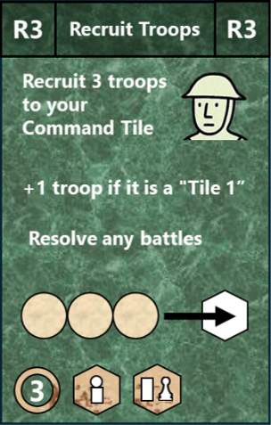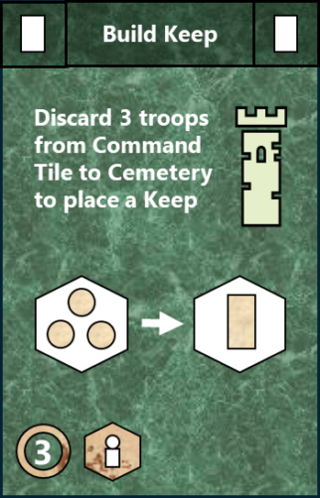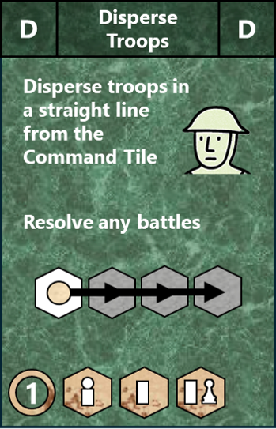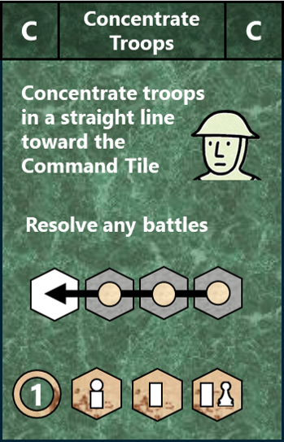
- Recruit Troops 3 – On the designated Command Tile, recruit 3 Troops taken from your supply. If the Command Tile is a 1-point Tile (Grey), you gain a bonus of 1 Troop (representing a poor land where it is easy to find recruits). Furthermore:
  - If your supply is not empty but does not contain enough Troops, recruit as many as possible. If your supply is completely empty, you cannot play this card.
  - Enemy Troops occupying your Command Tile do not block recruitment. However, your newly recruited Troops must clash with them immediately (see §8.2.1).
Recruit 3
Supply
X 3
X 3
Supply
- Recruit Troops 2 – Identical to "Recruit Troops 3," but you recruit only 2 Troops (plus any potential terrain bonus).
- Recruit Troops 1 – Identical to "Recruit Troops 3," but you recruit only 1 Troop (plus any potential terrain bonus).
- Build Keep – Discard 3 Troops from the designated Command Tile to the Cemetery and place a Keep on that Tile. Constraints:
  - A Tile may be occupied by only one Keep.
  - Two Keeps, whether allied or enemy, must not be adjacent to each other.
Build
Cemetery
X 3
X 3
- Disperse Troops – From the designated Command Tile, move some or all of your Troops:
  - Each Troop moves in a straight line in its own direction, as far as you choose.
  - A Troop may not cross or occupy a Mountain Tile or a Tile controlled by enemy Knights (see §8.2.2).
  - A Troop must stop to resolve any Troop or enemy Keep clash (see §8.2.1).
  - A Troop must stop when entering a Tile with an enemy Keep, even if no clash is triggered. If no clash occurs during this action, this Troop may be concentrated or dispersed during a future action.

Valid Dispersions from

- Concentrate Troops – Toward the designated Command Tile, move some or all of your Troops that are aligned with said Command Tile:
  - Same rules as "Disperse Troops," but with the movement direction reversed. Specific rules are detailed below.
  - Each Troop moves in a straight line, as close as possible to the Command Tile. Any clashes triggered along the way are resolved immediately (see §8.2.1).
  - The concentration order cannot pass through a Mountain Tile or a Tile controlled by enemy Knights (see §8.2.2). Consequently, your Troops located on or beyond a Tile controlled by an opponent cannot be concentrated.

Valid Concentrations to
  - Hand Action Cards
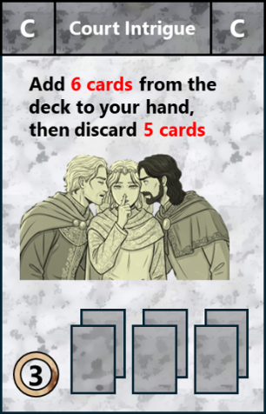
There is only one Action card that directly affects your hand:
- Court Intrigue (Rare) – First, add 6 Action cards from your deck to your hand (bringing your total to 11 cards). Then, choose and discard 5 cards of your choice, in addition to the "Court Intrigue" card itself. At the end of "Court Intrigue," you will have 6 cards in your hand; therefore, you do not draw any cards during the "Reinforce" phase.

- Event Card Effects
The 3 Event cards are Calamities. Each calamity applies to all players, regardless of which deck it originated from.
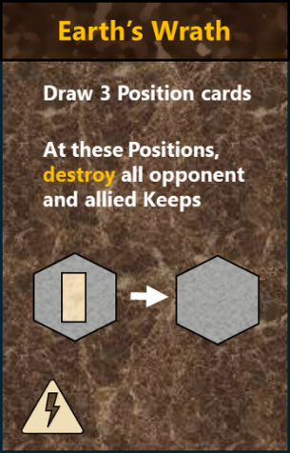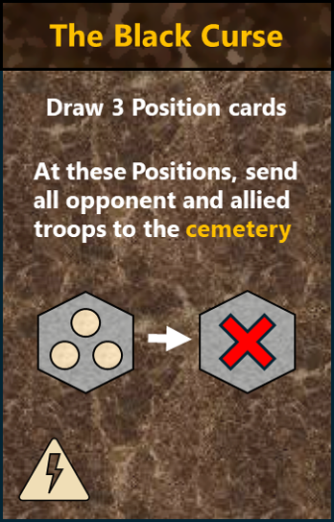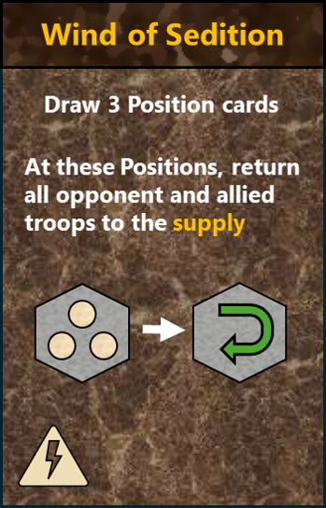
- Wrath of the Earth:
  - Draw 3 Position cards. At these Positions, destroy all Keeps, whether allied or enemy.
  - Then, place the Position cards at the bottom of the Position deck.
  - At the end of the active player's turn, update the score track.
- The Black Curse:
  - Draw 3 Position cards. At these Positions, send all Troops (allied and enemy) to the Cemetery.
  - Then, place the Position cards at the bottom of the Position deck.
  - At the end of the active player's turn, check the Exhaustion threshold.
- Wind of Sedition:
  - Draw 3 Position cards. At these Positions, return all Troops (allied and enemy) to their respective supplies.
  - Then, place the Position cards at the bottom of the Position deck.
Reminder: Event cards only join your deck starting from its second cycle.

Contents
1. Introduction 1
2. General Information 1
3. Components 2
4. Goal of the Game – Game End – Winner 2
4.1. Goal of the Game 2
4.2. Game End 3
4.3. Determining the Winner 3
4.4. Scoring Examples 3
5. Setup 4
5.1. Shaping the Terrain 4
5.2. Initial Deployment 4
5.3. Preparation of the Liege Lords 5
5.4. Table Layout 5
6. Turn Sequence 6
7. Managing the Deck and Discard Pile 7
8. Action Card Effects 8
8.1. Lord Action Cards 9
8.2. Combat – Control – Command 10
8.2.1. Clash Resolution 10
8.2.2. Controlling a Tile 11
8.2.3. Command Tile 12
8.3. Troop Action Cards 13
8.4. Hand Action Cards 15
9. Event Card Effects 16

Statistics : 17 pages ; 3 665 words ; 17 239 characters ; 17 144 002 bytes

