
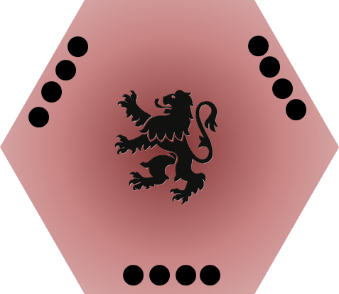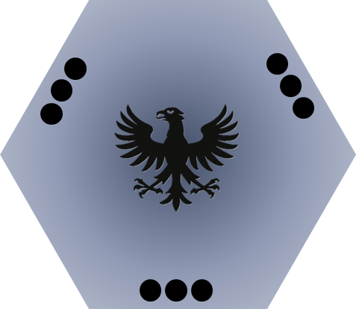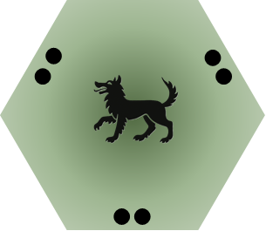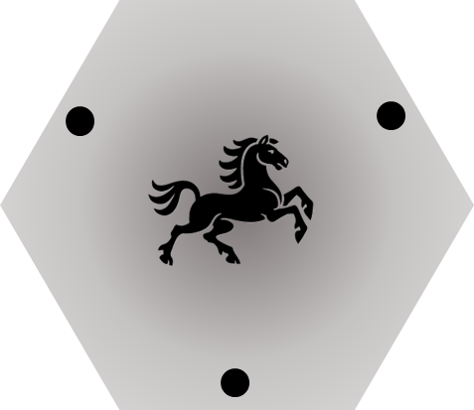

 |  | Command Tile
 |  | 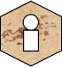 | Baron | 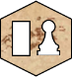 | Keep +  Knight | 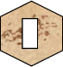 | Keep
Troop Orders | Concentrate | 
Troop Orders | Disperse
Troop Orders | Recruit |  |  |  |  | 
Troop Orders | Build

Resolution | Maneuver | Tile |  | Administration | Supply
Resolution | Build Keep | 3 Troops |  | 3 Troops | --
Resolution | Destroy Keep | 3 Troops |  | -- | 3 Troops
Resolution | Capture Keep | 9 Troops |  | 3 Troops | 6 Troops

