|  |
| --- |
| JERSI 4.0 |
| *Your white pieces challenge your opponent's blacks in order to bring your precious white "kunti" to the most distant opposing row, and vice versa. On the hexagonal field, stacks project your forces and protect your pieces from enemy threats. But not completely, because a cyclical and ternary order governs the strengths of the centerpieces. So, you will have to stack and unstack your pieces at the right time and in the right place!* |
|  |

# **Players**

JERSI is an abstract game between 2 players called "**white**" and "**black**".

# **Components**

On a field of 69 hexagonal cells, each player manage 21 pieces with his/her color (dice having 6 identical faces) divided into 7 kinds (see §References for the pronunciation of **jersi**, **kunti**…):

|  |  |  |  |
| --- | --- | --- | --- |
|  | 1 **kunti** (alias void) |  |  |
| **The triad** | 4 **cukla** (alias rock) |  |  |
| 4 **kuctai** (alias scissors) |  |  |
| 4 **kurfa** (alias paper) |  |  |
|  | 2 **darsi** (alias audacious) |  |  |
| **In the reserve** | 2 **bevri** (alias carrier) |  |  |
| 4 **cmana** (alias mountain) |  |  |

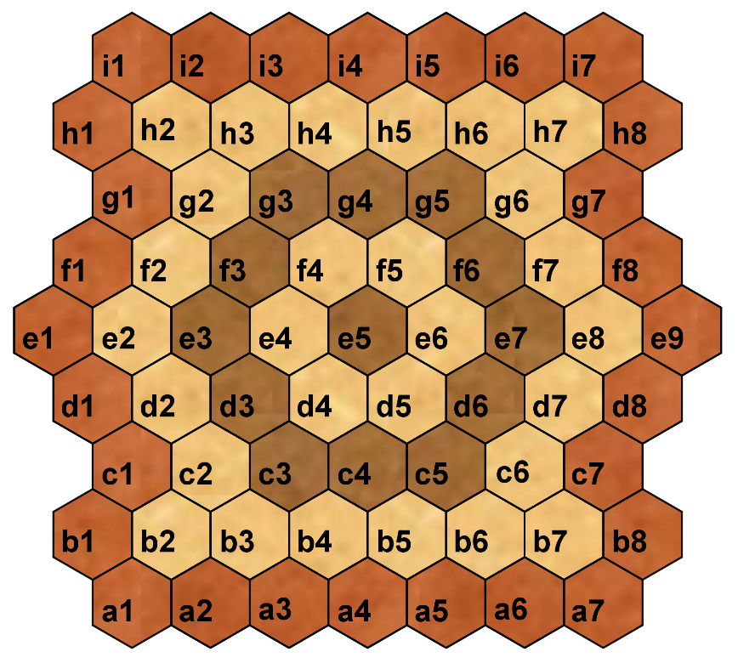

# **Goal of the game**

Be the first to bring his/her **kunti** to the most distant opposing row.

# **Setting**

The colors are drawn randomly.

The players position their pieces in the 2 rows closest to their sides according to the figure below. The pieces **bevri** (carriers) and **cmana** (mountains) are placed in the reserve, next to the field.

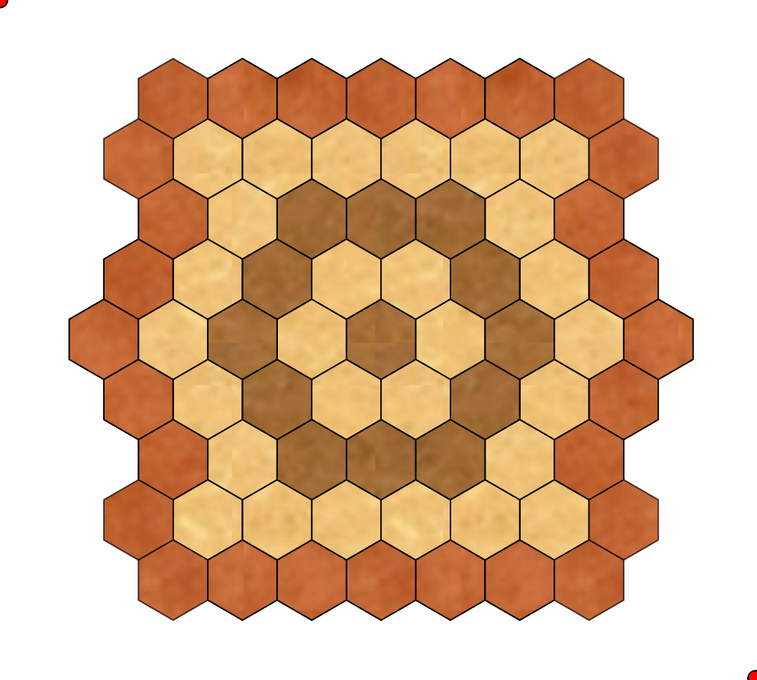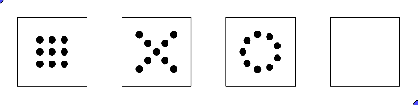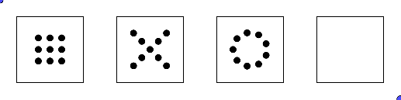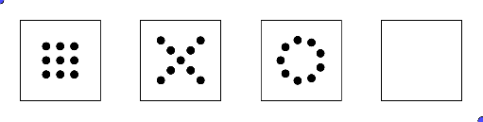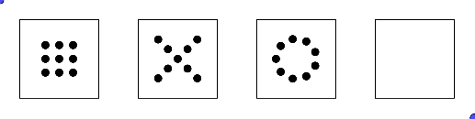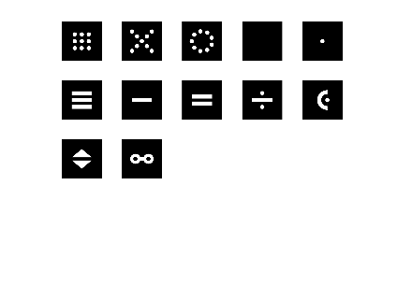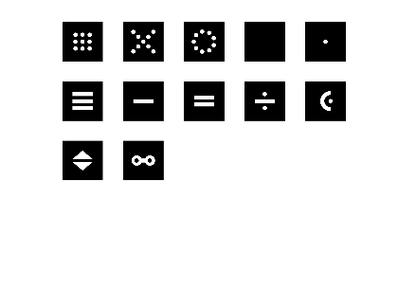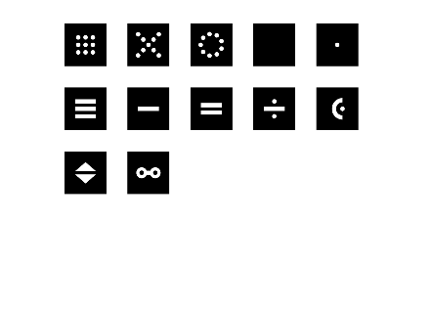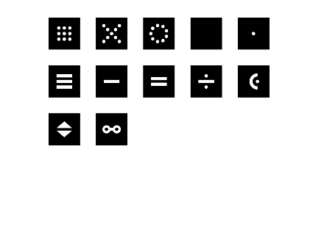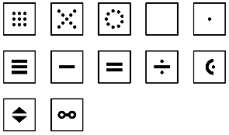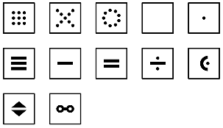

When all the pieces have been placed, the game continues, with the turn of **white**.

# **Stacking**

Each player can stack and unstack the pieces of his/her color.

The maximum stack height is 2.

The kinds of piece within a stack are arbitrary.

Exceptions:

* No piece should be stacked on the **kunti**.
* A **cmana** (mountain) piece cannot be unstacked.
* A **cmana** can only be stacked on a **cmana** of the same color.
* Whatever its color, a piece, which is not **cmana**, can be stacked on a **cmana**.

Conventions:

* A lonely piece is considered as a “stack of height 1”.

The stacking rules are applicable to all actions in the game (setting, resetting, dropping, moving and attacking).

# **Resetting**

When a player captures the opposing **kunti**, he/she must reset this caught **kunti** on the most distant opposing row, in a cell, empty or occupied, of his/her own choice. If no cell is valid, then the game ends with the win of this player.

# **Dropping**

During his/her turn, the player can drop one or two pieces off his/her reserve towards his/her half of the field: rows “a” to “d” for **white** and rows “f” to “i” for **black**; row "e" is forbidden (see §Components).

Any dropped piece must arrive on an empty cell or in a cell occupied by a piece of the same color.

When two pieces are simultaneously dropped off:

* The pieces can be of the same or distinct kinds.
* The pieces must arrive either in the same cell, or in two neighboring cells by an edge.

# **Moving**

A stack of height 1 moves by 1 cell.

A stack of height 2 moves by 1 cell or 2 cells aligned with the start cell.

Stacking or unstacking a piece is equivalent of moving a stack of height 1.

Passing over a piece is forbidden.

Exceptions:

* A **cmana** (mountain) piece does not move.
* A stack of height 2 with a **cmana** at its bottom does not move.

# **Attacking**

An attack is a movement arriving to a position occupied by the opponent.

An attack is only possible if the strength of the attacking stack is greater than that of the attacked stack. After the attack, the beaten opposing stack is entirely removed from the board.

The strength of a stack is determined by the piece of its top, regardless of its height.

Exceptions:

* When the **kunti** is caught, it is not removed from the field: the **kunti** is reset (see §Resetting).
* A **cmana** (mountain) piece never attacks and is never attacked.
* A non-**cmana** piece, at the top of a **cmana**, can only be attacked by a stack of height 1.
* A piece caught at the top of a **cmana** is removed from the field; the **cmana** remains on the field.

The strengths of the pieces are ordered as follows (disregard the colors on the figure):

|  |  |
| --- | --- |
| * **cukla** beats **kuctai**; * **kuctai** beats **kurfa**; * **kurfa** beats **cukla**; * any piece of the « **triad** » (**cukla**, **kurfa** or **kuctai**) beats **darsi**; * **darsi** beats any « **strong** » piece (of the **triad** or **darsi**); * any « **strong** » piece beats any « **weak** » piece (**kunti** or **bevri**). | kunti  cukla  kurfa  kuctai  darsi  cmana  bevri |

# **Turn of game**

On his/her turn, the player decides one of the following two actions; it is not possible to pass your turn:

* A dropping from his/her reserve.
* One or two moves in the field.

For his/her first move in the field:

* The player chooses one of his/her stacks and engages either the full stack of 1 or 2 pieces, or the top of a stack of 2 pieces.
* The player chooses an arrival position for the engaged piece/pieces:
  + If the arrival position is empty, then it is a displacement.
  + If the arrival position has the same color, then it is a stacking.
  + If the arrival position has a different color, then it's an attack.
* The rules for moving, stacking and attacking must be respected.

For his/her optional second move in the field, the player must engage 1 or 2 pieces of the arrival stack from the first move, respecting the following alternating condition:

* If, during the first move, 1 piece has moved, then, during the second move, 2 pieces must move.
* If, during the first move, 2 pieces have moved, then, during the second move, only 1 piece must move.

If the alternating condition cannot be satisfied, then the second move is impossible.

When two moves in the field are played and the **kunti** is caught, then its resetting is always the final action of the turn (see §Resetting).

The table below graphically illustrates the possible sequences of the two moves in the field of a player having the pieces "a", "b" and "c" and also mentions the associated possible attacks.

|  |  |  |  |  |
| --- | --- | --- | --- | --- |
| **Case** | **1st move** | | **2nd optional move** | |
| 1 | a  a | Move « a ».  Possibility to attack the arrival cell. | No option. | |
| 2 | a  a  b | Stack « a » over « b ».  No possible attack. | a  b    a  b | Move stack « a+b ».  Possibility to attack the arrival cell. |
| 3 | a  b    a  b | Move stack « a+b ».  Possibility to attack the arrival cell. | a  b  a | Unstack « a ».  Possibility to attack the arrival cell. |
| a  b  a  c | Unstack « a » et stack it over « c ».  No possible attack. |

# **Game endings**

When a player brings his/her **kunti** to a cell in the most distant opposing row, the game ends with the win of that player.

When a player catches the opposing **kunti** without being able to reset it (see §Resetting), the game ends with the win of that player.

# **Notation**

A game is described on several lines. Each line describes the turn of white then, after one or more spaces, the turn of black. Optionally, the lines are numbered, starting with 1 for the first line.

The coordinate system of the field makes it possible to note the positions of the pieces (see §Components). Each row is marked with a letter. Each position in a row is identified by the number corresponding to its order in the row. The **white** starting positions are rows a and b. A position is given by a letter followed by a number; example: c2.

The first two consonants, in capital letters, identify a piece: "BV" for **bevri**, "CM" for **cmana**, "CK" for **cukla**, "DR" for **darsi**, "KC" for **kuctai**, "KN" for **kunti** and "KR For "**kurfa**". This identifier is used only to describe a pose.

Each elementary pose is noted by the letter identifying the piece, then ":" and the position. The chained poses are separated by "/".

Example of notation of the initial setting (superfluous in JERSI 4 which fixes the initial setting):

|  |
| --- |
| **DR:b1/CK:b2/KR:b3/KC:b4/…/CK:a6/KR:a7 DR:h8/CK:h7/KR:h6/KC:h5/…/CK:i2/KR:i1** |

Each move is noted by the starting position, followed by "-" for 1 displaced piece or "=" for 2 displaced pieces. One adds "!” at the end of the move to notify a capture; for the capture of the **kunti**, one adds "!! ". The second move is noted by continuing after the arrival position of the first move.

The resetting of the captured **kunti** is noted after the movements of the turn, starting with "/ KN:" followed by the new position of the **kunti**.

The notation ends with the score: 1 for the winner; 0 for the loser.

Notation example of moves:

|  |  |  |  |
| --- | --- | --- | --- |
| **n°** | **turns of white and black** | **n°** | **turns of white and black** |
| ***1***  ***2***  ***3***  ***4***  ***5***  ***6***  ***7***  ***8***  ***9***  ***10***  ***11***  ***12***  ***13*** | ***a2-b2=d3 h4-h3=f4***  ***b3-b4=d5 f4=d3!***  ***d5=d3!-e4 CM:f3/CM:f4***  ***a4-a3=c2 i1-i2=g3***  ***c2=e2 h1-h2=f1***  ***e2=g2-h2 f1=h2!!-g2!/KN:a2***  ***e4-d3=f2 g2-f2!***  ***a2-a1=c2 i4-i3=g4***  ***CM:d4/CM:d5 h5-h6=f7***  ***b5-b6=d7 i6-i5=g6***  ***d7=f8-f7! g6=g7-f8!***  ***f7-f8! h8-g7=f8!***  ***a6-a5=b6 i7-h7=f6*** | ***14***  ***15***  ***16***  ***17***  ***18***  ***19***  ***20***  ***21***  ***22***  ***23***  ***24*** | ***b8-a7 g4=e6-e5***  ***b6-b7=c6 f8=d7-c6!***  ***a7=c6!-d7! f6=d7!=e7***  ***BV:c7/BV:b7 g3=g1-f1***  ***c6-c7=e9 e6-e7=e9!***  ***b7-b6=b4 f1-f2=e3***  ***b4=d3-c3 e3=c1-b1!***  ***c2=b3-b4 e9=e7-e6***  ***d3-c3=c1! e5-e6=c6***  ***CM:b6/CM:b7 c6-d7=b8***  ***c1=b1! b8-a7***  ***0 1*** |

# **References**

The following terms are taken from Lojban, a constructed language developed from 1955 to 1989 by the Logical Language Group:

* “**bevri**”, pronounced “b.e.v.r.i” in English or /ˈbevri/ in IPA, means “carry”.
* “**cmana**”, pronounced “sh.m.a.n.a” in English or /ˈʃmana/ in IPA, means “mountain”.
* “**cukla**”, pronounced “sh.oo.k.l.a” in English or /ˈʃukla/ in IPA, means “round” or “circular”.
* “**darsi**”, pronounced “d.a.r.s.i” in English or /ˈdarsi/ in IPA, means “audacity”.
* “**jersi**”, pronounced “j.e.r.ss.i” in English or /ˈʒer.si/ in IPA, means "hunt" or "pursue".
* “**kuctai**”, pronounced “k.oo.sh.t.ai” in English or /ˈkuʃtaɪ̯/ in IPA, means “cross”.
* “**kunti**”, pronounced “k.oo.n.t.i” in English or /ˈkun.ti/ in IPA, means “empty”.
* “**kurfa**”, pronounced “k.oo.r.ph.a” in English or /ˈkurfa/ in IPA, means “square”.

The strength order of the pieces is taken from the "rock-paper-scissors" game.

The acronym "IPA" stands for International Phonetic Alphabet.

# **Version**

This document, dated on March 30 2020, describes version 4.0 of the JERSI rules.

Changes compared to version 3: widening of the hexagonal field; fixed initial setting without stacking; removal of the “guardian” alias “mokca”; introduction of “audacious”, “mountains” and “carriers”; new “landing” goal on the opposing line; resetting the caught “kunti”; simplification of the moves notation; use of the word "piece" instead of "shape"; transition to CC-BY-NC-SA license.

# **Thanks**

I thank my wife "Pt" and my children, "Ad" and "Cr", for their patience, as well as my colleagues "Al", "At" and "Bn", for their participation in the first testing sessions and for their suggestions. I appreciated the exchanges on colors and shades with "Mr" who studies the visual arts. Special thanks to my son "Cr" for his contribution to the development and testing of versions 2, 3 and 4 of the rules. Finally, my little world has grown thanks to the audacity and ambition of "Fr" to edit the game JERSI, and beforehand, to test and improve it by his suggestions and by his group of testers; I thank him warmly!

# **Copyright**

[Licence Creative Commons](http://creativecommons.org/licenses/by-nc-sa/4.0/)

Copyright (C) 2020 Lucas Borboleta.

JERSI, rules of an abstract game for two players, by Lucas Borboleta (<https://github.com/LucasBorboleta/jersi>) is licensed under a Creative Commons Attribution-NonCommercial-ShareAlike 4.0 International License. To view a copy of this license, visit <http://creativecommons.org/licenses/by-nc-sa/4.0/>.

Permissions beyond the scope of this license may be available at [lucas.borboleta@free.fr](mailto:lucas.borboleta@free.fr).

# **Prototype**

On page 9, some photos illustrate my wooden creation of a wide format prototype of JERSI 2 and 3, more intended for demos than for marketing.

The two folded half-boards constitute a box measuring 44 cm x 22 cm x 5 cm.

The closure of the box is obtained by a cord passing through small holes in the two half-boards; two strips, taken from wooden clothespins, provide a releasable binding on the front of the box.

Inside the box, a felt on its bottom reduces the friction of the 28 dice (the pieces) and embellishes the inside.

The hexagonal cells of the board are delimited by pyrography with a cylindrical iron with a rounded flat head, then varnished in three shades.

The pieces are materialized by cubes of 2 cm side, black or white. The dots on the 6 faces of the cubes are engraved to a depth of at least 1 mm by pyrography with a cylindrical iron with a pointed head. For good contrast, the holes in the black pieces are plugged with white wood pulp. For the finish and their protection, the pieces, both white and black, are treated with colorless varnish.

# **Gallery**

Here are some photos of my wide format prototype of JERSI 2 and 3 intended for demo:

|  |  |
| --- | --- |
|  |  |
|  |  |
|  |
|  |

# **Journal**

Read the journal in the French document at <https://github.com/LucasBorboleta/jersi/blob/master/Jersi-les-regles.pdf>. It is not translated in English.

