|  |  |
| --- | --- |
| jersi 4.9 |  |

The two jersi players embody two armies of cubes fighting on a game board. Each player must bring his king cube to the opposite edge of the board and thus win the war. At the start, on the board, alongside the king, each player has warrior cubes with emblems of rock, paper, scissors and foul warriors. Then, from his reserve, each player can drop mountain or wise men cubes.

Each type of cube has a unique capacity. Thus, the king does not fight, but does not die: after its capture, it is sent back to its starting line. Cubes can be stacked for faster movement or to protect a threatened cube, indeed the power of a stack resides in the cube at its top. Cubes and stacks can fight each other.

On his turn, the player performs simple or combined actions such as building a stack and moving it or moving a stack and unbuilding it: beware of accelerations and double captures!

Juggle the stacks and take advantage of the rock-paper-scissor cycle!

# **General information**

|  |  |  |  |
| --- | --- | --- | --- |
| Number of players: 2 | Age limit: 8 years and up | Playing time: 20 to 45 minutes | |
| Author: Lucas Borboleta | Illustrator[1] : Lucas Borboleta | License CC-BY-NC-SA |  |

# **Version**

This document dated December 30, 2020 describes version 4.9 of the jersi rules.

Changes compared to version 4.8: improve the notation system; introduce the “pure” style.

# **Copyright**

[Licence Creative Commons](http://creativecommons.org/licenses/by-nc-sa/4.0/) Copyright © 2020 Lucas Borboleta

JERSI, rules of a strategy game for two players, by Lucas Borboleta (<https://github.com/LucasBorboleta/jersi>) is licensed under a Creative Commons Attribution-NonCommercial-ShareAlike 4.0 International License. To view a copy of this license, visit <http://creativecommons.org/licenses/by-nc-sa/4.0/>.

Permissions beyond the scope of this license may be available at [lucas.borboleta@free.fr](mailto:lucas.borboleta@free.fr).

# **Components**

The 2 players each manage 21 cubes, respectively white and black, on a game board of 69 hexagonal cells. Each player has 1 king, 2 fouls, 4 rocks, 4 papers, 4 scissors, 4 mountains and 2 wise men. The figure on the left shows the faces identifying the cubes. The figure on center shows the game board; the cell numbers are used to explain the rules and to record the moves. The figure on the right shows another style, called « pure », for the faces of cubes.

|  |  |  |  |  |  |  |
| --- | --- | --- | --- | --- | --- | --- |
| 1 king |  |  |  |  |  | style « pure » for the cubes |
| 2 fouls |  |  |  |  |
| 4 rocks |  |  |  |  |
| 4 papers |  |  |  |  |
| 4 scissors |  |  |  |  |
| 4 mountains |  |  |  |  |
| 2 wise men |  |  |  |  |

# **Overview and objective**

The players embody two armies of cubes which compete on a game board. Each player must bring his king to the opposite edge of the board and thus win the war. The cubes move on the board or are dropped from the players' reserves. Stacks of cubes move faster and capture from a greater distance than cubes alone: beware of accelerations and double captures!

# **Setup**

Each player places his king, 2 fouls, 4 rocks, 4 papers and 4 scissors on the board, as shown in the figure below. His 4 mountains and 2 wise men are placed in reserve at his disposal.

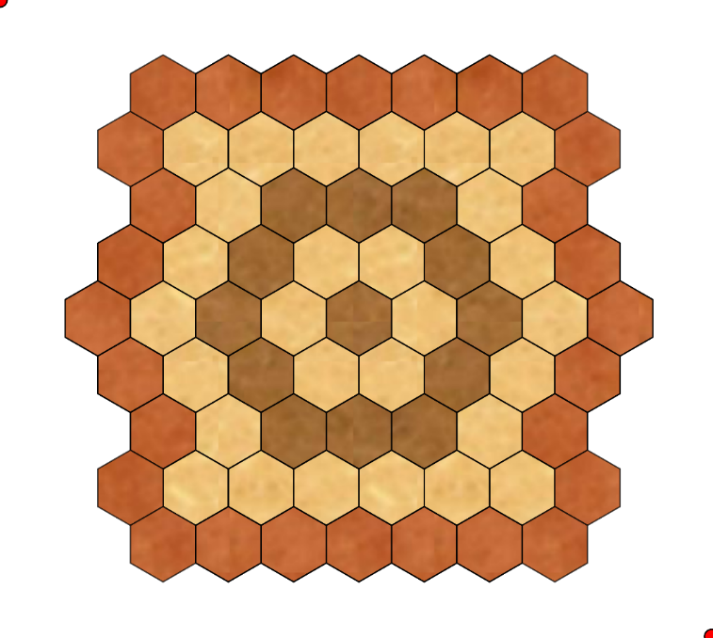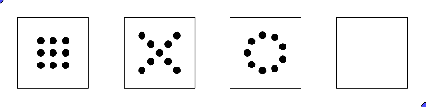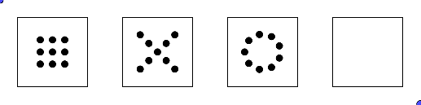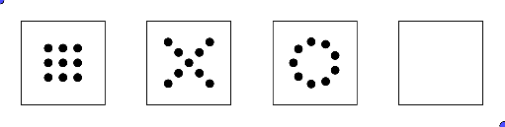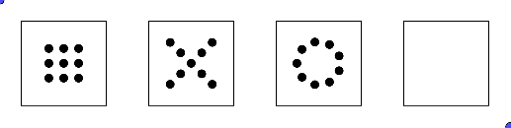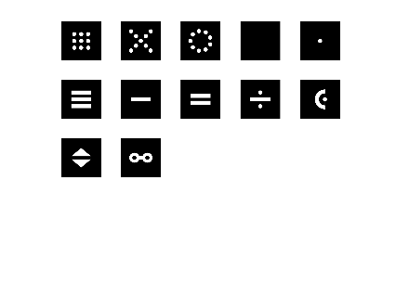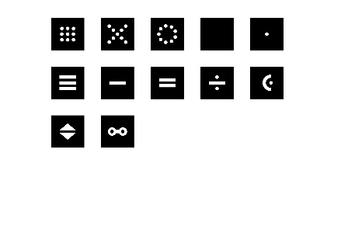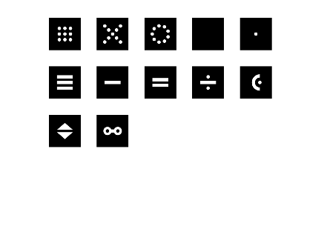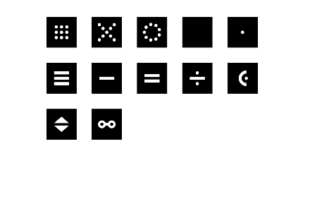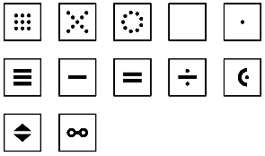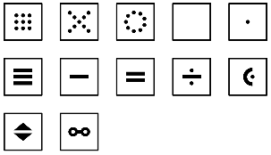

# **Gameplay**

White starts the game. On his turn, each player performs a first mandatory action, then optionally, a second action, which is constrained by the first action. This is equivalent to choosing one of the following actions, simple (in one step) or compound (in two steps):

|  |  |
| --- | --- |
| Action in one step | Action in two steps |
| move a cube | build a stack, then move it |
| move a stack | move a stack, then unbuild it |
| drop one cube from his reserve | drop two cubes from his reserve |

A stack is made up of two cubes: see stack rules.

A move is possibly accompanied by the capture of an opposing unit (cube or stack) located on the arrival cell of the played unit (cube or stack): see the capture rules.

Detailed descriptions follow. They are complemented visually by the diagrams on page 5.

## Allowed stacks

The stacks constructed at the end of each action step must comply with the following rules:

|  |
| --- |
| **Stack rules** |
| **General rule**:   * A stack consists of two cubes: no more no less. * The cubes of a stack are of the same color.   **King exception**: in a stack, the king must be at the top.  **Mountain exceptions**:   * A mountain can only be stacked on another mountain of the same color. * A cube, other than a mountain, can be stacked on an opposing mountain. |

## Action “move a cube or stack of cubes”

The player must respect the following movement rules (in addition to the applicable stack rules):

|  |
| --- |
| **Movement rules** |
| **General rules**:   * A cube moves by one cell, maintaining or changing its elevation (go up or down). * A stack moves by one or two cells in a straight line. * The following are illegal:   + Changing direction during a move step.   + Jumping over a cube or a stack.   **Mountain exception**: moving a mountain (alone or within a stack), after its drop, is illegal. |

## Action “build a stack”

The player must move a single cube and place it on top of another, respecting the movement rules and the stack rules.

## Action “unbuild a stack”

Respecting the movement rules (and stack rules, if applicable), the player must move only one cube, chosen at the top of a stack. This move is possibly accompanied by the construction of a new stack.

## Action “build a stack, then move it”

In two steps, the player chains these two simple actions respecting the associated rules. For his second action, the player must move the stack built on his first action.

## Action “move a stack, then unbuild it”

In two steps, the player chains these two simple actions respecting the associated rules. For his second action, the player must unbuild the stack moved on his first action.

## Action “drop one or two cubes from his reserve”

The player chooses one or two cubes from his reserve, then places them on the board in empty cells or occupied by his own cubes, respecting the stack rules (if applicable) and also the following rule: two dropped cubes must land either in the same cell or in two adjacent cells.

## Capture opposing cubes

Except for the drop, any action involves a movement which is possibly accompanied by the capture of an opposing unit (cube or stack) being on the cell of arrival of the moved unit (cube or stack). The capture rules are as follows:

|  |
| --- |
| **Capture rules** |
| **General rules**:   * A moved unit (cube or stack) can capture an opposing unit (cube or stack) if it is more powerful. * The power of a stack is determined by its top. * The power relationships are as follows (see also the corresponding diagram on page 5):   + king, wise man and mountain do not beat any cube.   + rock beats foul and scissors, as well as king and wise man.   + paper beats foul and rock, as well as king and wise man.   + scissors beat foul and paper, as well as king and wise man.   + foul beats foul, rock, paper and scissors, as well as king, but foul cannot beat wise man. * A captured unit (cube or stack) is entirely removed from the board and is no longer played.   **Exception from the king - relocation**: The captured king is relocated, at end of turn, on its starting row by the attacking player in a cell of his choice, respecting the stack rules, if applicable.  **Mountain exception**:   * A mountain is never captured, therefore never removed from the board. * At the top of a mountain, an opposing cube can only be captured by a cube, but never by a stack. |

The two-step action "move a stack, then unbuild it" is possibly accompanied by two captures: a first when moving the stack, then a second when unbuilding the stack. During this action, if the king is captured at the first step, then the second step must first be played before relocating the king.

# **Game end conditions**

A player wins the game when one of the following conditions is satisfied:

* His king reaches, alone or stacked, the opposite edge of the board (row “i” for White; row “a” for Black).
* The opposing captured king cannot be relocated.
* The opposing player cannot take any action during his turn.

The game is stopped and declared tie game if no capture occurred after 40 turns (20 turns of White and 20 turns of Black) since the start of the game or since the last capture.

# **F.A.Q.**

Here are answers to frequently asked questions:

* In the two-step actions “build a stack, then move it” and “move a stack, then unbuild it”, the directions of movement of the two steps may be different.
* A cube at the top of a mountain can only move by one cell when leaving the mountain.
* The relocation of the captured king mandatory at the end of turn and it is not counted as second action step.

# **Summary diagrams**

|  |  |  |  |  |  |  |
| --- | --- | --- | --- | --- | --- | --- |
| “a” 🡪 “b” means that the cube “a” or any cube in the group “a” can capture the cube “b” or any cube in the group “b”. Foul can capture another foul. Foul can capture the triad rock-paper-scissors and conversely. | | | | | | |
| Power relationships | | | | | | |
| king  rock  paper  scissors  foul  mountain  wise man | | | | | | |
| Moves and captures by White owning « a », « b » and « c »; « m » is a mountain of either White or Black. | | | | | | |
| **1st move step** | | | | **2nd optional move step** | | |
| Move a cube without stacking | a  a | a  c  a | a  m  a | no action | no option | |
| possible capture | | |
| Build a stack | a  a  b | a  a  b  c | a  a  b  m | then move it | possible capture  a  b    a  b | |
| no capture | | |
| Move a stack | possible capture  a  b    a  b | | | then unbuild it | a  b  a | a  b  a  m |
| possible capture | |
| no capture  a  b  a  c | |

# **Rules mnemonics**

The king is not hiding. The king never dies. Mountains are rooted. A cube can cross an allied or enemy mountain pass. Alternating 1-2 or 2-1 of moved cubes per turn. The foul and the wise man respect each other.

# **Variant without drop**

The mountains and the wise men are not used. This variant is recommended when discovering jersi.

# **Ransom variant**

Before relocating the captured king, the attacking player announces a type of ransom, that is, a type of opposing cube, on the board, other than a mountain or a cube below a stack. Then the attacked player chooses a cube of this type and gives it to the attacker as a capture. Finally, the attacker relocates the king. If the attacking player cannot demand a ransom, then he wins the game.

# **Notation of moves**

Each type of cube is referred by an upper-case letter for White and lower-case for Black: “K” for king, “F” for foul, “R” for rock, “P” for paper, “S” for scissors, “M” for mountain and “W” for wise man. Each cell on the game board is referred by its number; example: c2.

Each move is noted by the start cell, followed by “-” for a moved cube or “=” for a moved stack, and ends with the arrival cell. One appends “!” after a move to comment an ordinary capture; for the capture of the king, one appends “!!” instead. The second move is noted by continuing after the arrival cell of the first move.

The relocation of the captured king is noted after the moves, starting with “/K:” or “/k:” followed by the new king's cell. If this variant is played, the ransom is noted “$” followed by the cell containing the demanded cube.

Each drop is noted by the letter identifying the type of cube, then “:” and its arrival cell. Two drop actions are separated by “/”.

The notation sequence ends with the score: 2 for the winner; 0 for the loser; .1 to each player for a tie game.

|  |  |  |  |  |  |  |  |  |  |  |  |  |  |
| --- | --- | --- | --- | --- | --- | --- | --- | --- | --- | --- | --- | --- | --- |
|  |  | **Example of notation of a game won by Black** | | | | | | | | | | | |
| **n°** | **White** | **n°** | **Black** |  | **n°** | **White** | **n°** | **Black** |  | **n°** | **White** | **n°** | **Black** |
| ***1***  ***3***  ***5***  ***7***  ***9***  ***11***  ***13***  ***15*** | ***a2-b2=d3***  ***b3-b4=d5***  ***d5=d3!-e4***  ***a4-a3=c2***  ***c2=e2***  ***e2=g2-h2***  ***e4-d3=f2***  ***a2-a1=c2*** | ***2***  ***4***  ***6***  ***8***  ***10***  ***12***  ***14***  ***16*** | ***h4-h3=f4***  ***f4=d3!***  ***m:f3/m:f4***  ***i1-i2=g3***  ***h1-h2=f1***  ***f1=h2!!-g2!/K:a2***  ***g2-f2!***  ***i4-i3=g4*** |  | ***17***  ***19***  ***21***  ***23***  ***25***  ***27***  ***29***  ***31*** | ***M:d4/M:d5***  ***b5-b6=d7***  ***d7=f8-f7!***  ***f7-f8!***  ***a6-a5=b6***  ***b8-a7***  ***b6-b7=c6***  ***a7=c6!-d7!*** | ***18***  ***20***  ***22***  ***24***  ***26***  ***28***  ***30***  ***32*** | ***h5-h6=f7***  ***i6-i5=g6***  ***g6=g7-f8!***  ***h8-g7=f8!***  ***i7-h7=f6***  ***g4=e6-e5***  ***f8=d7-c6!***  ***f6=d7!=e7*** |  | ***33***  ***35***  ***37***  ***39***  ***41***  ***43***  ***45***  ***47*** | ***W:c7/W:b7***  ***c6-c7=e9***  ***b7-b6=b4***  ***b4=d3-c3***  ***c2=b3-b4***  ***d3-c3=c1!***  ***M:b6/M:b7***  ***c1=b1!***  ***0*** | ***34***  ***36***  ***38***  ***40***  ***42***  ***44***  ***46***  ***48*** | ***g3=g1-f1***  ***e6-e7=e9!***  ***f1-f2=e3***  ***e3=c1-b1!***  ***e9=e7-e6***  ***e5-e6=c6***  ***c6-d7=b8***  ***b8-a7***  ***2*** |

# **Thanks**

I thank my wife "Pt" and my children, "Ad" and "Cr", for their patience, my colleagues "Al", "At" and "Bn", as first testers, "Mr" student in visual arts for her reactions to my selection of colors. The reactions received from the Discord of Tabletopia, the "abstract games" forum of "Board Game Geek" and especially the Facebook group of "The LEAF" were invaluable. Special thanks to my son "Cr" for his involvement in the successive versions of the rules. Finally, my little world has grown thanks to the audacity of "Fr" to publish the game jersi, and beforehand, to test and improve it by its suggestions and by its group of testers; I thank him warmly!

1. For photos, figures, and diagrams of the present document. The cover photo is a screenshot of an implementation of jersi, by the author, on the platform <https://tabletopia.com/>.