JERSI

# **Players**

JERSI is an abstract game between 2 players called "**white**" and "**black**".

# **Components**

On the cells of a hexagonal board, with 5 side cells, each player moves 13 "shapes" of his/her color (13 dices with 6 identical sides) divided into 4 kinds:

|  |  |  |
| --- | --- | --- |
| 1 **kunti** |  |  |
| 4 **cukla** |  |  |
| 4 **kuctai** |  |  |
| 4 **kurfa** |  |  |

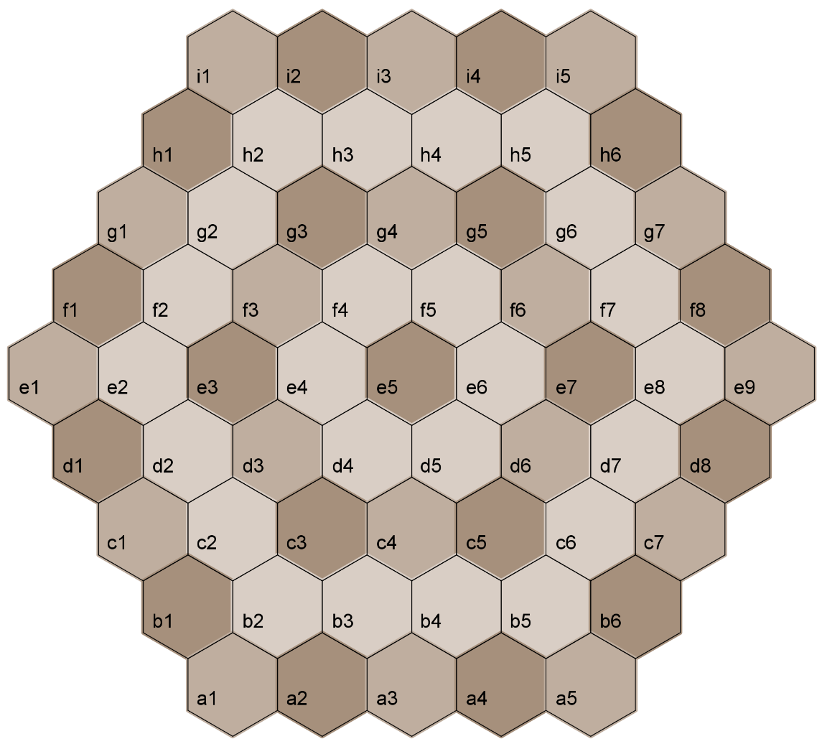

# **Goal of the game**

Be the first to capture the opposing **kunti**.

# Setting

The colors are drawn randomly.

**White** stands in front of rows a and b, and **black** stands in front of rows h and i (see §Components).

Players position all their shapes in the 2 rows closest to their sides, respecting the stacking rules (see §Stacking) and without obligation to completely fill these 2 rows.

Three setting methods are described in §Symmetrical setting, §Random setting and §Free setting. The symmetrical setting is the fastest and it is the one recommended for beginners.

When all the shapes have been placed, the game continues, with the turn of **blank**.

# **Stacking**

Each player can stack and unstack the shapes of his/her color.

The maximum height of a stack is 2. An isolated shape is considered as a stack of height 1.

The shapes within a stack are arbitrary.

The **kunti** can be placed in a stack of height 2, but only at the top.

# **Free setting**

The players set all their shapes, one by one, in turn, in the 2 rows closest to their sides, respecting the stacking rules (see §Stacking) and without obligation to completely fill these 2 rows. **White** begins the setting phase.

# **Symmetrical setting**

Here is the recommended symmetrical setting:

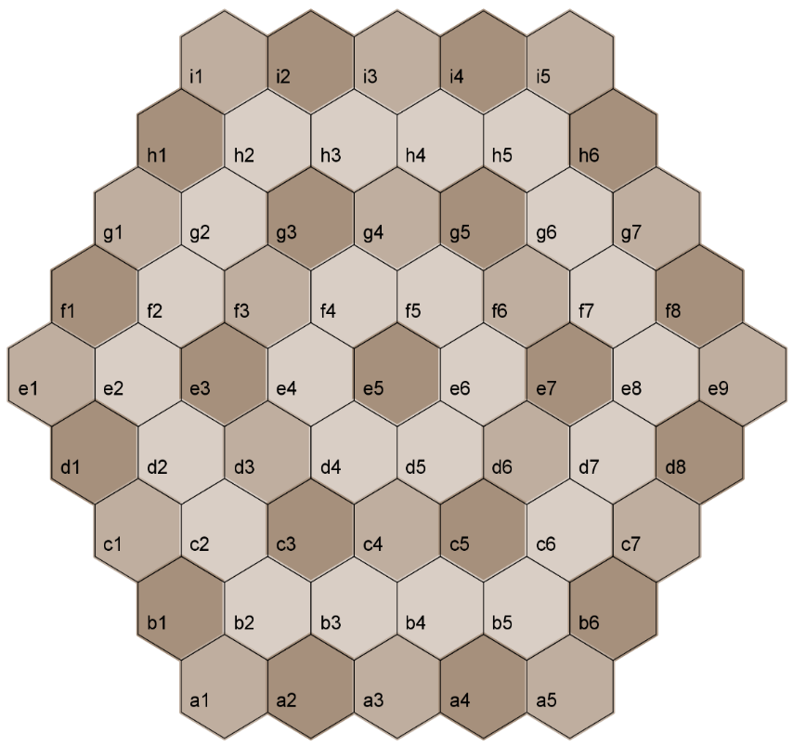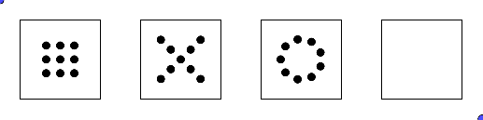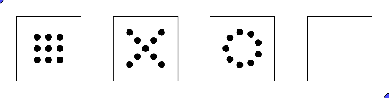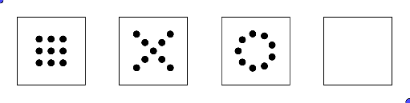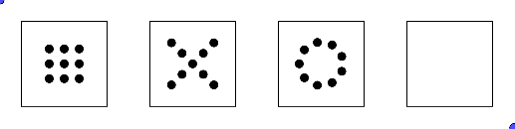

# **Random setting**

First place the **kunti**, then randomly shuffle the other shapes and place them in the following order:



1

2

3

4

5

6

7

8

9

10

11

12

1

2

3

4

5

6

7

8

9

10

11

12

# **Moving**

A stack of height 1 moves by 1 cell.

A stack of height 2 moves by 1 cell or 2 cells aligned with the start cell.

Stacking or unstacking a shape is equivalent of moving a stack of height 1.

Passing over a shape is forbidden.

# **Attacking**

An attack is a movement arriving to a position occupied by the opponent.

An attack is only possible if the strength of the attacking stack is greater than that of the attacked stack. After the attack, the beaten opposing stack is entirely removed from the board.

The strength of a stack is determined by the shape of its top, regardless of its height.

The strengths of the shapes are ordered as follows:

|  |  |
| --- | --- |
| * **cukla** beats **kuctai**; * **kuctai** beats **kurfa**; * **kurfa** beats **cukla**; * **cukla**, **kurfa** and **kuctai** beat **kunti**. | kunti  cukla  kurfa  kuctai |

# **Turn of game**

Each player plays one or two moves. It is not possible to pass your turn.

For his/her first move:

* The player chooses one of his/her stacks and engages either the full stack of 1 or 2 shapes, or the top of a stack of 2 shapes.
* The player chooses an arrival position for the engaged shape/shapes:
  + If the arrival position is empty, then it is a displacement.
  + If the arrival position has the same color, then it is a stacking.
  + If the arrival position has a different color, then it's an attack.
* The rules for moving, stacking and attacking must be respected.

For his/her optional second move, the player must engage 1 or 2 shapes of the arrival stack from the first move, respecting the following alternating condition:

* If, during the first move, 1 shape has moved, then, during the second move, 2 shapes must move.
* If, during the first move, 2 shapes have moved, then, during the second move, only 1 shape must move.

If the alternating condition cannot be satisfied, then the second move is impossible.

The table below graphically illustrates the possible sequences of the two moves of a player having the shapes "a", "b" and "c" and also mentions the associated possible attacks.

|  |  |  |  |  |
| --- | --- | --- | --- | --- |
| **Case** | **1er move** | | **2ème optional move** | |
| 1 | a  a | Move « a ».  Possibility to attack the arrival cell. | No option. | |
| 2 | a  a  b | Stack « a » over « b ».  No possible attack. | a  b    a  b | Move stack « a+b ».  Possibility to attack the arrival cell. |
| 3 | a  b    a  b | Move stack « a+b ».  Possibility to attack the arrival cell. | a  b  a | Unstack « a ».  Possibility to attack the arrival cell. |
| a  b  a  c | Unstack « a » et stack it over « c ».  No possible attack. |

# **Game endings**

When a player captures the opposing **kunti**, the game ends, and that player wins the game.

As soon as a player has only the **kunti** and only one kind of shape, then the game must be stopped at the latest after 20 turns (10 turns of **white** and 10 turns of **black**). If no **kunti** is captured after these 20 turns, then the following rules allow you to conclude:

* The player who has the greatest number of shape kinds on the board wins.
* If both players have the same number of shape kinds on the board, then the one who has the greatest number of shapes on the board wins.
* In all other cases, it is a tie game.

# **Notation**

The coordinate system of the board makes it possible to note the positions of the shapes (see §Components). Each row is marked with a letter. Each position in a row is identified by the number corresponding to its order in the row. The **white** starting positions are rows a and b. A position is given by a letter followed by a number; example: c2.

Each shape setting is noted by the letter identifying the shape, then ":" and the position. The shape identifier is its second consonant: "N" for **kunti**, "K" for **cukla**, "C" for **kuctai** and "R" for **kurfa**.

Notation example for the setting phase:

|  |
| --- |
| **N:a3 N:i3 K:b1 K:h6 R:b2 R:h5 C:b3 C:h4 …** |

Each move is noted by the starting position, followed by "-" for 1 displaced shape or "=" for 2 displaced shapes. One adds "!” at the end of the move to notify a capture. For the final capture of the **kunti**, one adds "!! ". The second move is noted by continuing after the arrival position of the first move. The notation ends with the score: 1 for the winner; 0 for the loser; 1 to each player for a tie game.

Notation example of moves:

|  |
| --- |
| **a5-b5=d7 i5-h5=f7**  **d7=e8-f7! h6-g6**  **e8-f7=g6! i2-h3=f5**  **g6=i4!-i3!!**  **1 0** |

# **References**

The following terms are taken from Lojban, a constructed language developed from 1955 to 1989 by the Logical Language Group:

* "**jersi**", pronounced [j.e.r.ss.i] in English or /ˈʒer.si/ in IPA, means "hunt" or "pursue";
* “**kunti**”, pronounced [k.oo.n.t.i] in English or /ˈkun.ti/ in IPA, means “empty”.
* “**cukla**”, pronounced [sh.oo.k.l.a] in English or /ˈʃukla/ in IPA, means “round” or “circular”;
* “**kuctai**”, pronounced [k.oo.sh.t.ai] in English or /ˈkuʃtaɪ̯/ in IPA, means “cross”;
* “**kurfa**”, pronounced [k.oo.r.ph.a] in English or /ˈkurfa/ in IPA, means “square”.

The strength order of the shapes is taken from the "rock-paper-scissors" game.

The acronym "IPA" stands for International Phonetic Alphabet.

# **Version**

This document, dated on January 26 2020, describes version 2.0 of the JERSI rules.

Changes compared to version 1: plain board enlarged by a ring; **kunti** in a stack, but only at its top; special game ending conditions; random setting; simplified coordinates; white and black colors instead of blue and red.

# **Thanks**

I thank my wife "Pt", my children "Ad" and "Cr", as well as my colleagues "Al", "At" and "Bn", for their participation in the first test sessions and for their suggestions. Special thanks to my son “Cr” for his contribution to the development of version 2 of the rules.

# **Overview of a wooden creation**

The following photo shows a handmade game making.

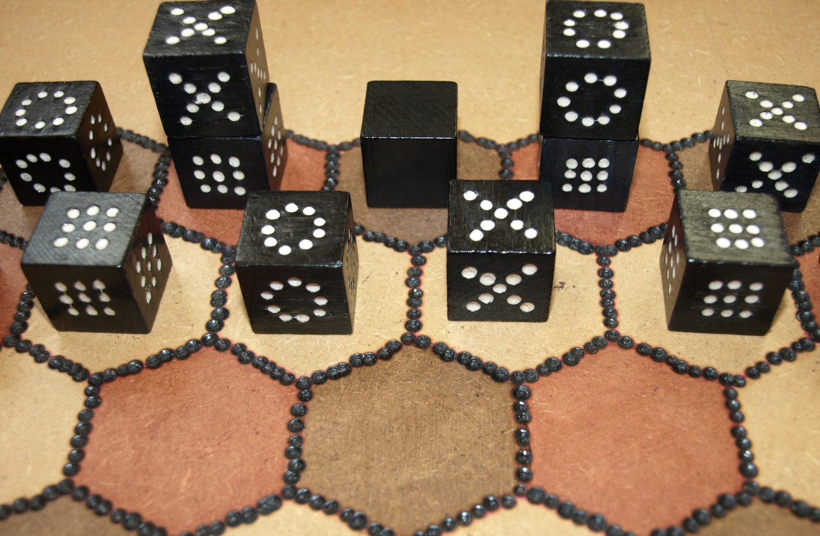

# **Copyright**

[Licence Creative Commons](http://creativecommons.org/licenses/by-sa/4.0/)

JERSI is an abstract game between 2 players

Copyright (C) 2019 Lucas Borboleta (lucas.borboleta@free.fr).

This work by Lucas Borboleta (http://lucas.borboleta.blog.free.fr) is licensed under the Creative Commons Attribution-ShareAlike 4.0 International License. To view a copy of this license, visit <http://creativecommons.org/licenses/by-sa/4.0>.