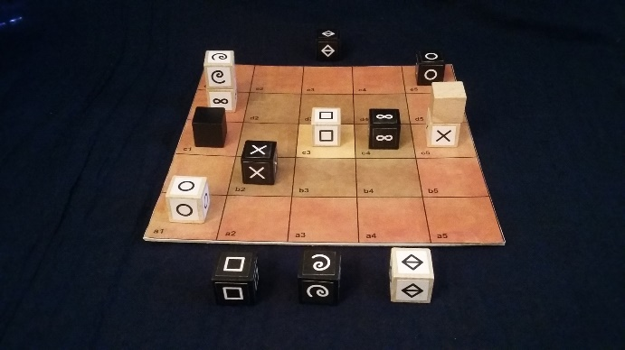

Mikjersi

In Mikjersi, both players maneuver their cubes, alone or in dynamic stacks, which confront each other in their roles of rock, paper, scissors, fool, wise man, king and mountain, with the aim of winning their king or blocking the opposing king. Mikjersi is a micro-variant of the game Jersi. Pronounce /mik-jer-ssi/ in [lojban](https://www.lojban.org/).

# General information

|  |  |  |  |
| --- | --- | --- | --- |
| Number of players: 2 | Age limit: 8 ans | Playing time: 10 à 20 minutes | |
| Author: Lucas Borboleta | Illustrator: Lucas Borboleta | Licence CC-BY-NC-SA |  |

# Components

* A square board of 5x5 spaces.
* For each player, white or black, 7 cubes of their color: rock  ; paper  ; scissors  ; fool  ; wise man  ; king  and mountain .

# Overview and objective

To win, a player must bring his king to the furthest line from his starting line or else make the opponent player unable to play.

# Setup

The board is placed between the two players. Between him and the board, each player has a reserve in which he places his wise man and his mountain. On the line closest to him, each player places his other cubes, from his left to his right: rock, paper, scissors, fool, king. The two kings are therefore aligned along a diagonal. See also variants.

# Gameplay

White starts the game. On their turn, each player chooses one of the following 6 actions of 1 or 2 steps:

|  |  |
| --- | --- |
| move a cube or a stack | build a stack, then move it |
| build a stack | move a stack, then unbuild it |
| unbuild a stack | drop one or two cubes from his reserve |

A stack is made up of two cubes. Cube and stack moves are either vertical or horizontal. Cube and stack capture are made by moves. See the following detailed descriptions.

## The stacks

Stacks built at the end of each action step must respect the following rules:

* **General rule** – A stack must consist of 2 cubes of the same color.
* **King's Rule** – In a stack, the king must be on top.
* **Mountain rule** – The mountain must be on the ground; it does not stack. Any cube, other than a mountain, can stack on an opposing mountain.

## The moves

Any cube or stack move must respect the following rules:

* **General rule** – A cube moves, horizontally or vertically, by one space, maintaining or changing its elevation (up or down). A stack moves horizontally or vertically by 1 or 2 spaces. Jumping is not allowed.
* **Mountain Rule** – After its drop, a mountain cannot be moved.

## Action “move a cube or a stack”

The player must move a single cube or a stack.

## Action “build a stack”

The player must move a single cube and place it on top of another.

## Action “unbuild a stack”

The player must move only one cube, chosen at the top of a stack. This move is possibly accompanied by the construction of a new stack.

## Action “build a stack, then move it”

In two steps, the player chains these two simple actions. For his second action, the player must move the stack built on his first action.

## Action “move a stack, then unbuild it”

In two steps, the player chains these two simple actions. For his second action, the player must unbuild the stack moved on his first action.

## Action “drop one or two cubes from his reserve”

The player chooses one or two cubes from his reserve, then places them on the board in empty cells or occupied by his own cubes, respecting the stack rules and also the following rule: two dropped cubes must land either in the same cell or in two horizontally or vertically adjacent cells.

## The captures

Any movement potentially involves the capture of an opposing unit (cube or stack) occupying the space of arrival of the moved unit (cube or stack). The capture rules are as follows:

* **The powers**:
  + A moved unit (cube or stack) can capture an opposing unit (cube or stack) if it is more powerful. The power of a stack (without a mountain) is determined by its top.
  + The power relationships are as follows:
    - The mountain is invincible, alone or in a stack, and cannot attack.
    - King and wise man do not beat any cube.
    - Rock  beats fool  and scissors , as well as king  and wise man  .
    - Paper  beats fool  and rock , as well as king  and wise man  .
    - Scissors  beats fool  and paper , as well as king  and wise man  .
    - Fool  beats fool , rock , paper  and scissors , as well as king , but fool cannot beat wise man.
* **Protection of the mountain**: At the top of a mountain, an opposing cube can only be captured by a cube, but never by a stack.
* **Capture**: A captured unit (cube or stack) is entirely removed from the board and is placed in the reserve of the attacking player, acting as a jail.
* **Return of the king**: The captured king is relocated, at end of turn, on its starting line by the attacking player in a position of his choice.
* **Exchange of prisoners**: At the end of the turn, the jailed cubes on either side are exchanged if they are of the same power. These exchanged cubes are placed in the respective reserves and can be dropped later.

The two-step action “move a stack, then unbuild it” is potentially accompanied by two captures.

# Game end conditions

A player wins the game when one of the following conditions is met:

* His king reaches, alone or stacked, the opposite line of the board.
* The captured opposing king cannot be repositioned.
* The opposing player cannot perform any action on his turn.

The game is stopped and declared a draw if no capture, other than the king, has taken place after 40 turns (20 white turns and 20 black turns) since the start of the game or since the last capture.

# Setup variants

The positions of the cubes on the starting lines can be varied in one of the following ways:

* Random setup – White randomly places his 5 cubes from his left to his right. Black reproduces this order from his left to his right.
* Played setup – Starting with white and alternating, each player places a cube on his line.

# Copyright Licence Creative Commons © 2021 Lucas Borboleta

Mikjersi, rules of a strategy game for two players, by Lucas Borboleta (<https://github.com/LucasBorboleta/mikjersi>) is licensed under a Creative Commons Attribution-NonCommercial-ShareAlike 4.0 International License. To view a copy of this license, visit <http://creativecommons.org/licenses/by-nc-sa/4.0/>.

Permissions beyond the scope of this license may be available at <lucas.borboleta@free.fr>.