General layout

Back captured cubes

White captured cubes

16

legend

Turn flag

Credit

Toggle menu

(hamburger button)

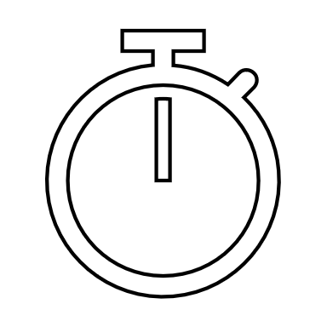

Inactive turn

Running mode

game over

Reviewing mode

Editing mode

stop

new

edit

resume



Note: the button “kebab” is reserved for either contextual or secondary menus

Hexagons

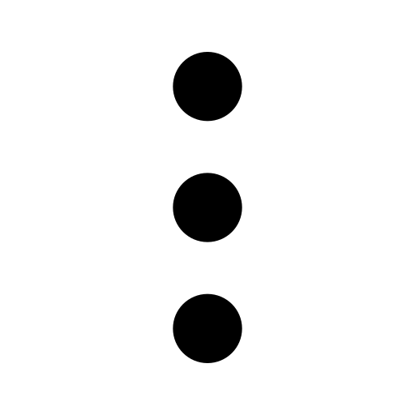

Captured cubes layout

Captured cubes

1

2

4

1

1

2

1

By black player

By white player

Setting mode layout

Hexagons

Back cleared cubes

White cleared cubes

16

legend

Radio buttons

Credit spin box



Cleared cube zones in setting mode

Reset/Clear buttons

1

2

4

1

1

2

1

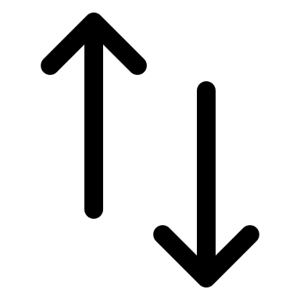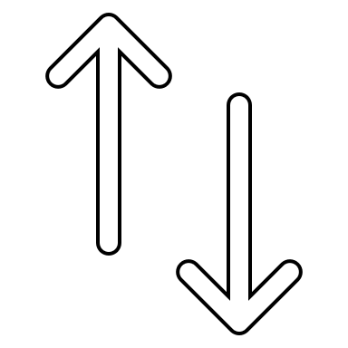

Clickable zones (as destination)