|  |  |
| --- | --- |
| Cailloux empilés avec un remplissage uni | **STAKU!** |

In the game "**staku**", two players, White and Black, move their tokens, stack them and unstack them to reach one of the two opponent's "palaces". Players will need to take advantage of neutral tokens, manage captures, and trampoline effects on stacks of 2 or 3 tokens!

|  |  |
| --- | --- |
| **Components**   * A board of hexagonal boxes. * 13 white tokens. * 13 black tokens. * 9 neutral tokens. |  |

**Goal**

* The goal is to occupy the first **one** of the **two opponent’s palaces** located at the corners of the board.
* The white palaces are at a6 and a6; the black palaces are at g1 and g6.

**Starting positions**

* The white and black tokens are positioned on the first two rows of each side.
* The neutral tokens are positioned on the "big-hearted flowers" of the 3 middle rows.

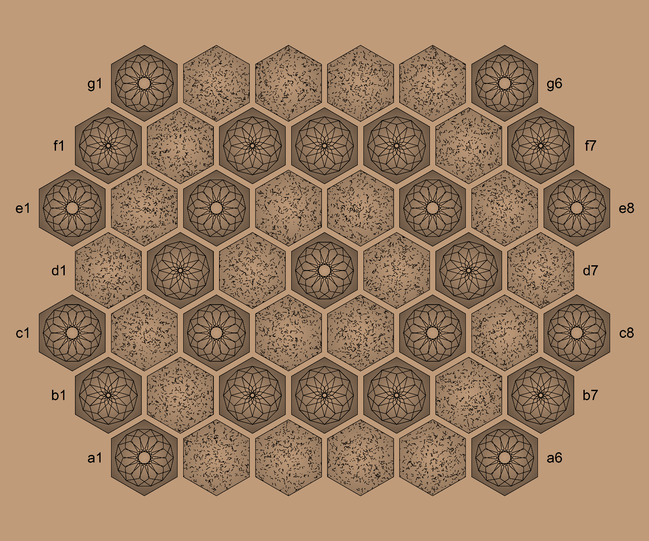

**Legal stacks**

* Stack of 2 or 3 tokens.
* Either all white or neutral tokens, or all black or neutral tokens, or all neutral tokens.
* A neutral token is never above a white or black token.

**Stacking**

* A token can be stacked:
  + Over a token to form a stack of size 2.
  + Over a stack of size 2 to form a stack of size 3.
* A stack of size 2 can be stacked:
  + Over a token to form a stack of size 3.

**Unstacking**

* The token at the top of a stack can be unstacked to do a token move.
* The 2 tokens at the top of a stack of 3 tokens can be unstacked to do a stack move.
* Moving while unstacking can create a new stack or capture opponent’s tokens.

**Moving**

* The moves are only through the faces of the hexagons:
  + To an empty box.
  + To a box occupied by the player color or the neutral color for stacking.
  + To a box occupied by the opponent's color for capturing.
* A token moves by 1 space.
* A stack of 2 tokens moves by 1 or 2 spaces, in a straight line.
* A stack of 3 tokens moves by 1, 2 or 3 spaces, in a straight line.
* A neutral token or stack of neutrals never moves by itself, but only in a stack with a white or black at its top.

**Capturing**

* Tokens and stacks of opposite colors capture each other while moving.
* The attack or defense color of a stack is determined by the color of its top.
* All tokens of an attacked stack are removed from the board.
* A single neutral token or a stack with just neutral tokens does not capture and is never captured.
* Neutral tokens at the bottom of a black or white stack are indirectly capturable.

**Game turn**

* Each player makes a first move, which may result in:
  + Stacking.
  + Unstacking.
  + Capturing.
* A second move is possible:
  + If a stack was built on the first move, then it can be moved.
  + If a stack was moved on the first move, then it can be unstacked.

**Copyright**

 Staku, rules of a boardgame for 2 players.  
Copyright (C) 2024 [lucas.borboleta@free.fr](mailto:lucas.borboleta@free.fr) ; license Creative Commons BY-NC-SA