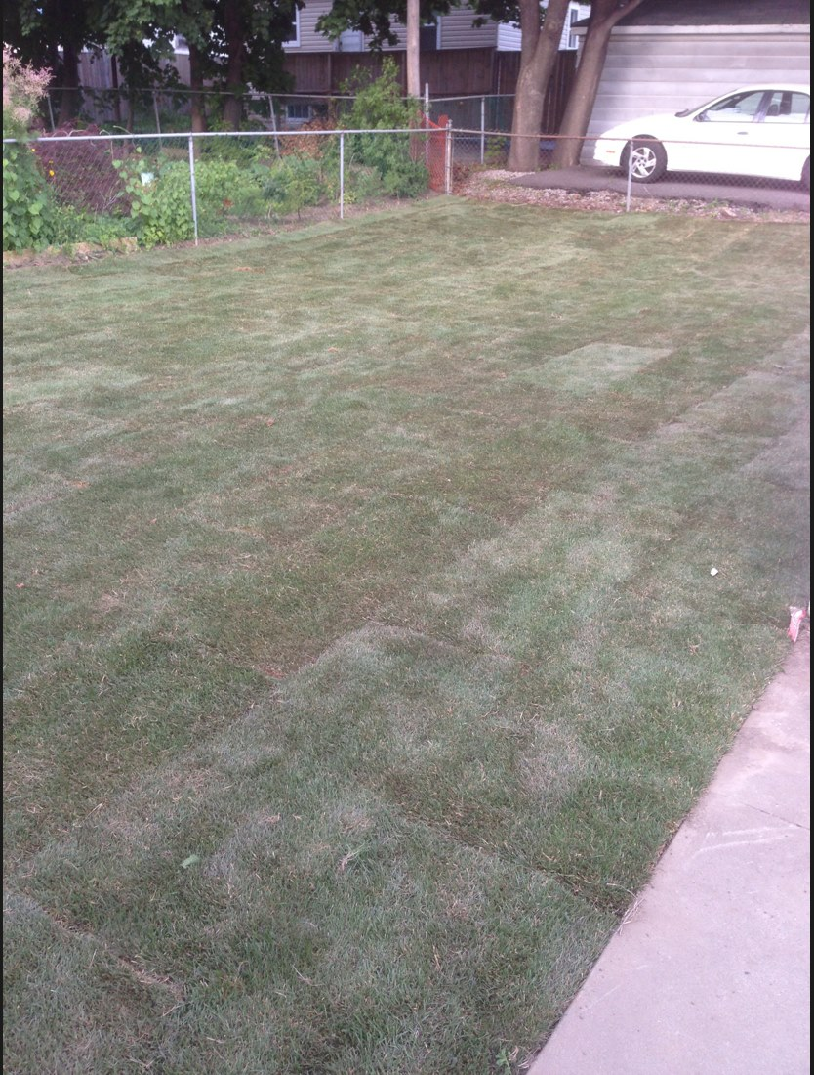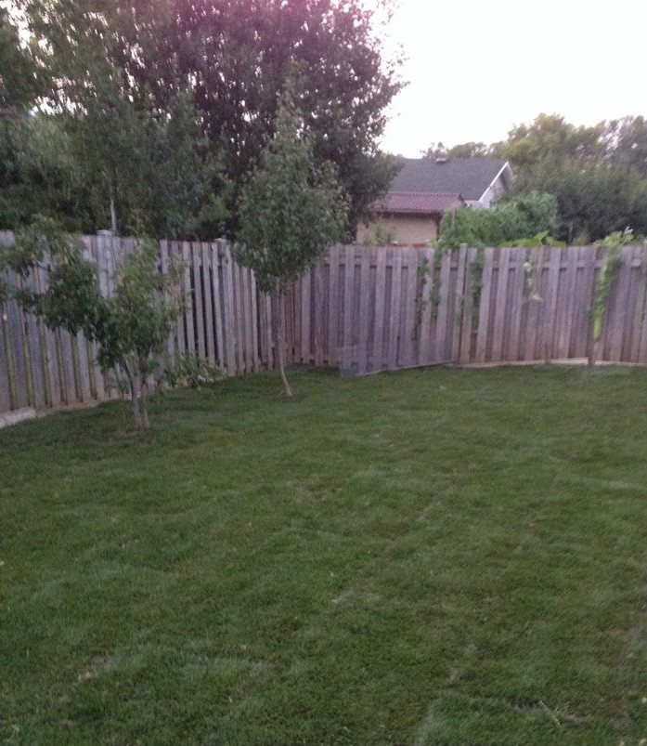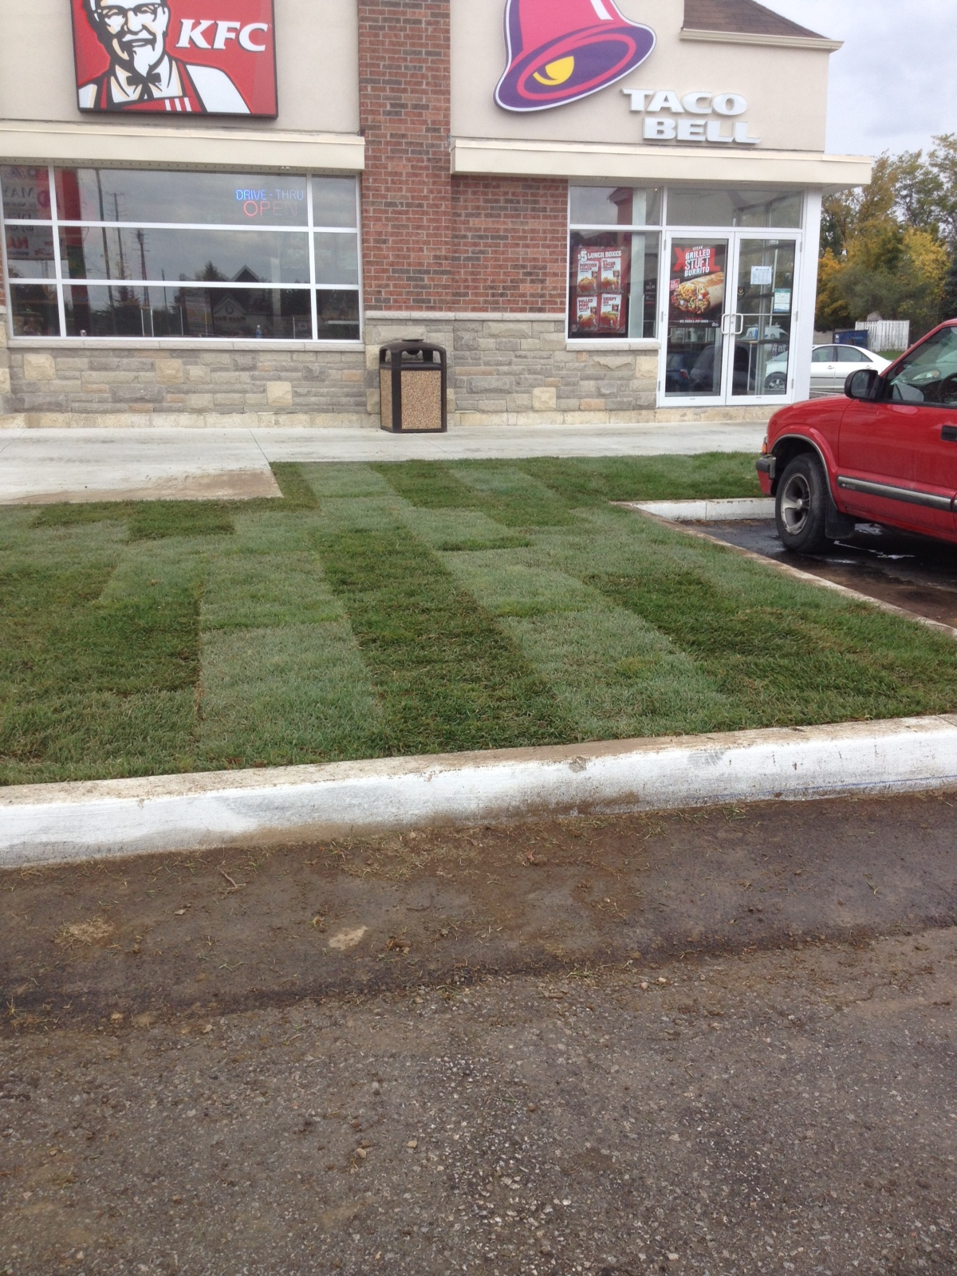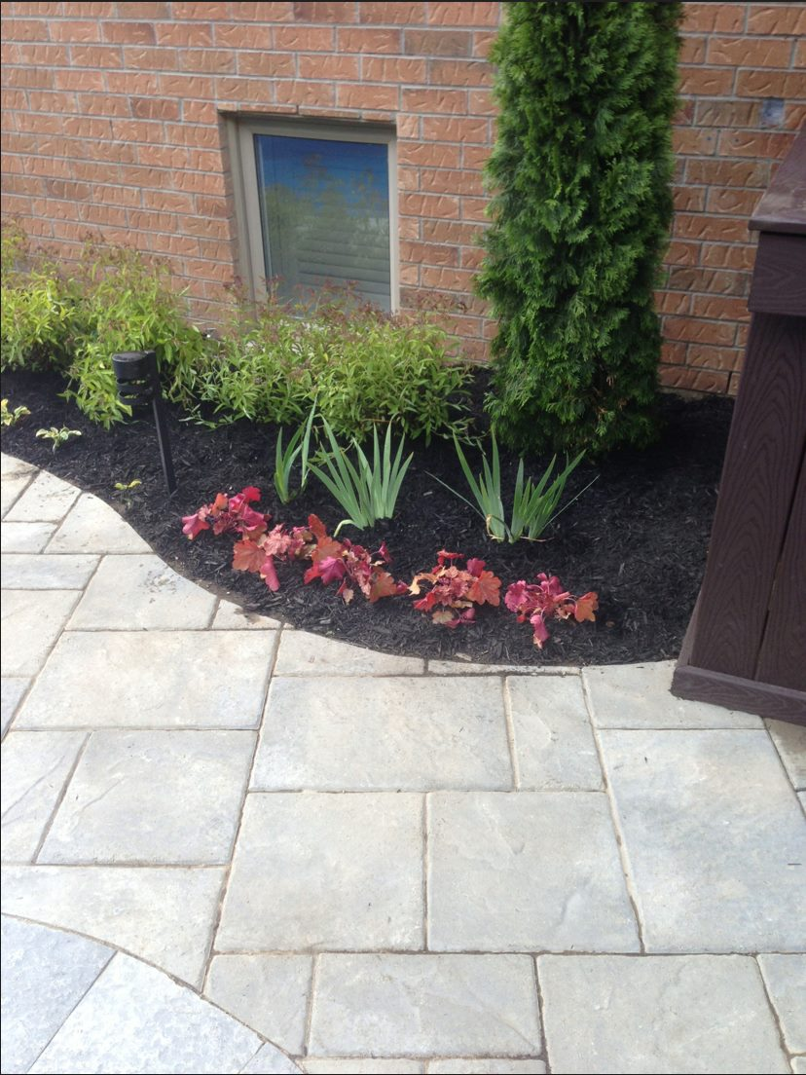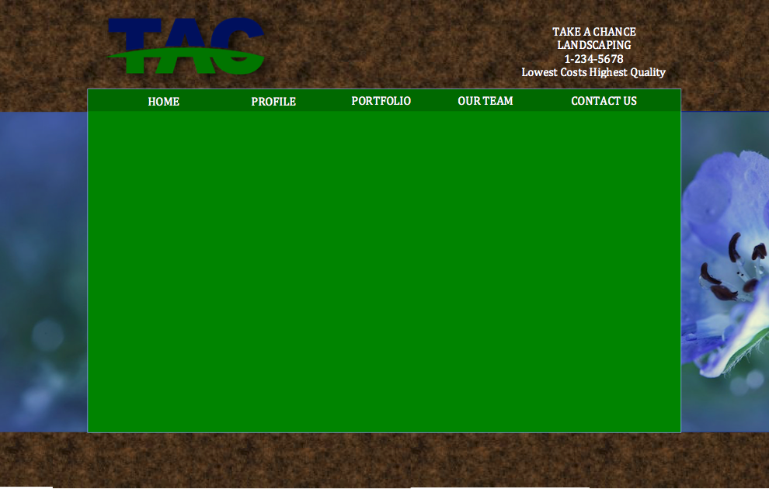

**CONTACT US**

TAC Landscaping

123 Fake Street

Town, Ontario A1B 2C3

Phone: 1-234-5678

Email: contact@taclandscaping.ca

More text about how you guys are the best and you can give a cost free quote for any project.

