Computer Graphics Coursework – Self Assessment Document

Name: Lucas Carter ID number: 23636298

Complete the self-assessment grid below by writing a short explanation of how you have satisfied the requirement and how it has implemented in your code.

Learning outcome | Mark | Weighted mark
1. Use appropriate mathematical tools (40%) |  | 40
2. Develop a 3D graphics application (30%) |  | 27
3. Write shader code (30%) |  | 28
 | Total | 95

Your mark for each Learning Outcome (LO) is the highest mark achieved based on the criteria specified in the self-assessment grid. Note that you will need to have satisfied all criteria at the lower mark bands to be awarded marks in the higher mark bands, e.g., to get a mark in the 70 - 80 band for a learning outcome you will have needed to have satisfied all criteria in the 40 – 50 and 50 – 60 mark bands.

Learning Outcomes:

LO1 Select and use appropriate mathematical tools for constructing and manipulating geometry in 3D space.
LO2 Develop an interactive 3D graphics application using an industry-standard API.
LO3 Write shader code for the programmable pipeline on modern graphics hardware using an industry standard shader language.

Self-assessment Grid

Mark | Criterion | Comments (state how and where you have achieved the criterion)
42, 45, 48 | LO1: Basic use of vector and matrix objects | Camera.hpp  Lines 17 – 23, basic vector objects created and defined for the camera object.  Maths.cpp  Lines 87 – 92, basic matrix created and altered to make a scale matrix
42, 45, 48 | LO2: Application compiles and runs without alterations to the source code of CMake file. | Paste a screenshot of your application below  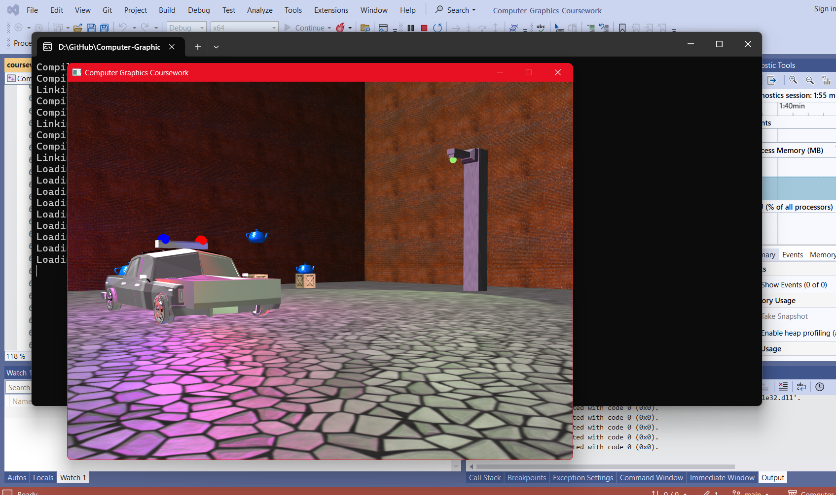
42, 45, 48 | LO3: Implementation of shaders to apply appropriate textures to objects. | Coursework.cpp  Lines 424 - 451, creates a texture and binds it then cycles through all the appropriate texture images and attaches them to the object.  Model.cpp  Lines 36 – 43, textures are binded for an object and sent to the shader with correct name.
52, 55, 58 | LO1: Basic use of translation, rotation and scaling transformations. | Coursework.cpp  Line 505 - 511, use of translate, scale and rotate matrixes to perform transformations on the objects according to their properties.
52, 55, 58 | LO1: Implementation of glm library functions for calculating view and projection matrices. | Camera.cpp  Lines 15 – 19, commented out lines where glm library functions (lookAt and perspective) are used to calculate the view and projection matrices.
52, 55, 58 | LO2: 3D virtual world has been created using instances of a single object type. | Coursework.cpp  Lines 174 – 203, Teapot object type has been created and its properties specified so that it can be added to the objects vector.  Then on Line 592, the teapot model is drawn into the objects position.
52, 55, 58 | LO3: Use of shaders to apply dynamic lighting from point light sources | Light.cpp  Line 4 -17, point light source properties are defined and added to the light sources vector which is then cycled through and sent to the shader.  fragmentShader.glsl  Lines 80 -109, reflection vectors are created for the point light sources and are returned to calculate the fragment colour of the object being lit/unlit.
62, 65, 68 | LO1: Implementation of students own functions for calculating view and projection matrices. | Camera.cpp  Lines 58 – 77, Method for calculating the view matrix  Lines 79 – 92, Method for calculating the perspective matrix for projection
62, 65, 68 | LO2: 3D world created using multiple object types. | Coursework.cpp  Lines 241 – 328, multiple object types are created and defined including floors and walls.  Lines 597 – 603, object models are “drawn” into the scene where the object positions are defined
62, 65, 68 | LO2: Users can navigate the virtual world using keyboard and mouse inputs. | Coursework.cpp  Lines 667 – 728, Keyboard input method that handles are possible user inputs including being able to move the camera with WASD as well as jump with SPACE.  Lines 730 – 745, Mouse input method that allows the user to control where the camera is looking using the mouse.
62, 65, 68 | LO3: Use of shaders to apply dynamic lighting from different types of light sources. | Light.cpp  Lines 19 – 45, spot light and direction light types are defined and added to the light sources vector.  fragmentShader.glsl  Lines 112 – 173, reflection vectors are created for the spot light and direction light sources and are returned to calculate the fragment colour of the object being lit/unlit
72 75, 78 | LO1: Implementation of students own functions to replace glm functions (e.g., glm::length(), glm::dot(), glm::cross() etc.). | Maths.cpp  Lines 124 – 142, own methods for calculating length, dot, cross products of vectors as well as being able to normalize them.
72 75, 78 | LO1: Implementation of quaternions to calculate rotation matrix. | Maths.cpp  Lines 144 – 151, quaternions are used to calculate the rotate matrix
72 75, 78 | LO2: Interactive dynamic aspects of the virtual word and controllable by the user (e.g., position of objects, location and function of light sources etc.). | Coursework.cpp  Lines 508 – 528, if the player is within 3 distance to the teapot then it starts to spin and then when the player is within 2 distance then it starts to float upwards. When it reached y 4 then it snaps back to its default position.
72 75, 78 | LO3: Appropriate implementation of normal and specular maps. | Courswork.cpp  Lines 175 – 177, diffuse, normal and specular textures are added to the teapot model for use in the fragment shader  fragmentShader.glsl  Line 47, normal vector is retrieved from the objects normal map  Line 100, specular reflection of the object from the light source is calculated using it’s specular map
85, 90, 100 | LO1: Use of quaternions to calculate view matrix. | Camera.cpp  Lines 37 – 40, quaternion orientation is used to calculate the view matrix
85, 90, 100 | LO1: Use of SLERP to smooth out changes in camera direction. | Maths.cpp  Lines 51 – 78, SLERP is calculated and used to smooth out changes in the camera direction by using it for the view matrix in camera.cpp lines 34 – 37.
85, 90, 100 | LO2: Implementation of a third person camera with the ability to switch between first and third period view. | Coursework.cpp  Lines 702 – 725, player can press 1, 2 and 3 keys to change between the different camera types by using Booleans.  Lines 617 – 621, player model is drawn at the correct position if the player is in third person.  Camera.cpp  Lines 43 – 47, if the player has activated third person then the camera is offset appropriately
85, 90, 100 | LO2: The position of the camera or character obeys the constraints of the physical space (e.g., can’t pass through objects, can’t hover in midair etc.). | Coursework.cpp  Lines 747 – 791, collision method is used to prevent the player from going into objects. If the player is within a certain distance of the center of the object then it moves them back until they aren’t. Method also limits the player’s movement area so that they are within the wall boundaries.  Camera.cpp  Line 26, y position of the camera is restricted to 0 so that player cannot fly through the sky and hover mid-air.
85, 90, 100 | LO3: Use of shaders to apply parameter driven effects within the scene, e.g., light properties controlled using camera/character position. | Coursework.cpp  Lines 542 - 564, if the player is within 5 distance of the street lamp then streetlights colour will randomise its colour every 1 second as well as start to move and point opposite the lamp.  Lines 566 – 580, if the player is within 5 distance of the police car then the siren lights will alternate between red and blue every 1 second.

