Decomposition-free Synchronous Multi-layer Cooperative 3D Printing for Enhanced Strength and Structural Integrity
Suyog Ghungrad, Reihane Arabpoor, Lucas Chen, Azadeh Haghighi*
Mechanical and Industrial Engineering, University of Illinois, Chicago, 60607, United States
* Corresponding author. E-mail address: ahaghi3@uic.edu
Abstract
Cooperative 3D printing can accelerate fabrication of large-scale structures by using multiple print heads; however, many cooperative strategies decompose a part into sub-domains, which introduces decomposition seams and alters inter- and intra-layer gap times. These changes can degrade bonding and modify stress evolution, reducing mechanical performance and increasing failure risk. This paper proposes a decomposition-free cooperative strategy, Synchronous Multi-Layer Printing (SMLP), in which each head prints complete layers under a controlled time shift, enabling synchronous deposition paths without geometric partitioning. SMLP is evaluated using thin-wall specimens produced by two extrusion-based additive manufacturing processes to connect strategy-induced timing effects to material integrity. First, SMLP is implemented on a dual-head fused deposition modeling system and compared against a traditional decomposition-based multi-head strategy using tensile and tear tests. Paired comparisons show that SMLP increases interlayer tensile strength by ~12.4 MPa (≈30%) relative to the traditional multi-head strategy (p<0.001), while tear strength is statistically unchanged (p=0.831). Second, to assess implications for large-scale construction AM, an analytical model is developed for extrusion-based concrete printing that maps strategy-dependent timing fields to time-dependent yield-stress evolution and compares them against evolving shear stress in straight walls. The polymer and concrete studies are linked at the cooperative-strategy level: in both cases, SMLP modifies the deposition-time history, and that timing history governs a material-specific strength evolution process. The polymer experiments resolve this through interface-limited tensile behavior, whereas the concrete model resolves it through time-dependent yield-stress development and structural stability. The model predicts that, over the parameter ranges considered, SMLP reduces build time by ~24% compared with single-head printing and increases the number of buildable layers before collapse by ~100–300% compared with traditional multi-head printing. Together, the experimental and analytical results support SMLP strategy improves both strength and structural integrity along with productivity.
Keywords: Cooperative 3D printing, Multi-head printing; Stress analysis; Analytical modeling; Part decomposition
List of symbols
$$x$$ | coordinate along wall length / printing direction
$$y$$ | coordinate along wall width (out-of-plane direction for wall cross-section interpretation)
$$z$$ | coordinate along build direction
$$L$$ | wall length
$$h$$ | layer height
$$n$$ | layer index
$$v_{p}$$ | print speed
$$v_{t}$$ | traverse speed
$\left(x_{1} , z_{1}\right)$, $\left(x_{2} , z_{2}\right)$ | positions of extruders 1 and 2
$$τ_{y}$$ | local yield stress of fresh concrete
$$τ_{y0}$$ | initial yield stress
$$A$$ | hardening coefficient
$$σ_{n}$$ | normal compressive stress due to material above
$$τ_{max}$$ | maximum shear stress
$$ρ$$ | density of fresh concrete
$$g$$ | gravitational acceleration

Introduction
Large-scale additive manufacturing (AM) is gaining popularity among researchers and industry professionals for autonomous fabrication of large components such as full-size prototypes of submarine hulls and multi-story buildings [1,2]. It opens new avenues for building infrastructures in harsh environments or in space with minimal to no human involvement. Existing commercially available large-scale 3D printers [3,4] are capable of working with a diverse range of materials, including composites, cementitious materials, and metals. More recently, cooperative 3D printing involving robot swarms or teams of robots has demonstrated increased mobility and flexibility compared to traditional gantry-based systems, expanding applications within AM [5,6]. The adoption of multiple print heads in cooperative 3D printing enables the manufacturing process to be decomposed into smaller tasks that can be performed in parallel, leading to higher efficiency and faster build speeds [7]. Moreover, it enables the realization of functionally-graded, multi-material, and/or multi-resolution parts for enhanced properties and performance [8,9].
At the same time, multi-head printing introduces new complexities: different print strategies, parameters, and toolpaths change the inter- and intra-layer gap time (the waiting time between successive passes of the nozzle), the extent of bonding or fusion, and the stress distribution within the deposited material. These effects ultimately control the quality, strength, and lifespan of the printed structure. Traditionally, cooperative multi-head printing has relied on geometric decomposition, in which the part is divided into subregions that are assigned to different print heads or robots for parallel fabrication [10,11]. While this improves productivity, it also introduces additional internal interfaces whose bonding quality and deposition history can reduce structural integrity and dimensional accuracy [12]. A substantial body of prior work has already addressed the mechanical consequences of these decomposition boundaries. Various seam-mitigation strategies have been proposed, including optimized chunk interfaces, non-flat or interlocking boundaries, adaptive deposition patterns, and staggered layer arrangements [13,14]. These studies show that the weakness associated with segmented cooperative printing can often be reduced through careful interface design rather than ignored. However, these methods still act on an interface that remains present in the printed architecture (as illustrated in Figure 1). There is little guidance on how cooperative strategies should be designed so that they preserve, or even enhance (if possible), the mechanical integrity achieved by conventional single-head printing [15]. It is also important to position this work relative to the broader literature on swarm printing, cooperative robotic additive manufacturing, and synchronized multi-robot deposition. Prior studies have demonstrated that teams of robots or multiple synchronized print heads can fabricate a common structure concurrently, improving mobility, workspace scalability, and production speed [16]. However, these studies typically emphasize coordination, localization, collision avoidance, and task allocation. Even when simultaneous deposition is achieved, the printed geometry is often still partitioned into subregions, chunks, or cells, meaning that interface quality remains a central mechanical concern.

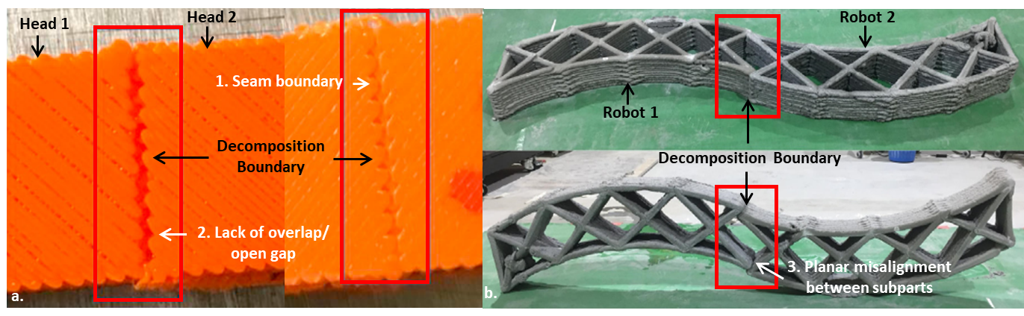
Figure 1. Illustrative examples of the inferior bonding and quality at decomposition boundary in existing multi-head cooperative printing scenarios, potentially leading to points of structural failure: a. Extrusion-based polymer cooperative printing [13], and b. Extrusion-based concrete cooperative printing [16]
To fill the above gap and address this trade-off between productivity and structural performance, this study introduces and evaluates a novel, decomposition-free multi-head cooperative printing strategy named synchronous multi-layer printing (SMLP). Unlike traditional "concurrent" strategies that print different segments of the same layer, SMLP assigns each head to print a complete layer. The heads operate simultaneously on consecutive layers with a controlled time delay, allowing them to follow one another in a synchronized path as shown in Figure 2. Unlike interlocking, adaptive-joint, or staggered-deposition approaches, SMLP does not primarily seek to improve the mechanics of a segmented interface; instead, it changes the cooperative assignment itself so that a same-layer seam need not be introduced in the wall geometry. Accordingly, the main distinction of SMLP is not simultaneous multi-head operation by itself, but simultaneous multi-head operation without same-layer geometric decomposition of the wall. This approach is designed to combine the build-time efficiency of multi-head systems with the mechanical integrity of single-head approaches by maintaining a continuous deposition path without vertical seams.
In this work, our overall objective is to understand how the proposed SMLP cooperative multi-head strategy would influence both the mechanical performance and deformation behaviour of extrusion-based printed structures (especially large-scale structures with a focus on thin-wall geometries), compared to traditional cooperative multi-head and single-head strategies. For example, large-scale construction features are generally produced by extrusion-based concrete AM process, which requires a careful examination of potential quality risks under multi-head cooperative print strategies. Existing studies have primarily examined single-head systems [17], where relationships between rheology [18–20], buildability, toolpath design [21–23] and failure modes are now relatively well understood [24,25]. In particular, single-head concrete-printing studies have linked material thixotropy, yield-stress evolution, and stress development to deformation and collapse behavior [24,25]. However, for multi-head systems, the toolpath and inter-pass timing are fundamentally altered, which changes the evolving stress state in the deposited material and can induce new failure modes that are not captured by single-head models [26]. At the same time, direct experimental exploration of these strategies, especially at architectural scales, is costly, time consuming, and often impractical [27]. This creates a clear need for modeling tools that can rapidly evaluate multi-head strategies and provide process guidelines without extensive trial-and-error. Therefore, the contribution of the present work is not to introduce mechanics into construction AM for the first time, but to apply a mechanically informed perspective specifically to the design and evaluation of a decomposition-free cooperative multi-head strategy. In multi-head systems, the deposition pattern itself becomes a design variable: cooperative toolpaths change inter-pass timing, deposition sequence, and the evolving stress field in ways that are not captured directly by single-head models.
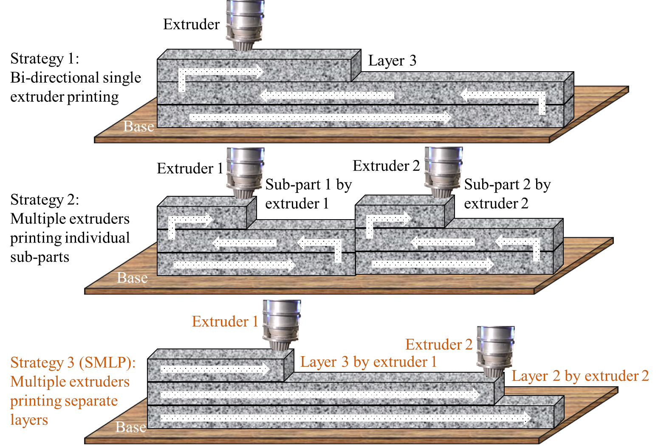
Figure 2. Simple illustration of different single-head and multi-head strategies adopted in this work, with the newly proposed Strategy 3 to enhance structural integrity
Addressing the above objective, we pursue two complementary studies in extrusion AM that are linked by a common physical idea: failure occurs when the stresses generated during printing exceed the evolving strength of the material, whether tensile strength in a polymer or yield stress in fresh concrete. First, we use a polymer material on a dual-extruder fused deposition modeling (FDM) system to experimentally quantify interlayer bond strength by performing tensile and tear tests on thin wall specimens. This setup enables direct measurement of how cooperative multi-head strategies, together with print speed and layer length, influence mechanical properties. Experimental studies that compare cooperative multi-head strategies with polymer material remain very limited, so this work provides rare quantitative data on the process-structure-property relationship. Second, we develop an analytical framework for extrusion based concrete printing in which a time dependent yield stress law and the stress build up during printing are used to predict deformation and collapse for thin walls. The maximum shear stress distribution during printing using Murata's slump prediction model [19] and force equilibrium, and the local yield stress is estimated from the elapsed time after deposition. The goal is to demonstrate SMLP (Strategy 3 in Figure 2) as a superior multi-head strategy compared to the traditional decomposition-based multi-head strategy (depicted as Strategy 2 in Figure 2), while highlighting print speedups compared to single-head Stategy 1 in Figure 2. In the polymer experiments, we quantify how SMLP modifies inter and intra layer gap times and measure the resulting tensile and tear strengths for different speeds and lengths. For concrete AM, we compare the predicted stress and yield stress fields for these different strategies to estimate the time of collapse of deposited concrete. Total build time and collapse time are used as key performance metrics, and a sensitivity analysis on rheological properties and printing parameters provides additional insight into structural stability and failure. In this study, “framework” refers to a general strategy-evaluation workflow for cooperative extrusion-based additive manufacturing rather than a single constitutive model shared by all materials. The common workflow is to: (i) determine how a cooperative printing strategy modifies the deposition-time history, (ii) map that timing history to a material-specific strength-evolution process, and (iii) compare the evolving strength against an appropriate failure or stability criterion together with productivity metrics. In the present work, this logic is instantiated experimentally for thin-wall polymer printing through interface-limited tensile behavior and analytically for concrete printing through time-dependent yield-stress development and stress buildup.
Although the polymer and cementitious systems considered here differ substantially in constitutive behavior, bonding mechanism, and rheology, they are combined in this study at the strategy level rather than the material-model level. The common question is how a cooperative printing strategy modifies the local deposition-time history and, through that history, alters the evolving resistance of the material to failure. In the polymer experiments, this resistance is expressed through interface-limited tensile and tear performance of thin-wall specimens. In the concrete analysis, it is expressed through the time-dependent yield stress of the fresh material and its ability to resist gravity-induced stress during layer-wise construction. Thus, the role of the polymer experiments is to provide direct experimental evidence that SMLP changes interface-sensitive mechanical performance through timing and seam elimination, while the role of the concrete model is to evaluate how the same strategy-level timing logic influences buildability and early-age structural stability in a large-scale cementitious context.
In summary, this work introduces a novel decomposition-free cooperative SMLP strategy, provides systematic experimental evidence from extrusion-based polymer AM on its effect on mechanical properties of thin-wall specimens, and develops an analytical framework for extrusion-based concrete AM that links multi-head toolpaths to early-age collapse, together offering a framework for designing structurally robust cooperative printing strategies.

Methodology
The printing path is one of the critical input parameters that typically must be determined before printing, including specifying the start and end coordinates as well as the trajectory and motion planning (e.g., for robotic systems). Even for a simple thin-wall geometry in a single-head additive manufacturing scenario, multiple path-planning strategies may be adopted, such as bi-directional versus single-directional deposition. Different printing paths result in different total build times and inter-layer gap times, which leads to different stress distribution within the deposited material. This consideration becomes even more important with multiple print heads, as a larger number of interconnected printing strategies become available. Traditionally, the part is decomposed into 𝑛 sub-parts, which are then assigned to 𝑛 printing heads [2,10]. For example, as illustrated Figure 2, two print heads collaborate to print a wall by dividing it into two sections, with each section managed by a separate print head. Alternatively, the SMLP approach proposed in this study assigns each layer of the part to a different head for printing, enabling coordinated printing of consecutive layers without geometric decomposition.
In this section, we present the methodology for two complementary studies in extrusion-based additive manufacturing of thin-wall specimens: (i) extrusion-based printing of polymeric materials and (ii) extrusion-based printing of concrete materials. These studies are designed to systematically evaluate how different cooperative printing strategies, particularly the proposed SMLP approach, affect build time, inter-layer timing, stress evolution, and resulting mechanical performance.

Experimental procedure for extrusion-based polymer printing

2.1.1 Materials and equipment
The filament used in this study is Bambu PLA Basic, a modified polymer composite consisting of 99% polylactic acid and less than 1% of additives such as Polycaprolactone (PCL), this is a common blend formula, oriented for high-speed printing and can achieve printing speeds up to 250-300 mm/s in certain machines. Being the most common material in FDM printing, PLA is widely adopted as it's easy to print and inexpensive. All samples were printed on a modified Independent Dual Extruder (IDEX) machine based on Tronxy Gemini S. As shown in Figure 3c, a customized dual-head mount was utilized for SMLP capabilities and it had two separate control boards for each hotends compared to the in-built capability.

2.1.2 Specimen and experimental design
For the experimental testing conducted in this study, ASTM D882-18 was adopted. This standard was selected because the specimens were intentionally fabricated as thin-wall, strip-like printed structures with a nominal thickness of 0.4 mm, which is within the dimensional regime of thin-sheet tensile testing. The objective of the experiments was not to determine bulk tensile properties of PLA, but to quantify the tensile response and interlayer integrity of the as-printed wall architecture produced by different cooperative printing strategies. For this reason, a rectangular strip specimen was considered more representative of the printed structure than a necked dogbone specimen such as those used in ASTM D638 or ISO 527 Type V. In addition, preserving the as-printed wall geometry reduces geometry-induced artifacts that may arise in very thin FDM specimens at the shoulder-to-gauge transition of dogbone coupons. Accordingly, the tensile results should be interpreted as comparative measures of thin-wall structural performance and bonding quality. The nominal width of the specimens shall be in the range from 5.0 mm to 25.4 mm, and the width to thickness ratio should be greater than 8. And the test specimens should be selected so that thickness is uniform to within 5% of the average thickness over the length of the specimens between the grips. Specimens had a height of 18 mm (60 deposited layers at 0.3 mm) and a thickness of 0.4 mm. The selected 0.4 mm thickness should be interpreted as a reduced-order thin-wall test geometry. It was chosen primarily to isolate the influence of cooperative printing strategy on interlayer adhesion and wall integrity under controlled conditions, rather than to reproduce a specific end-use component exactly. Nevertheless, this geometry is application-relevant because thin-wall and single-track or near-single-track features are common local structural elements in extrusion-based additive manufacturing, particularly in wall-like and shell-like constructions where deposition sequence and seam formation strongly influence performance. One of the objective was to evaluate the effect of SMLP printing strategy for cooperative printing on the tensile strength and inter-layer adhesion. The independent variables to achieve this were varied as follows: print speed: 5 mm/s to 60 mm/s with 5 mm/s step size and length: 50 mm, 100 mm, and 150 mm. The 5–60 mm/s range was selected to generate a broad and controlled variation in inter-pass delay while remaining within the stable extrusion window of the modified IDEX system for thin-wall, single-bead specimens. The parameters that remained unchanged were layer height: 0.3 mm, gap between two heads: 33 mm, travel speed: 60 mm/s, nozzle temperature: 208°C and bed temperature: 60°C. Because nozzle temperature, bed temperature, travel speed, and layer height were held constant across all trials, differences between strategies are interpreted primarily as arising from deposition timing and seam formation rather than from intentionally varied thermal settings. For each combination of print speed and length, a total of two replicate specimens were fabricated. Additionally, to demonstrate the effectiveness of proposed strategy, it was compared with the traditional decomposition-based muti-head cooperative printing strategy, as illustrated in Figure 2b. Prior to mechanical testing, all specimens underwent visual inspection. The final experimental dataset was collected only after the printer had been tuned and stabilized. During this preliminary calibration phase, 27 specimens were discarded due to obvious manufacturing defects. Rejection criteria included horizontal misalignment caused by Y-offset errors, visible voids within extruded lines, improper first-layer deposition due to bed-leveling or Z-gap errors, embedded nozzle residue in the base layers, incomplete fusion at line ends, and imperfect hatch formation associated with non-uniform cooling. Only specimens passing visual inspection were retained for mechanical testing.

2.1.3 Testing procedure
Tensile testing was performed using a TSA750 test stand with a M5-750 digital force gauge and G1061-2 wedge grips, the combination provides capacity upto 3750 N (750 lbF / 375 kgF), Accuracy of the force gauge is ±0.1% of full scale, and resolution is 1/5000. Specimens were mounted in the grips with the longitudinal axis aligned with the direction of applied force. Constant incremental force was applied gradually until specimen rupture. The crosshead speed was selected to provide a consistent strain rate according to the guidelines. Prior to testing, specimen dimensions were verified using vernier calipers with an accuracy of ±0.02 mm. Specimens exhibiting obvious manufacturing defects or failures at the grip interface (jaw breaks) were excluded from the dataset. For tear resistance analysis, the specimen was oriented to apply load perpendicular to the deposited layers to assess the resistance to force applied along the specimen's width. The maximum force required to initiate and propagate separation was recorded as the tear strength.

Analytical modeling for extrusion-based concrete printing

2.2.1 Assumptions for the analytical model
The structural integrity of printed structures fabricated using the single-head and multi-head strategies (traditional versus the proposed approach) are evaluated through analytical stress analysis associated with extrusion-based additive manufacturing of concrete material for a straight wall. In this process, it is widely known that the elapsed time from the deposition of fresh concrete to a fully printed structure affects the stress distribution within the part, and thus, adequate yield stress of fresh concrete to print is necessary to avoid any deformation or collapse during the printing process. Consequently, analytical models are established for the newly presented cooperative printing strategy to detect early failure, and are then compared with the existing results associated with single-head and traditional multi-head cooperative
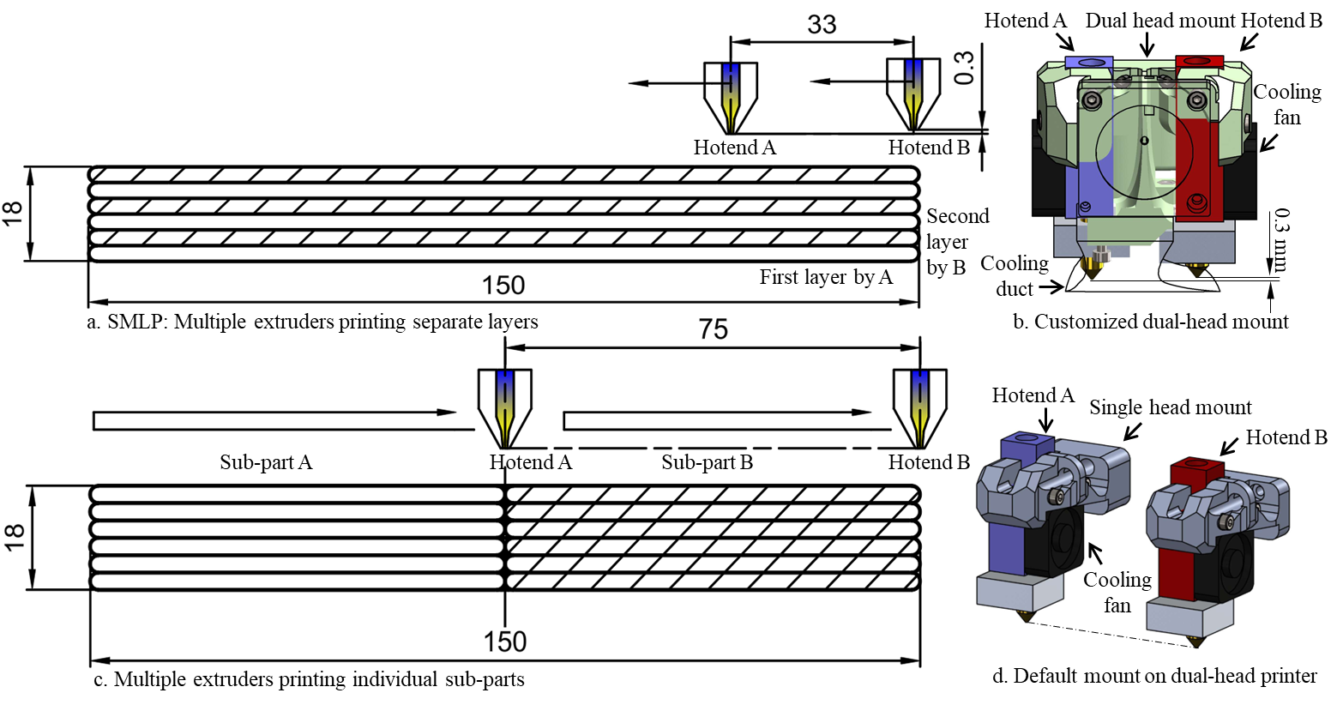
Figure 3. Illustration of two printing strategies for multi-head printing utilized in the experiment a. SMLP and c.Bi-directional multi-head strategy, with b. customized dual-head mount for SMLP printing and d. default mount for dual-head printing on the FDM machine

printing strategies. Figure 4 shows the flow chart illustrating the analytical framework utilized in this study. With design requirements and printing strategies considered as inputs, the analytical model iteratively evaluates each layer and discrete points throughout the layer, starting from layer 1, to determine if the yield stress of the printed concrete is higher than the maximum shear stress, ensuring a stable printing process. If maximum shear stress exceeds the yield stress in the initial layers, the model indicates early deformation and predicts the time of collapse, which is inspired from a verified model [27]. Important metrics such as deformation and build time for all strategies are obtained from the analytical model. Based on these metrics, an optimal strategy can be decided for cooperative 3D printing. Several assumptions were made to simplify the calculations:
- The interlayer bond strength reduces as the printing time gap between layers increases. However, the effect of interlayer time gap on bonding was neglected here only as a first-order approximation for near-continuous extrusion within the material’s printability/open-time window. This assumption is supported for some cement-based systems by studies showing that, for short intervals below about 10 min, the reduction in interlayer bond strength is limited compared with the much larger deterioration observed at longer delays. For example, Pan et al. [28] reported that bond-strength reduction was not remarkable for most mixtures when the time gap was below 10 min, whereas rapid losses occurred beyond 20 min; they related this transition to a material-dependent maximum operational time associated with structural build-up and moisture evolution. Consistent with this interpretation, Chen et al. [29] found only modest bond-strength variation for 20 s, 1 min, and 10 min intervals in a limestone-calcined clay-based printable mortar and concluded that short intervals of 20 s–10 min had no or minimal influence on bonding, with strength differences mainly governed by local porosity. However, this approximation is not universal: other cement-based studies have shown measurable early decay even within the first 1–5 min [30], and the critical transition time depends on mix design, structural build-up, and drying conditions. Accordingly, the present model should be interpreted as applicable only to the short-gap continuous-print regime, where no pronounced cold joint has formed; longer time gaps would require an explicit bond-reduction model or dedicated interfacial characterization.
- The supply of raw materials is assumed to be continuous and ideal.
- Fresh concrete is deposited vertically, with the width, height (i.e., thickness), and length of each layer remaining constant throughout the study. A multi-layer, single-track structure is adopted. This simplification was adopted to isolate the influence of cooperative printing strategy on the evolution of stress and yield stress in a tractable manner. For straight walls, the deposition history can be described directly as a function of the print-head position along a single path direction. However, for curved toolpaths or more complex geometries, the local deposition sequence, travel distance, and stress transfer path may differ from the straight-wall case and will be studied in future works.
- The extrusion head is assumed to deposit perfectly rectangular cross-section beads. Deviations from the assumed rectangular geometry may shift the absolute failure time or number of printable layers, but the relative comparison among strategies is expected to remain informative because the same geometric idealization is applied consistently to all cases.
- The speed of multiple extrusion heads are assumed to be similar and constant throughout this study. The assumptions of constant extrusion speed and identical extruder performance are first-order idealizations introduced to isolate the effect of cooperative printing strategy and keep the analytical model tractable. In practice, cooperative printing systems may exhibit nozzle-to-nozzle differences, synchronization errors, and material-flow fluctuations, all of which can alter the local deposition history and stress development.
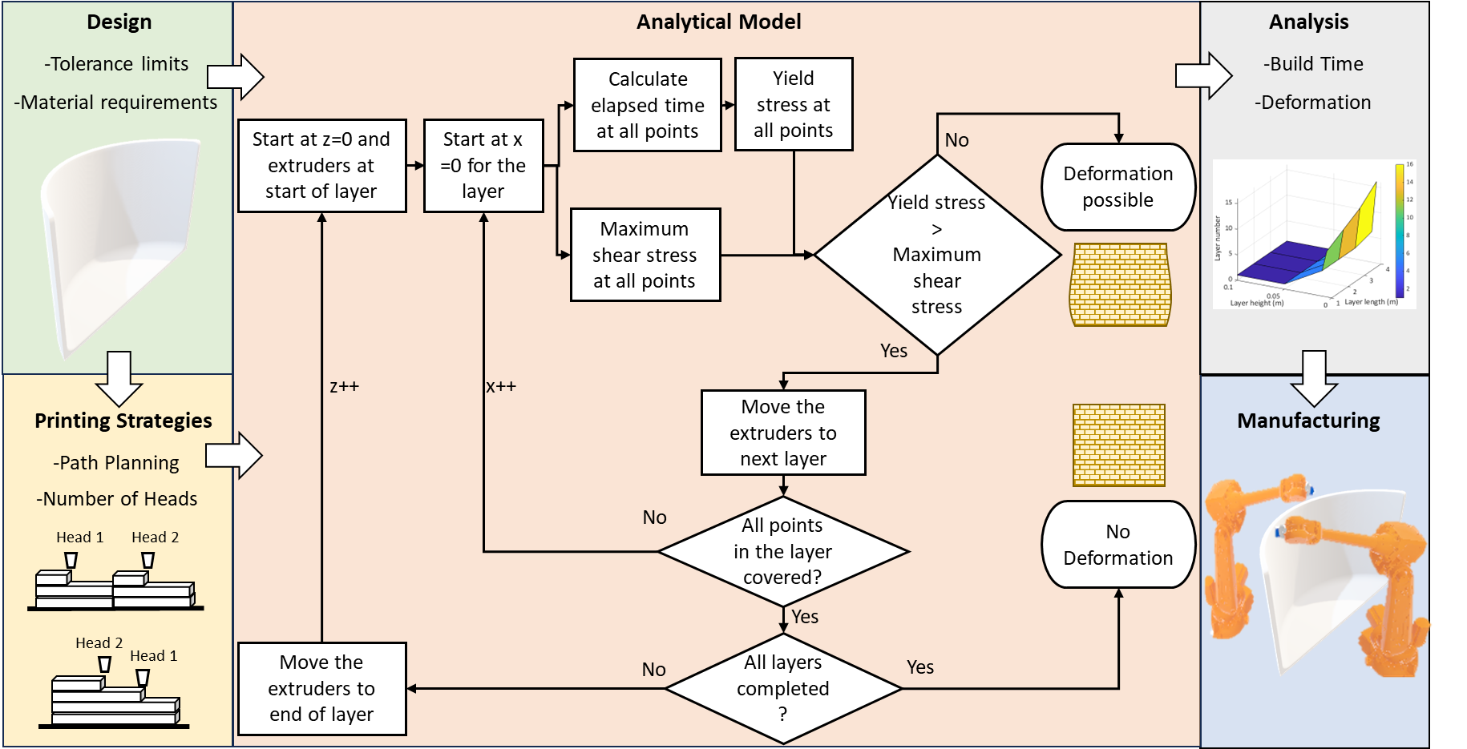
Figure 4. Analytical framework for modeling structural integrity in extrusion based concrete AM of large-scale thin-wall structures

2.2.2 Yield stress distribution
The analytical model is formulated in a Cartesian coordinate system for a straight printed wall, where $x$denotes the wall-length direction (printing direction within a layer), $y$denotes the wall width/thickness direction, and $z$denotes the build direction. A material point in the wall is represented by $\left(x , y , z\right)$. The layer height is denoted by $h$, the wall length by $L$, the print speed by $v_{p}$, and the traverse speed by $v_{t}$. The positions of extruders 1 and 2 are represented by $\left(x_{1} , z_{1}\right)$and $\left(x_{2} , z_{2}\right)$, respectively, as functions of time. The elapsed time since deposition at any material point determines the local yield stress $τ_{y}$, where $τ_{y0}$is the initial yield stress and $A$is the hardening coefficient in the adopted time-dependent yield-stress law. The density of fresh concrete is $ρ$, gravitational acceleration is $g$, the normal compressive stress is $σ_{n}$, and the maximum shear stress is $τ_{max}$. Additional local shear contributions induced by extrusion pressure are denoted separately for each active extruder where applicable. Studies in the literature have demonstrated that the yield stress of fresh concrete varies with elapsed time ($t_{p})$ in either linear or exponential manner [25]. This relationship can be expressed as follows:
 | $$τ_{x}\left(t_{p}\right)=τ_{0}e^{αt_{p}}$$ | (1)
 | $$τ_{x}\left(t_{p}\right)= αt_{p}+τ_{0}$$ | (2)
where $α$ and $τ_{0}$ are the hardening coefficient and the initial yield stress. Equation 1 or 2 can be selected and applied based on the yield stress measurement results of the fresh concrete. However, to ensure safety, It is always assumed that the yield stress calculated from the elapsed time-yield stress equation is lower than the measured yield stress [27]. The next subsections aim to convert the printing kinematics into a spatial map of material age and, from that, to derive a spatial map of local yield stress for different printing strategies. Physically, each point in the deposited wall has a different elapsed time since deposition, depending on where it lies relative to the current position of the print head(s). Since fresh concrete undergoes time-dependent structural build-up, this elapsed time determines the local yield stress available to resist deformation during printing. Therefore, the purpose is to describe how the deposition path and current head position generate a nonuniform strength field throughout the partially printed wall.

2.2.2.1 Single-head printing (Strategy 1)
In Strategy 1, at any point where fresh concrete has been extruded at time ($t_{0}$), and with the current position of the extruder ($t_{e})$, the yield stress can be calculated as follows:
 | $$τ_{1x}\left(L_{e},L_{o}\right)=τ_{0}e^{α*\left(\left(\frac{h}{V_{t}}\right)\left({\left[\frac{L_{e}}{l}\right]}_{f}-{\left[\frac{L_{o}}{l}\right]}_{f}\right)+\frac{L_{e}-L_{o}}{V_{p}}\right)}$$ | (3)
 | $τ_{1x}\left({L_{e},L}_{o}\right)= α\left(\left(\frac{h}{V_{t}}\right)\left({\left[\frac{L_{e}}{l}\right]}_{f}-{\left[\frac{L_{o}}{l}\right]}_{f}\right)+\frac{L_{e}-L_{o}}{V_{p}}\right)+τ_{0}$ | (4)
where $L_{e}$ and $L_{o}$ are the respectively lengths measured from extruder position at any point (o) from start point, as illustrated in Figure 5a. The floor operator is introduced to connect the continuous spatial coordinates of a point to the discrete layer-by-layer nature of the printing process. Because the wall is deposited in layers of fixed height, a point with vertical coordinate 𝑧 must first be assigned to a specific layer index before its deposition time can be evaluated. In this context, the floor operator identifies the number of completed layers below a point. It serves as a kinematic mapping between spatial position and the actual order of layer deposition. In the above equations, the yield stress is expressed as a function of lengths. However, it is preferable to represent yield stress as a function of the spatial coordinates $\left(x,z\right)$. This is because the coordinates provide a clearer understanding of the locations of potential failures. Therefore, the following relationship can be established:
 | $L_{o}\left(x,z\right)=\left\{\begin{aligned}x+l{\left[\frac{z}{h}\right]}_{f} ,where{\left[\frac{z}{h}\right]}_{f}is odd \\ \left(l-x\right)+l({\left[\frac{z}{h}\right]}_{f}-1) ,where{\left[\frac{z}{h}\right]}_{f}is even\end{aligned}\right.$ | (5)
 | $L_{e}\left(x^{'},z^{'}\right)= \left\{\begin{aligned}x^{'}+l{\left[\frac{z^{'}}{h}\right]}_{f} ,where{\left[\frac{z^{'}}{h}\right]}_{f}is odd \\ \left(l-x^{'}\right)+l{(\left[\frac{z^{'}}{h}\right]}_{f}-1) ,where{\left[\frac{z^{'}}{h}\right]}_{f}is even\end{aligned}\right.$ | (6)
These Equations (3–6) describe the deposition history created by a bi-directional single nozzle. The distance between the current nozzle position and a previously deposited point is converted into elapsed time through the print speed, and that elapsed time is then used to calculate the local yield stress. Thus, points deposited earlier have had more time to build up strength, while points deposited more recently remain weaker.
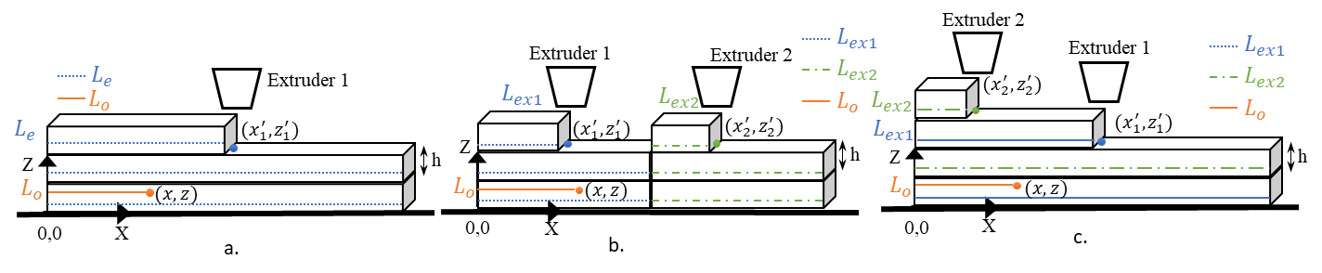
Figure 5. Different lengths based on current extruder position for a. Strategy 1 (single-head), b. Strategy 2 (traditional decomposition-based multi-head), and c. Strategy 3 (proposed SMLP)

2.2.2.2 Cooperative multi-head printing using traditional multi-head strategy (Strategy 2)
For Strategy 2, at any point where fresh concrete has been extruded at time ($t_{0})$, and with the current position of the extruders to be similar to that in strategy 1, and given that the elapsed time for the material extruded by both the extruders is consistent, the yield stress can be calculated as follows:
 | $$τ_{2x}\left(L_{o},L_{e}\right)=τ_{0}e^{α*\left(\left(\frac{h}{V_{t}}\right)\left({\left[\frac{{2L}_{e}}{l}\right]}_{f}-{\left[\frac{{2L}_{o}}{l}\right]}_{f}\right)+\frac{L_{e}-L_{o}}{V_{p}}\right)}$$ | (7)
 | $τ_{2x}\left({L_{o},L}_{e}\right)= α\left(\left(\frac{h}{V_{t}}\right)\left({\left[\frac{2L_{e}}{l}\right]}_{f}-{\left[\frac{{2L}_{o}}{l}\right]}_{f}\right)+\frac{L_{e}-L_{o}}{V_{p}}\right)+τ_{0}$ | (8)
However, as a function of coordinates, the location of the extruders plays a crucial role in establishing the relationship between yield stress distribution across the entire built wall. Both the equations (7–8) apply the same principle to a decomposition-based two-head process. Physically, the wall is divided into two independent sub-regions, each printed by a different extruder. The local yield stress at a point depends on which extruder deposited that point and how much time has elapsed since that deposition event. This formulation captures the fact that the two halves of the wall can have different age distributions even when both heads are printing simultaneously. To determine which extruder was used to deposit material at any point $\left(o\right)$, one can simply check if its $x$ coordinate is between 0 and $l$/2 or between $l$/2 and $l$ as shown in Figure 6.
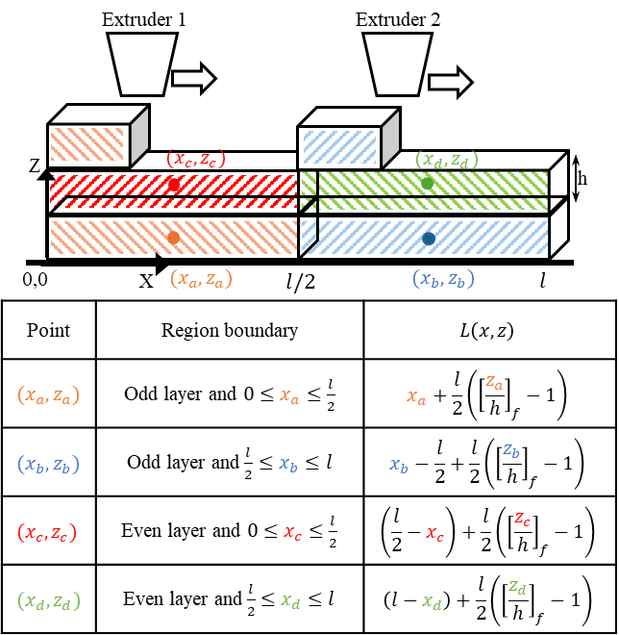
Figure 6. Relationship between various points in the printing path to the layer length in strategy 2

2.2.2.3 Cooperative multi-head printing using SMLP (Strategy 3)
For SMLP, at any point where fresh concrete has been extruded at time ($t_{0})$, and with the current position of the extruder, the yield stress can be calculated, as shown:
 | $$τ_{3x}\left(L_{o},L_{ex1},L_{ex2}\right)=\left\{\begin{aligned}τ_{0}e^{α*\left(\left(\frac{D}{V_{max}}\right)\left({\left[\frac{L_{ex1}}{l}\right]}_{f}-{\left[\frac{L_{o}}{l}\right]}_{f}\right)+\frac{L_{ex1}-L_{o}}{V_{p}}\right)} , where {\left[\frac{L_{o}}{l}\right]}_{c} is odd \\ τ_{0}e^{α*\left(\left(\frac{D}{V_{max}}\right)\left({\left[\frac{L_{ex2}}{l}\right]}_{f}-{\left[\frac{L_{o}}{l}\right]}_{f}\right)+\frac{L_{ex2}-L_{o}}{V_{p}}\right)} , where {\left[\frac{L_{o}}{l}\right]}_{c} is even\end{aligned}\right.$$ | (9)
where $L_{ex1}$ and $L_{ex2}$ are the lengths measured for extruder positions and $L_{o}$ is the length measured for any point $\left(o\right)$ from start point of the extruder used for deposition as shown in Figure 5c. The ceiling operator is particularly important because consecutive layers are deposited by different extruders. Its practical role is to determine which discrete layer a point belongs to, so that the elapsed time is evaluated relative to the correct extruder trajectory. This reflects the actual sequence of the process, where each layer is deposited as a separate event rather than as part of a continuously varying vertical coordinate. the effect of the time shift is represented implicitly through the extruder-position functions used to compute elapsed time. Depending on where the layer point (o) exists, it is compared with the respective extruder’s position. For instance, if point $\left(o\right)$ is in an odd layer, the elapsed time is calculated with extruder one’s position. The yield stress as a function of the coordinates of point $\left(x,z\right)$ in the space can be established as:
 | $L_{o}\left(x,z\right)=\left\{\begin{aligned}x+l\left(\frac{{\left[\frac{z}{h}\right]}_{c}-1}{2}\right) ,where{\left[\frac{z}{h}\right]}_{c}is odd \\ x+l\left(\frac{{\left[\frac{z}{h}\right]}_{c}}{2}-1\right) ,where{\left[\frac{z}{h}\right]}_{c}is even\end{aligned}\right.$ | (10)
 | $L_{ex1}\left(x_{1}^{'},z_{1}^{'}\right)=x_{1}^{'}+l\left(\frac{{\left[\frac{z_{1}^{'}}{h}\right]}_{c}-1}{2}\right); L_{ex2}\left(x_{2}^{'},z_{2}^{'}\right)=x_{2}^{'}+l\left(\frac{{\left[\frac{z_{2}^{'}}{h}\right]}_{c}}{2}-1\right)$ | (11)
Where ${\left[.\right]}_{c}$ is the ceiling function and ($x_{1}^{'},z_{1}^{'}$) and ($x_{2}^{'},z_{2}^{'}$) are the extruder positions for extruder 1 and 2, respectively. These Equations (9–11) represent the deposition history for SMLP, where two extruders print consecutive layers with a time shift. The physical meaning is that each point in the wall is associated with the extruder that deposited its layer, and its local yield stress is computed from the elapsed time relative to that extruder’s current position. In this way, the equations capture the layer-wise age offset created by SMLP and explain why upper layers generally exhibit lower yield stress than lower layers at a given instant.

2.2.3 Maximum shear stress distribution
The relationship between material properties or rheological properties of concrete and stress is well established. The pressure exerted by the weight of concrete above a layer results in a compressive normal stress on that layer. This compressive normal stress due to height $z$ of material printed on the $n^{th}$ layer in an x-z plane can be shown as [27]:
 | $$σ\left(z\right)=ρg\left(nh-z\right)$$ | (12)
where $ρ$ is the density of fresh concrete and g is the gravity acceleration. The maximum shear stress which acts on the surface is approximated by one half of the pressure and can be expressed as:
 | $$τ_{\max\left(z\right)}=0.5ρg\left(nh-z\right)$$ | (13)
The wall is modeled as a straight, single-track, multilayer structure with constant width, layer height, and bead geometry throughout printing. Material deposition is assumed to occur vertically, with continuous ideal material supply and nominally constant extrusion speed for all active heads. The stress analysis is evaluated on the printed wall under self-weight and extrusion-induced loading during construction. For a fully formed wall with the same number of layers, the maximum shear stress distribution will be consistent across strategies; however, during partial formation of a layer, the stress field depends on the instantaneous positions of the extruder heads and the selected printing strategy. However, when fresh concrete is only partially formed within the same layer, the maximum shear stress distribution will vary depending on the strategy employed.

2.2.3.1 Single-head printing (Strategy 1)
For strategy 1, the normal compressive stress and the maximum shear stress generated at a position $\left(x^{'},z^{'}\right)$ within a build-up layer in the x-y plane can be calculated as shown in Figure 7, where $τ_{d}$ is the shear stress caused by the discharge pressure. It is an additional stress acting at the point where the printing is taking place. There are three primary regions, i.e., before, at and after the head, that have the change in normal compressive and maximum shear stress of the deposited concrete.
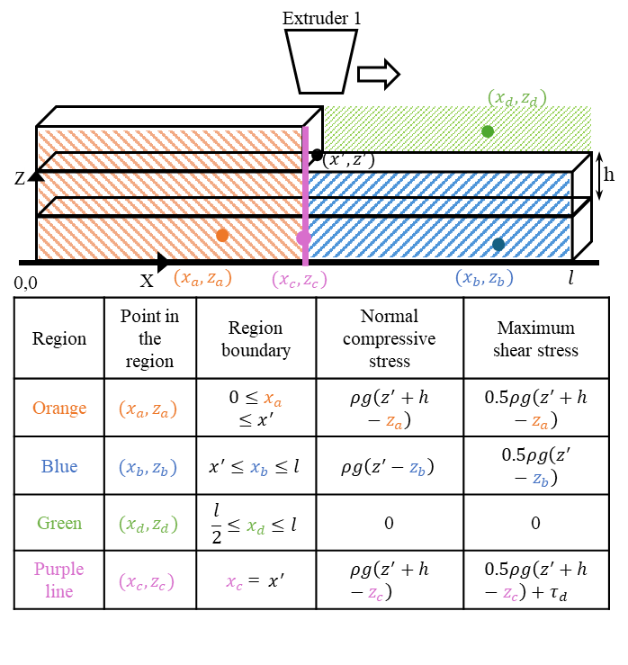
Figure 7. Normal compressive and maximum shear stress while printing using strategy 1

2.2.3.2 Cooperative multi-head printing using traditional multi-head strategy (Strategy 2)
For strategy 2, with two extruders located at ($x_{1}^{'},z_{1}^{'}$) and ($x_{2}^{'},z_{2}^{'}$), where $z_{1}^{'}$ and $z_{2}^{'}$ are equal as both are printing the same layer. Additionally, extruder head 2 will be $l$/2 units away in the x-direction from extruder head 1. The normal compressive stress generated from these positions of a build-up layer in the x-y plane is shown in Figure 8 with consideration of various scenarios. The scenarios are critical as the printing direction is changed across layers, which impacts the deformation or failure point of the structure. Moreover, the maximum shear stress generated from these positions of a build-up layer in the x-y plane as illustrated in Figure 8.

2.2.3.3 Cooperative multi-head printing using SMLP (Strategy 3)
In Figure 9, $τ_{d1}$and $τ_{d2}$ represent the shear stresses caused by the discharge pressures of extruder 1 and extruder 2. It is important to note that $z_{1}^{'}$ is consistently used in the tables as both $z^{'}$s, (i.e., $z_{1}^{'}$, $z_{2}^{'}$) are the same for uniform layer heights. However, in SMLP, there are two extruders operating at different $z$-positions ($x_{1}^{'},z_{1}^{'}$) and ($x_{2}^{'},z_{2}^{'}$), as illustrated in Figure 5c. Therefore, from a positional perspective, two configurations are possible: either extruder 1 is ahead of extruder 2, or vice versa. The relative position of the extruders impacts the failure point of the wall. Additionally, this relative position is influenced by several factors, including speed of extruders, the time delay between the operations of extruders, and the number of layers to be printed. The normal compressive stress and maximum shear stress generated at specific positions within a build-up layer in the x-y plane for SMLP can be calculated as illustrated in Figure 9, where $τ_{d1}$and $τ_{d2}$ are the shear stress caused by discharge pressures of extruder 1 and extruder 2.

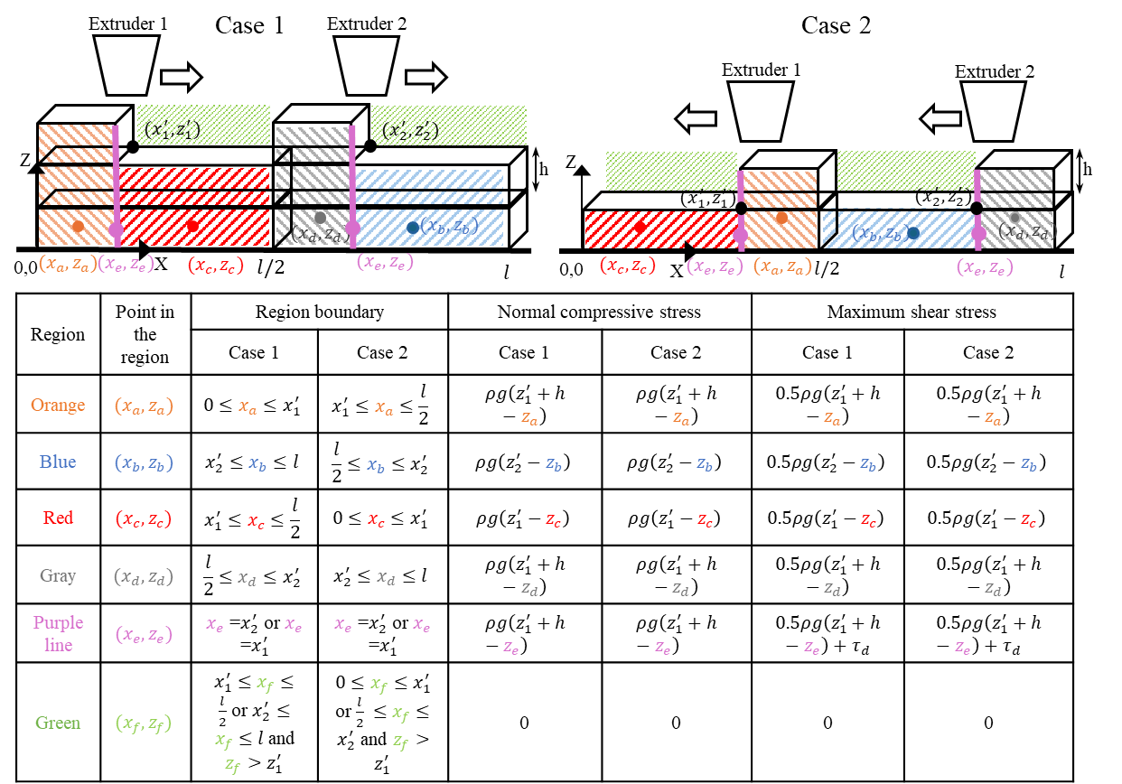
Figure 8. Normal compressive and maximum shear stress while printing using strategy 2
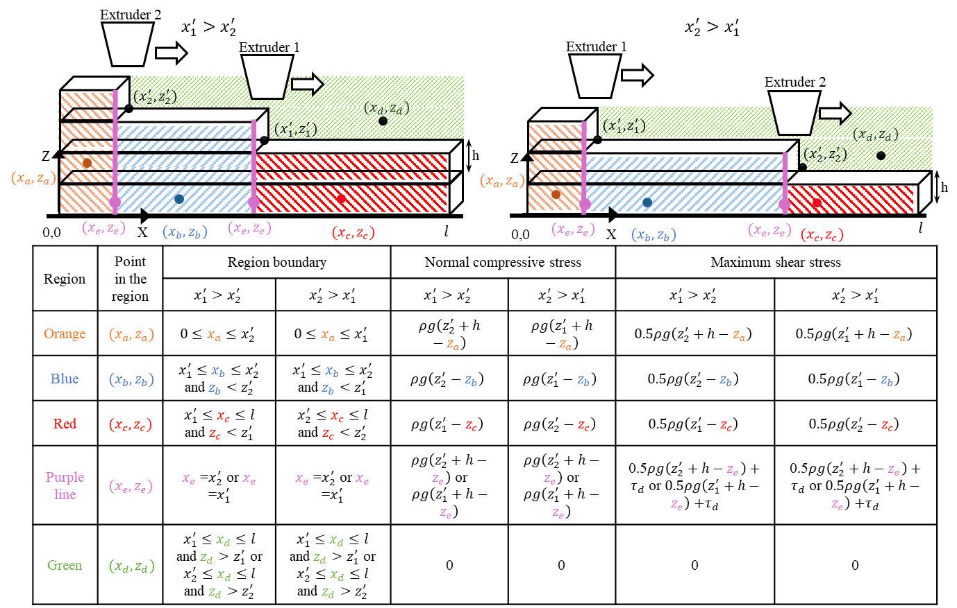
Figure 9. Normal compressive and maximum shear stress while printing using SMLP strategy

3. Results

3.1 Experimental results for extrusion-based polymer printing

3.1.1 Analysis for synchronous multi-layer printing
The material was initially tested along the vertical height of thin wall. The chosen 0.4 mm thin-wall geometry intentionally amplifies the influence of interfacial bonding and seam quality by minimizing bulk load redistribution. This makes the configuration useful for isolating the effect of cooperative printing strategy, although the absolute magnitude of the strength difference should be interpreted with caution when extrapolating to thicker printed components. A two-way ANOVA indicates both factors significantly affect tensile strength: print speed, F(11,22)=2.52, p=0.031; layer length, F(2,22)=4.58, p=0.022 as shown in Table 1. Model fit is moderate (R²=62.6%) with residual standard deviation S=1.29. From sums of squares, the effect size is larger for speed than for length: partial η²_speed = 46.17/(46.17+36.61) ≈ 0.56 vs partial η²_length = 15.23/(15.23+36.61) ≈ 0.29. The probability test on the data showed normality (Anderson–Darling test, AD = 0.384, p = 0.377) and all the assumptions of ANOVA were met (shown in Figure 19 in the appendix). Practically, this says (i) where you set the speed matters more for tensile performance than which of the tested length you print, and (ii) once speed is controlled, length still contributes a non-trivial (≈30%) share of explainable variance. The unexplained variance is not unexpected for extrusion-based printed thin walls, where mechanical response depends not only on nominal print settings but also on local deposition quality and machine-condition effects that are difficult to control perfectly in practice. In this study, such factors were minimized through calibration and screening, but they were not parameterized explicitly in the statistical model.
Table 1. Two-way ANOVA results for tensile strength.
Source | DF | SS | MS | F | P
Print speed | 11 | 46.16 | 4.20 | 2.52 | 0.031
Layer Length | 2 | 15.23 | 7.62 | 4.58 | 0.022
Error | 22 | 36.61 | 1.66
Total | 35 | 98.01
Later, the thin wall was tested along it’s horizontal length. For tear strength, both main effects are again significant and stronger than for tensile: print speed and layer length as displayed in Table 2. Model fit is higher (R²=74.7%) with residual S=1.88. Effect sizes from sums of squares show speed dominates: partial η²_speed = 188.355/(188.355+77.476) ≈ 0.71 (large), while partial η²_length = 40.270/(40.270+77.476) ≈ 0.34 (moderate). From an engineering perspective, the interpretation is that tear resistance is even more speed-sensitive than tensile strength, highlighting the dominant role of inter-pass gap time in interfacial bonding. At very low speeds, excessive aging of the previously deposited material weakens the interface, whereas at very high speeds insufficient wetting and compaction limit bonding. Because the specimens were single-bead-thick thin walls, print speed influences not only the nominal build rate but also the local thermal history, inter-pass delay, interfacial wetting, and defect formation. This makes speed a process variable that directly modifies bond quality rather than merely changing productivity. Accordingly, the large effect size of print speed is physically reasonable for this geometry. Layer length remains a meaningful secondary factor, primarily through its influence on inter-pass delay. The tear strength data was approximately normally distributed as per the normality test (Anderson–Darling test, AD = 0.377, p = 0.392). Figure 20 in the appendix shows that all the assumptions for ANOVA were satisfied.
Table 2. Two-way ANOVA results for tear strength.
Source | DF | SS | MS | F | P
Print speed | 11 | 188.35 | 17.12 | 4.86 | 0.0001
Layer Length | 2 | 40.270 | 20.14 | 5.72 | 0.0010
Error | 22 | 77.476 | 3.52
Total | 35 | 306.10

3.1.2 Comparative results from experiments
Paired t-tests were used to compare the mechanical performance of thin-wall specimens printed using the traditional decomposition-based multi-head strategy and the proposed SMLP strategy. For tensile strength, SMLP exhibits a statistically significant improvement over the traditional multi-head approach (mean gap ≈ +12.4 in SMLP’s favor, 95% CI [10.7, 14.1], p<0.001), while no statistically significant difference is observed in tear strength between the two strategies (mean gap −0.27, 95% CI [−2.88, 2.34], p=0.831), as shown in Table 3 and Table 4, respectively. For the paired t-test, with the null hypothesis being that there is a difference between traditional multi-head and SMLP, the result was statistically significant, which is supported by the mean gap of 12.4 MPa (30% higher than traditional multi-head). Additionally, Figure 10 supports the t-test results that SMLP has higher tensile strength with similar tear strength as traditional multi-head printing. In other words, SMLP significantly improves tensile strength without compromising tear strength. Together with the ANOVAs, the picture is consistent: (i) choose speed first, because it is the largest lever for both tensile and tear; (ii) use SMLP within the mid-speed window, because it preserves tear strength and substantially elevates tensile strength while enabling faster builds; and (iii) account for layer length as a secondary lever via its impact on inter-pass gap time.
Table 3. Paired t-test for tensile strength of thin wall via traditional multi-head and SMLP.
Source | Mean | Stdeviation | SE mean
Bi-directional | 35.07 | 2.55 | 0.74
SMLP | 47.49 | 1.16 | 0.33
Table 4.Paired t-test for tear strength of thin wall via traditional multi-head and SMLP.
Source | Mean | Stdeviation | SE mean
Bi-directional | 13.88 | 2.98 | 0.86
SMLP | 14.15 | 3.17 | 0.91
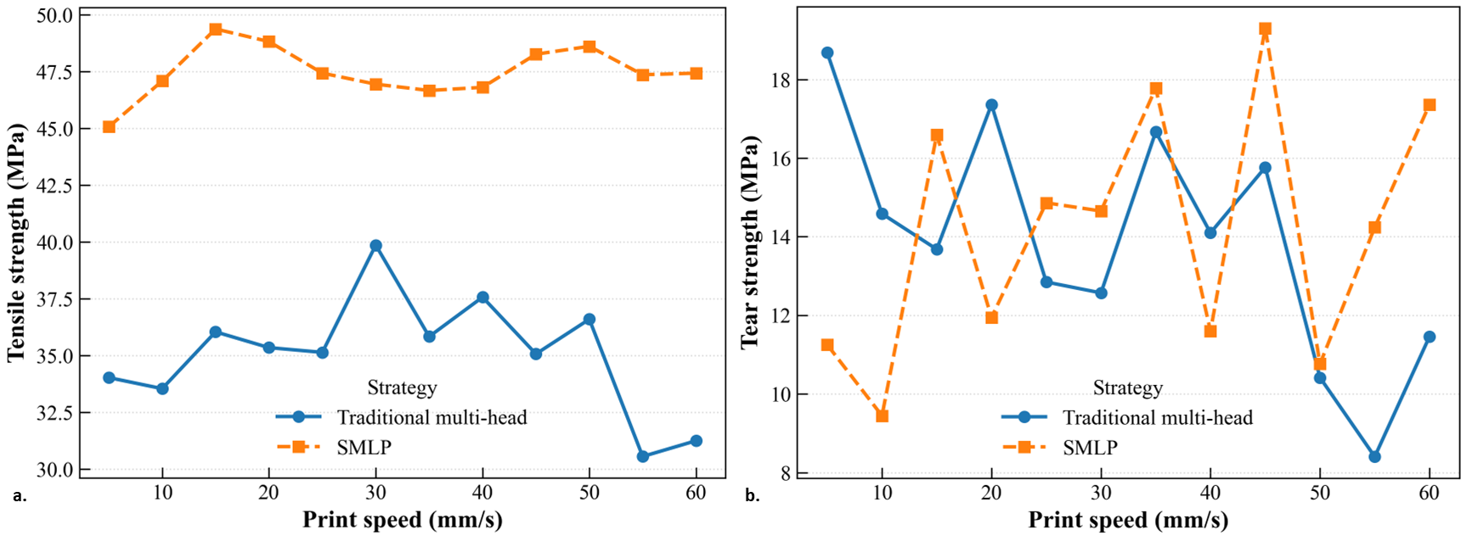
Figure 10. Comparison of a. tensile strength and b. tear strength of parts printed via bi-directional (traditional multi-head) and SMLP printing strategies

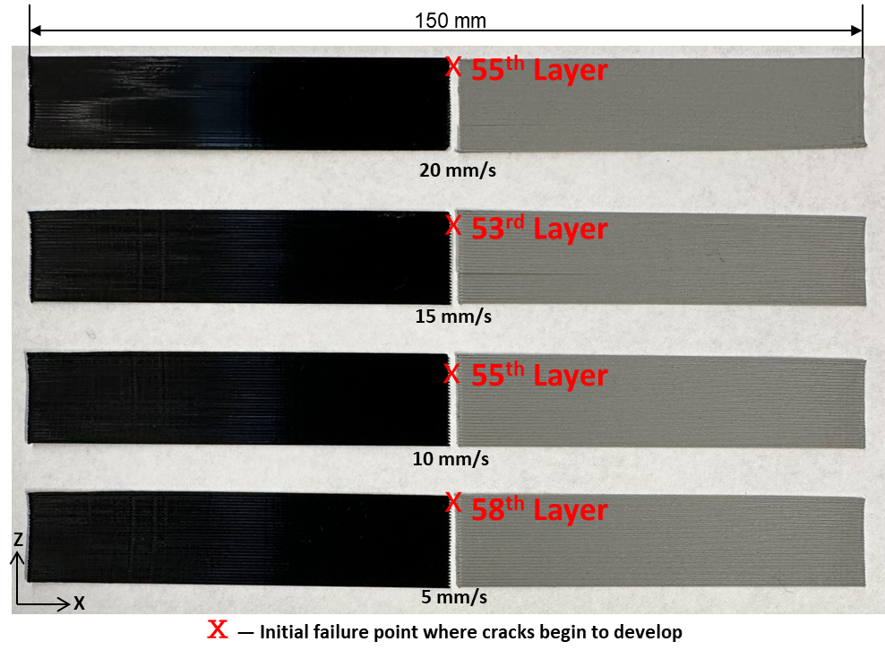
Figure 11. Failure location observed during tensile testing of specimens printed using the traditional multi-head strategy, showing that fracture consistently initiates at the decomposition seam

Another point of discussion is initiation and the propagation of cracks for both the printing strategies. As the scope of this study is to introduce the novel printing strategy and investigate it’s strength compared to traditional strategy, we briefly discuss about the failure of specimens and the initiation of the crack. As clearly seen in Figure 11, for the traditional multi-head printing strategy, the tensile test failure occurs at the decomposition boundary, which proves that the weakest spot is placed on the decomposition boundary. The present results should be interpreted in the context of the broader cooperative-printing literature. Most existing cooperative or multi-robot additive-manufacturing approaches improve productivity by dividing the part into subregions that can be printed in parallel. This strategy is effective from a planning and throughput perspective, but it also introduces internal interfaces whose mechanical quality becomes a key design variable. Prior work on chunk-based cooperative printing showed that the tensile strength of segmented parts can approach that of conventional printing when interface parameters such as overlap depth and chunk slope are selected carefully, indicating that decomposition can be mechanically acceptable but only after explicit joint optimization [13]. Similarly, LayerLock introduced topologically interlocked segmented geometries specifically to compensate for the structural penalties associated with segmented multi-robot printing [14]. Reviews of cooperative robotic AM likewise identify part decomposition, slicing strategy, and defect generation at interfaces as central unresolved challenges, even as these methods improve scalability and fabrication speed [1,2]. In this context, the main distinction of SMLP is that it seeks to preserve the productivity benefit of multi-head printing without introducing a decomposition seam into the wall geometry. This is consistent with the experimental observations in the present study, where fracture in the traditional multi-head specimens initiated at the decomposition boundary, whereas SMLP significantly increased tensile strength while preserving tear strength.

3.2 Simulation results for extrusion-based concrete printing

3.2.1 Analysis for synchronous multi-layer printing
To test the hypothesis that SMLP strategy enhances the printing efficiency compared to single-head strategy (Strategy 1) while simultaneously enhancing the structural integrity over traditional multi-head strategy (Strategy 2), two complementary metrics are evaluated. build time is compared between SMLP and the single-head strategy to quantify efficiency gains. Second, the number of layers deposited before collapse is compared between SMLP and the traditional multi-head strategy to assess improvements in structural stability. As demonstrated in Figure 12, SMLP strategy enables the construction of susbtantially more layers prior to collapse than Strategy 2 (as many as 60 additional layers), while also achieving a significant reduction in the totoal build time in comparison to Strategy 1. Overall, SMLP increases the number of printable layers by approximately 100–300% compared to the traditional multi-head strategy and reduces build time by approximately 24% compared to the single-head strategy.
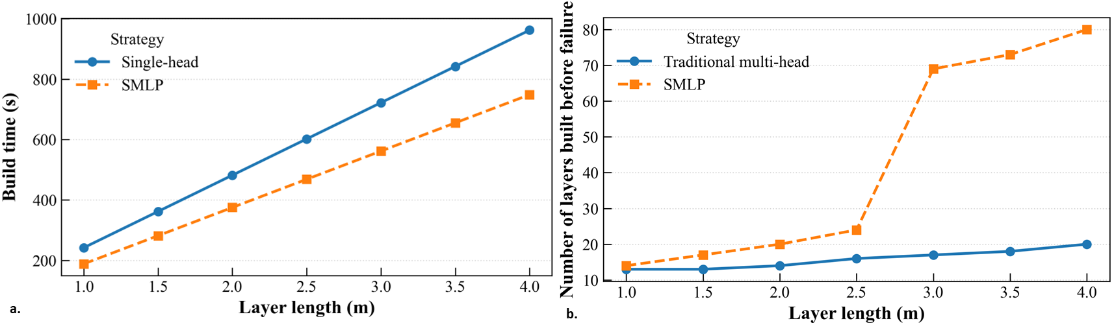
Figure 12. Performance of SMLP compared to a. strategy 1 in build times and b. strategy 2 in number of layers built
The influence of various rheological properties and printing parameters on the structural integrity of concrete deposited through the SMLP strategy was analyzed using analysis of variance (ANOVA). The factors examined were initial yield stress (A: low - 500 Pa, high - 4000 Pa), time gap (B: low - 0.5 s, high - 5.0 s), layer length (C: low - 0.5 m, high - 4.0 m), layer height (D: low - 0.01 m, high - 0.1 m), and print speed (E: low - 25 mm/s, high - 100 mm/s), with each factor tested at two levels. The response variable was defined as the time of failure, measured by the number of layers.
ANOVA was conducted up to second-order terms, as shown in Table 5. Based on the p-values obtained, initial yield stress and layer height emerged as the most significant linear terms, while the interaction terms AD and CD were the most significant quadratic terms. The time gap between the two heads had a relatively minor effect on the structure’s failure time; however, minimizing this time gap could improve efficiency. Therefore, it is recommended to minimize the distance/time gap between the heads, provided it does not lead to collisions. In subsequent sections, the impact of these significant terms on both structural integrity and build time metrics will be compared with those of two other strategies.
Table 5. ANOVA analysis results for SMLP for time of structural failure.
Source | DF | SS | MS | F | P
A - Initial yield stress | 1 | 7938 | 7938 | 36.51 | 0 | Significant
B - Time gap | 1 | 1.1 | 1.1 | 0.01 | 0.944
C - Layer length | 1 | 288 | 288 | 1.32 | 0.267
D - Layer height | 1 | 4560.1 | 4560.1 | 20.97 | 0 | Significant
E - Print speed | 1 | 392 | 392 | 1.8 | 0.198
AB | 1 | 0.1 | 0.1 | 0 | 0.981
AC | 1 | 242 | 242 | 1.11 | 0.307
AD | 1 | 3321.1 | 3321.1 | 15.27 | 0.001 | Significant
AE | 1 | 338 | 338 | 1.55 | 0.23
BC | 1 | 1.1 | 1.1 | 0.01 | 0.944
BD | 1 | 0 | 0 | 0 | 1
BE | 1 | 120.1 | 120.1 | 0.55 | 0.468
CD | 1 | 1596.1 | 1596.1 | 7.34 | 0.015 | Significant
CE | 1 | 200 | 200 | 0.92 | 0.352
DE | 1 | 351.1 | 351.1 | 1.61 | 0.222
Error | 16 | 3479 | 217.4
Total | 31 | 22828

3.2.2 Comparative results from analytical model
The length of wall is fixed at 0.15 m for the proposed analytical model, allowing verification with the results from literature model [27]. This short wall should therefore be interpreted as a validation case rather than the sole basis for the study’s conclusions. The parameters selected for this study are detailed in Table 6.
Table 6. Case study parameters and their values [27].
Parameter | Symbol | Value
Initial yield stress | $$τ_{0}$$ | 500 Pa
Hardening co-efficient | $$α$$ | 0.0003/s
Acceleration of gravity | $$g$$ | 9.8 m/s²
Density of concrete | $$ρ$$ | 2500 kg/m³
Traverse speed | $$V_{t}$$ | 0.01 m/s
Print speed | $$V_{p}$$ | 0.025 m/s
Layer height | $$h$$ | 0.01 m
Across all three strategies, the maximum shear stress surpasses the yield stress of the printed concrete as the extruder initiates printing layer 5. In other words, during the printing of layer 5, deformation becomes evident at layer 1, as depicted in both Figure 13 and Figure 14. These figures illustrate the evolution of yield stress and maximum shear stress during the construction process using strategies 2 and 3, respectively. It is worth noting that these figures illustrate the yield stress distribution across the entire deposited surface for both Strategy 2 and the SMLP method, with sub-figures capturing this distribution at distinct time intervals. Deformation is apparent in both strategies when layer 6 is completely printed. The yield stress shows a little inclination at the top because material deposited in the upper layers experiences a delayed deposition relative to the lower layers, leading to lower yield stress values in the upper layers compared to the base layers. Consequently, the top layers exhibit progressively lower yield stress at these specific intervals, while the base layers continue to build yield stress over time.
Another important metric for simulation model is the computation time. The analytical model took only 0.0181 seconds for one run. Furthermore, a comparison for total build time underscores the efficacy of these multi-head strategies. For 5 layers with a length of 0.15 m, the total build time is 38, 20, and 30.33 seconds for strategies 1, 2, and 3, respectively. Notably, the wall begins deforming at layer 5 across all strategies, indicating that the adoption of multiple heads has not affected the start time for collapse. In fact, the utilization of multi-heads has led to a reduction in the overall build time for the wall.

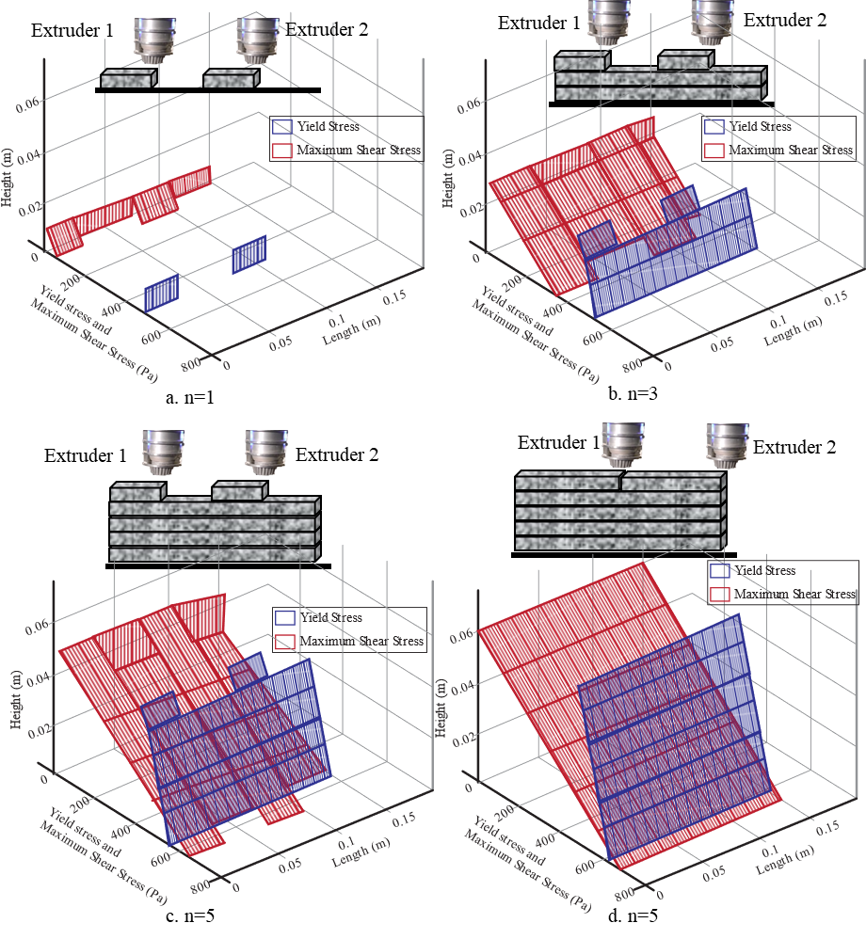
Figure 13. Comparison of yield stress and maximum shear stress for strategy 2 a. n=1, b. n=3, c. start of n=5 and d. completion of n=5 layer

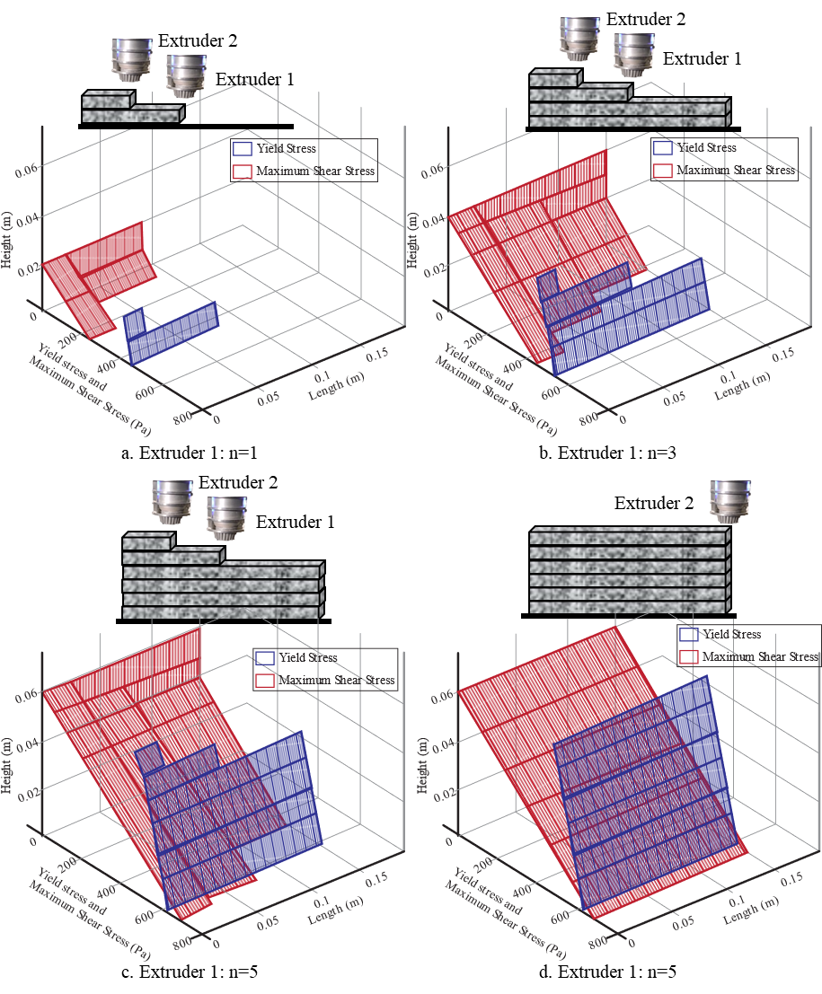
Figure 14. Comparison of yield stress and maximum shear stress for SMLP a. Extruder 1 n=1, b. Extruder 1 n=3, c. Extruder 1 n=5 and d. completion of Extruder 1 as well as extruder 2

3.2.3 Sensitivity Analysis

3.2.3.1 Impact of initial yield stress of concrete
The rheological properties of materials are fundamental in determining the deformation and buildability of parts. Specifically, the initial yield stress of fresh concrete is a controllable parameter that can be enhanced during its preparation. Various methods, such as incorporating accelerators or other additives into the fresh concrete, can be employed to achieve a higher initial yield stress [18]. According to the findings presented in Section 3.2.1, an increase in the initial yield stress from 500 to 4000 Pa [31,32] affects the time to collapse, as depicted in Figure 15. By elevating the initial yield stress, fresh concrete can bear greater weight and sustain higher build layers before structural failure occurs. Specifically, increasing the initial yield stress from 500 to 4000 Pa resulted in a roughly 600% increase in the number of layers sustained before failure across all strategies. In other words, more layers could be successfully built. Among the strategies, the proposed SMLP strategy (Strategy 3) demonstrated a slight advantage (~3.03%) over Strategy 1 (single-head print), which itself showed better performance (~6.06%) than Strategy 2 (traditional multi-head print strategy). Furthermore, the benefits of higher initial yield stress became increasingly apparent as the yield stress rose, as shown in Figure 15b. This indicates an improved stress distribution in the proposed cooperative printing approach compared to the conventional single-head and multi-head printing strategies.
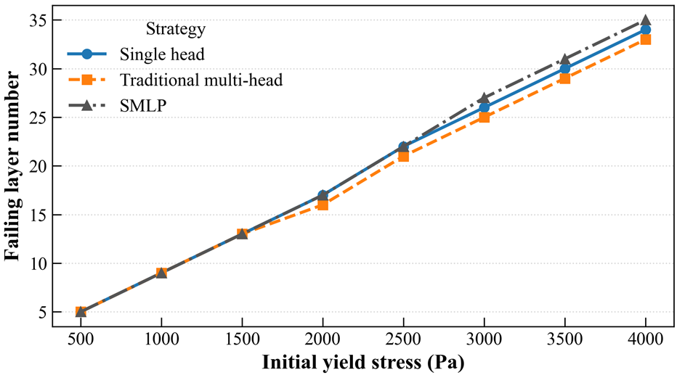
Figure 15. Sensitivity analysis for varying initial yield stress on a. failing layer number (i.e., time of collapse) for all three strategies

3.2.3.2 Impact of print speed and layer length
The extrusion head speed and layer length were adjusted to assess their influence on both build time and the yield stress of the deposited concrete. To assess whether the results on short walls remain relevant beyond this verification scale, the analytical framework was further applied in a broader sensitivity study in which wall length was varied up to 4.0 m, together with other material and process parameters. Across this extended range, the proposed SMLP strategy continued to provide more printable layers before collapse than the traditional multi-head strategy, while retaining a build-time advantage over the single-head strategy. Equations to calculate the total build time for all the strategies are provided in the Appendix. In this study, three different speed values, i.e., 25 mm/s, 50 mm/s, and 100 mm/s, were employed. The number of layers was held constant at 5, with a 1-second time gap between the two extruders. In Figure 16, it can be seen that SMLP saves time compared to strategy 1 and is slower in comparison to strategy 2. As illustrated in Figure 17a, the yield stress development for SMLP very closely follows that of strategy 1, which is widely used in the industry. In addition to that, SMLP achieves higher yield stress value compared to strategy 2 as seen in Figure 17b. Furthermore, among the strategies examined, SMLP fell between strategies 2 and 1 in terms of both build time and yield stress development metrics. Notably, SMLP exhibited closer alignment with strategy 1 in terms of yield stress development and approached strategy 2 in the build time metric. This highlights the advantages inherent in the proposed multi-head printing strategy, making it favorable in real-world applications.
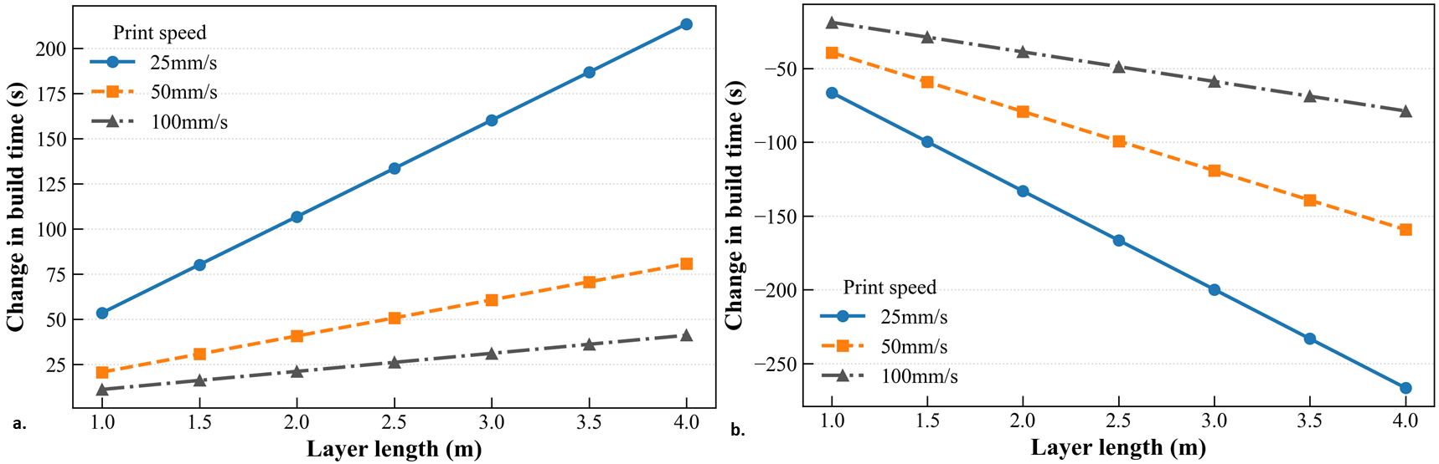
Figure 16. Influence of print speeds on the performance of SMLP compared to a. strategy 1 and b. strategy 2 in build times
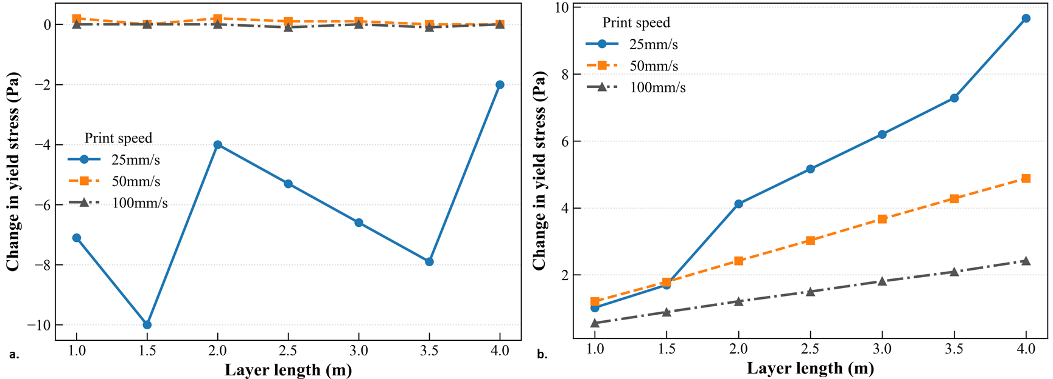
Figure 17. Influence of print speeds on the performance of SMLP compared to a. strategy 1 and b. strategy 2 in yield stress

3.2.3.3 Impact of layer height
The investigation into collapse times for all three strategies across varying layer heights, with a fixed print velocity of 25 mm/s, was explored, as illustrated in Figure 18. As the layer height increases, there is a corresponding increase in the maximum shear stress on the initial layer, resulting in premature failure. Hence, a smaller layer height is preferable across all strategies, regardless of layer length. Among the strategies evaluated, strategy 1, which utilizes a single head, exhibits superior performance across all combinations of layer heights and lengths compared to other strategies. For instance, with a layer length of 4 m and a layer height of 0.01 m, strategies 1, 2, and 3 can print 20, 12, and 16 layers, respectively, before any indication of collapse. In other words, SMLP can build 25% more layers before failing compared to strategy 2. Furthermore, it is noteworthy that the SMLP approach can print a greater number of layers compared to strategy 2 for walls of equivalent length and height.
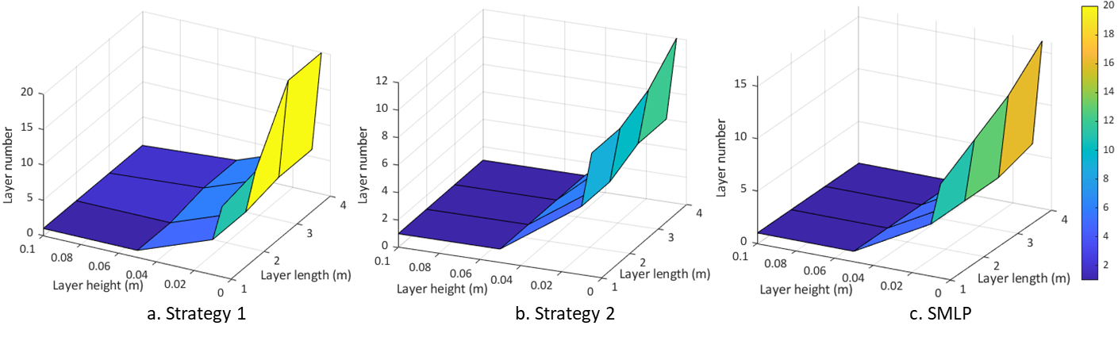
Figure 18. Time of collapse for varying layer height/thickness and layer length for a. strategy 1, b. strategy 2 and c. SMLP

3.3 Discussion
The results of this study should be interpreted in the broader context of cooperative additive manufacturing, where the main challenge is not only to increase productivity, but to do so without introducing new mechanically weak features. Most existing cooperative or multi-robot printing approaches achieve speedup by partitioning the part into subregions that can be fabricated simultaneously. This improves scalability and print time, but it also creates additional interfaces whose bonding quality, path discontinuity, and local stress history can reduce structural performance. In that sense, the present study is less about showing that a multi-head strategy can be faster, which is already well established, and more about showing that the form of cooperation itself strongly influences mechanical integrity. Thus, the main novelty of SMLP is not simply simultaneous multi-head printing, which has already been demonstrated in segmented and mobile-robot systems, but simultaneous multi-head printing without geometric decomposition of the wall cross-section.
A useful point of comparison is segmented cooperative printing. In chunk-based cooperative printing, the part is divided into chunks that are printed separately and then joined through chunk interfaces. Prior work showed that the mechanical penalty of this approach can be reduced, and in some cases largely mitigated, if interface parameters such as chunk slope and overlap depth are carefully optimized. However, that result also makes clear that the interface remains a critical design variable rather than disappearing as a governing weakness [13,14]. By contrast, the central idea of SMLP is to avoid introducing a decomposition seam into the wall at all. That distinction is consistent with the polymer experiments in the present study: fracture in the traditional decomposition-based multi-head specimens initiated at the decomposition boundary, whereas SMLP increased tensile strength by about 12.4 MPa, or roughly 30%, without significantly changing tear strength. In other words, relative to segmented cooperative methods, SMLP does not attempt to strengthen a necessary seam; it attempts to eliminate the seam as a dominant structural feature.
A second comparison is with geometry-based seam-management approaches, including topologically interlocked or staggered deposition strategies. LayerLock, for example, also addresses the limitations of segmented cooperative printing, but it does so by deliberately introducing interlocked layer-wise cells so that the interfaces created by partitioning are mechanically more tolerant. Its value lies in improving damage tolerance and collision-free coordination in segmented multi-robot printing, but the method still depends on geometric partitioning and cell-level path planning [14]. Similarly, recent concrete-printing work on print geometry alteration and layer staggering shows that mechanical performance can be improved when interfilament and interlayer joints are prevented from aligning through the section. In that literature, flexural strength improvement is achieved by redistributing or offsetting defects rather than removing them entirely [33]. SMLP differs from both of these approaches in mechanism. Its advantage does not come from reshaping, offsetting, or interlocking weak interfaces; instead, it preserves a continuous full-layer deposition path and changes only the timing relationship between heads. This makes SMLP mechanically closer to single-head printing, while still retaining much of the productivity benefit of multi-head operation. That interpretation is also supported by the analytical results, where SMLP exhibits yield-stress development closer to Strategy 1 but build-time performance closer to Strategy 2.
The polymer experiments also provide a useful process-structure-property interpretation of why SMLP performs better than the decomposition-based benchmark. The ANOVA results indicate that print speed is the strongest factor for both tensile and tear response, and the tear results are even more speed-sensitive than the tensile results, highlighting the importance of inter-pass timing and interfacial quality. This observation is consistent with prior extrusion-based printing literature, in which time gap and interface quality are repeatedly identified as dominant factors in interlayer strength [29]. Thus, the higher tensile strength observed for SMLP should not be interpreted only as an effect of “using two heads differently,” but more specifically as the consequence of a strategy that controls the time field and avoids a vertical decomposition seam. In the traditional decomposition-based case, the interface created by spatial partitioning becomes the weakest location; in SMLP, the main remaining sensitivities are those already present in extrusion-based printing, namely inter-pass timing, wetting, and local bonding.
The concrete-model results reinforce this interpretation at a larger structural scale. Existing multi-robot and swarm-style construction systems have demonstrated clear benefits in mobility, coverage, and scalability. In particular, teams of mobile robots can print structures larger than the workspace of a single robot and can do so concurrently, offering a compelling route toward construction-scale fabrication. However, that literature primarily emphasizes localization, robot placement, collision avoidance, and coordinated execution. Mechanical continuity is acknowledged as a concern, especially when piecewise assembly or segmented coordination is involved, but it is less often analyzed directly in terms of strategy-dependent stress evolution [16]. The present analytical model contributes in that specific direction: it compares cooperative strategies not only by build time, but by how the strategy modifies the relationship between time-dependent material strengthening and gravity-induced stress buildup. From this perspective, SMLP occupies a useful middle ground. It is not as broadly scalable as fully mobile swarm approaches, but it offers a more mechanically interpretable framework for cooperative wall printing because the deposition-history field remains structured and analyzable.
These comparisons also clarify the limits of the present strategy. Relative to swarm robotic printing, SMLP is more constrained geometrically and operationally. Mobile-robot systems can, in principle, scale to much larger structures and more complex site conditions by adding robots and redistributing work over a broad spatial domain. SMLP, especially on gantry-type platforms, is more naturally suited to hollow or wall-like structures where one head can follow another without collision. As the number of heads increases, the spacing between active heads decreases, synchronization becomes tighter, and collision avoidance and calibration requirements become more severe. Thus, SMLP should not be interpreted as a universal replacement for swarm or fully distributed systems. Rather, its contribution is to show that within the important class of thin-wall cooperative extrusion problems, it is possible to recover a substantial fraction of multi-head productivity without accepting the mechanical penalties usually associated with geometric partitioning.
The same strategy-evaluation workflow could be extended to other extrusion-based AM systems by substituting the material-specific constitutive and failure components. In large-scale polymer extrusion, the strength-evolution law would be governed by thermal history, interlayer diffusion, and healing. In robotic multi-nozzle printing, the framework would additionally need to represent synchronization, collision-avoidance constraints, and nozzle-to-nozzle variability. In WAAM and related metal-deposition systems, the material-specific component would instead involve thermal accumulation, melt-pool interaction, residual stress, and distortion/cracking criteria. Therefore, the framework is “unified” at the level of relating cooperative toolpaths to timing fields and timing fields to material-dependent structural performance, rather than at the level of identical process physics across materials.
Overall, the comparisons suggest that cooperative-printing methods can be organized according to how they handle interfaces. Segmented methods accept internal interfaces and attempt to optimize them; interlocked or staggered methods attempt to redistribute or toughen them; swarm systems prioritize scalability and coordination, often leaving interface mechanics as a secondary issue; and SMLP instead attempts to minimize the structural role of such interfaces by preserving continuous layer paths. Within the scope studied here, that distinction appears to matter mechanically. The polymer experiments indicate that seam elimination can produce substantial tensile gains without loss of tear resistance, while the analytical model suggests that a similar strategy-level advantage may extend to wall stability in concrete printing.

Limitations
The applicability of SMLP is highly dependent on the motion system used. If a traditional gantry-based system is utilized, the printed geometry is generally limited to hollow structures to allow one print head to follow the other without restriction. Complex geometries may require more advanced setups like drones or 6-DOF robotic arms. The implementation on gantry-based system requires specific hardware modifications, such as a customized dual-head mount and separate control boards for each hotend to enable the synchronized delay. SMLP requires higher computational power compared to single-head strategies, specifically to manage collision avoidance between multiple active heads. Coordinated layer-wise assignment requires accurate synchronization of two or more heads in space and time and continuous collision avoidance, especially when the heads operate at different heights and pass over previously printed material. On real hardware this translates into more complex motion planners, tighter requirements on calibration, and potentially higher sensitivity to tracking error or communication delays. However, this challenge exists for most of the multi-head printing strategies and not SMLP. Moreover, as the number of heads increases the spacing in height between heads shrinks ,collision risk and coordination complexity grow and non-productive travel may increase if all heads must span the entire layer. At some number of heads, the additional speed gain may not justify the extra complexity, especially on gantry systems where all heads share same axes. In future studies, these limitations can be addressed. A limitation of the polymer experiments is the relatively small number of replicates for each print-speed/layer-length combination. Accordingly, the ANOVA should be interpreted primarily as a tool for identifying dominant factor effects and overall trends rather than as a high-power predictive model. Nevertheless, the main statistical conclusions remain reasonably robust because the dataset satisfied the ANOVA assumptions, the observed factor effects were moderate to large in magnitude, and the principal strategy-level finding was independently supported by paired comparisons showing a large tensile-strength improvement of SMLP relative to the traditional multi-head strategy. In the current analytical model, the path is linear; therefore, the model does not yet account for curvature-induced changes in deposition timing, local filament orientation, or geometry-dependent load redistribution. The present analytical model predicts failure when the local maximum shear stress exceeds the local yield stress of the deposited material. This criterion is intended to represent yield-governed early collapse under self-weight in a straight, thin-wall printed structure. It does not explicitly account for other possible failure mechanisms, such as buckling, lateral instability, or material segregation. These mechanisms may become important when the structure is slender, when out-of-plane imperfections or asymmetric deposition are present, or when the material exhibits nonuniform composition or rheological evolution. In such cases, structural instability may occur even if the local shear stress has not yet exceeded the local yield stress predicted by the present model. Accordingly, the model should be interpreted as a reduced-order comparative framework for stress-driven collapse, rather than a complete description of all possible failure modes in printed concrete structures.

Conclusion and Future Work
In this study, a novel decomposition-free cooperative printing strategy, named synchronous multi-layer printing (SMLP), is proposed. In SMLP each printing head is assigned to complete individual layers in a coordinated manner, so that consecutive layers are deposited with controlled and nearly uniform inter and intra layer gap times. This design aims to retain the mechanical robustness typically associated with single head printing while achieving build times comparable to conventional multi-head strategies.
The proposed strategy was first implemented on a dual head FDM system using PLA, and its performance was compared with a conventional multi-head strategy. Tensile and tear tests on printed walls covering a range of printing speeds and layer length showed that SMLP can increase strength and reduce variability. Paired comparisons show that SMLP increases interlayer tensile strength by ~12.4 MPa (≈30%) relative to the traditional multi-head strategy (p<0.001), while tear strength is statistically unchanged (p=0.831). These experiments provide rare quantitative evidence that cooperative multi-head strategies, when designed to control the material at bonding, can improve mechanical performance rather than simply matching single head behavior.
To investigate the implications for extrusion based concrete printing, an analytical model was formulated that couples a time dependent yield stress law with the evolving shear stress distribution in walls printed using SMLP, decomposition based multi-head printing, and single head printing. Collapse was predicted as the time when the maximum shear stress exceeds the local yield stress. The analytical model supports the hypothesis that SMLP can substantially delay collapse and reduce deformation relative to traditional strategies. For the parameter ranges considered, SMLP increased the number of layers that could be built before failure by roughly 100 to 300 percent compared with the decomposition based strategy, and reduced build time by about 24 percent relative to bi directional single head printing. The parametric study further showed that initial yield stress and layer height have the largest influence on collapse time for all strategies. SMLP benefits particularly from higher initial yield stress, where its advantage over other strategies becomes more pronounced. Across strategies, higher initial yield stress, moderate printing speeds that avoid excessive inter pass waiting times, smaller layer heights, and appropriately chosen wall lengths were identified as desirable for enhancing structural integrity.
Overall, the combined experimental and analytical results demonstrate that cooperative printing strategies do not have to trade structural performance for productivity. By explicitly accounting for the interaction between toolpath design, gap times, and material build up, SMLP provides a pathway to faster and more reliable large scale additive manufacturing. Future work will extend the framework to more complex geometries and loading scenarios, and further tune coordination among multiple print heads to target specific structural performance and quality requirements. Additionally, future work will investigate different decomposition patterns for effect on the mechanical properties and will study microstructural behavior including crack initiation and propagation in more detail.

Declaration
The authors declare that no funds, grants, or other support were received during the preparation of this manuscript. The authors have no relevant financial or non-financial interests to disclose.

References
[1] Khosravani MR, Haghighi A. Large-Scale Automated Additive Construction: Overview, Robotic Solutions, Sustainability, and Future Prospect. Sustainability 2022;14:9782. https://doi.org/10.3390/su14159782.
[2] Shen H, Pan L, Qian J. Research on large-scale additive manufacturing based on multi-robot collaboration technology. Addit Manuf 2019;30:100906. https://doi.org/10.1016/j.addma.2019.100906.
[3] Roschli A, Gaul KT, Boulger AM, Post BK, Chesser PC, Love LJ, et al. Designing for Big Area Additive Manufacturing. Addit Manuf 2019;25:275–85. https://doi.org/10.1016/j.addma.2018.11.006.
[4] Lowke D, Dini E, Perrot A, Weger D, Gehlen C, Dillenburger B. Particle-bed 3D printing in concrete construction – Possibilities and challenges. Cem Concr Res 2018;112:50–65. https://doi.org/10.1016/j.cemconres.2018.05.018.
[5] Ghungrad S, Mohammed A, Haghighi A. Energy-efficient and quality-aware part placement in robotic additive manufacturing. J Manuf Syst 2023;68:644–50. https://doi.org/10.1016/j.jmsy.2023.05.019.
[6] Tang P, Zhao X, Shi H, Hu B, Ding J, Yang B, et al. A review of multi-axis additive manufacturing: Potential, opportunity and challenge. Addit Manuf 2024;83. https://doi.org/10.1016/j.addma.2024.104075.
[7] Poudel L, Elagandula S, Zhou W, Sha Z. Decentralized and Centralized Planning for Multi-Robot Additive Manufacturing. J Mech Des Trans ASME 2023;145:1–10. https://doi.org/10.1115/1.4055735.
[8] Hasanov S, Alkunte S, Rajeshirke M, Gupta A, Huseynov O, Fidan I, et al. Review on additive manufacturing of multi-material parts: Progress and challenges. J Manuf Mater Process 2022;6. https://doi.org/10.3390/jmmp6010004.
[9] Brackett J, Yan Y, Cauthen D, Kishore V, Lindahl J, Smith T, et al. Characterizing material transitions in large-scale Additive Manufacturing. Addit Manuf 2021;38:101750. https://doi.org/10.1016/j.addma.2020.101750.
[10] Ghungrad S, Haghighi A. Three-dimensional spatial energy-quality map construction for optimal robot placement in multi-robot additive manufacturing. Robot Comput Integr Manuf 2024;88:102735. https://doi.org/10.1016/j.rcim.2024.102735.
[11] Haghighi A, Mohammed A, Wang L. Energy Efficient Multi-Robotic 3D Printing for Large-Scale Construction – Framework, Challenges, and a Systematic Approach. Vol. 2 Manuf. Process. Manuf. Syst. Nano/Micro/Meso Manuf. Qual. Reliab., vol. Volume 2:, American Society of Mechanical Engineers; 2021. https://doi.org/10.1115/MSEC2021-63787.
[12] Wachsmuth JP, Bøhn JH. Multiple Independent Extrusion Heads for Fused Deposition Modeling. Mech Eng 2008;Master of:101.
[13] Poudel L, Sha Z, Zhou W. Mechanical strength of chunk-based printed parts for cooperative 3D printing. Procedia Manuf 2018;26:962–72. https://doi.org/10.1016/j.promfg.2018.07.123.
[14] Krishnamurthy V, Poudel L, Ebert M, Weber DH, Wu R, Zhou W, et al. LayerLock: Layer-Wise Collision-Free Multi-Robot Additive Manufacturing Using Topologically Interlocked Space-Filling Shapes. CAD Comput Aided Des 2022;152:103392. https://doi.org/10.1016/j.cad.2022.103392.
[15] Jin Y an, He Y, Fu J zhong, Gan W feng, Lin Z wei. Optimization of tool-path generation for material extrusion-based additive manufacturing technology. Addit Manuf 2014;1:32–47. https://doi.org/10.1016/j.addma.2014.08.004.
[16] Zhang X, Li M, Lim JH, Weng Y, Tay YWD, Pham H, et al. Large-scale 3D printing by a team of mobile robots. Autom Constr 2018;95:98–106. https://doi.org/10.1016/j.autcon.2018.08.004.
[17] Buswell RA, Leal de Silva WR, Jones SZ, Dirrenberger J. 3D printing using concrete extrusion: A roadmap for research. Cem Concr Res 2018;112:37–49. https://doi.org/10.1016/j.cemconres.2018.05.006.
[18] Le TT, Austin SA, Lim S, Buswell RA, Gibb AGF, Thorpe T. Mix design and fresh properties for high-performance printing concrete. Mater Struct Constr 2012;45:1221–32. https://doi.org/10.1617/s11527-012-9828-z.
[19] Murata J. Flow and deformation of fresh concrete. Matériaux Constr 1984;17:117–29. https://doi.org/10.1007/BF02473663.
[20] Saak AW, Jennings HM, Shah SP. A generalized approach for the determination of yield stress by slump and slump flow. Cem Concr Res 2004;34:363–71. https://doi.org/10.1016/j.cemconres.2003.08.005.
[21] Duballet R, Gosselin C, Roux P. Additive Manufacturing and Multi-Objective Optimization of Graded Polystyrene Aggregate Concrete Structures. In: Thomsen MR, Tamke M, Gengnagel C, Faircloth B, Scheurer F, editors. Model. Behav., Cham: Springer International Publishing; 2015, p. 225–35. https://doi.org/10.1007/978-3-319-24208-8_19.
[22] Bos F, Wolfs R, Ahmed Z, Salet T. Additive manufacturing of concrete in construction: potentials and challenges of 3D concrete printing. Virtual Phys Prototyp 2016;11:209–25. https://doi.org/10.1080/17452759.2016.1209867.
[23] Nguyen-Van V, Panda B, Zhang G, Nguyen-Xuan H, Tran P. Digital design computing and modelling for 3-D concrete printing. Autom Constr 2021;123:103529. https://doi.org/10.1016/j.autcon.2020.103529.
[24] He L, Chow WT, Li H. Effects of interlayer notch and shear stress on interlayer strength of 3D printed cement paste. Addit Manuf 2020;36:101390. https://doi.org/10.1016/j.addma.2020.101390.
[25] Perrot A, Rangeard D, Pierre A. Structural built-up of cement-based materials used for 3D-printing extrusion techniques. Mater Struct 2016;49:1213–20. https://doi.org/10.1617/s11527-015-0571-0.
[26] Perrot A, Pierre A, Nerella VN, Wolfs RJM, Keita E, Nair SAO, et al. From analytical methods to numerical simulations: A process engineering toolbox for 3D concrete printing. Cem Concr Compos 2021;122:104164. https://doi.org/10.1016/j.cemconcomp.2021.104164.
[27] Jeong H, Han S-J, Choi S-H, Lee Y, Yi S, Kim K. Rheological Property Criteria for Buildable 3D Printing Concrete. Materials (Basel) 2019;12:657. https://doi.org/10.3390/ma12040657.
[28] Pan T, Jiang Y, He H, Wang Y, Yin K. Effect of structural build-up on interlayer bond strength of 3d printed cement mortars. Materials (Basel) 2021;14:1–17. https://doi.org/10.3390/ma14020236.
[29] Chen Y, Jansen K, Zhang H, Romero Rodriguez C, Gan Y, Çopuroğlu O, et al. Effect of printing parameters on interlayer bond strength of 3D printed limestone-calcined clay-based cementitious materials: An experimental and numerical study. Constr Build Mater 2020;262. https://doi.org/10.1016/j.conbuildmat.2020.120094.
[30] Tay YWD, Ting GHA, Qian Y, Panda B, He L, Tan MJ. Time gap effect on bond strength of 3D-printed concrete. Virtual Phys Prototyp 2019;14:104–13. https://doi.org/10.1080/17452759.2018.1500420.
[31] Ivanova I, Mechtcherine V. Effects of volume fraction and surface area of aggregates on the static yield stress and structural build-up of fresh concrete. Materials (Basel) 2020;13. https://doi.org/10.3390/ma13071551.
[32] White C, Lees JM. Yield stress prediction from 3D reconstruction of fresh concrete slump. Cem Concr Res 2023;174:107331. https://doi.org/10.1016/j.cemconres.2023.107331.
[33] Tripathi A, Nair SAO, Chauhan, Harshitsinh, Neithalath N. Print Geometry Alterations and Layer Staggering to Enhance Mechanical Properties of Plain and Fiber- Reinforced Three-Dimensional-Printed Concrete. ACI Mater J 2024;121. https://doi.org/10.14359/51740262.

Appendix
For strategy 1, if the velocity of nozzle while printing and traversing is $V_{p}$ and $V_{t}$, respectively. The print time for layer $i$ is $L_{i}/V_{p}$ and traverse time between layer $i$ to layer $i+1$ would be $L_{t}/V_{t}$, where $L_{i}$ and $L_{t}$ are the length of printing path and traverse length, respectively. So, the total build time for strategy 1 can be written as:
 | ${TBT}_{1}= \sum_{i}{\left(\frac{L_{p,i}}{V_{p}}\right)+\frac{(n-1)*h}{V_{t}}}$ | (14)
where $h$ is the layer height and is the traversed length by the extruder head in the strategy 1. For strategy 2, the total build time for strategy 2 with $m$ robots can be written as:
 | ${TBT}_{2}= \sum_{i}{\left(\frac{L_{p,i}}{mV_{p}}\right)+\frac{(n-1)*h}{V_{t}}}$ | (15)
In this work, as two extruders are used, the equation will become as,
 | ${TBT}_{2}= \sum_{i}{\left(\frac{L_{p,i}}{2V_{p}}\right)+\frac{(n-1)*h}{V_{t}}}$ | (16)
For SMLP, traverse time will be equal to ${D/V}_{max}$, where $D$ is the distance covered by the head from the end point of current layer to the next start point without any collisions. It is represented by $V_{max}$ and will take less time to reach the start location. The total build time for $m$ extruders can be calculated as,
 | ${TBT}_{3}={\left[\frac{n}{2}\right]}_{c}*\frac{L_{p}}{V_{p}}+{\left[\frac{n-m}{2}\right]}_{c}*\frac{D}{V_{max}}+\left(\left(n+1\right)\%m*t_{d}\right)$ | (17)
where $n$ is the number of layers, ${\left[.\right]}_{c}$ is the ceiling function and $\%$ is a modulo operation. In this work, as two extruders are used, the equation will become as,
 | ${TBT}_{3}={\left[\frac{n}{2}\right]}_{c}*\frac{L_{p}}{V_{p}}+{\left[\frac{n-2}{2}\right]}_{c}*\frac{D}{V_{max}}+\left(\left(n+1\right)\%2*t_{d}\right)$ | (18)
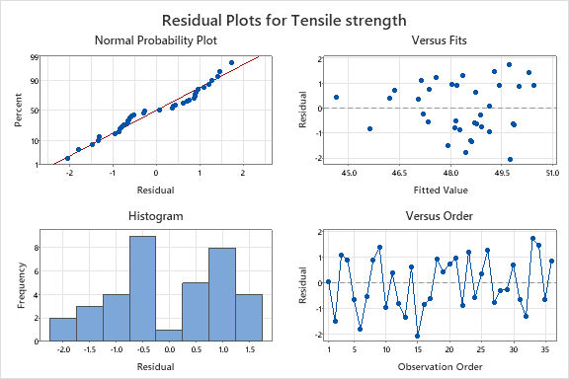
Figure 19 Residual plots for validating assumptions for ANOVA testing for tensile strength
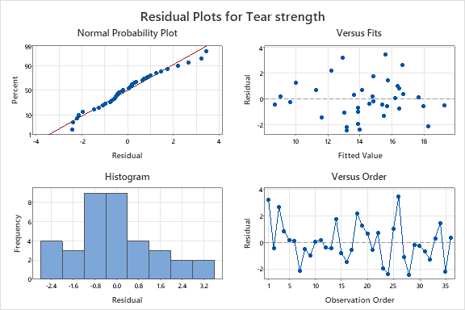
Figure 20.Residual plots for validating assumptions for ANOVA testing for tear strength

