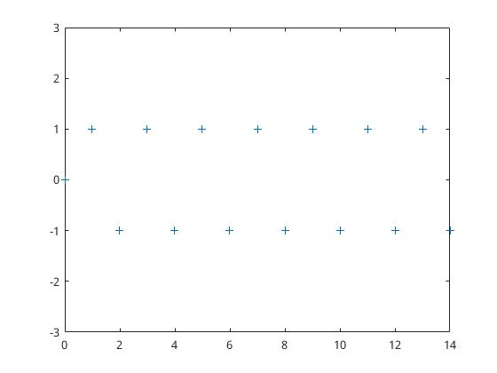
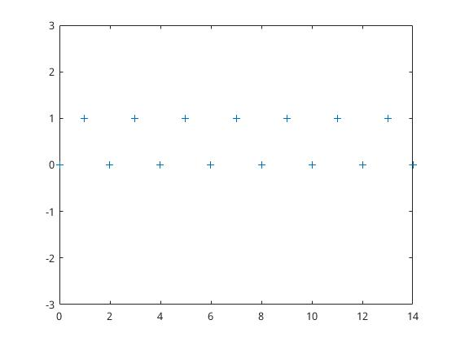
第一章
%Code:
n = 0:14;

#x = [1];

x(1:15) = 1;

y = [0];

e = [];

e(1) = x(1) - y(1);

for i = 2:15,

y(i) = e(i-1);

e(i) = x(i) - y(i);

end

y

plot(n,y,'+');

ylim([-3,3]);
%Code:
n = 0:14;

x = [1];

x(2:15) = 0;

y = [0];

e = [];

e(1) = x(1) - y(1);

for i = 2:15,

y(i) = e(i-1);

e(i) = x(i) - y(i);

end

y

plot(n,y,'+');

ylim([-3,3]);

第二章
无

