Problem set #3
- The swap() function is not thread safe. The function does not guarantee mutual exclusion. Multiple threads can execute the function and access global variables and shared data which can result in undefined behavior.
- Swap is not reentrant because it uses a global variable temp which may be changed during the interrupt. The function also accepts pointers y and z whose dereferenced values are changed in the function. This alters the state of the program outside the function which is not a characteristic of reentrant code.
- In the first Readers/Writers solution, starvation can happen if multiple readers arrive sequentially. The third Readers/Writers solution solves this problem with the readBlock. The readBlock in the writer function blocks any readers from acquiring the wrt lock. The writers will not starve because the write function will only block when there are readers pending.
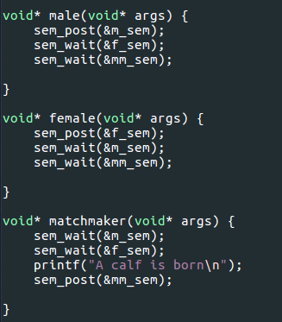

5.
