Programming Assignment 4:
Investigating the Linux Scheduler
CSCI 3753 – Operating Systems
Professor Chris Womack
Lucas Dachman

- Abstract
- Introduction
- Method
- Results
- Analysis
- Conclusion
- References
- Appendix a: Raw Data
- Appendix b: Code
1. Abstract
The goal of this experiment was to test the behaviors of different process scheduling algorithms. The three shceduling policies used were SCHED_OTHER(CFS), SCHED_FIFO(RT) and SCHED_RR(RT). The tests were run on three program types; An IO bound program which reads random data from /dev/urandom and writes it to /dev/null, a CPU bound program which statistically calculates pi, and a mixed program which calculates pi and writes it to /dev/null.

2. Introduction
Tests were done using the C programming language and a bit of bash scripting. Some of the libraries used were sched.h, sys/wait.h, sys/resource.h and sys/time.h. These standard libraries are used to collect data about each individual process.

2.1 Test System
Output of ‘lscpu’
Architecture: x86_64
CPU op-mode(s): 32-bit, 64-bit
Byte Order: Little Endian
CPU(s): 8
On-line CPU(s) list: 0-7
Thread(s) per core: 2
Core(s) per socket: 4
Socket(s): 1
NUMA node(s): 1
Vendor ID: GenuineIntel
CPU family: 6
Model: 60
Model name: Intel(R) Core(TM) i7-4710HQ CPU @ 2.50GHz
Stepping: 3
CPU MHz: 3100.000
CPU max MHz: 3500.0000
CPU min MHz: 800.0000
BogoMIPS: 4988.83
Virtualization: VT-x
L1d cache: 32K
L1i cache: 32K
L2 cache: 256K
L3 cache: 6144K
NUMA node0 CPU(s): 0-7

3. Method (Experiment Design):
3.1 Files:
- calc_pi.c: A CPU bound program that uses a statistical method to calculate pi across specified iterations. I used the default number of iterations, 1,000,000, for all tests.
- rw.c: An IO bound program that reads bytes into a buffer and writes the data out to a file. The input and output files used were /dev/urandom and /dev/null, respectively.
- rwpi.c: A program that is a mix of CPU and IO bound. The program calculates pi using the same method as calc_pi.c and writes out to a file. In this case the output file was /dev/null. This program also uses the same size buffer as rw.c and the same number of iterations as in calc_pi.c.
- shed_test.c: This is the parent program. The three important functions are runIOBound(), runCPUBound() and runMixed(). Each function spawns a specified number of children with vfork(). Each child process simply executes the corresponding program using exec(). The parent process reaps the children using wait3() and acquires CPU data through the rusage struct. This data is printed out to a specified output file. System time, user time, number of voluntary context switches and number of involuntary context switches for each individual process are summed here. After all children processes have finished, the program writes the data out to the bottom of the output file in the form of a table.
- run_benchmarks.sh: This script has two tasks. First, launch ‘./sched_test’ with different scheduling policies and process counts. Then, compile the data from the different sched_test.c output files into a single file called ‘table-data’.
- Makefile: compiles C files.

3.2 Summary:
run_benchmarks.sh runs ‘./sched_test’ nine times, each with a different scheduling policy and number of processes. The bash script creates nine different output files; each containing data for all three program types (CPU bound, IO bound and mixed). The script then compiles this data into a final data file called table_data. Table data contains data for all 27 cases.
The 27 cases are as follows:

IO bound SHED_OTHER, 100 processes
CPU bound SHED_OTHER, 100 processes
Mixed SHED_OTHER, 100 processes

IO bound SHED_OTHER, 1000 processes
CPU bound SHED_OTHER, 1000 processes
Mixed SHED_OTHER, 1000 processes

IO bound SHED_OTHER, 10000 processes
CPU bound SHED_OTHER, 10000 processes
Mixed SHED_OTHER, 10000 processes

IO bound SHED_FIFO, 100 processes
CPU bound SHED_FIFO, 100 processes
Mixed SHED_FIFO, 100 processes

IO bound SHED_FIFO, 1000 processes
CPU bound SHED_FIFO, 1000 processes
Mixed SHED_FIFO, 1000 processes

IO bound SHED_FIFO, 10000 processes
CPU bound SHED_FIFO, 10000 processes
Mixed SHED_FIFO, 10000 processes

IO bound SHED_RR, 100 processes
CPU bound SHED_RR, 100 processes
Mixed SHED_RR, 100 processes

IO bound SHED_RR, 1000 processes
CPU bound SHED_RR, 1000 processes
Mixed SHED_RR, 1000 processes

IO bound SHED_RR, 10000 processes
CPU bound SHED_RR, 10000 processes
Mixed SHED_RR, 10000 processes

The table_data file contains nine tables, each containing the following data for all three program types: system time, user time, total time (system+user), average time, voluntary context switches, average voluntary context switches, involuntary context switches and average involuntary context switches. Data for each program type can be compared side by side.

4. Results:
Average Process Time (100 Processes)
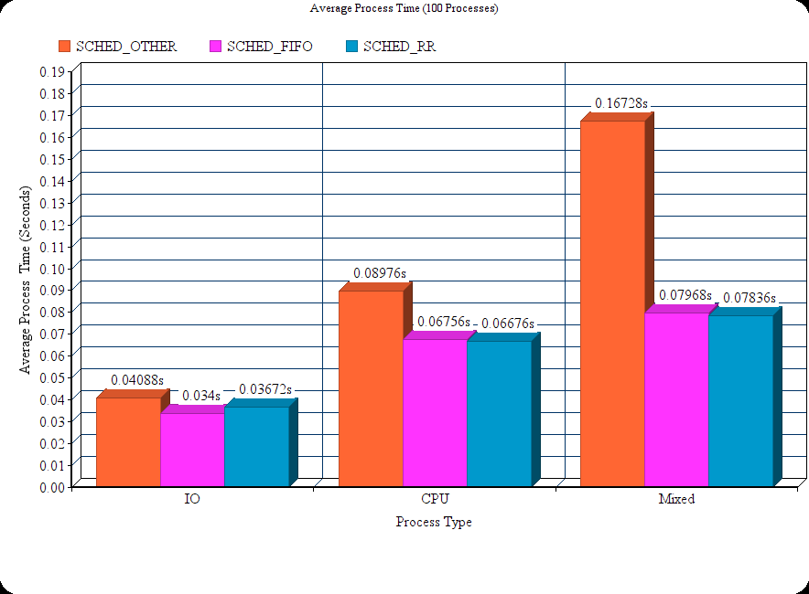

Average Process Time (1,000 Processes)
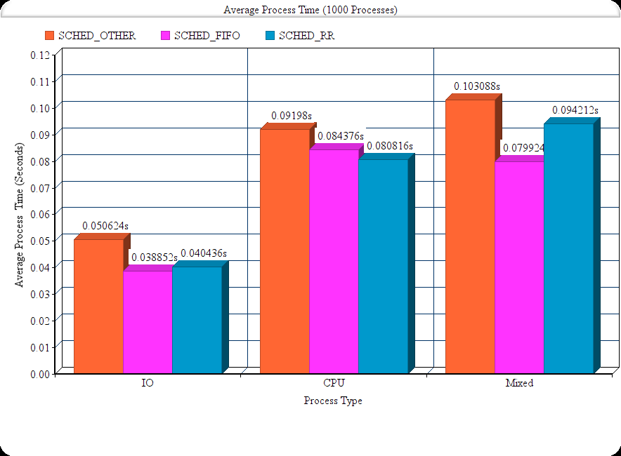

Average Process Time (10,000 Processes)

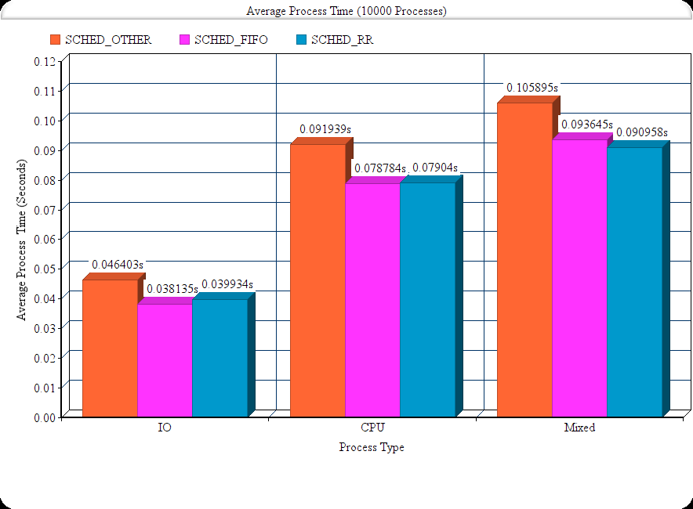

Average Context Switches (100 Processes)
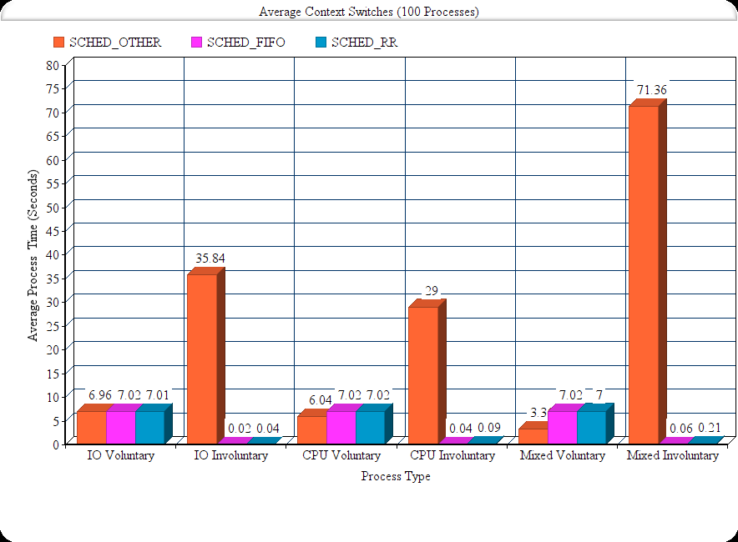

Average Context Switches (1,000 Processes)
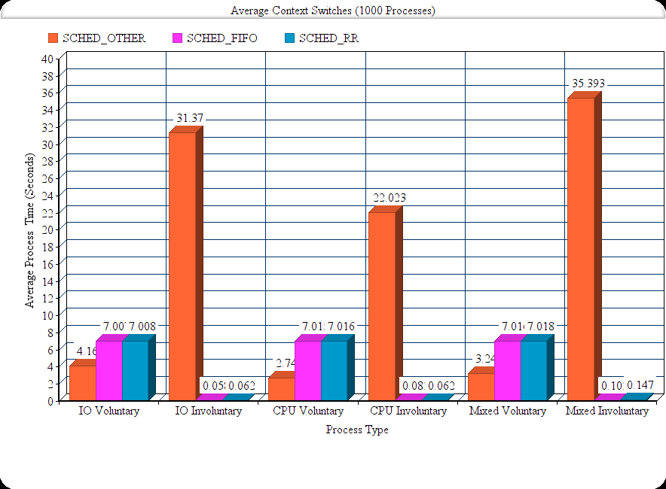

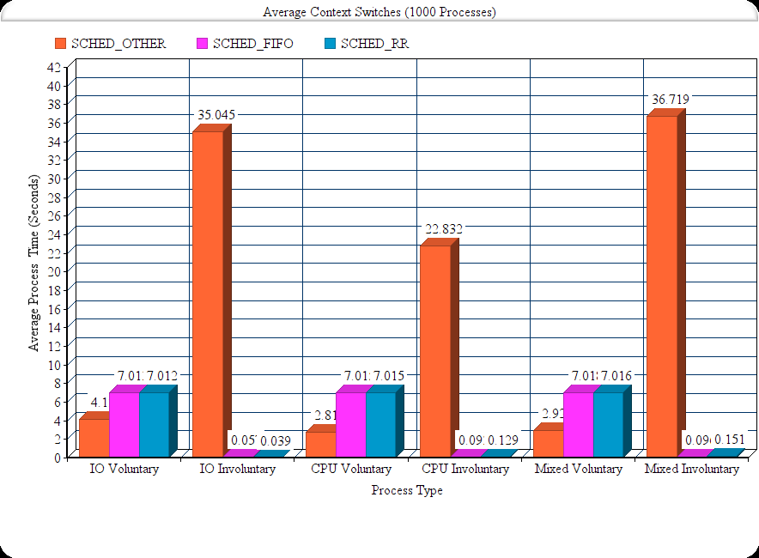
Average Context Switches (10,000 Processes)

5. Analysis:
The Completely Fair Scheduler (SCHED_OTHER) always takes the most time. This is because it causes more context switches. Processes run with SCHED_FIFO and SCHED_RR always have very similar durations. IO bound processes typically finish fastest with SCHED_FIFO. CPU bound processes typically have shortest duration when run with SCHED_RR. However, theses durations are very similar to those of CPU bound processes run with SCHED_FIFO. There is no clear winner for best scheduling policy for mixed processes. SCHED_OTHER causes the longest durations but SCHED_FIFO and SCHED_RR typically have very similar durations.

6. Conclusion:
Processes that use SCHED_FIFO and SCHED_RR policies always have shorter durations than those that use SCHED_OTHER. This makes theses policies more suited for real time systems. The drawback of these policies is that they cause high response and turnaround time and low throughput. On the other hand, processes using the SCHED_OTHER policy have low response and turnaround time and high throughput. This makes this policy better suited for interactive processes.

7. References:
Operating System Concepts, Silberchatz
man7.org

8. Appendix a: Raw Data
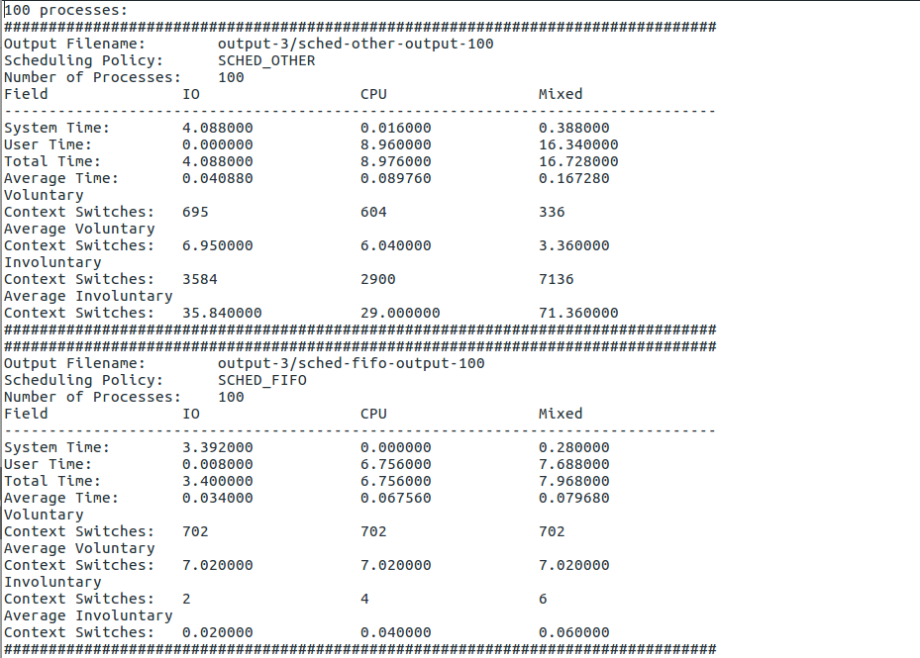
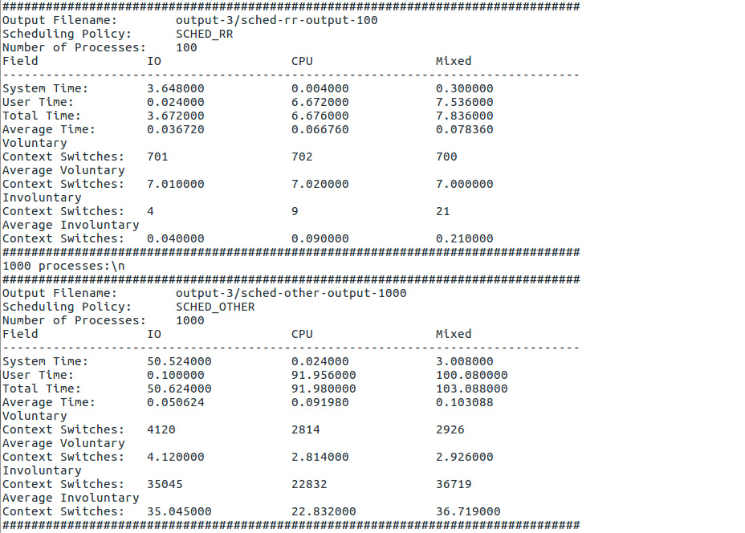
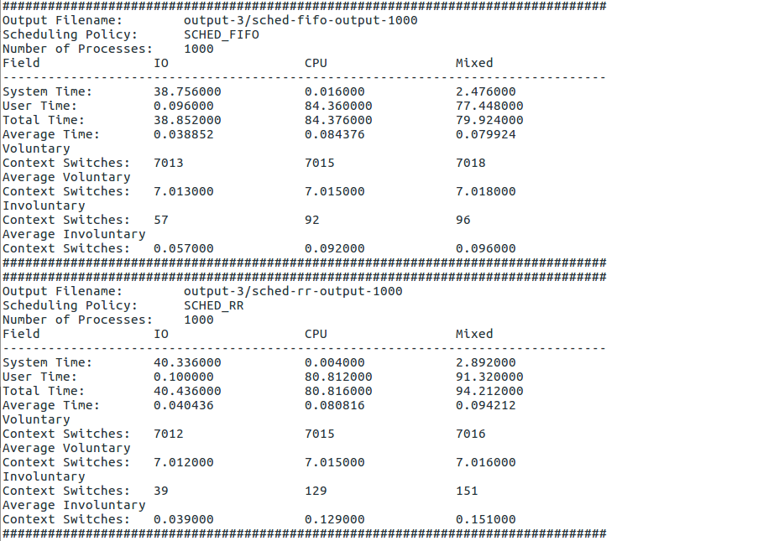

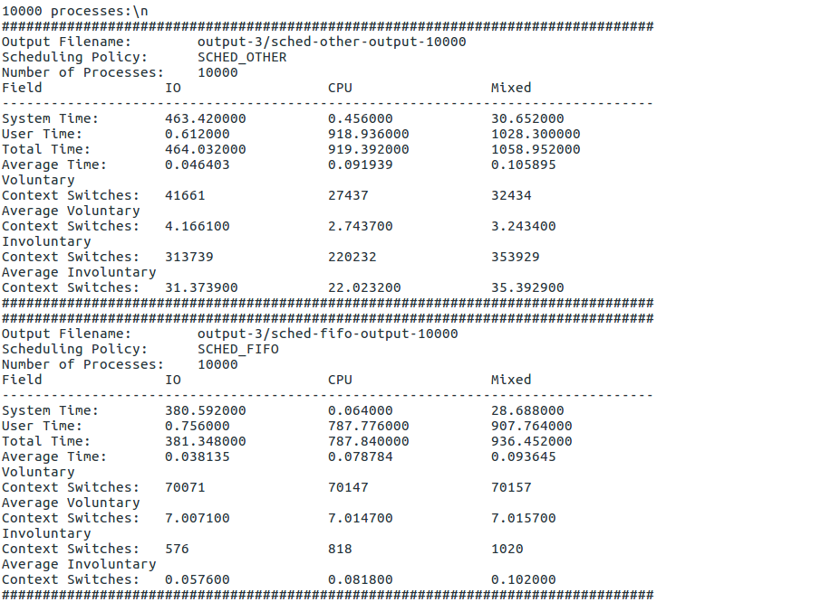

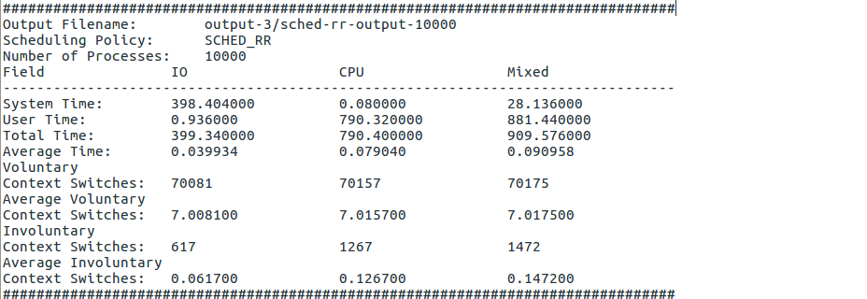

9. Appendix b: All Code
All code can be found in this directory. Check the README for more information on compiling and running the code.

