Homework 8: Prime Factorization

This program uses Pollard’s Rho Algorithm to find prime factors p and q such that p*q=N where N is composite. Pollard’s Rho Algorithm uses the fact that the probability of picking two equal random numbers from a list of t random numbers from 1 to N is 50% if t > 1.177N^{1/2}. This is known as the Birthday Problem. Similarly, we will have the same probability of finding two numbers who’s difference is a factor of N. More generally, GCD(x₁ - x₂, N) = p. The algorithm uses a pseudo random sequence, f(x) = x*x + seed mod N where the seed changes when a cycle has been detected. The program uses Floyd’s cycle-finding algorithm to detect repetition. On each loop, a is set to f(a) and b is set to f(f(a). when f(a) = f(f(a), a cycle has been detected and the seed in f(x) is changed. The random numbers are generated by picking a random number from 0 to 9 and inserting the number as a character in a string. I used this method because
Observations
The time for completion is variable due to the fact that the algorithm uses random numbers.

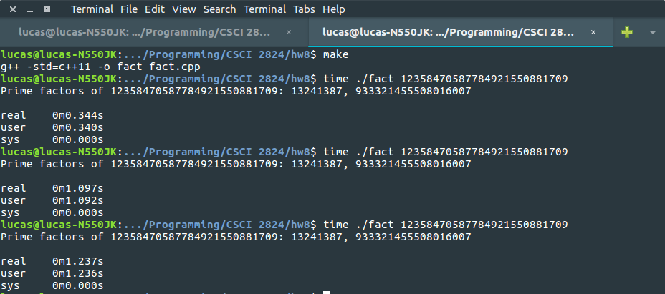How To Run
First compile with ‘make’. Then run ‘./fact <number>’. Running ‘./fact’ with no arguments outputs a usage message.

