Log in
As a guest user
I want to log in to my profile
So that I can publish my academic resources and interact with the ones already available

Wireframe
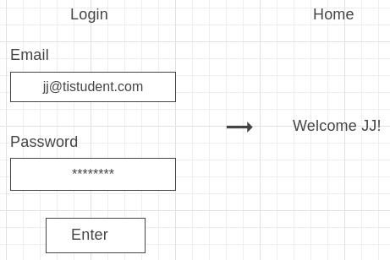

Acceptance criteria
- A guest user can log in in to their profile with the login form by email and password
- After logging in the user is redirected to the homepage where the user will be welcomed by username

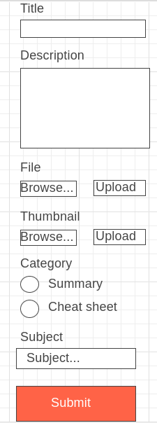
Create resource
As a user
I want to post an academic resource
So that others can use it to study

Wireframe: ->

Acceptance criteria
- A form to add a resource:
  - Title input (max 60 chars)
  - Description input (max 500 chars)
  - Radio input to select category
  - Dropdown menu to select subject
  - File upload
  - Thumbnail upload

- Everything except thumbnail is required
- The user has to be logged in
- After creating the resource, it is added to the resources overview

Get resources
As a user
I want to get an overview of all resources
So that I can see which resources are available

Wireframe

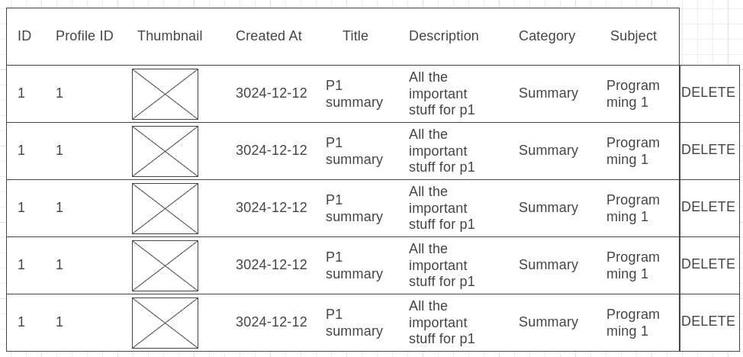
Acceptance criteria
- Table overview of all resources is displayed
- Row has these columns: Resource ID, Profile ID, Thumbnail, Created At, Title, Description, Category, Subject
- For ADMIN users there is an extra column DELETE to remove the resource

