tiStudent


A platform for students to share academic resources
Table of Contents
Description 3
User stories 3
Academic resources complete overview 3
Wireframe 3
Acceptance criteria 3
Feed overview 4
Wireframe 4
Acceptance criteria 4
Filter resources 5
Wireframe 5
Acceptance criteria 5
Resource interaction 6
Wireframe 6
Acceptance criteria 6
Login 7
Wireframe 7
Acceptance criteria 7
Add resource 8
Wireframe 8
Acceptance criteria 8
Account settings 9
Wireframe 9
Acceptance criteria 9
Domain model 10
Entity Relationship Diagram 11

Description
tiStudent will be a platform where students can share, like, comment and publish academic resources.

User stories

Academic resources complete overview
As a user
I’m able to get a list of academic resources
So that I can see which academic resources are available

Wireframe
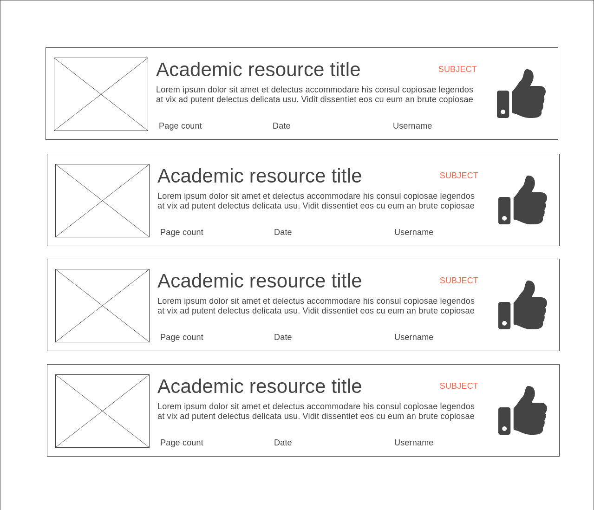

Acceptance criteria
- List of academic resources is displayed
- Each academic resource is labeled by subject
- When there are no academic resources, display “No academic resources exist”

Feed overview
As a user
I want to be able to have an overview of the latest updates in newly shared academic resources
So that I can stay up to date and have access to the latest summaries, cheat sheets, etc.

Wireframe
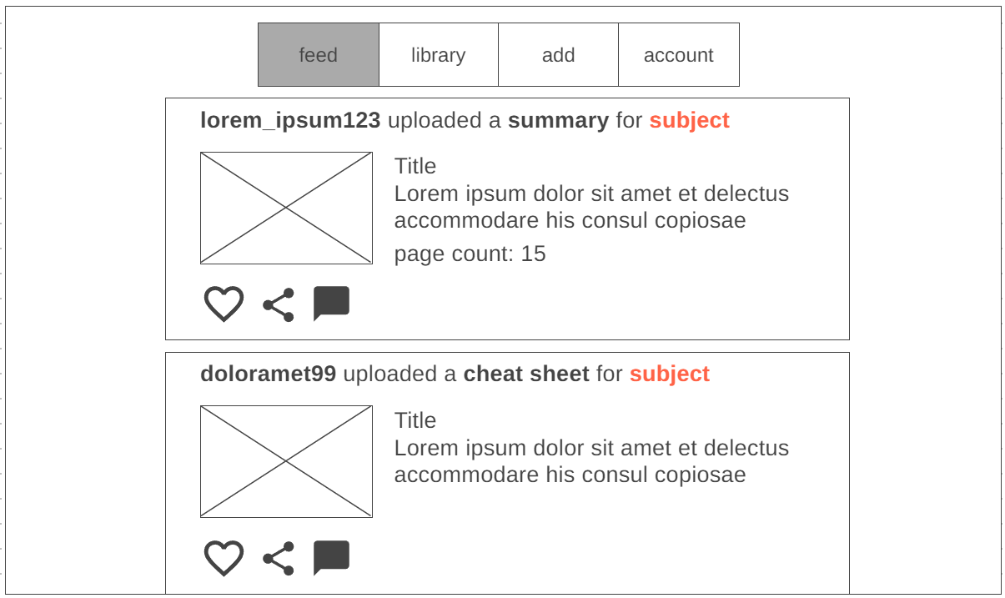

Acceptance criteria
- Feed updates whenever someone uploads a new resource
- Resource contains: thumbnail, username, category, subject, title, (description), likes and page count
- Option to like resource
- Option to share
- Option to comment

Filter resources
As a user
I want to be able to filter all the academic resources
So that I can find exactly what I’m looking for

Wireframe
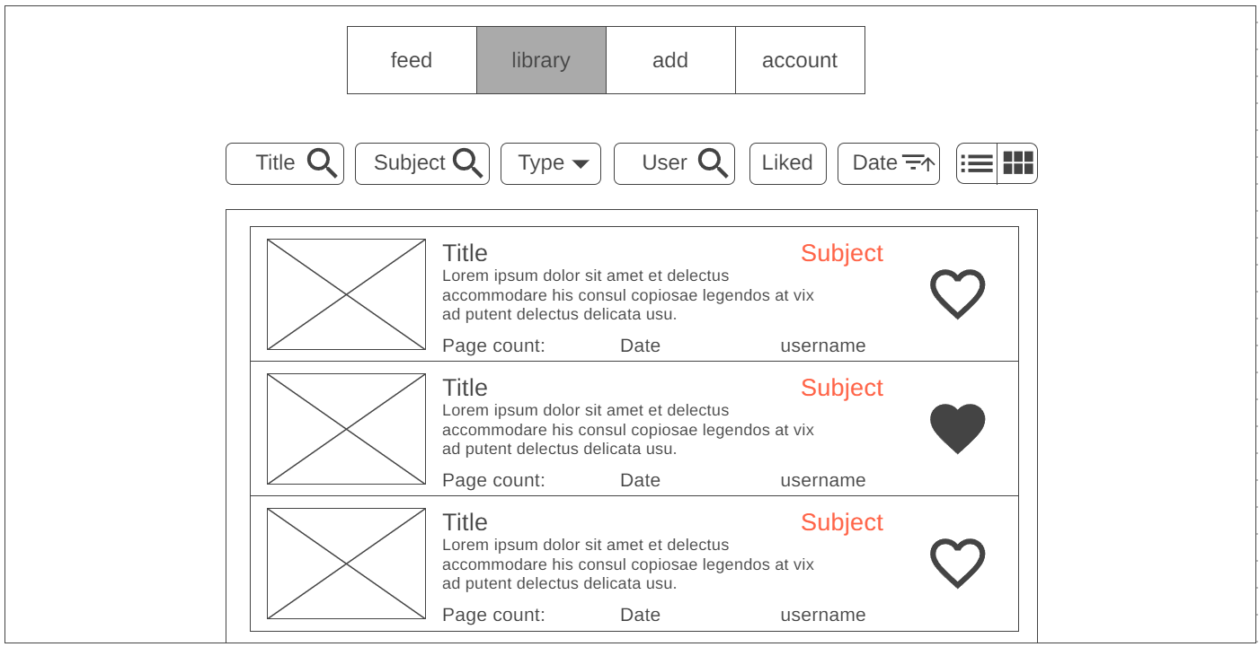

Acceptance criteria
Filter on:
- Title: searches for a specific resource with a name
- Subject: gets all the resources for a specific subject
- Type: finds all resources of a specific type
- User: selects all resources published by a certain user
- Liked: shows all resources you have liked
Sort by:
- Date: descending or ascending
- Display: list or block

Resource interaction
As a registered user
I want to be able to interact with a resource
So that I can ask a question, thank the author, download the resource, etc.

Wireframe
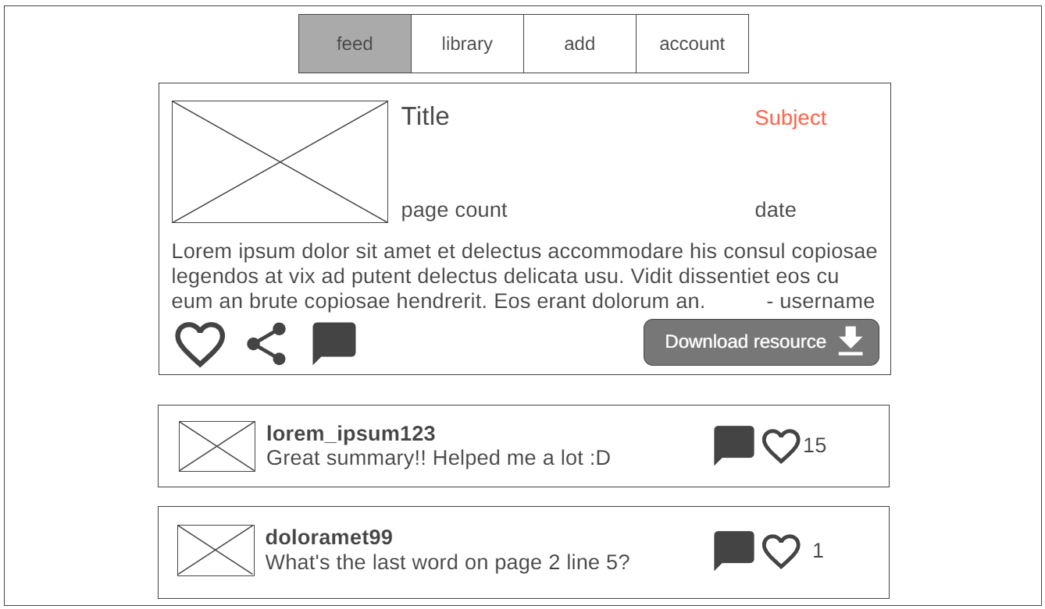

Acceptance criteria
- Users can like, share and comment on a post
- Users can comment on comments to help people if they have a question
- Users can download the resource

Login
As a guest
I want to be able to log into an account
So that I can like, comment and publish academic resources

Wireframe
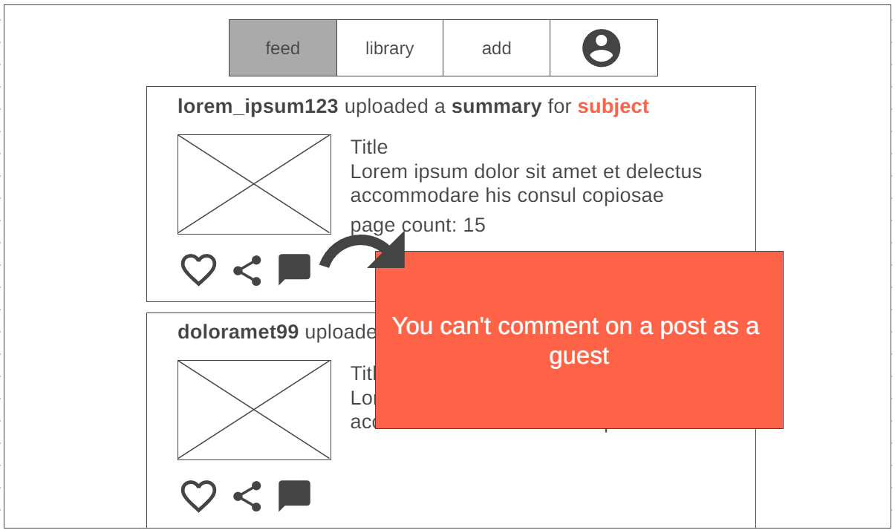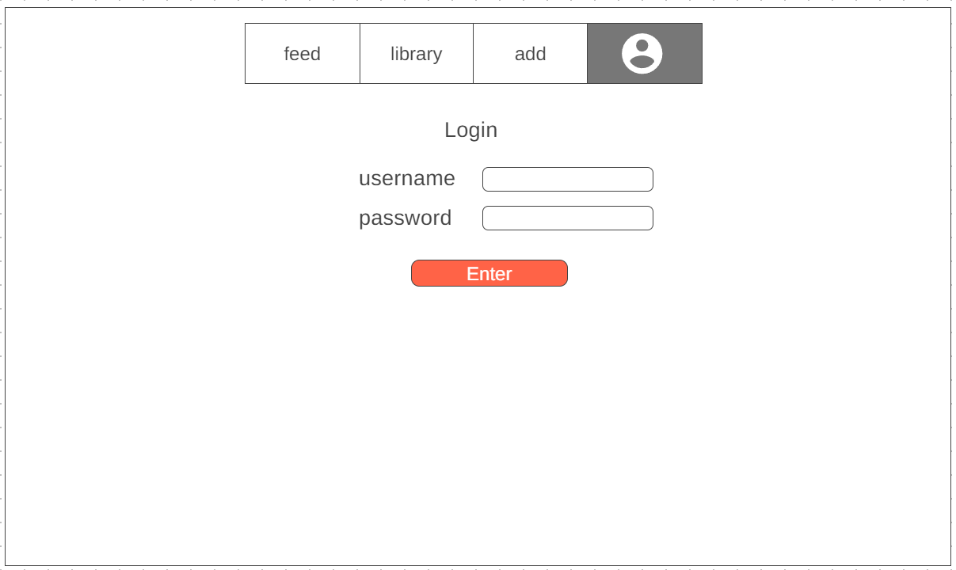

Acceptance criteria
- A guest user can look at and browse through posts.
- A guest user can’t comment or like posts
- A guest user can’t create posts
- A guest user can login to their account with the login form
- For a guest user, instead of “account” the last box in the navigation shows an account logo to remind them they are not logged in

Add resource
As a user
I want to be able to add my personal academic resources (summaries, cheat sheets, etc.)
So that others can use them to study

Wireframe
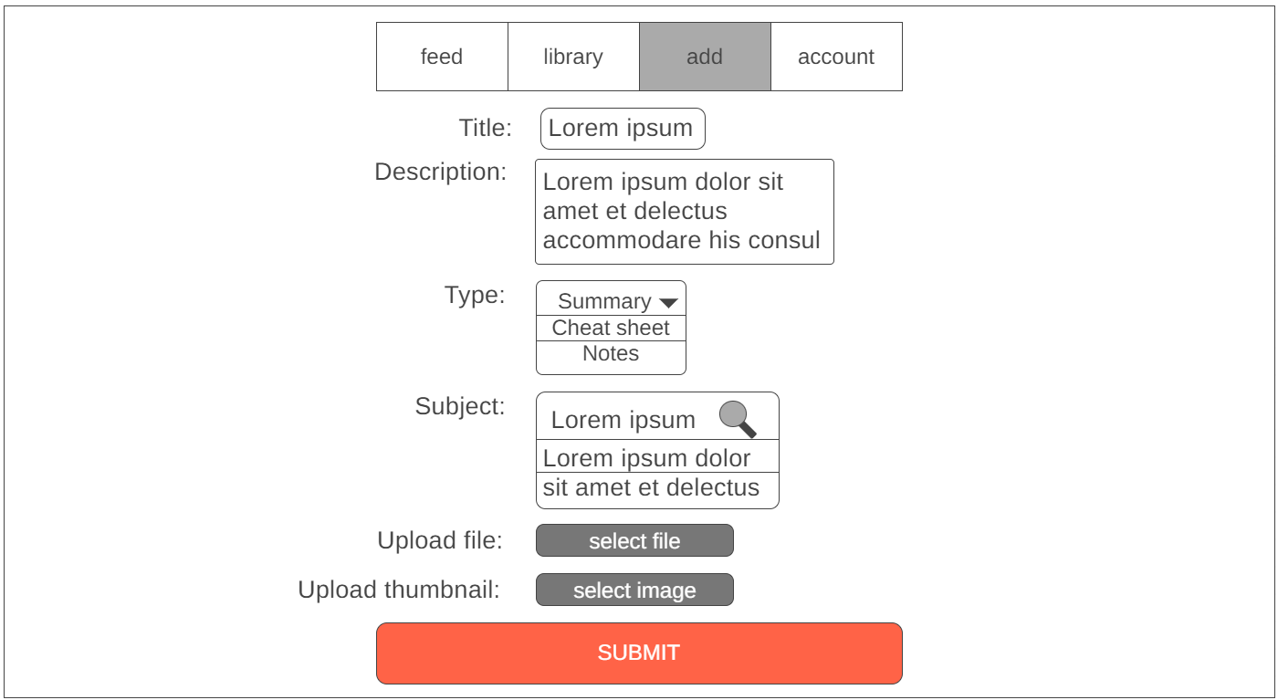

Acceptance criteria
- A form to add a resource:
  - Form fields for text to add title, description
  - A filter dropdown menu to select subject
  - A normal dropdown menu to select resource type
  - Buttons to upload files
- The same file can’t be added twice
- Thumbnail is not required
- The user needs an account in order to upload
- After adding you are directed to your feed

Account settings
As a registered user
I want to have control over my account settings
So that I can personalize my experience and manage my account effectively.

Wireframe
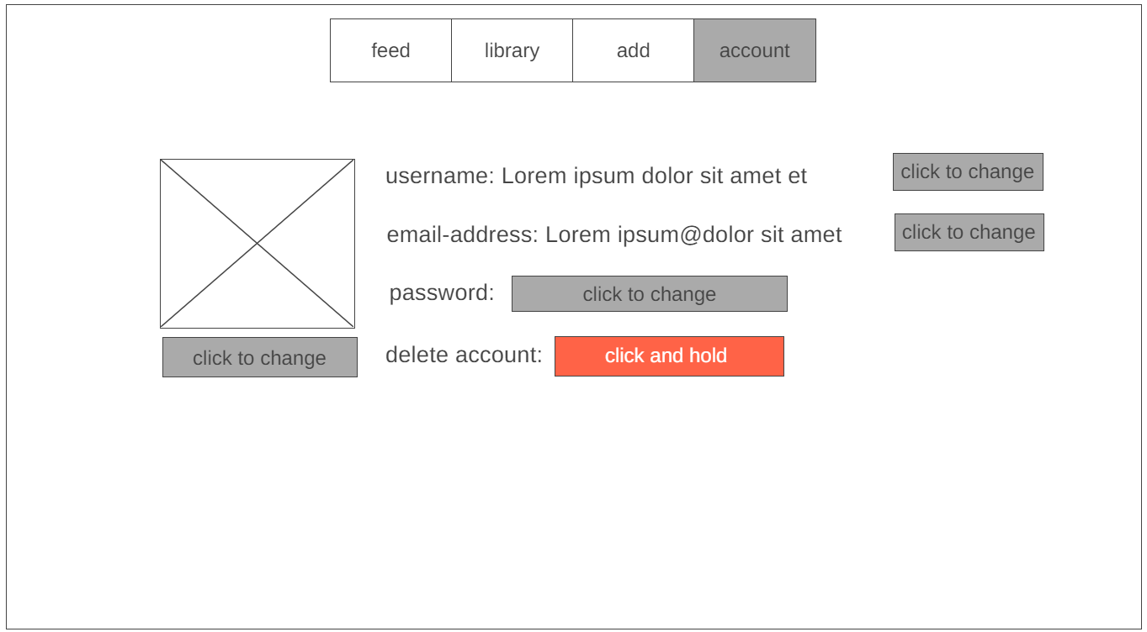

Acceptance criteria
- When logged in user can control his account and settings
- Profile Picture:
  - I should be able to upload or change my profile picture.
  - The uploaded picture should be displayed in my account profile.
- Account information:
  - I should be able to edit my account information, including my name and email address.
  - Changes to account information should be saved and reflected in my profile.
- Deletion:
  - I should be able to delete my account.
  - Account deletion should result in permanent removal of my data.

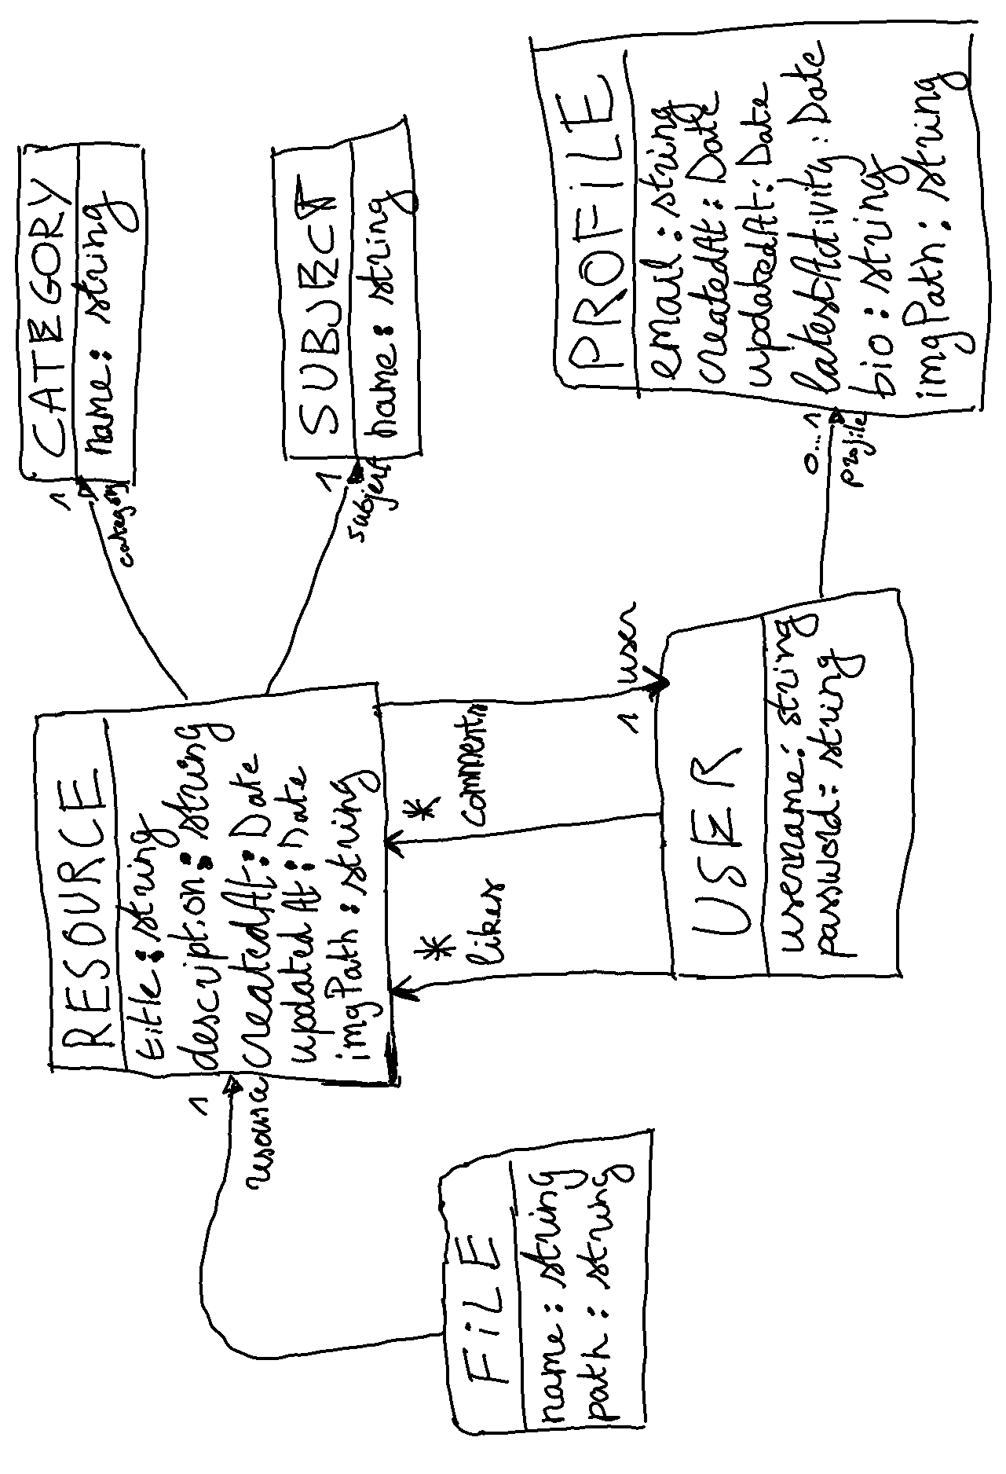
Domain model

Entity Relationship Diagram
