CS 474 Image Processing
Assignment 1 – Report
Lucas Davis

Theory:

Image Sampling
Sub-sampling an image involves reducing the resolution of an image by selecting only a subset of its original pixels.
To take a subsample of an image, we can follow this formula:

Where subN and subM are the rows and columns of the original image that have been reduced by a defined factor.
To map the image back to the original size we can use Bilinear Interpolation. This function fits the four closest neighbors. It can be calculated by the following function.

Where a, b, c, and d are the four closest neighbors to the point x, y.

Image Quantization
Quantization is a process in digital image processing that involves reducing the shades of gray in an image. The process involves mapping each pixel's original intensity value to one of the new intensity levels. Uniform quantization, where the intensity range is divided into equal intervals, and each interval is represented by a single intensity value.
To change the Quantization level of an image, we can use the following formula:

Where is the size of each quantization interval,

Q is the quantization levels of the original image, Levels is the reduced quantization level that we want the image to have (ie, 128, 32, 8 and 2), X is the pixel intensity of the original image .

Histogram Equalization
Histogram Equalization increases the global contrast of images. This method is useful in images with background and foregrounds that are both bright or both dark.
To calculate Histogram Equalization for a given image, we first need to generate the histogram of the the original image by recording the occurrence of each gray level in the image. Once we have that, we can calculate the probability of occurrence of intensity level

With this, we can calculate the Cumulative Distribution Function (CDF)

With the CDF we can get the levels of s by

Once we have the intensity values of the new image. We can index into that array by using the original pixel intensity and set that value to the image.

Results and Discussion:

Image Sampling
After taking the subsample of the original images of “Lenna” and “Peppers,” I got the following images:
For Lenna:
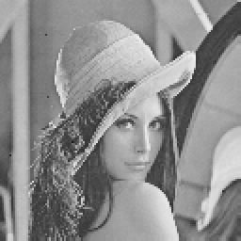
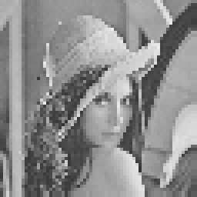
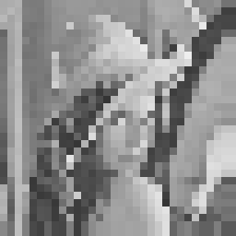
Lenna SubSampled By 2 Lenna SubSampled By 4 Lenna SubSampled By 8
For Peppers:
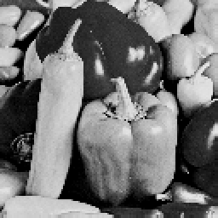
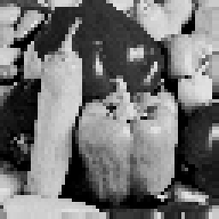
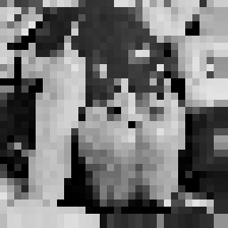
Peppers SubSampled By 2 Peppers SubSampled By 4 Peppers SubSampled By 8
As we can see from the results above, the higher the factor you subsample an image by, the more pixelated the image becomes. These results are expected because we are reducing the number of samples in the original image as we increase the factor. This would intuitively result in a more and more pixelated image.

Image Quantization
After reducing the grey-levels of the “Lenna” and “Peppers” images, I got the following:
For Lenna:
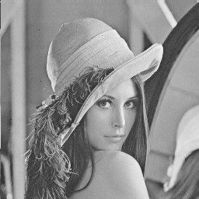
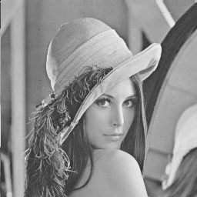
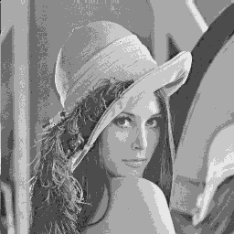
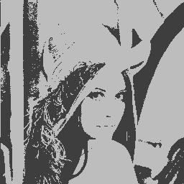

128 Gray Levels 32 Gray Levels 8 Gray Levels 2 Gray Levels
For Peppers:
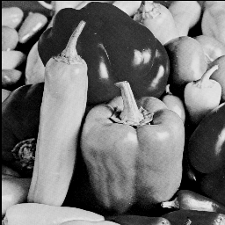
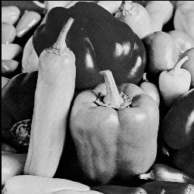
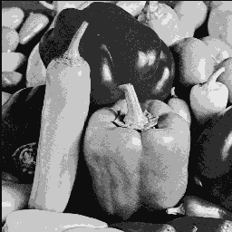
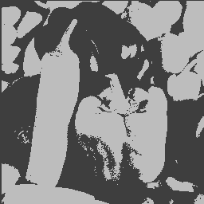

128 Gray Levels 32 Grey Levels 8 Gray Levels 2 Gray Levels
As we reduce the number of gray values in these images, we don’t really see any different between the original, 128, and the 32 gray images. You begin to see some differences at the 8 gray level image, though it is slight. At 2 gray levels, we see a dramatic difference since there is only two values a pixel can be.

Histogram Equalization

For Boat:
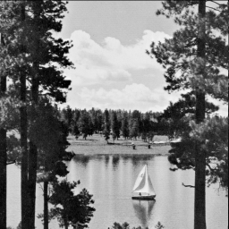
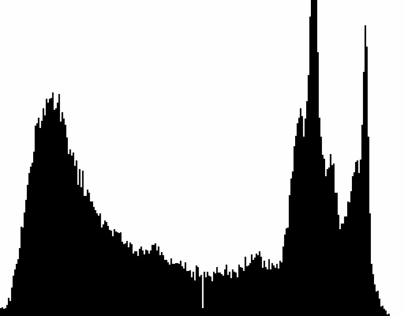

Boat: Before Equalization Boat Histogram
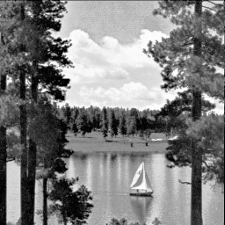
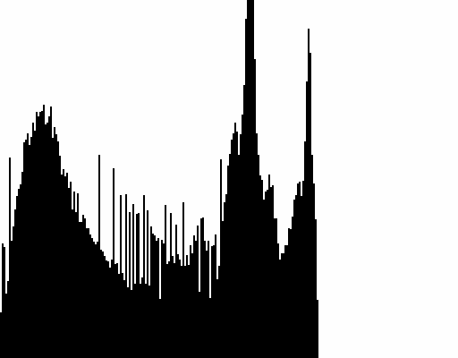

Boat: After Equalization Boat Equalization Histogram
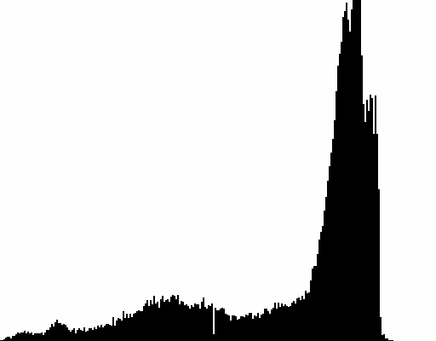
For F_16
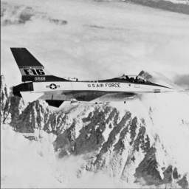

F_16: Before Equalization Boat Histogram

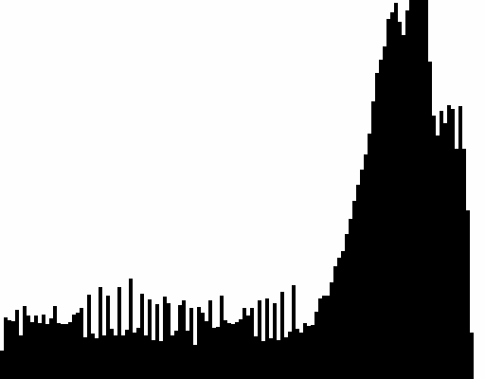
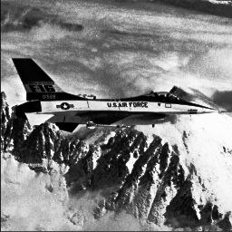

F_16: After Equalization F_16 Equalization Histogram
For the Boat image, there isn’t much difference between the before and after image. The leaves have a bit more detail and so does the clouds. However, with the F_16 image, there is a major difference. There is a lot more contrast in the after picture. You can see more details in the clouds, the plane is more pronounced.

Code
The code for this assignment is broken into three header files, and one controller. The ImageType class is the one provided to us by the teacher. A histogram class, which is used to store the histogram data for the Histogram equalization method; it also contains a method to write the histogram as a pgm image. And the ImageProcessing class, which holds the methods for each question.

