**Post_Lab1**

**Shikai Shen**

Lab Results:

1. Oscilloscope screenshot showing the complementary PWM waveforms with 50% duty ratio

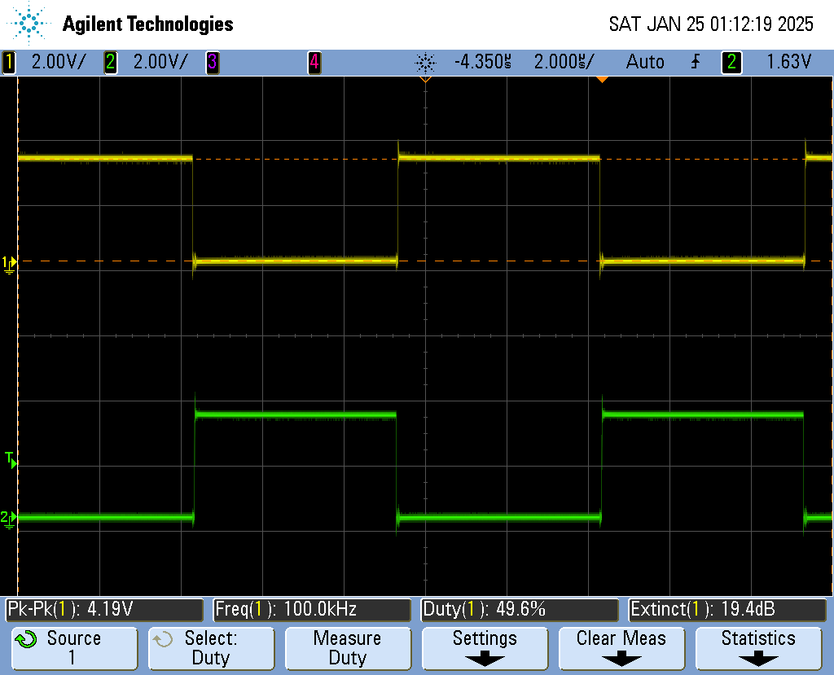

1. Code showing how duty_cmp set in the CCS debugger changes the EPWM CMPA register and oscilloscope screenshot.





oscilloscope screenshot showing a duty ratio different from 50%:

(Below is the duty cycle of 20%)

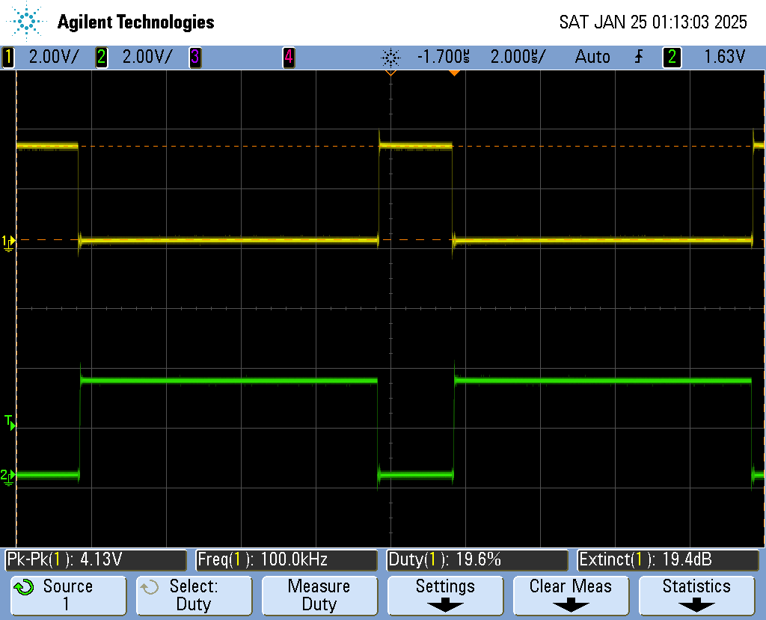

1. Code showing how duty set in the CCS debugger changes the EPWM CMPA register.





Code that clearly shows the implementation of the saturation function

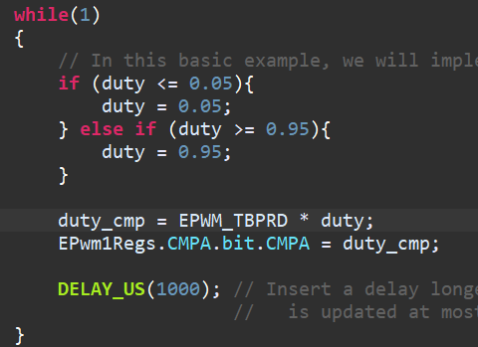

Lab Takeaways:

1. In a short paragraph of your own words, describe how to solder through hole components, check their connections, and remove them.

First insert the solder into the appropriate holes on the PCB board. When the components are placed at proper position, use soldering iron to touch solder strand in the joint area with the hole. When the tin is heated to flow evenly to form a shiny and cone-shaped connection, soldering is done. As for checking the connections, we can get two short-circuited points and test its connectivity by testing its resistance, which should be below 1ohm. As for removing them, we have to use soldering wick. When we put soldering iron on the wick, it will absorb the melting tin on the components, which can allow the components to be pulled out gently.

1. In a short paragraph of your own words, describe how to solder surface mount components, inspect their connections, and remove them.

We use solder paste to help connecting surface mount, when solder paste melts, it will be automatically connected to the metal nearby, to the surface mount components. We use heat gun to help melt the solder paste and let it cool down to immobilize the components. Inspection: the same as above. Removing them would also need heat gun, change temperature to about 400 Degree Celsius and use tweezer to gently shake it until the component can be removed.

1. Describe the concerns associated with choosing how much solder paste to use on a pad. What happens as a result of too much or too little solder paste?

Too much: pins may get connected because of extra solder paste, leading to short-circuited between pins of IC.

Too little: not enough paste would lead to virtual welding, connectivity not good.

1. When removing components, why is it important to wait until the component can be “nudged” before taking it off the board?

Otherwise, any violent movement can damage the board.

1. In your own words, describe how analog pulse width modulation is implemented using a comparator. You may include a figure to aid your description.

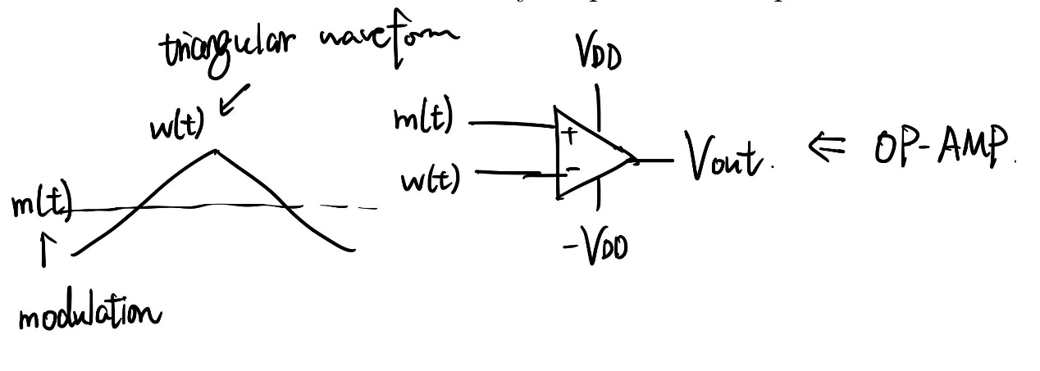

We would use an OP-AMP to compare the modulation and the carrier signal, normally, in the connection mode above, when m(t) is larger than w(t), the PWM waveform amplitude is positive, otherwise it’s negative.

1. In your own words, contrast the three types of carriers that can be used. What effect do they have on the switching waveform?

Leading edge carrier, trailing edge carrier and triangular carrier (dual edge carrier). Leading edge carrier has a rapid rising edge, which requires quick transitions but can introduce ripples and distortions. Trailing edge has a rapid falling edge, which also requires quick transitions. These two ways would lead to unbalanced rising and falling time, which we might not want to see (except for some special requirement).

Triangular waveform: balanced rising and falling time. This approach is typically used for symmetrical switching and reduces harmonic distortion and can stabilize the PWM waveform by reducing some distortions.

1. How does digital PWM differ from analog PWM? What are the relevant registers that must be configured in the C2000 to generate a PWM waveform, and how do they relate to each other?

Digital PWM is achieved by settings multiple levels of output voltage, and the level of which is stored in EPWM_Regx in C2000. The register can store the level of the output voltage and finally tell the ADC or digital output pin to send out adjacent voltage levels to mimic a seemingly continuous output.

Analog PWM uses analog circuits like OP-AMP and oscillators to generate the signal, which is less flexible and susceptible to some of disturbance.

Lab Takeaways:

1. Describe the tradeoffs associated with choosing a soldering iron temperature.

High temperature: faster heating and melting of solder, better joint flow **vs** overheating and damaging components on PCB.

1. Describe the tradeoffs associated with choosing a hot air gun temperature, air flow rate, and distance from the board. How do these choices affect how long it takes for solder to liquefy?

High temperature: faster solder liquefaction vs overheating and damage.

High air flow: quickly heating over larger area, faster liquefaction vs blowing away small components.

Closer distance: faster heating transfer and liquefaction vs overheating and uneven heat distribution.

1. What happens to the digital PWM carrier as the PWM clock frequency is reduced? For a fixed switching frequency, how does this affect the maximum value of the digital PWM counter (i.e TBPRD)? How might this affect a power converter controller?

When PWM clock frequency is reduced, Ts increases, TBPRD increases. But EPWM_Regx has finite levels of output voltage, with TBPRD increasing, which can lead to digital PWM carrier wave staying at each voltage level longer and digital carrier becomes more discrete.

Lower clock frequency can also lead to slower updating and response to dynamic changes, which challenges high-frequency converter controls.

1. Under what operating conditions can analog and digital PWM be considered nearly identical?

When digital PWM resolution is high enough, the output waveform can closely mimic the analog PWM. This occurs when digital PWM counter is large.

Post-Lab time: ~1.5hours.