Computer control using hand gesture

Recognition

Student: Lucas Evans
Candidate number: 6505
Center number: 12290
Contents
Analysis 1
Project Background 1
Interview 1
Requirements 2
Essential requirements: 2
Non-essential requirements: 3
Framerate calculations: 3
Existing solutions: 3
GestIA: 3
Myo Mouse: 3
Tutorials: 4
Research: 4
First paper – Human Computer Interaction using Hand Gesture: 4
Second Paper – A real-time Hand Gesture Recognition and Human-Computer Interaction System: 4
Third paper – Vision-Based Interpretation of Hand Gestures for Remote Control of a Computer Mouse: 5
Decisions made after research: 5
Design: 5
Gui Design: 6
Start Program: 6
Main loop flowchart: 6
Main loop data flow diagram: 8
Thread 0 class: 8
Grab frame pseudocode: 9
Thread 1 class: 9
Find pseudocode: 10
Normalise flowchart and dry run: 10
Normalise pseudocode: 11
Thread 2 Class: 12
Neural network architecture: 12
Thread 3 Class: 13
Label_to_func construction pseudocode: 14
Run pseudocode: 14
Move mouse flowchart: 14
Calc coord pseudocode: 14
Move mouse pseudocode: 15
Execute gesture flowchart: 15
Executing a gesture: 15
Queue logic: 16
Mainloop Runner Class: 16
General function pseudocode: 17
Config: 17
Class: 18
Config.json: 18
18
Label_to_str.json: 18
File structure: 19
Save as pseudocode: 19
Save pseudocode: 19
Load pseudocode: 19
Adding gestures 20
Flowchart 21
Retrain method 21
CSV class: 23
Prepare data flowchart 23
Gesture Adder Class: 24
GUI: 25
Windows: 26
GUI class diagram: 26
Start pseudocode: 27
Add new gesture pseudocode: 27
Save config as pseudocode: 27
Load config pseudocode: 28
Edit config pseudocode: 28
Reset method: 28
Technical Solution 28
Development log 28
Day 1 28
Day 2 29
Day 3 31
Day 4 33
Day 5 36
Data generation idea: 39
Change to hand_finder.py 40
Neural network architecture changes: 42
Day 6: 44
Day 7 47
Day 8: 50
Day 9: 53
Hand identification logic discovery: 53
Boolean logic for determining whether to run: 53
Day 10: 55
Day 11 61
Day 12 61
Changes to mainloop_runner.py: 62
Changes to gui.py: 62
Completed project: 62
Camera.py: 62
Hand_finder.py: 63
Model.py: 65
Commander.py: 67
Funcs.py: 69
Config.py: 71
Mainloop_runner.py: 73
CSV_handle.py: 75
Gesture_adder.py: 76
GUI_edit_config.py: 78
GUI_run_edit_config.py: 80
GUI.py: 80
Main.py: 84
Testing 84
Testing Log 84
Day 1 84
Camera FPS test 84
Camera function test 85
Day 2 86
Handfinder working test 86
Handfinder time test 87
Day 3 89
Add_row test: 89
Prepare_data test 90
Model Retrain updates bar test 91
Day 4: 92
Model accuracy test: 92
Day 5: 93
Config test: 93
Day 6: 95
Commander test: 95
Day 7: 95
Day 8: 97
Performance issue with commander: 97
Issue with model accuracy: 97
Day 9 98
Webcam issue discovered during final testing: 98
Final testing 98
Issue with calling functions 98
Testing against requirements 100
Evaluation 104
Evaluation against requirements 104
Essential requirements 105
Must grab frames from the client’s webcam 105
Must identify each gesture accurately to where the user doesn’t notice an incorrect classification 105
Must translate gestures into a keyboard or mouse command 105
Must move the mouse depending on where the hand is 105
Must have a GUI 105
Must have a gesture to deactivate the program 105
Must be able to change which command each gesture is bound to 105
Must be able to save/load configuration files in the GUI 105
Must be able to open an on-screen keyboard 105
Must run at a smooth framerate 106
Non-essential requirements 106
Must have the ability to add extra gestures 106
Have the GUI be easy to use 106
Report errors if the user incorrectly uses the GUI 106
Client and user feedback 106
Positive feedback 106
Potential improvements 106
Overall evaluation 107
Demonstration video 107
References 107

Analysis

Project Background
My client, Sami Nakmouch, often uses his computer by using his TV as a display. Since he uses a TV, the sofa which he sits on to use it, is quite far from the display and the computer. So, he needs to run cables from the keyboard and mouse to the computer. He finds having to constantly keep the keyboard and mouse around him quite annoying, and often when he has guests over, they trip over the cables.
However, he does have a 720p, 30FPS webcam. My proposed solution is to use that webcam to feed frames into an AI, that identifies where his hands are, and recognises which gesture he is making. It then uses this information to move the mouse, and perform keyboard and mouse commands for him, without him having to touch any hardware.
Below I have an interview with my client, which I will use to fully scope the requirements.

Interview

What hardware do you have available to use?
Answer: I have a webcam on each computer
How powerful are the computer(s) you plan to use this with?
Answer: I have a gaming laptop and a gaming pc and an apple macbook
How far do want to be from the computer with the program working?
Answer: 3m
Do you want the program to work with just keyboard inputs, or mouse as well?
Answer: I want it to work with both of them
Would you rather the program have buttons, or just type commands in?
Answer: Buttons
Do you want to deactivate the program through a button, or have a gesture to do that?
Answer: I want to have a gesture that I come up with
I assume you want to be able to change what control each gesture will correspond to?
Answer: yes
So would you like to have the ability to save and load those settings?
Answer: yes
How many gestures do you want the program to be able to identify?
Answer: 7
In case that isn’t enough, do you want the ability to add your own gestures?
Answer: I might want it if its not enough
How important is performance to you, as in how smooth does it have to be?
Answer: performance is very important so it has to be very smooth
Are there any more features you think the program needs?
Answer: Add a keyboard to the screen when activated so you can type words with the program

Requirements

Essential requirements:
- Must grab frames from client’s webcam
- Must identify what gesture each hand is making accurately enough to where the user doesn’t notice incorrect classification very frequently, an inaccuracy should be considered a rare occurrence
- Must translate the gesture(s) into a keyboard or mouse command
- Must calculate an appropriate mouse position given the hand’s position, and move the mouse there
- Must have a GUI
- Must have a gesture to deactivate the program
- Must be able to change what command each gesture corresponds to
- Must be able to save/load configuration files from within the GUI
- Must be able to activate an on-screen keyboard
- Run at a framerate good enough to seem smooth. For 24FPS, if everything is done , processing one frame must take at most 8.375 MS (calculation can be found bel sequentially ow). If done in parallel, it can take up to 33.3 MS, as the webcam grabs frames at 30fps

Non-essential requirements:
- Have the ability to add extra gestures in case the user runs out
- Have the GUI be easy to use (if not I will provide a README containing all the information on how to use it)
- Report errors to the user when they incorrectly use the GUI

Framerate calculations:
- 30 FPS has frames take 33.33333 MS [1]
- 24 FPS (minimum for smooth perceived motion) has frames take 41.70838 MS [1]
- Frametime for 24FPS – frametime for 30FPS gives maximum amount of time processing a frame can take
- 41.70838 – 33.33333 = 8.37505

Existing solutions:

GestIA:
GestIA is a program that detects hand gestures and translates them into keyboard inputs. Which keyboard inputs are used can be customized by the user. However, it only supports 6 different gestures, and has no support for mouse movement or buttons.
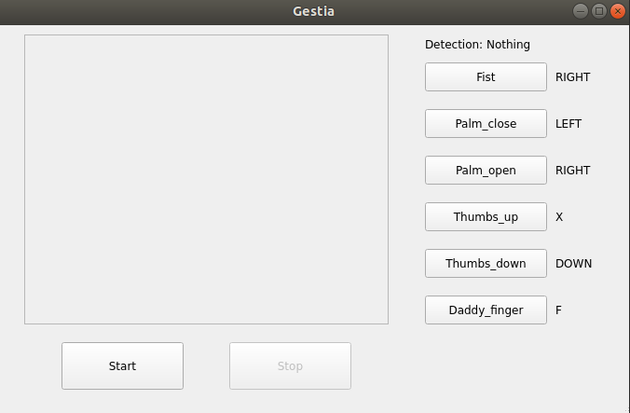
As seen from this screenshot of the GUI, it also has limited features, in that configurations cannot be saved, so my client would have to change all the settings before using it each time.
All of these factors make GestIA inferior to my product when in it’s completed form. [2]

Myo Mouse:
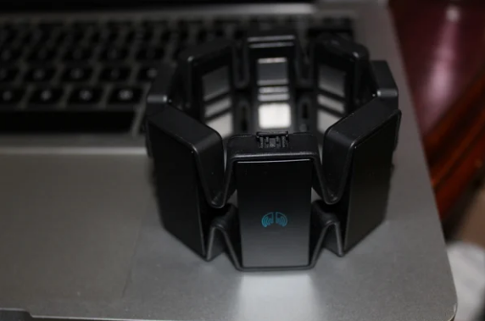
The Myo Mouse is a physical device that measures the motion of your arm and hand, classifies the movement, and communicates with the computer via a USB dongle to translate the movement into a command. [3]
Unlike the previous product, this does allow for mouse control. However, it only supports 5 gestures. Furthermore, the website of the manufacturer raises an error when trying to purchase it, and the only other place it can be found is for £1,000 on eBay, making this an unviable option. [4]

Tutorials:
Multiple tutorials exist on how to implement the basic functionality of hand gesture recognition and translating it into computer inputs. However, they all require a decent amount of coding ability, but my client has none, and so it would be unviable for him to try and use one of these. They also don’t implement as much functionality, and sometimes require extra hardware, e.g. Arduinos.

Research:

First paper – Human Computer Interaction using Hand Gesture:
This paper initially looked promising, as it uses a very computationally inexpensive way of classifying hand gestures. It uses skin colour detection techniques to identify where the hand is and uses morphological processes to remove noise. It then extracts different attributes of the detected objects and counts how many there are after processing. It uses this to determine which gesture it has detected. However, when the researchers tested it, some gestures would be at up to 100% accuracy, however some would be significantly below, the lowest they recorded at 52% recognition rate. This is not sufficient for my purposes, and so I will look at other approaches. [5]

Second Paper – A real-time Hand Gesture Recognition and Human-Computer Interaction System:
This paper uses 2 steps in order to locate and classify the hand. Firstly, the researchers use multiple preprocessing techniques such as background subtracting, filtering, gaussian blurring, morphological transformations, and contour extractions to create a binary image where everything but the hand is black. This is then fed into a CNN classifier which outputs a label for the gesture, and coordinates for an estimate of the centre of the hand.
This method results in correct classification 98.8% of the time. However, it took 20,000 epochs to learn this at a 128x128 image size, which suggests that training for a 1280x720 image size may take quite a long time. Additionally, only one of my client’s computers has a DGPU, and so running a CNN could cause a very large performance hit, making it not smooth enough to use. [6]

Third paper – Vision-Based Interpretation of Hand Gestures for Remote Control of a Computer Mouse:
This paper detects what gesture the hand is making and it’s location by finding different parts of the hand in each frame, including the fingertips, and the hand centroid.
It discusses a useful method of avoiding errors due to noise, which is that the system must detect the same gesture for a minimum amount of time (set to 0.5 seconds by the researchers), before it is executed.
It also discusses ways of calculating mouse cursor coordinates. It uses the hand centroid to calculate the position as it isn’t susceptible to noise due to finger movements. However, as it cannot be easily located when the hand is near the image borders, strips along the borders are excluded, and the rest is mapped onto the computer desktop. [7]

Decisions made after research:
The third paper looked the most promising in terms of performance and usefulness, so I will be taking their approach of identifying different parts of the hand and will use their methods of calculating the mouse cursor position.
To do this, I found that the Google MediaPipe API has a library for detecting 21 hand landmarks. [8] I will use this to identify the location of parts of the hand, then feed this into a simple feedforward neural network for the gesture classification.
Once the landmarks are extracted, I still need a way of classifying the hand gesture. The first paper uses a CNN classifier to go straight from the image to a gesture, however, once the landmarks are extracted, there is no need for the convolutional layers as they only help extract data that can be anywhere in an image, but the data is already extracted. Therefore, I can still keep the feed forward layers as the landmark extractor can effectively replace the convolutional layers. This is why to complete the classification I will use a feed forward neural network (FFNN)
Using MediaPipe [8] means that I have to use python as my programming language. As I know the OpenCV [9], PyTorch [10], Tkinter [11], and PyAutoGUI [12] frameworks, I will use them for video capture, the AI, the GUI, and inputting commands to the computer, respectively.

Design:

Gui Design:
Here is my wireframe for the main page that the user will see:
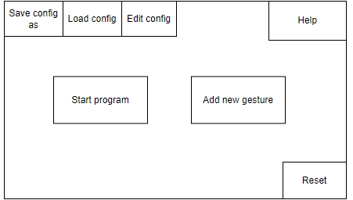
An overview of what each of the buttons will do:
- ‘Start program’: Starts the main function of the program, the gesture recognition, and controlling the computer through it.
- ‘Add new gesture’: Opens a window that allows the user to create a new gesture and will retrain the neural network.
- ‘Save config as’: Allows the user to save the current config under a new Json file.
- ‘Load config’: Opens a file explorer window that allows the user to select a file to be loaded as the new config.
- ‘Edit config’: Opens a window with all the various settings the program requires, allowing the user to change them and save them.
- ‘Help’: Opens a .txt file that contains all the necessary information on how to operate the program.
- ‘Reset’: Resets all the settings to their default. All the settings will be stored in separate Json files that won’t ever be overwritten by the program.

Start Program:
The start program button will call the program’s main loop

Main loop flowchart:
The below flowchart shows how the main functionality of the program works. Frames are grabbed from the camera, and landmarks are detected. The mediapipe tool only detects one hand, which is why only 0 and 1 are options for how many hands are detected. The landmarks are then normalised. These are passed through the feed forward neural network (FFNN). The mouse position is calculated and the mouse is moved there. If exactly the last 10 gestures are the same, it is executed, and added the to the list of previous gestures.
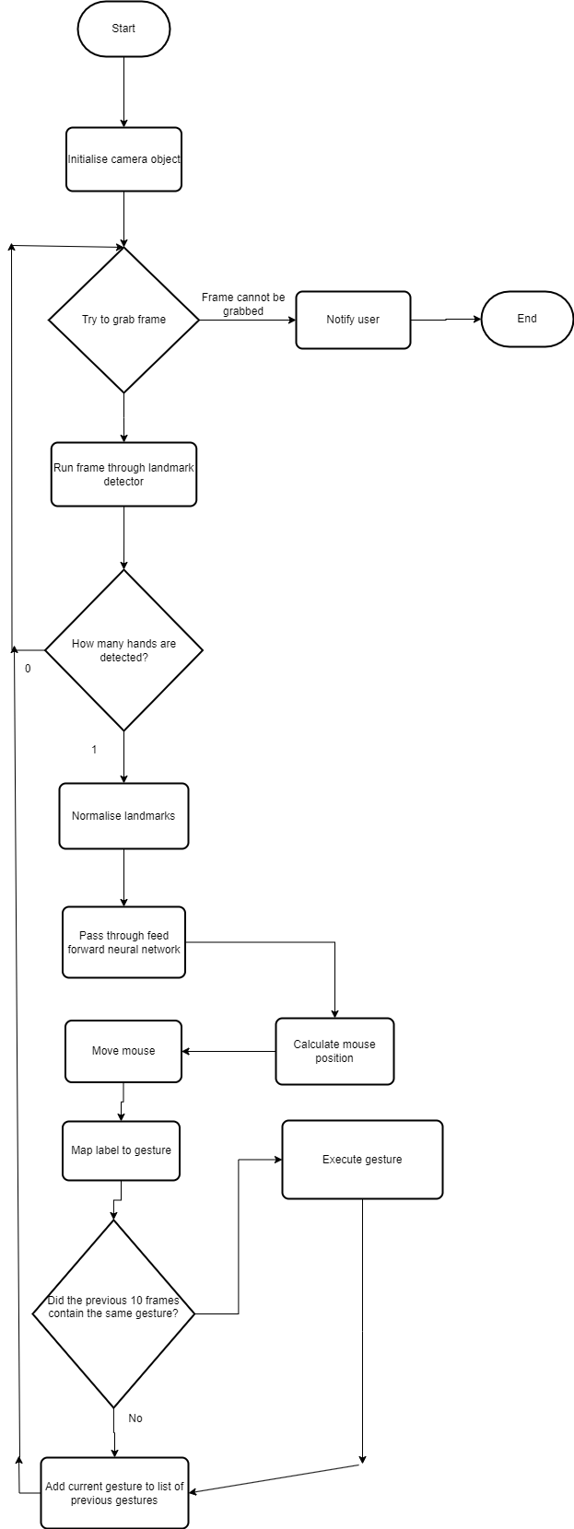

Main loop data flow diagram:
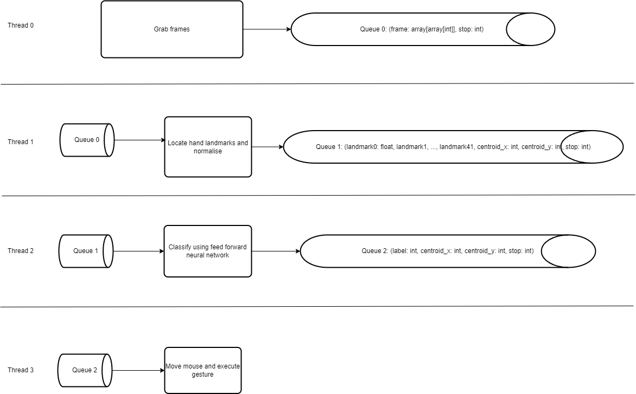
I have decided to split the execution of the main loop into multiple parallel threads. This is because according to the Google docs for the MediaPipe hand landmarker, the CPU latency was 17.12MS [19], which doesn’t give much execution time for the rest of the program. I went with this design choice to avoid performance issues.
Each thread will place the result of its execution into the next queue. Python has in built queues designed for parallel processing with thread safety, which is what I will use to implement the queues.
The integer ‘stop’ is passed at the end of each queue element, as thread 0 is what detects if the user has pressed ‘esc’ or used the corresponding gesture to terminate the program. Without passing the information that this has happened to the other threads, they won’t know to stop execution. Passing on this variable allows all threads to be terminated. It will take the value of 0 if the program executes correctly, 1 if the user terminated the program, or 2 connecting to the camera failed
Since each thread operates independently of each other, I decided to create a class that contains all the code that each thread needs to execute.

Thread 0 class:
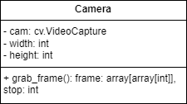
The ‘cam’ attribute is an object from the OpenCV library that enables getting data from a webcam. The grab_frame() method will return the next frame, and if the program should be stopped, through the value of ‘stop’. The ‘width’ and ‘height’ object have their values stored in the config, and represent the width and height of webcam.

Grab frame pseudocode:
METHOD grab_frame(self: Camera):
return_val, frame = self.cam.read()
stop = 0

if esc IS PRESSED:
stop = 1
else if return_val == FALSE:
stop = 2
return frame, stop
END METHOD

This pseudocode performs the functions as described above.

Thread 1 class:
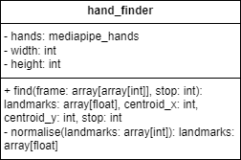
The ‘hands’ attribute is an instance of the class provided by mediapipe for hand landmark identification. The find() method will extract the landmarks, normalise them and extract the centroid. The ‘width’ and ‘height’ attributes are the width and height of the webcam, and are found in the config.
This diagram is provided by the Google docs [8] to show what landmarks the mediapipe hand landmark detector detects:
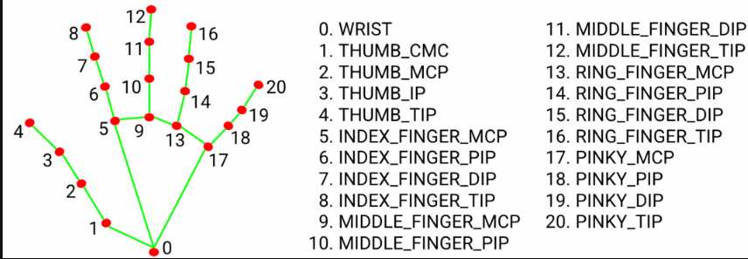
[8]
The landmark that is closest to the centre of the hand is the MIDDLE_FINGER_MCP, and it won’t be affected by finger movements, so gesture change shouldn’t move the mouse.

Find pseudocode:
METHOD find(self: HandFinder, frame: array[array[int]], stop: int):
landmarks = self.hands.process(frame)
landmarks = list(landmarks)

norm_landmarks = self.normalise(landmarks)

centroid_x, centroid_y = landmarks[9]

norm_landmarks = flatten(norm_landmarks)

return norm_landmarks, centroid_x, centroid_y, stop
END METHOD

Note: the flatten() function will convert a 2d array e.g. [[1, 2], [3, 4]] into a 1d array e.g. [1, 2, 3, 4]

Normalise flowchart and dry run:
Here is the flowchart for the normalisation algorithm I devised. The mediapipe tool returns x values between 0 and the display width, and y values between 0 and the display height. My normalisation algorithm converts them to values between 0 and 1. Below is the flowchart for it.
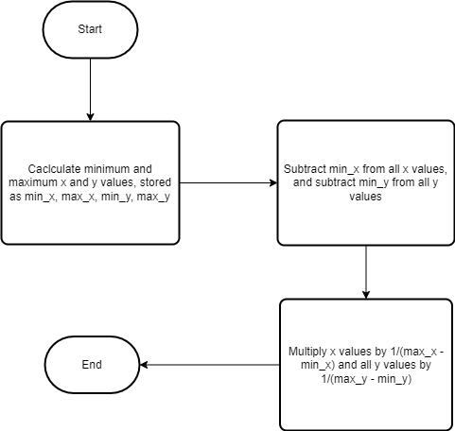

Below is a dry run of the algorithm on a list of 4 landmarks. During the dry run I realised that it could be converted into matrix operations, which would make the implementation easier. This is included under the dry run.

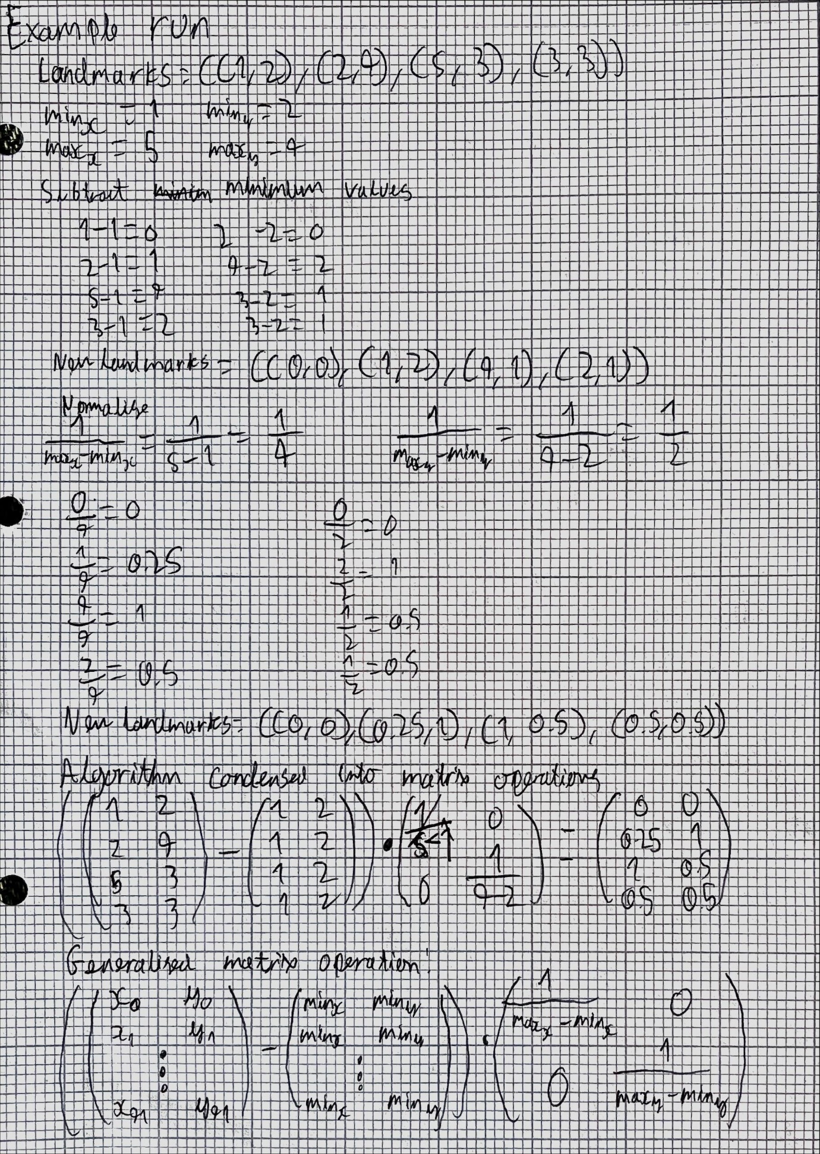

Normalise pseudocode:
METHOD normalise(self: HandFinder, landmarks: array[array[int]]):
x_arr = [landmarks[i][0] for i in range(42)]
y_arr = [landmarks[i][1] for i in range(42)]

x_min, x_max = min(x_arr), max(x_max)
y_min, y_max = min(y_arr), max(y_arr)

scale_matrix = [[1 / (x_max – x_min), 0], [0, 1 / (y_max – y_min)]]

return matmul(landmarks – [x_min, y_min], scale_matrix)
END METHOD

Thread 2 Class:
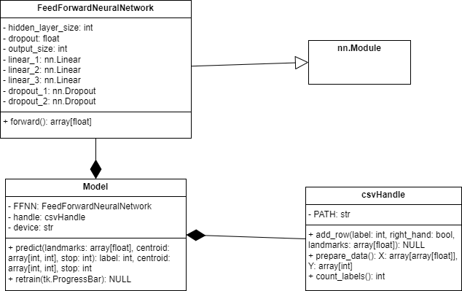
This thread requires multiple classes to function. The FeedForwardNeuralNetwork class contains the neural network that will classify gestures. Since I am using the PyTorch library, it must inherit from nn.Module to have access to all the necessary attributes and methods. [12]
The Model class contains both the neural network, and an object to interact with the csv file (csvHandle), and the ‘device’ attribute. ‘Device’ is an attribute acquired from the config, and tells the Model whether the neural network should be ran/trained on the CPU or GPU.
The retrain() method and the csvHandle class will be covered later in the design, as it is relevant to adding new gestures, and isn’t used in the main loop.

Neural network architecture:
Below is a drawn description of what my initial idea for the neural network architecture will be. However, this may change during the initial training if it turns out not to be suitable.
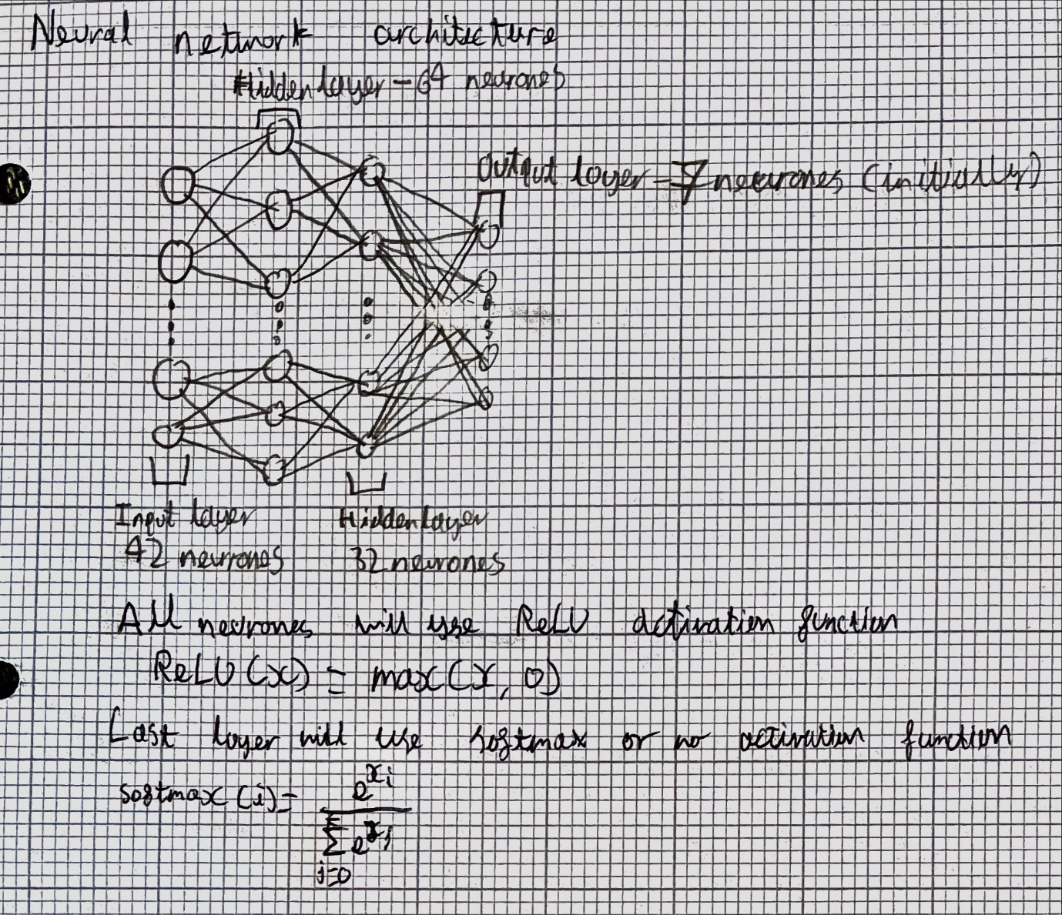
Due to the neural network being of fixed size once trained, all attributes of FeedForwardNeuralNetwork will be hard coded constants.

Thread 3 Class:
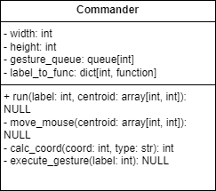
As with the other classes, ‘width’ and ‘height’ refer to the width and height of the webcam and are stored in the config. ‘gesture_queue’ is used in the execute_gesture() method to ensure that gestures are only executed when held for long enough, and are not executed twice. The calc_coord() method is used to prevent repetition in the move_mouse() method.
The run() method will call both move_mouse() and execute_gesture().
The ‘label_to_func’ attribute is constructed from the config files, which contain a map from integer labels to a string, which maps to a function.

Label_to_func construction pseudocode:
METHOD str_to_func(config_path: str):
config = Config()
config.load(config_path)
label_to_str = config.json_dict[‘label_to_button’]
label_to_func = dictionary()

map = dictionary that maps from string to desired function
label_to_func = {int(label): map[label_to_str[label]]}
return label_to_func
END METHOD

Run pseudocode:
METHOD run(self: Commander, label: int, centroid: array[int, int]):
self.move_mouse(centroid)
self.execute_gesture(label)
END METHOD

Move mouse flowchart:
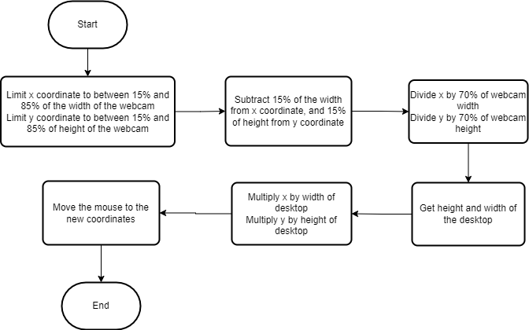
This algorithm uses a method described in one of the research papers, of removing the issues that occur when the hand is in the extremities of the webcam by removing strips on the top, bottom, left and right of it. I have chosen 15% arbitrarily, as it seems reasonable, but may change depending on what happens during testing.

Calc coord pseudocode:
METHOD calc_coord(self: Commander, coord: int, type: str):
if type == ‘x’:
webcam_dim = self.width
screen_dim = get_screen_size()[0]
else:
webcam_dim = self.height
screen_dim = get_screen_size()[1]

coord = max(coord, 0.15 * webcam_dim)
coord = min(coord, 0.85 * webcam_dim)

coord -= 0.15 * webcam_dim
coord /= 0.7 * webcam_dim

coord = int(coord * screen_dim)
return coord
END METHOD
Note: the get_screen_size() function is a placeholder for a method from the PyAutoGUI library that gets screen dimensions. [13]

Move mouse pseudocode:
METHOD move_mouse(self: Commander, centroid: array[int, int]):
x, y = centroid

x = self.calc_coord(x, ‘x’)
y = self.cal_coord(y, ‘y’)

move_to(x, y)
END METHOD

Note: the move_to() function is a placeholder for a method from the PyAutoGUI library that moves the mouse to a given coordinate. [13]

Execute gesture flowchart:
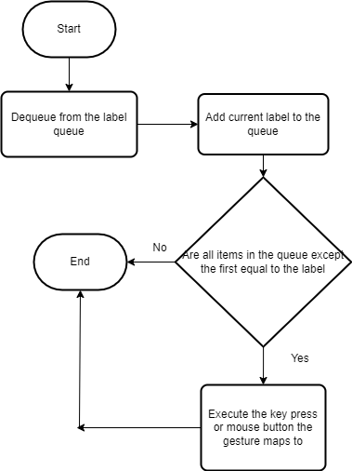
The queue is referring to the ‘gesture_queue’ attribute of the Commander class.

Executing a gesture:

Queue logic:
A gesture must be held for 10 frames to be executed, as 10 frames = 1/3 of a second @30FPS.
This will prevent an gesture being immediately executed when the neural network misclassifies a frame.
Initialise a queue of 11 NULL elements. Whenever a new label is received, dequeue the first element and enqueue the new element.
If all elements except the first are equal, execute the gesture. E.g.
[0, 1, 1, 1, 1, 1, 1, 1, 1, 1, 1] – Will be executed, as it has changed to 1 for 10 frames
[1, 1, 1, 1, 1, 1, 1, 1, 1, 1, 0] – Won’t be executed, gesture has just changed to 0
[0, 0, 1, 1, 1, 1, 1, 1, 1, 1, 1] – Won’t be executed, gesture hasn’t been held for long enough
[0, 1, 0, 1, 0, 1, 1, 0, 1, 0] – Won’t be executed, neither gesture has been executed for long enough
Checking the first element is not equal is very important. If the queue was only 10 in length, and the gesture was executed when the entire queue was equal, this raises a potential issue.
Suppose the queue has just changed to [1, 1, 1, 1, 1, 1, 1, 1, 1, 1] (10 ones), then the gesture will be executed. If the user holds gesture 1 for any more frames, then a 1 will be dequeued and enqueued. This leaves the queue in the same state of 10 ones, and so the corresponding command will be executed again for every frame past the 10th it is held for. This is very likely to happen as it is unlikely the user will hold a gesture for exactly 10 frames before changing.
With a queue 11 in length, when the gesture has been held for 10 frames, it will be in this state: [0, 1, 1, 1, 1, 1, 1, 1, 1, 1, 1]. After the gesture is executed, if the user holds gesture 1 for any more frames, the queue will be in the state [1, 1, 1, 1, 1, 1, 1, 1, 1, 1, 1] (11 ones). The gesture will not be executed, as the first element is also a 1. This prevents repeated execution of commands.

Mainloop Runner Class:
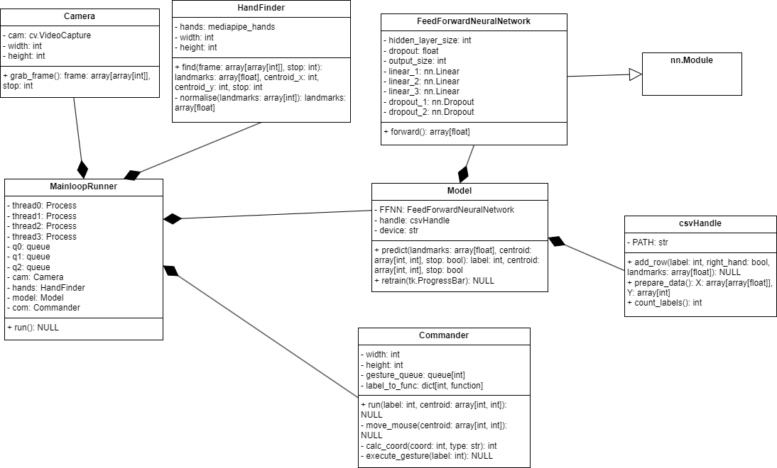
This is the class diagram for the class that will control the running of the main loop. Each of the thread attributes are an object of the Process class, as in Python, Processes can execute in parallel [14], but threads only execute concurrently [15]. As concurrent execution is similar in performance to single threading, I am going to use parallel execution instead.
Each Process will be assigned a function, that takes the object it uses, and the queue(s) it uses, and executes until the user terminates the whole process. The initialisation of all the processes, queue and other objects will occur during the initialisation of MainloopRunner. The run() method will just start all the processes.

General function pseudocode:
FUNCTION general(object, receive_queue, send_queue):
while True:
data = receive_queue.get()

if data[-1] == 1: # Last item is stop
break
if data[-1] == 2:
error_window() # Only present in the final process
break

data = object.run(data[0], data[1], …, data[-1])
send_queue.put(data)
END FUNCTION

Checking if the process has failed is only present in the last thread, as opening a window will not stall the execution of the processes after it, as there are none.

Config:

Class:

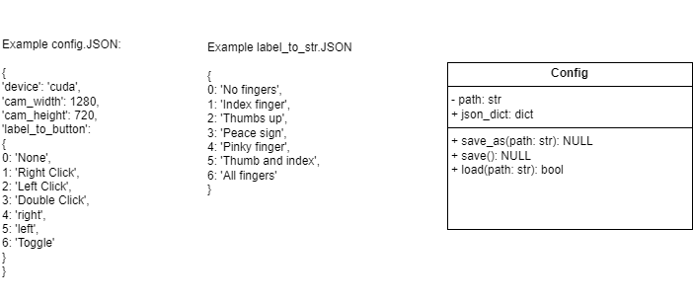
The data for the config will be stored in a JSON file and loaded into the ‘json_dict’ dictionary. This attribute is public as most of the other classes will need to access it for data.
The save() method will save the current settings under the current path, in a Json file.
The save_as() method will save the current settings under a new path, as a new file.
The load() method will load values into the dictionary from an already existing Json file.
Two objects of the Config class will be needed. One, called config, will store all the settings the user changes. The other will be called label_to_str, and maps an integer label to a string that it represents. This will increase in length every time a new gesture is added.

Config.json:

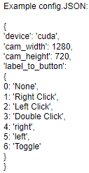
This is the structure of the file that will store all the settings that the user can change.
The device setting exists as in order to meet the requirements and run smoothly, it will likely be necessary to run the neural network on a CUDA-enabled GPU. However, as not all my client’s computers have access to one, he needs the option to also run it on the CPU.

Label_to_str.json:
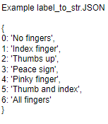
This is the structure of the file that maps integer labels to a string. This is used to make it clearer for the user which gesture they are changing the setting for.

File structure:
Files:
- default_config.json
- config.json
- [user created config files]
- default_label_to_str.json
- label_to_str.json
- config_path.txt
- default_data.csv
- data.csv
- model.pickle
- default_model.pickle
The three default files exist if the user wishes to reset all settings to their default. Config.json is initially a copy of the default default config file, so the user can change the settings without accidentally changing the default file. The default model.pickle exists as resetting will have there only being the original 7 gestures, so the original AI I trained that only detects 7 gestures must be used.
The config_path.txt contains the path to the current config file. It will get changed when calling save_as() or load() as those change what config file is currently being used.

Save as pseudocode:
METHOD save_as(self: Config, path: str):
self.path = path

dump(self.json_dict, path)
write(‘config_path.txt’, path)
END METHOd

Save pseudocode:
METHOD save(self: Config):
json.dump(self.json_dict, path)
END METHOD

Load pseudocode:
METHOD load(self: Config, path: str):
json_dict = json.load(path)

if is_valid(json_dict):
self.path = path
self.json_dict = json.load(path)
write(‘config_path.txt’, path)
return True
else:
return False
END METHOD

All of these methods interact directly with json files using the python json module
During loading, the is_valid() function checks if the json file contains all the necessary fields to be a valid config file. The error_window() function opens a window which notifies the user that the file was invalid.

Adding gestures

Flowchart
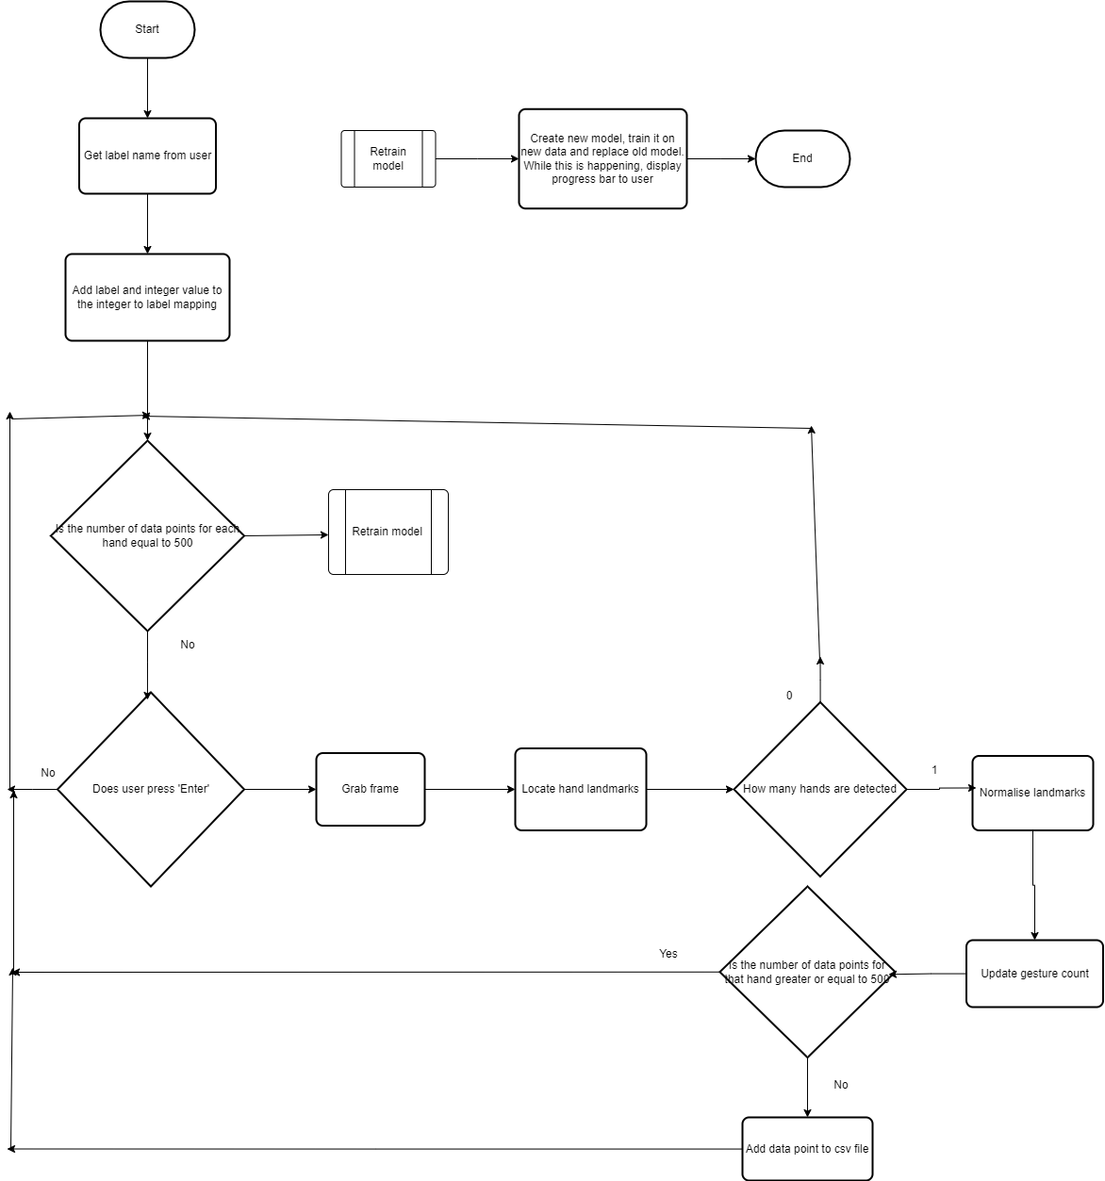
This flowchart shows how the algorithm for adding new gestures should work.

Retrain method
The class diagram for Model is repeated here


The retrain method is run after all the new data has been created, so the neural network can learn the gesture and recognise it. Below is the flowchart for retraining.
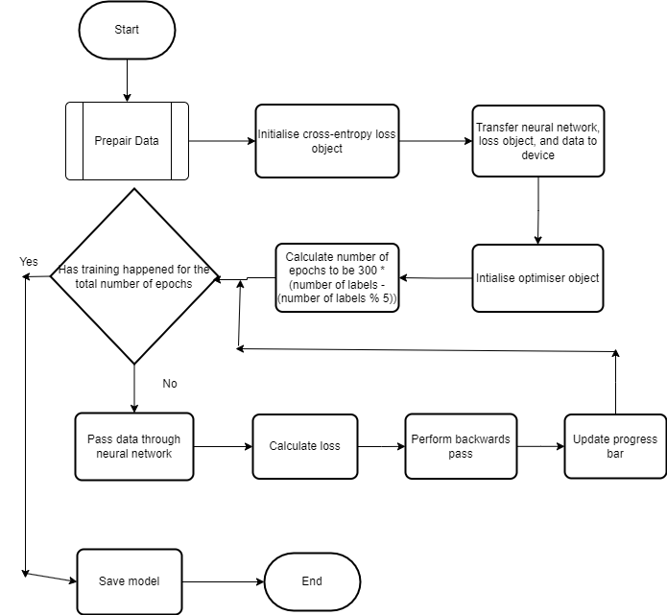

As you can see from the flowchart, the number of epochs to train for is calculated as:
$$300 * (n - mod(n, 5))$$
Where n denotes the number of labels.
I chose to use $n - mod(n, 5)$ as this will map all values from $[5 * k, 5 * (k + 1) -1]$
For example, if n takes any of these values: 5, 6, 7, 8, 9, $n - mod(n, 5) = 5$
I decided to do this, as if I just did a multiple of n, the number of epochs would increase linearly as the amount of labels increase, which from experience with neural networks, I believe to be too rapid of an increase. This could lead to overfitting, and decreased accuracy when in actual use, which is bad for the user experience.
Using the number 300 may change during testing, however, given the size of the neural network, for 7, 8 and 9 gestures, this give 1500 epochs, which I feel is large enough to allow the network to learn, but is small enough to avoid overfitting.

CSV class:
Here is the class diagram for the csvHandle class
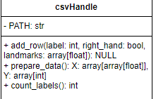
The ‘path’ constant is the path to the csv file containing all the training data and is hard coded as it will not change from anything else in the program.
Each row of the csv file will contain data in this format: $[label: int, data0: float, data1: float, ..., data41: float]$
The count_labels() method will return how many different labels are present in the csv file. The add_row() method will add a row to the csv file.
All interaction with the csv file containing this data will be done using the python module pandas. [17]

Prepare data flowchart
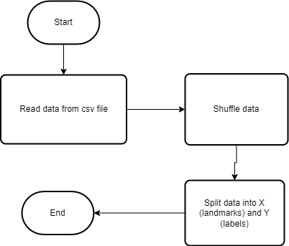
Not much preparation needs to be done as the data is already normalised. Furthermore, I do not think the data will need to be split into a train and test set, as the user will not use a test set for anything.
It is extremely important that the data is shuffled before being split into the X and Y sets, as otherwise X and Y will be shuffled independently, and the data will no longer match up to the labels.

Gesture Adder Class:
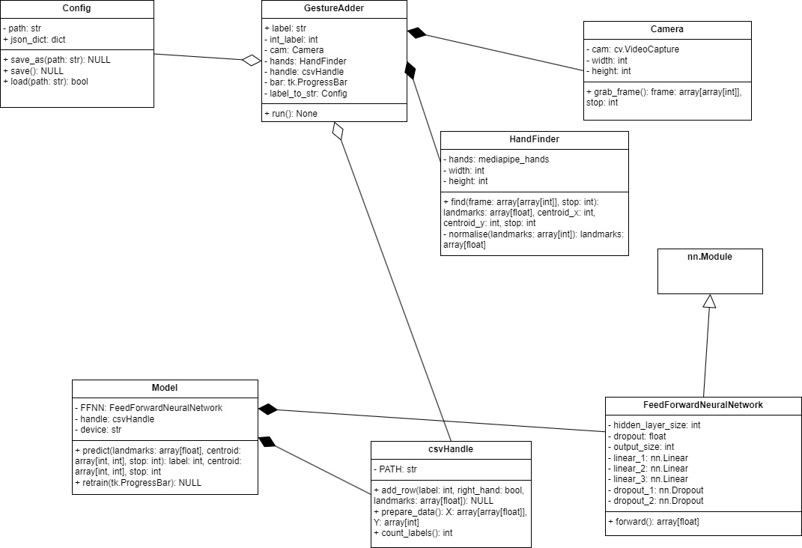
This class reuses the same classes from the MainloopRunner class, but with a few changes. The csvHandle object which is composed in the Model class will be aggregated with the GestureAdder as the ‘handle’ attribute. Also the Config object that is the ‘label_to_str’ attribute is actually initialised in the superclass that runs the entire application, but that has not been covered yet.
The ‘label’ attribute is the string inputted by the user, and the ‘int_label’ attribute is the integer it maps to. The ‘bar’ attribute is the loading bar used to display to the user how far the model is into retraining.

GUI:

Windows:
Here is the design for the GUI repeated, as well as the design for all the necessary windows to go along with it:
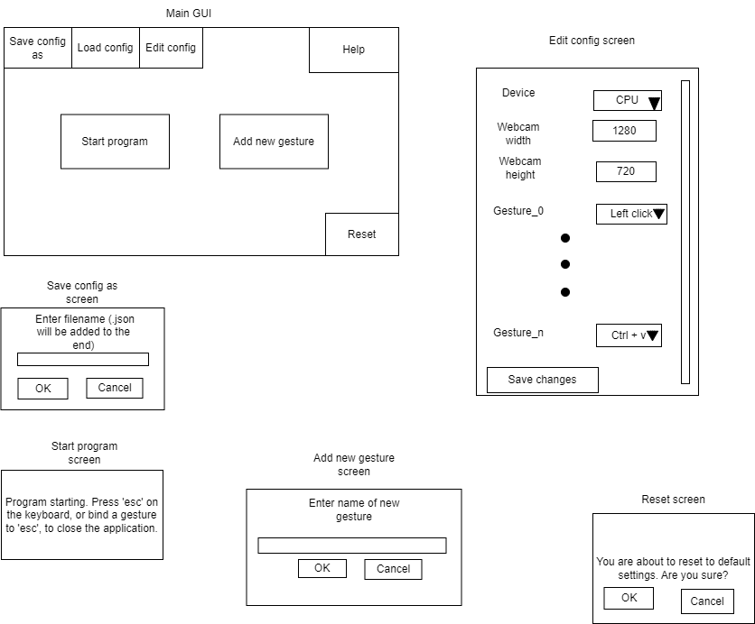
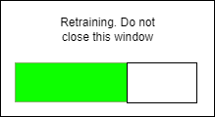

GUI class diagram:
From this, I drew up the class diagram for the GUI:
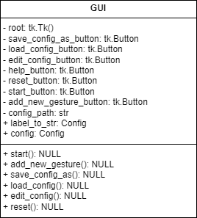

Start pseudocode:
METHOD start():
runner = new MainloopRunner()
runner.run()
END METHOD

Add new gesture pseudocode:
METHOD add_new_gesture(self: GUI):
FUNC adder_helper(label: str, label_to_str: Config, bar: tk.Progressbar):
adder = new GestureAdder(label, label_to_str, bar)
adder.run()
END FUNC
FUNC destroy_helper(bar_win: tk.Tk, bar: tk.ProgressBar):
While True:
if bar.step == bar.maximum – 1:
bar_win.destroy()
label = get_str_from_user()

bar_win = tk.Tk()
bar = new ProgressBar(bar_win)
bar.place()

adder_thread = new Thread(adder_helper)
destroy_thread = new Thread(destroy_helper)
adder_thread.start()
destroy_thread.start()
END METHOD

Both the adder_helper and destroy_helper functions must be run in separate threads, as running a tkinter window creates an infinite loop that prevents other code in the same thread from being executed.
Note: the get_str_from_user() function can be implemented using a function from the dialog module of the tkinter library [18]

Save config as pseudocode:
METHOD save_config_as(self: GUI):
path = ‘.\\’ + get_str_from_user() + ‘.json’

self.config.save_as(path)
self.config_path = path

write(‘config_path.txt’, path)
END METHOD

Load config pseudocode:
METHOD load_config(self: GUI):
path = get_file_path_from_user()

success = self.config.load(path)
if success:
self.config_path = path
write(‘config_path.txt’, path)
END METHOD

Edit config pseudocode:
METHOD edit_config(self: GUI):
Create window
Add label for each setting
Add field for each setting

FUNCTION save_changes(vals: list, config: Config):
config,json_dict[‘device’] = vals[0]
config.json_dict[‘width’] = vals[1] if vals[1] is a positive integer else return
config.json_dict[‘height’] = vals[2] if vals[2] is a positive integer else return

for val in vals[3 to length of vals]:
config.json_dict[‘label_to_button’][val idx – 3] = vals[i]
config.save()
destroy window
END FUNCTION

Create save changes button and assign it to save_changes() function
Run window mainloop
END METHOD

Reset method:
The reset method should copy the data from default_data to data. It should also copy the data from default_label_to_str to label_to_str, and default_config to config, and set config_path to ‘config.txt’.

Technical Solution

Development log

Day 1

Firstly, I wrote the code for the Camera object, contained in camera.py:
import cv2 as cv
import numpy as np

class Camera:

def __init__(self, width: int, height: int):
"""
Initialises a class that acts as a wrapper around an opencv VideoCapture object
The width and height parameters will be set as the width and height dimensions that frames are grabbed at
"""
self.cam = cv.VideoCapture(0)
self.width = width
self.height = height

# 3 corresponds to width, 4 corresponds to height
self.cam.set(3, self.width)
self.cam.set(4, self.height)

def grab_frame(self) -> tuple[np.ndarray[np.ndarray[np.int]], uint8]:
"""
Grabs a frame from the user's webcam
If the user presses 'esc', the value of integer returned will be 1
If the camera fails to initialise or a frame cannot be grabbed it will return 2
A return value of 0 indicates that it is okay to continue
"""
ret, frame = self.cam.read()
stop = 0

# 27 is the UTF-8 code for 'esc'
if cv.waitKey(1) & 0xFF == 27:
stop = 1
elif ret == False:
stop = 2

return frame, stop

When writing the tests for this class, I realised that it was possible for the user to input values for the width and height that are larger than the dimensions the webcam reads at. Using the IDLE program, I attempted to set the dimensions to something larger than 1280 x 720. When doing this, the set() method returned False and didn’t set the dimensions to that. From this, I decided not to implement error handling for this.
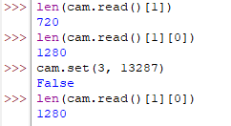

Day 2
Today, I wrote the code for the HandFinder object, contained in hand_finder.py:
import numpy as np
import cv2 as cv
import mediapipe as mp
mp_hands = mp.solutions.hands

COMPLEXITY = 0

class HandFinder:

def __init__(self, width: int, height: int):
"""
This class contains all the functionality to locate hand landmarks and normalise them
It contains a mediapipe hands object which is used for the location
The width and height parameters are the width and height of the users webcam, and is used for the normalisation process
"""
self.hands = mp_hands.Hands(model_complexity=COMPLEXITY,
min_detection_confidence=0.5,
min_tracking_confidence=0.5)
self.width = width
self.height = height

def find(self, frame: np.ndarray[np.ndarray[np.uint8]], stop: int) -> tuple[list[float], int, int, int]:
"""
Locates hands within the frame
Return the normalised landmarks and the unnormalised centroid coordinates
"""
# Gets the results from the hands ai
frame = cv.cvtColor(frame, cv.COLOR_BGR2RGB)
results = self.hands.process(frame)

# Only runs if any hands are actually detected
if results.multi_hand_landmarks:
# Only uses data from the first hand detected to avoid issues with multiple hands
points = results.multi_hand_landmarks[0]

landmarks = []

for point in points.landmark:
# Converts the points from float values into integers for normalisation
# Take the minimum in case any points are calculated to be outside the webcam's dimensions
x = min(int(point.x * self.width), self.width - 1)
y = min(int(point.y * self.height), self.height - 1)
landmarks.append([x, y])

norm_landmarks = self._normalise(landmarks)
# This is the same effect as flattening the array
# e.g. reshape([[1, 2], [3, 4]], -1) = [1, 2, 3, 4]
norm_landmarks = np.reshape(norm_landmarks, -1)

# The 9th element is the middle finger joint, which is chosen to represent the centre as it's location is least affected by finger movement
centroid_x, centroid_y = landmarks[9]
else:
norm_landmarks = centroid_x = centroid_y = None

return norm_landmarks, centroid_x, centroid_y, stop

def _normalise(self, landmarks: list[list[int]]) -> np.ndarray[np.ndarray[float, float]]:
"""
Custom normalisation routine for converting hand landmarks anywhere in the frame into float values between 0 and 1
This ensures that the same gesture in a different part of the image will be represented by similar values
e.g. without this process, the ai will see a gesture more to the right as different as it's x values will be higher
Dry run to explain the process

landmarks = [[1, 2], [2, 4], [5, 3], [3, 3]]
x_min = 1
x_max = 5
y_min = 2
y_max = 4

subtract the minimum values:
landmarks - [x_min, y_min] = [[0, 0], [1, 2], [4, 1], [2, 1]]

multiply x values by 1 / (x_max - x_min) and y values by 1 / (y_max - x_min)
1 / (x_max - x_min) = 1/4
1 / (y_max - x_min) = 1/2
landmarks = [[0, 0], [0.25, 1], [1, 0.5], [0.5, 0.5]]

This process can be generally represented by these matrix operations:

||[x0, y0] | |[x_min, y_min]||
||[x1, y1] | |[x_min, y_min]||
|| . | | . || |[1 / (x_max - x_min), 0]|
|| . | - | . || * |[0, 1 / (y_max - y_min)]|
|| . | | . ||
||[x40, y40]| |[x_min, y_min]||
||[x41, y41]| |[x_min, y_min]||

(landmarks - [x_min, y_min]) * ([1 / (x_max - x_min), 0], [0, 1 / (y_max - y_min)])
"""
x_max, y_max = np.max(landmarks, axis=0)
x_min, y_min = np.min(landmarks, axis=0)

scale_matrix = np.array([[1 / (x_max - x_min), 0], [0, 1 / (y_max - y_min)]])
min_subtracted = np.array(landmarks) - [x_min, y_min]

return np.matmul(min_subtracted, scale_matrix)

Day 3
Today I started implementing the Model class. The FeedForwardNeuralNetwork class has been created. However, as the CSVHandle class is not implemented yet, the retrain method cannot be implemented, and there isn’t data available to test with.
Code so far in model.py:
import torch
import torch.nn as nn
import torch.nn.functional as F

class FeedForwardNeuralNetwork(nn.Module):

def __init__(self, hidden_layer_size: int, output_size: int, dropout: float=None):
"""
Feed forward neural network with 3 linear layers
First layer: 42 inputs, hidden_layer_size outputs
Second layer: hidden_layer_size inputs, hidden_layer_size / 2 outputs
Third layer: hidden_layer_size / inputs, output_size outputs
Each layer uses the ReLU activation function
Dropout determines what percentage of the neurones are turned off during training each epoch
"""
super().__init__()
self.l1 = nn.Linear(42, hidden_layer_size)
self.l2 = nn.Linear(hidden_layer_size, hidden_layer_size // 2)
self.l3 = nn.Linear(hidden_layer_size // 2, output_size)
if dropout:
self.d1 = nn.Dropout(dropout)
self.d2 = nn.Dropout(dropout)
else:
self.d1 = self.d2 = None

def forward(self, X):
"""
Forward pass of the neural network
"""
X = F.relu(self.l1(X))
if self.d1:
X = self.d1(X)
X = F.relu(self.l2(X))
if self.d2:
X = self.d2(X)
X = F.relu(self.l3(X))
return F.softmax(X)

class Model:

def __init__(self, device: str, output_size: int):
"""
A class that containst a FeedForwardNeuralNetwork
Enables label prediction and retraining of the network
device can be either cuda or cpu, which determines which one the model will run on
output_size determines how many possible labels the network can output
"""
self.device = device
self.FFNN = FeedForwardNeuralNetwork(64, output_size, 0.5)
self.FFNN.load_state_dict(torch.load(".\\model.pickle"))
# TODO: Implement csv handle for retraining

def predict(self, landmarks: list[float], centroid: list[int, int], stop: int):
"""
Gets the output from the neural network and performs an argmax to get the label it chose
"""
self.FFNN.eval()
# The input tensor must be on the same device as the model in order to run
landmarks = torch.tensor(landmarks, dtype=torch.float).to(self.device)
y = self.FFNN(landmarks)

label = torch.argmax(y).item()
return label, centroid, stop

Day 4
Today I implemented the csvHandle class so that I could finish the implementation of the Model class
csv_handle.py:
import pandas as pd
import numpy as np
import csv

class csvHandle:

def __init__(self, path: str):
"""
Creates an object that allows for all the needed interaction with the csv file
Path is the path to the csv file
"""
self.path = path

def add_row(self, label: int, right_hand: bool, landmarks: list[float]) -> None:
"""
Adds a new row to the csv file
The format of each row is:
[label: int, right_hand: int, landmark_0, landmark_1, ..., landmark_41]
"""
hand = 1 if right_hand else 0
data = [label] + [hand] + landmarks

with open(self.path, 'a') as f:
writer = csv.writer(f)
writer.writerow(data)

def prepare_data(self) -> tuple[np.ndarray[np.ndarray[np.float_]], np.ndarray[np.float_]]:
"""
Returns X and Y data in a format that can be used by the neural network
X contains all the landmark data
Y contains all the label data
The right handedness data is removed
The csv also get shuffled to avoid long lengths of the same label appearing
"""
data = pd.read_csv(self.path)

# Sample(frac=1) takes a random sample whose size is the same as the entire csv file
# reset_index(drop=True) enables the indices to be reset so the order of the file actually changes
data = data.sample(frac=1).reset_index(drop=True)

cols = data.columns
# First column is the label, second column is handedness, and the remaining columns are landmark data
Y, X = data[cols[0]], data[cols[2:]]
X = X.to_numpy()
Y = Y.to_numpy()

return X, Y

def count_labels(self) -> int:
"""
Returns how many different labels are present in the data
"""
data = pd.read_csv(self.path)

# Only the first column contains label data
labels = data[[data.columns[0]]]
# Get rid of unnecessary DataFrame information (indices and column)
labels = labels.values
# Labels.values returns a 2d array where each subarray contains only one element
# It needs to be flattened in order to be usable
labels = labels.reshape(-1)
# Convert to a set so only one of each values occurs
labels = set(labels)
# The length of the set is the number of unique labels that occur
n = len(labels)

return n

With this class implemented, I am now able to finish implementing the Model class.
Here is the modified Model class. The __Init__ function has added initialising the csvHandle. The retrain method has also been implemented.
class Model:

def __init__(self, device: str, output_size: int, path: str):
"""
A class that containst a FeedForwardNeuralNetwork
Enables label prediction and retraining of the network
device can be either cuda or cpu, which determines which one the model will run on
output_size determines how many possible labels the network can output
"""
self.device = device
self.FFNN = FeedForwardNeuralNetwork(64, output_size, 0.5)
if os.path.exists(".\\model.pickle"):
self.FFNN.load_state_dict(torch.load(".\\model.pickle"))
self.handle = csvHandle(path)

def predict(self, landmarks: list[float], centroid: list[int, int], stop: int):
"""
Gets the output from the neural network and performs an argmax to get the label it chose
"""
self.FFNN = self.FFNN.to(self.device)
self.FFNN.eval()
# The input tensor must be on the same device as the model in order to run
landmarks = torch.tensor(landmarks, dtype=torch.float).to(self.device)
y = self.FFNN(landmarks)

label = torch.argmax(y).item()
return label, centroid, stop

def retrain(self, bar: ttk.Progressbar) -> None:
"""
Retrains the model using all data available in the csv file
Will also step a progressbar at each step to give the user an indication of how long it will take
The number of epochs used = 300 * (n - (n % 5)) where n is the number of labels
"""
X, Y = self.handle.prepare_data()

n = self.handle.count_labels()

# A new FFNN must be created as to not reuse the previous weights, as they will not work in case the amount of labels has increased
self.FFNN = FeedForwardNeuralNetwork(64, n, 0.2)

loss_fn = nn.CrossEntropyLoss()
# Everything must be transferred to the same device in order to work
self.FFNN = self.FFNN.to(self.device)
loss_fn = loss_fn.to(self.device)

X = torch.tensor(X, dtype=torch.float).to(self.device)
Y = torch.tensor(Y, dtype=torch.int64).reshape(-1).to(self.device)

optimiser = torch.optim.Adam(self.FFNN.parameters())

n = self.handle.count_labels()
epochs = 300 * (n - (n % 5))
# This way the bar has an equal number of steps as epochs, so each epoch only bar.step() must be called, no extra maths
# 1 has to be added to epochs to stop it from resetting back to 0 when it reaches the final epoch
bar.config({"maximum": epochs + 1})

for epoch in range(epochs):
optimiser.zero_grad()

Y_pred = self.FFNN(X)

loss = loss_fn(Y_pred, Y)

loss.backward()
optimiser.step()
bar.step()

torch.save(self.FFNN.state_dict(), '.\\model.pickle')
bar.step()

Day 5
Today I will test the effectiveness of the neural network architecture I devised. In order to do this, I will need to collect initial data. I will write a basic script that I can use to take pictures of my hand in different configurations.
In the interview, my user said that he wanted 7 gestures. These initial gestures will be ‘point’, ‘fist’, ‘thumbs up’, ‘peace sign’, ‘all fingers’, ‘thumb and finger’ and ‘thumb and 2 finger’.
Examples are provided below:
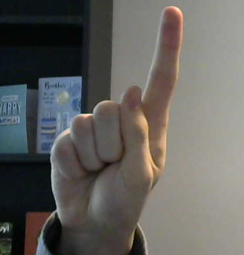
Point
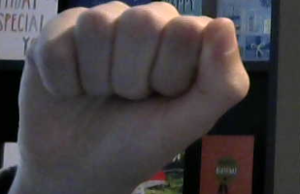
Fist
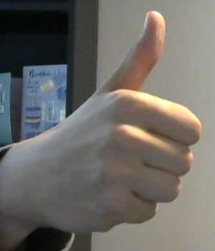
Thumbs up
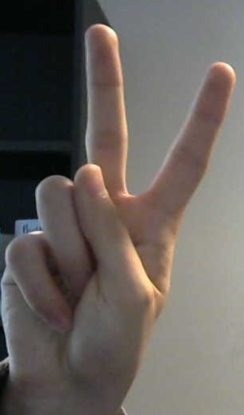
Peace sign
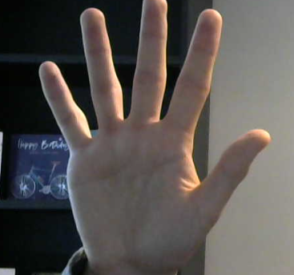
All fingers
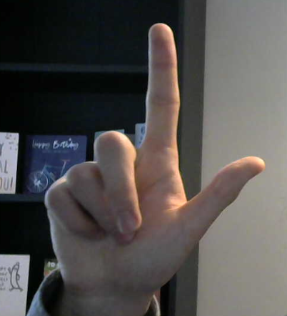
Thumb and finger
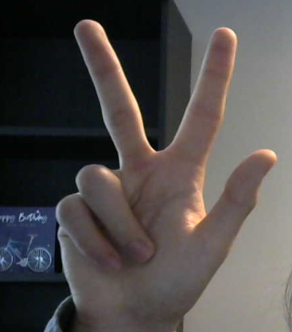
Thumb and 2 finger

Data generation idea:
It occurred to me that when making gestures, people’s hands may not always be upright. Due to this, when gathering training data, I will rotate some of the data to mimic this effect. Since it is likely that people’s hands will be mostly upright, I will copy 45% of the data and rotate it by a random angle between 90 and -90 degrees, and 5% of the data will be copied and rotated by a random angle between 90 and 180 degrees, and -90 and -180 degrees.

Change to hand_finder.py
I realised that in the HandFinder class I had forgotten to implement extraction of whether the left or right hand is detected. When testing, I found that the object was returning incorrect values for the handedness, and I realised the image had to be flipped horizontally due to hwo the webcam captures frames. Here is the changed find method:
def find(self, frame: np.ndarray[np.ndarray[np.uint8]], stop: int) -> tuple[list[float], int, int, int, int]:
"""
Locates hands within the frame
Return the normalised landmarks and the unnormalised centroid coordinates
"""
# Gets the results from the hands ai
frame = cv.flip(frame, 1)
frame = cv.cvtColor(frame, cv.COLOR_BGR2RGB)
results = self.hands.process(frame)

# Only runs if any hands are actually detected
if results.multi_hand_landmarks:
# Only uses data from the first hand detected to avoid issues with multiple hands
points = results.multi_hand_landmarks[0]
handedness = results.multi_handedness[0]
hand = handedness.classification[0].index

landmarks = []

for point in points.landmark:
# Converts the points from float values into integers for normalisation
# Take the minimum in case any points are calculated to be outside the webcam's dimensions
x = min(int(point.x * self.width), self.width - 1)
y = min(int(point.y * self.height), self.height - 1)
landmarks.append([x, y])

norm_landmarks = self._normalise(landmarks)
# This is the same effect as flattening the array
# e.g. reshape([[1, 2], [3, 4]], -1) = [1, 2, 3, 4]
norm_landmarks = np.reshape(norm_landmarks, -1)

# The 9th element is the middle finger joint, which is chosen to represent the centre as it's location is least affected by finger movement
centroid_x, centroid_y = landmarks[9]
else:
norm_landmarks = hand = centroid_x = centroid_y = None

return norm_landmarks, hand, centroid_x, centroid_y, stop

Below is the code that I used to generate the initial data for training. There are 500 datapoints for each label, 250 for each hand.
from camera import Camera
from hand_finder import HandFinder
from csv_handle import csvHandle
import numpy as np
import cv2 as cv
import random

# 0: point, 1: fist, 2: thumbs up, 3: peace sign, 4: all fingers, 5: thumb and finger, 6: thumb and 2 fingers
LABEL = 6

def main():
cam = Camera(1280, 720)
finder = HandFinder(1280, 720)
handle = csvHandle('.\\data.csv')

left_count = 0
right_count = 0

stop = 0

while left_count < 251 or right_count < 251 and stop == 0:
frame, stop = cam.grab_frame()

if cv.waitKey(1) == 121:
landmarks, hand, c_x, c_y, stop = finder.find(frame, stop)

if landmarks is not None and ((hand == 0 and right_count < 251) ^ (hand == 1 and right_count < 251)):
print('Running')
if hand == 0:
left_count += 1
else:
right_count += 1

points = np.reshape(landmarks, (len(landmarks) // 2, 2))

x = random.random()

if 0 < x < 0.5:
if 0 < x < 0.05:
a = random.uniform(0.5 * np.pi, 1.5 * np.pi)
else:
a = random.uniform(-0.5 * np.pi, 0.5 * np.pi)
rot = np.array([[np.cos(a), -np.sin(a)], [np.sin(a), np.cos(a)]])
new_points = np.matmul(rot, points.T).T
new_landmarks = new_points.reshape(-1)
new_data = new_landmarks.tolist()
handle.add_row(LABEL, hand, new_data)

handle.add_row(LABEL, hand, landmarks.tolist())

cv.putText(frame, f'Left count: {left_count}', (10, 100), cv.FONT_HERSHEY_SIMPLEX, 1, (0, 255, 0), 2, cv.LINE_AA)
cv.putText(frame, f'Right count: {right_count}', (10, 600), cv.FONT_HERSHEY_SIMPLEX, 1, (0, 255, 0), 2, cv.LINE_AA)
cv.imshow('data gathering', frame)

if __name__ == '__main__':
main()

Neural network architecture changes:
I wrote a script that used the same code as the model’s retrain method, to create a neural network of the same architecture and test its accuracy.
When using the architecture I devised, the highest accuracy it got was 82.2%, which is too low.
I tried changing the size of the layers from 64, 32, 7 to 128, 128, 64, 7, and changed the dropout from 20% to 50%, and this caused the accuracy to consistently reach 97-98%, with that percentage only being reached near the end of training, suggesting that overfitting is not occurring.
After these changes, here is the updated model.py:
import torch
import torch.nn as nn
import torch.nn.functional as F
import tkinter as tk
import os
from csv_handle import csvHandle
from tkinter import ttk

class FeedForwardNeuralNetwork(nn.Module):

def __init__(self, hidden_layer_size: int, output_size: int, dropout: float=None):
"""
Feed forward neural network with 3 linear layers
First layer: 42 inputs, hidden_layer_size outputs
Second layer: hidden_layer_size inputs, hidden_layer_size / 2 outputs
Third layer: hidden_layer_size / inputs, output_size outputs
Each layer uses the ReLU activation function
Dropout determines what percentage of the neurones are turned off during training each epoch
"""
super().__init__()
self.l1 = nn.Linear(42, hidden_layer_size)
self.l2 = nn.Linear(hidden_layer_size, hidden_layer_size)
self.l3 = nn.Linear(hidden_layer_size, hidden_layer_size // 2)
self.l4 = nn.Linear(hidden_layer_size // 2, output_size)
if dropout:
self.d1 = nn.Dropout(dropout)
self.d2 = nn.Dropout(dropout)
else:
self.d1 = self.d2 = None

def forward(self, X):
"""
Forward pass of the neural network
"""
X = F.relu(self.l1(X))
X = F.relu(self.l2(X))
if self.d1:
X = self.d1(X)
X = F.relu(self.l3(X))
if self.d2:
X = self.d2(X)
X = F.relu(self.l4(X))
# return F.softmax(X)
return X

class Model:

def __init__(self, device: str, output_size: int, path: str):
"""
A class that containst a FeedForwardNeuralNetwork
Enables label prediction and retraining of the network
device can be either cuda or cpu, which determines which one the model will run on
output_size determines how many possible labels the network can output
"""
self.device = device
try:
self.FFNN = FeedForwardNeuralNetwork(128, output_size, 0.5)
if os.path.exists(".\\model.pickle"):
self.FFNN.load_state_dict(torch.load(".\\model.pickle", weights_only=False))
except RuntimeError: # Occurs when sizes in save file and the sizes that are intialised dont match up
self.FFNN = FeedForwardNeuralNetwork(128, output_size, 0.5)
self.handle = csvHandle(path)

def predict(self, landmarks: list[float], centroid: list[int, int], stop: int):
"""
Gets the output from the neural network and performs an argmax to get the label it chose
"""
self.FFNN = self.FFNN.to(self.device)
self.FFNN.eval()
# The input tensor must be on the same device as the model in order to run
landmarks = torch.tensor(landmarks, dtype=torch.float).to(self.device)
y = self.FFNN(landmarks)

label = torch.argmax(y).item()
return label, centroid, stop

def retrain(self, bar: ttk.Progressbar) -> None:
"""
Retrains the model using all data available in the csv file
Will also step a progressbar at each step to give the user an indication of how long it will take
The number of epochs used = 300 * (n - (n % 5)) where n is the number of labels
"""
X, Y = self.handle.prepare_data()

n = self.handle.count_labels()

# A new FFNN must be created as to not reuse the previous weights, as they will not work in case the amount of labels has increased
self.FFNN = FeedForwardNeuralNetwork(128, n, 0.5)

loss_fn = nn.CrossEntropyLoss()
# Everything must be transferred to the same device in order to work
self.FFNN = self.FFNN.to(self.device)
loss_fn = loss_fn.to(self.device)

X = torch.tensor(X, dtype=torch.float).to(self.device)
Y = torch.tensor(Y, dtype=torch.int64).reshape(-1).to(self.device)

optimiser = torch.optim.Adam(self.FFNN.parameters())

n = self.handle.count_labels()
epochs = 300 * (n - (n % 5))
# This way the bar has an equal number of steps as epochs, so each epoch only bar.step() must be called, no extra maths
# 1 has to be added to epochs to stop it from resetting back to 0 when it reaches the final epoch
bar.config({"maximum": epochs + 1})

for epoch in range(epochs):
optimiser.zero_grad()

Y_pred = self.FFNN(X)

loss = loss_fn(Y_pred, Y)

loss.backward()
optimiser.step()
bar.step()

torch.save(self.FFNN.state_dict(), '.\\model.pickle')
bar.step()

Day 6:
Today, I implemented the Config class in config.py:
import json

class Config:

def __init__(self):
"""
Class for storing configuration data
Data is accessed using the json_dict attribute, which is a dictionary
There are 2 valid forms of configuration data

Config:
Contains data about settings the user has chosen
'device': 'cuda'/'cpu'
'cam_width': int
'cam_height': int
'label_to_button': {int: str} - Maps from a label to the string representation of the function it invokes

Label_to_str:
{int : str} - Maps from a label to the name of the gesture, which is what the user sees when adding a new gesture
"""
self.path = None
self.json_dict = {}

def save_as(self, path: str) -> None:
"""
Saves the current configuration data under a new path
"""
self.path = path

with open(self.path, 'w') as f:
json.dump(self.json_dict, f)

def save(self) -> None:
"""
Saves new configuration data under the current path
"""
with open(self.path, 'w') as f:
json.dump(self.json_dict, f)

def load(self, path: str) -> int:
"""
Attempts to load data from a new path
Returns an integer detailing wether there was a success or not
0: An invalid file was loaded
1: A valid label_to_str file was loaded
2: A valid config file was loaded
"""
if not path.endswith('.json'):
return 0

with open(path, 'r') as f:
json_dict = json.load(f)

valid = self._is_valid(json_dict)

if valid != 0:
self.path = path
self.json_dict = json_dict
if valid == 2:
with open('config_path.txt', 'w') as f:
f.write(path)
return valid
else:
return 0

def _is_valid(self, json_dict: dict) -> int:
"""
Checks if the data in the file is of a valid configuration for either
0: Invalid
1: label_to_str
2: config
"""
keys = json_dict.keys()
required = {'device', 'cam_width', 'cam_height', 'label_to_button'}

all_int = self._all_keys_int(json_dict)

# If not all of the required keys are present, and they arent all integers (label_to_str)
if any([r not in keys for r in required]) and not all_int:
return 0
if self._all_keys_int(json_dict):
return 1
# If it contains all the required keys, but has extra, then it is invalid
if len(keys) > 4:
return 0
# Checks that all the keys in the label_to_button field are integers
if self._all_keys_int(json_dict['label_to_button']):
return 2
# If not it is invalid
return 0

def _all_keys_int(self, json_dict: dict) -> bool:
"""
Returns True if all the keys are integers, otherwise False
"""
keys = json_dict.keys()

# The keys are all stored as strings
# If converting from string to integer raises an error, then it must not be an integer
for key in keys:
try:
int(key)
except ValueError:
return False

return True

Day 7
Today I implemented the commander class in the commander.py file. I haven’t implemented every possible command that can be given to the computer, but I have implemented what are the most important for my client’s primary use case. Thes are: on screen keyboard, left click, right click, middle click, double click, next track, previous track, print screen, windows, delete, browser back, browser forward, browser refresh, page up, page down, volume up, volume down, mute, and a function that does nothing in case my client wants a gesture to use when he doesn’t want to input a command.
Here is the code in commander.py:
import pyautogui
from config import Config
from typing import Callable

class Commander:

def __init__(self, width: int, height: int, config_path: str):
"""
A class whose purpose is to encapsulate all of the interaction with the computer
Controls moving the mouse and executing gestures
Width and height are the width and height of the webcam
"""
self.width = width
self.height = height
# Fill with -1 as -1 wont be assigned to any gesture
self._gesture_queue = [-1 for _ in range(11)]
self._label_to_func = _str_to_func(config_path)

def _move_mouse(self, centroid: list[int, int]) -> None:
"""
Moves the mouse to the X and Y coordinate determined by the centroid
"""
x, y = centroid

x = self._calc_coord(x, 'x')
y = self._calc_coord(y, 'y')

pyautogui.moveTo(x, y)

def _calc_coord(self, coord: int, type: str):
"""
Converts the coordinate from in the webcam space to the equivalent in the screen space
Cuts off 15% from the sides in order to make it easier to move the mouse to the extremites of the screen
"""
if type == 'x':
webcam_dim = self.width
screen_dim = pyautogui.size()[0]
else:
webcam_dim = self.height
screen_dim = pyautogui.size()[1]

# Cut off 15% from the sides
coord = max(coord, 0.15 * webcam_dim)
coord = min(coord, 0.85 * webcam_dim)

# Convert the origin from (0.15 * webcam_x, 0.15 * webcam_y) to (0, 0)
coord -= 0.15 * webcam_dim
# Normalise to between 0 and 1
coord /= 0.7 * webcam_dim

coord = int(coord * screen_dim)
return coord

def _execute_gesture(self, label: int) -> None:
"""
Executes a gesture given the label prediction
Only executes a gesture when it has been held for exactly 10 frames
"""
self._gesture_queue.pop(0)
self._gesture_queue.append(label)

valid = True

# The first element in the queue cannot be same as the other 10, to ensure it only gets executed once after the first 10 frames
if self._gesture_queue[0] == self._gesture_queue[1]:
valid = False

for i in range(2, len(self._gesture_queue)):
if self._gesture_queue[i] != self._gesture_queue[i - 1]:
valid = False
break

if valid:
self._label_to_func[label]()

def run(self, label: int, centroid: list[int, int]) -> None:
"""
Takes the label and centroid information
Moves the mouse to the new coordinate
Executes the gesture if it has been held for exactly 10 frames
"""
self._move_mouse(centroid)
self._execute_gesture(label)

def _str_to_func(config_path: str) -> dict[int: Callable]:
"""
Maps using the label_to_str.json file
label_to_str contains an integer to string mapping, and this method contains a string to function mapping
This is converted into an integer to function mapping, which is what is returned
"""
config = Config()
config.load(config_path)

label_to_str = config.json_dict['label_to_button']

label_to_func = {}

# Functions that the user can assign to a gesture
# left, right, double and middle click are implemented using their respective pyautgui functions
# Opening an on screen keyboard has its own function
# Keyboard keys to be used using pyautogui: nexttrack, prevtrack, printscr, windows, delete, browserback, browserforward, browserrefresh, pageup, pagedown, volumeup, volumedown, volumemute
# Also have a None function if the user wants a gesture that wont execute anything

def osk():
pyautogui.hotkey('win', 'ctrl', 'o')

# The strings that the user select are different to the ones pyautogui uses, so this mapping is needed
str_to_key = {'Next Track': 'nexttrack', 'Prev Track': 'prevtrack', 'Print Screen': 'printscr', 'Windows': 'win', 'Delete': 'delete', 'Browser Back': 'browserback',
'Browser Forward': 'browserforward', 'Browser Refresh': 'browserrefresh', 'Page Up': 'pageup', 'Page Down': 'pagedown', 'Volume Up': 'volumeup',
'Volume Down': 'volumedown', 'Mute': 'volumemute', 'Escape': 'esc'}

def none():
pass

for label in label_to_str:
match label_to_str[label]:
case 'On Screen Keyboard':
label_to_func[int(label)] = osk
case 'Left Click':
label_to_func[int(label)] = pyautogui.click
case 'Right Click':
label_to_func[int(label)] = pyautogui.rightClick
case 'Middle Click':
label_to_func[int(label)] = pyautogui.middleClick
case 'Double Click':
label_to_func[int(label)] = pyautogui.doubleClick
case 'None':
label_to_func[int(label)] = none

if label_to_str[label] in str_to_key:
label_to_func[int(label)] = lambda: pyautogui.press(str_to_key[label_to_str[label]])

return label_to_func

Day 8:
Today I implemented the main loop of the program. This includes the entire pipeline from grabbing frames to executing commands and moving the mouse.
Code in mainloop_runner.py:
import multiprocessing
import tkinter as tk
from camera import Camera
from hand_finder import HandFinder
from model import Model
from commander import Commander

def cam_func(width: int, height: int, out_queue: multiprocessing.Queue):
"""
Function for the process that runs the Camera
"""
cam = Camera(width, height)

while True:
frame, stop = cam.grab_frame()

out_queue.put((frame, stop))

if stop == 1 or stop == 2:
break

def handfinder_func(width: int, height: int, in_queue: multiprocessing.Queue, out_queue: multiprocessing.Queue):
"""
Function for the process that runs the HandFinder
"""
hands = HandFinder(width, height)

while True:
data = in_queue.get()

if data[-1] == 1 or data[-1] == 2:
out_queue.put(([0 for _ in range(42)], [0, 0], data[-1]))
break

data = hands.find(*data)
out_queue.put(data)

def model_func(device: str, output_size: int, path: str, in_queue: multiprocessing.Queue, out_queue: multiprocessing.Queue):
"""
Function for the process that runs the Model
"""
model = Model(device, output_size, path)

while True:
landmarks, hand, c_x, c_y, stop = in_queue.get()

if stop == 1 or stop == 2:
out_queue.put((0, [0, 0], stop))
break

# If no hands have been detected, then this wont run and nothing will be placed in the queue
if landmarks is not None:
data = model.predict(landmarks, [c_x, c_y], stop)

out_queue.put(data)

def commander_func(width: int, height: int, config_path: str, in_queue: multiprocessing.Queue):
"""
Function for the process that runs the Commander
"""
com = Commander(width, height, config_path)

while True:
label, centroid, stop = in_queue.get()

if stop == 1:
break
if stop == 2:
error_window()
break

com.run(label, centroid)

def error_window():
"""
Reports to the user when there is an issue with connecting to the webcam
"""
root = tk.Tk()
root.geometry = "420x360"

l1 = tk.Label(root, text="There was an error running the program.")
l1.pack()
l2 = tk.Label(root, text="Try checking your webcam is plugged in")
l2.pack()

root.mainloop()

class MainloopRunner:

def __init__(self, width: int, height: int, device: str, output_size: int, path: str, config_path: str):
"""
Class that runs the main loop of the program, i.e. grabbing frames -> executing commands and moving the mouse
Width: int is the width of the webcam
Height: int is the the height of the webcam
Device: str is what device the neural network will be run on ('cuda' or 'cpu')
Ouput_size: int is how many different gestures hte neural network has to predict from
Path: str is for the Model object, and is the path to the csv file where the training data is stored
Config_path: str is path to the config
"""
self.cam = Camera(width, height)
self.hands = HandFinder(width, height)
self.model = Model(device, output_size, path)
self.com = Commander(width, height, config_path)

self.q0 = multiprocessing.Queue()
self.q1 = multiprocessing.Queue()
self.q2 = multiprocessing.Queue()

self.thread0 = multiprocessing.Process(target=cam_func, args=(width, height, self.q0,))
self.thread1 = multiprocessing.Process(target=handfinder_func, args=(width, height, self.q0, self.q1,))
self.thread2 = multiprocessing.Process(target=model_func, args=(device, output_size, path, self.q1, self.q2,))
self.thread3 = multiprocessing.Process(target=commander_func, args=(width, height, config_path, self.q2,))

def run(self) -> None:
"""
Runs the mainloop by starting all the 4 threads used in the loop
"""
self.thread0.start()
self.thread1.start()
self.thread2.start()
self.thread3.start()

Day 9:
Today I implemented the GestureAdder class, to enable the functionality of users adding their own gestures.

Hand identification logic discovery:
I found that when updating the count of how many data points there are for each hand, which hand is detected is determined by either a 0 or 1, so boolean logic can be used to update the value. 1 corresponds to right, and 0 to left. If the hand is 1, r+= 1, l +=0. If hand is 0, r += 0, l +=1. From this it is easy to see that r+= hand, and l += not hand.

Boolean logic for determining whether to run:
There should be exactly 250 data points for each hand. The loop only runs if the counts for both are less than 251 (r < 251 and l < 251), but if one of these is true, e.g. r = 260, l = 240, and the right hand is detected, excess data points for the right hand will be created, which could lead to skew in the data. Within that loop, if the ‘esc’ key is pressed, and a hand is detected, I created a boolean expression to determine if the data should be counted.
$$if \left(hand==1 and r<251\right) XOR (hand==0 and l<251)$$
The below truth table demonstrates that this only lets the program run when the data is needed:
Hand == 1 | R < 251 | Hand == 0 | L < 251 | Result
1 | 0 | 0 | 0 | 0
1 | 0 | 0 | 1 | 0
1 | 1 | 0 | 0 | 1
1 | 1 | 0 | 1 | 1
0 | 0 | 1 | 1 | 1
0 | 1 | 1 | 1 | 1
0 | 0 | 1 | 0 | 0
0 | 1 | 1 | 0 | 0
The logic is that for either hand, one expression will be true only if its count is less than 251, and the other expression will always be false as the other hand can’t be detected as well. So the only way the expression returns True is if for the hand that is detected, its count is less than 251.
Below is the code for the GestureAdder, in gesture_adder.py:
import cv2 as cv
from tkinter import ttk
from camera import Camera
from hand_finder import HandFinder
from model import Model
from config import Config
from mainloop_runner import error_window

class GestureAdder:

def __init__(self, label_to_str: Config, bar: ttk.Progressbar, label: str, width: int, height: int, device: str, path: str):
"""
Class that contains the code for allowin ghte user to add new gestures
label_to_str is the integer label to string mapping config file
bar is the bar that will be updated during retraining
label is the string the user has inputted to identify the getsture
width is the width of the webcam
height is the height of the webcam
device is the device the model will be run on
path is the path to the csv file
"""
self.label = label
self.label_to_str = label_to_str

max_int = max([int(key) for key in self.label_to_str.json_dict.keys()])
self.label_int = max_int + 1
self.label_to_str.json_dict[str(self.label_int)] = self.label
self.label_to_str.save()

self.bar = bar

self.cam = Camera(width, height)
self.hands = HandFinder(width, height)
self.model = Model(device, self.label_int, path)
self.handle = self.model.handle

def run(self):
"""
Runs the program that allows the user to add new gestures
Press 'enter' to take a photo, and the hand data will be added to the csv file
When 250 of each hand are taken, it will retrain the model
"""
right_count = 0
left_count = 0

while right_count < 251 or left_count < 251:
frame, stop = self.cam.grab_frame()

if stop == 2:
error_window()
break

if cv.waitKey(1) == 13: # Code for 'enter'
landmarks, hand, c_x, c_y, stop = self.hands.find(frame, stop)

# Only run if the count for the given hand is less than 500 to avoid skewing the data with too much of one hand
# The statement in the XOR for the hand that isnt detected is automatically false
# So it will only run if the hand found has less than 500 already taken
# if landmarks is not None and ((hand == 1 and right_count < 500) ^ (hand == 0 and left_count < 500)):
if landmarks is not None:
if (hand == 1 and right_count < 251) ^ (hand == 0 and left_count < 251):
# If hand is 1 (right): r +=1, l += 0
# If hand is 0 (left): r += 0, l += 1
# This can be rewritten as r += hand, l += not hand
right_count += hand
left_count += int(not hand)

self.handle.add_row(self.label_int, hand, landmarks.tolist())

font = cv.FONT_HERSHEY_SIMPLEX
font_scale = 1
colour = (0, 255, 0)
thickness = 2
linetype = cv.LINE_AA
frame = cv.putText(frame, f'Left count: {left_count}', (10, 25), font, font_scale, colour, thickness, linetype)
frame = cv.putText(frame, f'Right count: {right_count}', (10, 70), font, font_scale, colour, thickness, linetype)
cv.imshow(f'Adding gesture {self.label}', frame)

self.model.retrain(self.bar)

Day 10:
Today I implemented the GUI, and all the functions to ensure that it has full functionality. All the functionality is contained in the constructor of GUI, so an object only has to be initialised to run the app. The code is split into multiple files, one containing the main GUI, and the other containing the edit config screen. The details about the issues that led to this are detailed in the testing log, but the underlying cause is still unknown.
Code for the main GUI in gui.py:
import tkinter as tk
import multiprocessing
import threading
import shutil
import os
from tkinter import ttk
from tkinter import filedialog
from tkinter import simpledialog
from tkinter import messagebox
from config import Config
from mainloop_runner import MainloopRunner
from gesture_adder import GestureAdder

class GUI:

def __init__(self):
"""
Initialising this object runs the whole app
"""
self.root = tk.Tk()

self._save_config_as_button = tk.Button(self.root, text='Save config as', width=22, height=2, command=self.save_config_as)
self._save_config_as_button.grid(row=0, column=0)

self._load_config_as_button = tk.Button(self.root, text='Load config', width=22, height=2, command=self.load_config)
self._load_config_as_button.grid(row=0, column=1)

self._edit_config_button = tk.Button(self.root, text='Edit config', width=22, height=2, command=self.edit_config)
self._edit_config_button.grid(row=0, column=2)

self._help_button = tk.Button(self.root, text='Help', width=10, height=2)
self._help_button.grid(row=0, column=5, padx=(75, 0))

self._start_button = tk.Button(self.root, text='Start program', width=15, height=5, command=self.start)
self._start_button.grid(row=3, column=1, padx=40, pady=50)

self._add_new_gesture_button = tk.Button(self.root, text='Add new gesture', width=15, height=5, command=self.add_new_gesture)
self._add_new_gesture_button.grid(row=3, column=3, padx=40, pady=50)

self._reset_button = tk.Button(self.root, text='Reset', width=10, height=2, command=self.reset)
self._reset_button.grid(row=5, column=5, padx=(75, 0))

self._config_path = open('.\\config_path.txt', 'r').read()

self.label_to_str = Config()
self.label_to_str.load('.\\label_to_str.json')

self.config = Config()
self.config.load(self._config_path)

self.root.mainloop()

def save_config_as(self):
"""
Asks for a string from the user that will be the filename
.\\ is added to the beginning of the string to make sure it is saved in the main directory
.json is added to the end to make sure it is saved a .json file
The config_path.txt file is also updated appropriately
"""
path = '.\\' + simpledialog.askstring('Save config as', 'Enter filename (.json will be added to the end)') + '.json'

self.config.save_as(path)
self._config_path = path

with open('.\\config_path.txt', 'w') as f:
f.write(path)

def load_config(self):
"""
Opens a file explorer window where the user has to open a config file
If the file is not valid, nothing happens
"""
path = filedialog.askopenfilename()

success = self.config.load(path)
if success == 2:
self._config_path = path
with open('.\\config_path.txt', 'w') as f:
f.write(path)

def start(self):
"""
Starts the main loop of the program
"""
width = self.config.json_dict['cam_width']
height = self.config.json_dict['cam_height']
device = self.config.json_dict['device']
output_size = max([int(key) for key in self.label_to_str.json_dict.keys()])
path = '.\\data.csv'

info_win = tk.Tk()
l1 = tk.Label(info_win, text="Program starting. Press 'esc' on\n the keyboard, or bind a gesture\n to 'esc',to close the application")
l1.grid(row=0, column=0)

# Has to be spawned in its own process otherwise the tkinter mainloop will prevent it from running
p = multiprocessing.Process(target=run_mainloop, args=(width, height, device, output_size, path, self._config_path, ))
p.start()

info_win.mainloop()

def add_new_gesture(self):
"""
Asks the user for a string which will be the label for the new gesture
Then runs the code for adding a gesture
Also opens a tkinter window with a progress bar that indicates how far along the NN is in training after the data has been gathered
"""
label = simpledialog.askstring('Add new gesture', 'Enter name of new gesture')

if label is not None:
progress_win = tk.Tk()
l = tk.Label(progress_win, text='Retraining. Do not close this window')
l.grid(row=0, column=0)

bar_step = tk.IntVar()
bar_step.set(0)
bar = ttk.Progressbar(progress_win, variable=bar_step)
bar.grid(row=1, column=0)

width = self.config.json_dict['cam_width']
height = self.config.json_dict['cam_height']
device = self.config.json_dict['device']
path = '.\\data.csv'

# These have to be threads not processes, as launching a process requires pickling all the args
# Unfortunately both tkinter objects and Config objects are not pickleable
adder_thread = threading.Thread(target=adder_helper, args=(self.label_to_str, bar, label, width, height, device, path,))
destroy_thread = threading.Thread(target=destroy_helper, args=(progress_win, bar, bar_step))
adder_thread.start()
destroy_thread.start()

progress_win.mainloop()

def reset(self):
"""
Copys data from all the default files to the actual files
Will delete any extra gestures that have been added
"""
choice = messagebox.askokcancel('Reset', 'You are about to reset to default settings. Any extra gestures you have added will be deleted')
if choice:
shutil.copyfile('.\\default_data.csv', '.\\data.csv')
shutil.copyfile('.\\default_label_to_str.json', '.\\label_to_str.json')
shutil.copyfile('.\\default_config.json', '.\\config.json')
with open('.\\config_path.txt', 'w') as f:
f.write('.\\config.json')

shutil.copyfile('.\\default_model.pickle', '.\\model.pickle')

def edit_config(self):
"""
Opens the window where the user can edit all the config files
"""
# For some weird reason running this exact code in thie file breaks all the option menus
# making them stop showing the user what value is current selected
# The program technically still runs, but the user won’t be able to see what they selected
# which would obviously be super annoying
# this is the only way I have found to fix it so do not change it
os.system('python repo\\gui_run_edit_config.py')

def run_mainloop(width: int, height: int, device: str, output_size: int, path: str, config_path: str):
"""
Helper function that initialises a MainloopRunner object and runs it
"""
runner = MainloopRunner(width, height, device, output_size, path, config_path)
runner.run()

def adder_helper(label_to_str: Config, bar: ttk.Progressbar, label: str, width: int, height: int, device: str, path: str):
"""
Helper function that initialises a GestureAdder object and runs it
"""
print('Creating adder')
adder = GestureAdder(label_to_str, bar, label, width, height, device, path)
adder.run()

def destroy_helper(bar_win: tk.Tk, bar: ttk.Progressbar, step: tk.IntVar):
"""
Helper function that checks the current step of the progress bar, and if it is completed, destroys the window to indicate to the user it is done
"""
maximum_step = bar.config()['maximum'][-1] - 1
while True:
if step.get() == maximum_step:
bar_win.destroy()

Code for the edit config screen, contained in gui_edit_config.py:
import tkinter as tk
from config import Config

def invalid_int_win():
"""
Opens a window informing the user that they have entered an invalid value
"""
error_win = tk.Tk()
l = tk.Label(error_win, text='Enter a valid positive integer')
l.grid(row=0, column=0)
error_win.mainloop()

def valid_int(val: tk.StringVar) -> bool:
"""
Returns True if the value given is a positive integer, otherwise opens a window telling the user of the error, and returns False
"""
try:
if int(val.get()) < 0:
invalid_int_win()
return False
return True
except ValueError:
invalid_int_win()
return False

def assign_val_if_valid(field: str, config: Config, val: tk.StringVar) -> int:
"""
If the value is a valid integer, it writes it into the config object and returns 0
If invalid returns -1
"""
if valid_int(val):
config.json_dict[field] = val.get()
return 0
else:
return -1

def save_changes(vals: list[tk.StringVar], config: Config, win: tk.Tk):
"""
Saves the changes to the config file if the width and height values are positive integers
If the changes are invalid, none will be saved
"""
config.json_dict['device'] = vals[0].get()
if assign_val_if_valid('cam_width', config, vals[1]) == -1:
return
if assign_val_if_valid('cam_height', config, vals[2]) == -1:
return

for i in range(3, len(vals)):
# label_to_button starts at 0, but the settings to be stored in them starts at vals[3]
config.json_dict['label_to_button'][str(i - 3)] = vals[i].get()

config.save()
win.destroy()

def edit_config_win(label_to_str: Config, config: Config):
"""
Creates the window where the user can edit their config settings
"""
N = max([int(key) for key in label_to_str.json_dict.keys()])

root = tk.Tk()

device_label = tk.Label(root, text='Device')
device_label.grid(row=0, column=0)
devices = ['cpu', 'cuda']
device = tk.StringVar()
device.set(config.json_dict['device'])
device_menu = tk.OptionMenu(root, device, *devices)
device_menu.grid(row=0, column=1)

width_label = tk.Label(root, text='Webcam width')
width_label.grid(row=1, column=0)
width = tk.StringVar()
width.set(config.json_dict['cam_width'])
width_entry = tk.Entry(root, textvariable=width)
width_entry.grid(row=1, column=1)

height_label = tk.Label(root, text='Webcam height')
height_label.grid(row=2, column=0)
height = tk.StringVar()
height.set(config.json_dict['cam_height'])
height_entry = tk.Entry(root, textvariable=height)
height_entry.grid(row=2, column=1)

gesture_options = ['Next Track', 'Prev Track', 'Print Screen', 'Windows', 'Delete',
'Browser Back', 'Browser Forward', 'Browser Refresh', 'Page Up',
'Page Down', 'Volume Up', 'Volume Down', 'Mute', 'Escape', 'On Screen Keyboard',
'Left Click', 'Right Click', 'Middle Click', 'Double Click', 'None']

stringvars = []
menus = []
for i in range(N):
l = tk.Label(root, text=f'{label_to_str.json_dict[str(i)]}')
# I wrote this as 2 + i + 1 to make it clearer that the first 2 are already used
# Then incrementing i increments the location of the object once
# and the +1 exists to prevent it overlapping with the previous objects
l.grid(row=2 + i + 1, column=0)
var = tk.StringVar()
stringvars.append(var)
var.set(config.json_dict['label_to_button'][str(i)])
menu = tk.OptionMenu(root, var, *gesture_options)
menus.append(menu)
menu.grid(row=2 + i + 1, column=1)

vals = [device, width, height] + stringvars
save_button = tk.Button(root, text='Save changes', command=lambda: save_changes(vals, config, root))
save_button.grid(row=2 + N + 2, column=0)

root.mainloop()

Code in gui_run_edit_config.py, the file that gui.py runs in order to get the edit config screen to execute correctly:
from config import Config
from gui_edit_config import edit_config_win

def main():
label_to_str = Config()
label_to_str.load('.\\label_to_str.json')
config = Config()
config.load(open('.\\config_path.txt').read())
edit_config_win(label_to_str, config)

if __name__ == '__main__':
main()

Finally, the code in main.py, which runs the entire app:
from gui import GUI

def main():
gui = GUI()

if __name__ == '__main__':
main()

Day 11
Today I made a small change to gui.py, I had forgotten to implement the functionality of the ‘help’ button. I added a method to GUI that will open a word document explaining the functionality of the program and how to use it correctly when this button is pressed.
Here is the extra method:
def help(self):
"""
Opens word document guiding the user on how to use the program
"""
os.system('.\\help.docx')

Day 12
Today I made the final finishing touches, removing excess code that doesn’t do anything, and are leftovers from testing or changing how the code works.

Changes to mainloop_runner.py:
My original approach was to create objects and pass those into their respective functions, but these objects cannot be passed into Process objects as they cannot be pickled, so instead their parameters are passed in and the objects are created in the functions. I had accidentally left in the original code creating those objects, so I removed it.
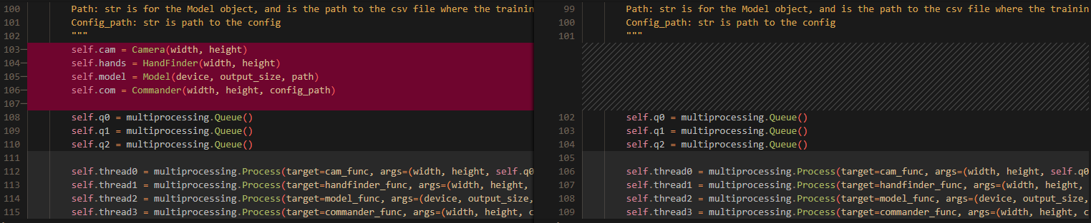
Removed a print statement I used to check the neural network was running properly
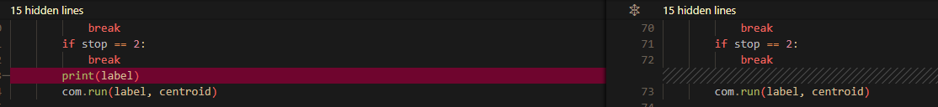
Changed what data was passed into the queues when the program terminates. Data was not being passed in with the correct format and was causing errors in the console when the program was terminated.
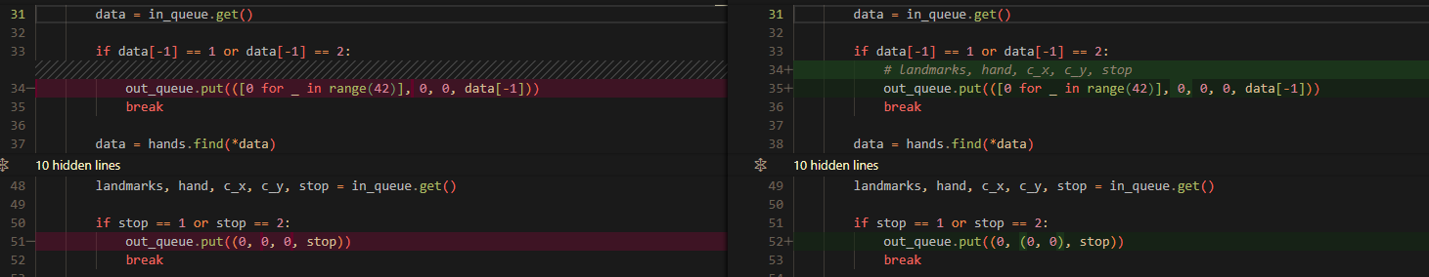

Changes to gui.py:
Removed a print statement

Completed project:

Camera.py:
import cv2 as cv
import numpy as np
from win32api import GetKeyState

class Camera:

def __init__(self, width: int, height: int):
"""
Initialises a class that acts as a wrapper around an opencv VideoCapture object
The width and height parameters will be set as the width and height dimensions that frames are grabbed at
"""
self.cam = cv.VideoCapture(0)
self.width = width
self.height = height

# 3 corresponds to width, 4 corresponds to height
self.cam.set(3, self.width)
self.cam.set(4, self.height)

def grab_frame(self) -> tuple[np.ndarray[np.ndarray[np.uint8]], int]:
"""
Grabs a frame from the user's webcam
If the user presses 'esc', the value of integer returned will be 1
If the camera fails to initialise or a frame cannot be grabbed it will return 2
A return value of 0 indicates that it is okay to continue
"""
ret, frame = self.cam.read()
stop = 0

# 27 is the UTF-8 code for 'esc'
key = GetKeyState(27)
if key == -127 or key == -128:
stop = 1
elif ret == False:
stop = 2

return frame, stop

Hand_finder.py:
import numpy as np
import cv2 as cv
import mediapipe as mp
mp_hands = mp.solutions.hands

COMPLEXITY = 0

class HandFinder:

def __init__(self, width: int, height: int):
"""
This class contains all the functionality to locate hand landmarks and normalise them
It contains a mediapipe hands object which is used for the location
The width and height parameters are the width and height of the users webcam, and is used for the normalisation process
"""
self.hands = mp_hands.Hands(model_complexity=COMPLEXITY,
min_detection_confidence=0.5,
min_tracking_confidence=0.5)
self.width = width
self.height = height

def find(self, frame: np.ndarray[np.ndarray[np.uint8]], stop: int) -> tuple[list[float], int, int, int, int]:
"""
Locates hands within the frame
Return the normalised landmarks, which hand is detected (0: left, 1: right), and the unnormalised centroid coordinates
"""
# Gets the results from the hands ai
frame = cv.flip(frame, 1)
frame = cv.cvtColor(frame, cv.COLOR_BGR2RGB)
results = self.hands.process(frame)

# Only runs if any hands are actually detected
if results.multi_hand_landmarks:
# Only uses data from the first hand detected to avoid issues with multiple hands
points = results.multi_hand_landmarks[0]
handedness = results.multi_handedness[0]
hand = handedness.classification[0].index

landmarks = []

for point in points.landmark:
# Converts the points from float values into integers for normalisation
# Take the minimum in case any points are calculated to be outside the webcam's dimensions
x = min(int(point.x * self.width), self.width - 1)
y = min(int(point.y * self.height), self.height - 1)
landmarks.append([x, y])

norm_landmarks = self._normalise(landmarks)
# This is the same effect as flattening the array
# e.g. reshape([[1, 2], [3, 4]], -1) = [1, 2, 3, 4]
norm_landmarks = np.reshape(norm_landmarks, -1)

# The 9th element is the middle finger joint, which is chosen to represent the centre as it's location is least affected by finger movement
centroid_x, centroid_y = landmarks[9]
else:
norm_landmarks = hand = centroid_x = centroid_y = None

return norm_landmarks, hand, centroid_x, centroid_y, stop

def _normalise(self, landmarks: list[list[int]]) -> np.ndarray[np.ndarray[float, float]]:
"""
Custom normalisation routine for converting hand landmarks anywhere in the frame into float values between 0 and 1
This ensures that the same gesture in a different part of the image will be represented by similar values
e.g. without this process, the ai will see a gesture more to the right as different as it's x values will be higher
Dry run to explain the process

landmarks = [[1, 2], [2, 4], [5, 3], [3, 3]]
x_min = 1
x_max = 5
y_min = 2
y_max = 4

subtract the minimum values:
landmarks - [x_min, y_min] = [[0, 0], [1, 2], [4, 1], [2, 1]]

multiply x values by 1 / (x_max - x_min) and y values by 1 / (y_max - x_min)
1 / (x_max - x_min) = 1/4
1 / (y_max - x_min) = 1/2
landmarks = [[0, 0], [0.25, 1], [1, 0.5], [0.5, 0.5]]

This process can be generally represented by these matrix operations:

||[x0, y0] | |[x_min, y_min]||
||[x1, y1] | |[x_min, y_min]||
|| . | | . || |[1 / (x_max - x_min), 0]|
|| . | - | . || * |[0, 1 / (y_max - y_min)]|
|| . | | . ||
||[x40, y40]| |[x_min, y_min]||
||[x41, y41]| |[x_min, y_min]||

(landmarks - [x_min, y_min]) * ([1 / (x_max - x_min), 0], [0, 1 / (y_max - y_min)])
"""
x_max, y_max = np.max(landmarks, axis=0)
x_min, y_min = np.min(landmarks, axis=0)

scale_matrix = np.array([[1 / (x_max - x_min), 0], [0, 1 / (y_max - y_min)]])
min_subtracted = np.array(landmarks) - [x_min, y_min]

return np.matmul(min_subtracted, scale_matrix)

Model.py:
import torch
import torch.nn as nn
import torch.nn.functional as F
import tkinter as tk
import os
from csv_handle import csvHandle
from tkinter import ttk

class FeedForwardNeuralNetwork(nn.Module):

def __init__(self, hidden_layer_size: int, output_size: int, dropout: float=None):
"""
Feed forward neural network with 3 linear layers
First layer: 42 inputs, hidden_layer_size outputs
Second layer: hidden_layer_size inputs, hidden_layer_size / 2 outputs
Third layer: hidden_layer_size / inputs, output_size outputs
Each layer uses the ReLU activation function
Dropout determines what percentage of the neurones are turned off during training each epoch
"""
super().__init__()
self.l1 = nn.Linear(42, hidden_layer_size)
self.l2 = nn.Linear(hidden_layer_size, hidden_layer_size)
self.l3 = nn.Linear(hidden_layer_size, hidden_layer_size // 2)
self.l4 = nn.Linear(hidden_layer_size // 2, output_size)
if dropout:
self.d1 = nn.Dropout(dropout)
self.d2 = nn.Dropout(dropout)
else:
self.d1 = self.d2 = None

def forward(self, X):
"""
Forward pass of the neural network
"""
X = F.relu(self.l1(X))
X = F.relu(self.l2(X))
if self.d1:
X = self.d1(X)
X = F.relu(self.l3(X))
if self.d2:
X = self.d2(X)
X = F.relu(self.l4(X))
# return F.softmax(X)
return X

class Model:

def __init__(self, device: str, output_size: int, path: str):
"""
A class that containst a FeedForwardNeuralNetwork
Enables label prediction and retraining of the network
device can be either cuda or cpu, which determines which one the model will run on
output_size determines how many possible labels the network can output
"""
self.device = device
self.FFNN = FeedForwardNeuralNetwork(128, output_size, 0.5)
if os.path.exists(".\\model.pickle"):
self.FFNN.load_state_dict(torch.load(".\\model.pickle", weights_only=False))
self.handle = csvHandle(path)

def predict(self, landmarks: list[float], centroid: list[int, int], stop: int):
"""
Gets the output from the neural network and performs an argmax to get the label it chose
Returns landmarks, centroid, and stop
"""
self.FFNN = self.FFNN.to(self.device)
self.FFNN.eval()
# The input tensor must be on the same device as the model in order to run
landmarks = torch.tensor(landmarks, dtype=torch.float).to(self.device)
y = self.FFNN(landmarks)

label = torch.argmax(y).item()
return label, centroid, stop

def retrain(self, bar: ttk.Progressbar) -> None:
"""
Retrains the model using all data available in the csv file
Will also step a progressbar at each step to give the user an indication of how long it will take
The number of epochs used = 300 * (n - (n % 5)) where n is the number of labels
"""
X, Y = self.handle.prepare_data()

n = self.handle.count_labels()

# A new FFNN must be created as to not reuse the previous weights, as they will not work in case the amount of labels has increased
self.FFNN = FeedForwardNeuralNetwork(128, n, 0.5)

loss_fn = nn.CrossEntropyLoss()
# Everything must be transferred to the same device in order to work
self.FFNN = self.FFNN.to(self.device)
loss_fn = loss_fn.to(self.device)

X = torch.tensor(X, dtype=torch.float).to(self.device)
Y = torch.tensor(Y, dtype=torch.int64).reshape(-1).to(self.device)

optimiser = torch.optim.Adam(self.FFNN.parameters())

n = self.handle.count_labels()
epochs = 300 * (n - (n % 5))
# This way the bar has an equal number of steps as epochs, so each epoch only bar.step() must be called, no extra maths
# 1 has to be added to epochs to stop it from resetting back to 0 when it reaches the final epoch
bar.config({"maximum": epochs + 1})

for epoch in range(epochs):
optimiser.zero_grad()

Y_pred = self.FFNN(X)

loss = loss_fn(Y_pred, Y)

loss.backward()
optimiser.step()
bar.step()

torch.save(self.FFNN.state_dict(), '.\\model.pickle')
bar.step()

Commander.py:
import pyautogui
import threading
from funcs import *
from config import Config
from typing import Callable

class Commander:

def __init__(self, width: int, height: int, config_path: str):
"""
A class whose purpose is to encapsulate all of the interaction with the computer
Controls moving the mouse and executing gestures
Width and height are the width and height of the webcam
"""
self.width = width
self.height = height
# Fill with -1 as -1 wont be assigned to any gesture
self._gesture_queue = [-1 for _ in range(11)]
self._label_to_func = _str_to_func(config_path)

def _move_mouse(self, centroid: list[int, int]) -> None:
"""
Moves the mouse to the X and Y coordinate determined by the centroid
"""
x, y = centroid

x = self._calc_coord(x, 'x')
y = self._calc_coord(y, 'y')

pyautogui.moveTo(x, y)

def _calc_coord(self, coord: int, type: str):
"""
Converts the coordinate from in the webcam space to the equivalent in the screen space
Cuts off 15% from the sides in order to make it easier to move the mouse to the extremites of the screen
"""
if type == 'x':
webcam_dim = self.width
screen_dim = pyautogui.size()[0]
else:
webcam_dim = self.height
screen_dim = pyautogui.size()[1]

# Cut off 15% from the sides
coord = max(coord, 0.15 * webcam_dim)
coord = min(coord, 0.85 * webcam_dim)

# Convert the origin from (0.15 * webcam_x, 0.15 * webcam_y) to (0, 0)
coord -= 0.15 * webcam_dim
# Normalise to between 0 and 1
coord /= 0.7 * webcam_dim

coord = int(coord * screen_dim)
return coord

def _execute_gesture(self, label: int) -> None:
"""
Executes a gesture given the label prediction
Only executes a gesture when it has been held for exactly 10 frames
"""
self._gesture_queue.pop(0)
self._gesture_queue.append(label)

valid = True

# The first element in the queue cannot be same as the other 10, to ensure it only gets executed once after the first 10 frames
if self._gesture_queue[0] == self._gesture_queue[1]:
valid = False
return

for i in range(2, len(self._gesture_queue)):
if self._gesture_queue[i] != self._gesture_queue[i - 1]:
valid = False
return

if valid:
self._label_to_func[label]()

def run(self, label: int, centroid: list[int, int]) -> None:
"""
Takes the label and centroid information
Moves the mouse to the new coordinate
Executes the gesture if it has been held for exactly 10 frames
"""
move_thread = threading.Thread(target=self._move_mouse, args=(centroid,))
execute_thread = threading.Thread(target=self._execute_gesture, args=(label,))
move_thread.start()
execute_thread.start()

def osk():
pyautogui.hotkey('win', 'ctrl', 'o')

def none():
pass

def _str_to_func(config_path: str) -> dict[int: Callable]:
"""
Maps using the label_to_str.json file
label_to_str contains an integer to string mapping, and this method contains a string to function mapping
This is converted into an integer to function mapping, which is what is returned
"""
config = Config()
config.load(config_path)

label_to_str = config.json_dict['label_to_button']

label_to_func = {}

# Functions that the user can assign to a gesture
# left, right, double and middle click are implemented using their respective pyautgui functions
# Opening an on screen keyboard has its own function
# Keyboard keys to be used using pyautogui: nexttrack, prevtrack, printscr, windows, delete, browserback, browserforward, browserrefresh, pageup, pagedown, volumeup, volumedown, volumemute
# Also have a None function if the user wants a gesture that wont execute anything

for label in label_to_str:
label_to_func[int(label)] = func_from_str(label_to_str[label])

return label_to_func

Funcs.py:
import pyautogui

def osk():
pyautogui.hotkey('win', 'ctrl', 'o')

def click():
pyautogui.click()

def right_click():
pyautogui.rightClick()

def middle_click():
pyautogui.middleClick()

def double_click():
pyautogui.doubleClick()

def none():
pass

def nexttrack():
pyautogui.press('nexttrack')

def prevtrack():
pyautogui.press('prevtrack')

def printscr():
pyautogui.press('printscr')

def win():
pyautogui.press('win')

def delete():
pyautogui.press('Delete')

def browserback():
pyautogui.press('browserback')

def browserforward():
pyautogui.press('browserforward')

def browserrefresh():
pyautogui.press('browserrefresh')

def pageup():
pyautogui.press('pageup')

def pagedown():
pyautogui.press('pagedown')

def volumeup():
pyautogui.press('volumeup')

def volumedown():
pyautogui.press('volumedown')

def volumemute():
pyautogui.press('volumemute')

def esc():
pyautogui.press('esc')

def func_from_str(s: str):
str_to_key = {'Next Track': nexttrack, 'Prev Track': prevtrack, 'Print Screen': printscr, 'Windows': win, 'Delete': delete, 'Browser Back': browserback,
'Browser Forward': browserforward, 'Browser Refresh': browserrefresh, 'Page Up': pageup, 'Page Down': pagedown, 'Volume Up': volumeup,
'Volume Down': volumedown, 'Mute': volumemute, 'Escape': esc, 'On Screen Keyboard': osk, 'Left Click': click, 'Right Click': right_click,
'Middle Click': middle_click, 'Double Click': double_click, 'None': none}
return str_to_key[s]

Config.py:
import json

class Config:

def __init__(self):
"""
Class for storing configuration data
Data is accessed using the json_dict attribute, which is a dictionary
There are 2 valid forms of configuration data

Config:
Contains data about settings the user has chosen
'device': 'cuda'/'cpu'
'cam_width': int
'cam_height': int
'label_to_button': {int: str} - Maps from a label to the string representation of the function it invokes

Label_to_str:
{int : str} - Maps from a label to the name of the gesture, which is what the user sees when adding a new gesture
"""
self.path = None
self.json_dict = {}

def save_as(self, path: str) -> None:
"""
Saves the current configuration data under a new path
"""
self.path = path

with open(self.path, 'w') as f:
json.dump(self.json_dict, f)

def save(self) -> None:
"""
Saves new configuration data under the current path
"""
with open(self.path, 'w') as f:
json.dump(self.json_dict, f)

def load(self, path: str) -> int:
"""
Attempts to load data from a new path
Returns an integer detailing wether there was a success or not
0: An invalid file was loaded
1: A valid label_to_str file was loaded
2: A valid config file was loaded
"""
if not path.endswith('.json'):
return 0

with open(path, 'r') as f:
json_dict = json.load(f)

valid = self._is_valid(json_dict)

if valid != 0:
self.path = path
self.json_dict = json_dict
if valid == 2:
with open('config_path.txt', 'w') as f:
f.write(path)
return valid
else:
return 0

def _is_valid(self, json_dict: dict) -> int:
"""
Checks if the data in the file is of a valid configuration for either
0: Invalid
1: label_to_str
2: config
"""
keys = json_dict.keys()
required = {'device', 'cam_width', 'cam_height', 'label_to_button'}

all_int = self._all_keys_int(json_dict)

# If not all of the required keys are present, and they arent all integers (label_to_str)
if any([r not in keys for r in required]) and not all_int:
return 0
if self._all_keys_int(json_dict):
return 1
# If it contains all the required keys, but has extra, then it is invalid
if len(keys) > 4:
return 0
# Checks that all the keys in the label_to_button field are integers
if self._all_keys_int(json_dict['label_to_button']):
return 2
# If not it is invalid
return 0

def _all_keys_int(self, json_dict: dict) -> bool:
"""
Returns True if all the keys are integers, otherwise False
"""
keys = json_dict.keys()

# The keys are all stored as strings
# If converting from string to integer raises an error, then it must not be an integer
for key in keys:
try:
int(key)
except ValueError:
return False

return True

Mainloop_runner.py:
import multiprocessing
import tkinter as tk
from camera import Camera
from hand_finder import HandFinder
from model import Model
from commander import Commander

def cam_func(width: int, height: int, out_queue: multiprocessing.Queue):
"""
Function for the process that runs the Camera
"""
cam = Camera(width, height)

while True:
frame, stop = cam.grab_frame()

out_queue.put((frame, stop))

if stop == 1 or stop == 2:
break

def handfinder_func(width: int, height: int, in_queue: multiprocessing.Queue, out_queue: multiprocessing.Queue):
"""
Function for the process that runs the HandFinder
"""
hands = HandFinder(width, height)

while True:
data = in_queue.get()

if data[-1] == 1 or data[-1] == 2:
# landmarks, hand, c_x, c_y, stop
out_queue.put(([0 for _ in range(42)], 0, 0, 0, data[-1]))
break

data = hands.find(*data)
out_queue.put(data)

def model_func(device: str, output_size: int, path: str, in_queue: multiprocessing.Queue, out_queue: multiprocessing.Queue):
"""
Function for the process that runs the Model
"""
model = Model(device, output_size, path)

while True:
landmarks, hand, c_x, c_y, stop = in_queue.get()

if stop == 1 or stop == 2:
out_queue.put((0, (0, 0), stop))
break

# If no hands have been detected, then this wont run and nothing will be placed in the queue
if landmarks is not None:
data = model.predict(landmarks, [c_x, c_y], stop)

out_queue.put(data)

def commander_func(width: int, height: int, config_path: str, in_queue: multiprocessing.Queue):
"""
Function for the process that runs the Commander
"""
com = Commander(width, height, config_path)

while True:
label, centroid, stop = in_queue.get()

if stop == 1:
break
if stop == 2:
break
com.run(label, centroid)

def error_window():
"""
Reports to the user when there is an issue with connecting to the webcam
"""
root = tk.Tk()
root.geometry = "420x360"

l1 = tk.Label(root, text="There was an error running the program.")
l1.pack()
l2 = tk.Label(root, text="Try checking your webcam is plugged in")
l2.pack()

root.mainloop()

class MainloopRunner:

def __init__(self, width: int, height: int, device: str, output_size: int, path: str, config_path: str):
"""
Class that runs the main loop of the program, i.e. grabbing frames -> executing commands and moving the mouse
Width: int is the width of the webcam
Height: int is the the height of the webcam
Device: str is what device the neural network will be run on ('cuda' or 'cpu')
Ouput_size: int is how many different gestures hte neural network has to predict from
Path: str is for the Model object, and is the path to the csv file where the training data is stored
Config_path: str is path to the config
"""
self.q0 = multiprocessing.Queue()
self.q1 = multiprocessing.Queue()
self.q2 = multiprocessing.Queue()

self.thread0 = multiprocessing.Process(target=cam_func, args=(width, height, self.q0,))
self.thread1 = multiprocessing.Process(target=handfinder_func, args=(width, height, self.q0, self.q1,))
self.thread2 = multiprocessing.Process(target=model_func, args=(device, output_size, path, self.q1, self.q2,))
self.thread3 = multiprocessing.Process(target=commander_func, args=(width, height, config_path, self.q2,))

def run(self) -> None:
"""
Runs the mainloop by starting all the 4 threads used in the loop
"""
self.thread0.start()
self.thread1.start()
self.thread2.start()
self.thread3.start()

CSV_handle.py:
import pandas as pd
import numpy as np
import csv

class csvHandle:

def __init__(self, path: str):
"""
Creates an object that allows for all the needed interaction with the csv file
Path is the path to the csv file
"""
self.path = path

def add_row(self, label: int, right_hand: bool, landmarks: list[float]) -> None:
"""
Adds a new row to the csv file
The format of each row is:
[label: int, right_hand: int, landmark_0, landmark_1, ..., landmark_41]
"""
hand = 1 if right_hand else 0
data = [label] + [hand] + landmarks

with open(self.path, 'a') as f:
writer = csv.writer(f)
writer.writerow(data)

def prepare_data(self) -> tuple[np.ndarray[np.ndarray[np.float_]], np.ndarray[np.float_]]:
"""
Returns X and Y data in a format that can be used by the neural network
X contains all the landmark data
Y contains all the label data
The right handedness data is removed
The csv also get shuffled to avoid long lengths of the same label appearing
"""
data = pd.read_csv(self.path)

# Sample(frac=1) takes a random sample whose size is the same as the entire csv file
# reset_index(drop=True) enables the indices to be reset so the order of the file actually changes
# data = data.sample(frac=1).reset_index(drop=True)
data = data.sample(frac=1)

cols = data.columns
# First column is the label, second column is handedness, and the remaining columns are landmark data
Y, X = data[cols[0]], data[cols[2:]]
X = X.to_numpy()
Y = Y.to_numpy()

return X, Y

def count_labels(self) -> int:
"""
Returns how many different labels are present in the data
"""
data = pd.read_csv(self.path)

# Only the first column contains label data
labels = data[[data.columns[0]]]
# Get rid of unnecessary DataFrame information (indices and column)
labels = labels.values
# Labels.values returns a 2d array where each subarray contains only one element
# It needs to be flattened in order to be usable
labels = labels.reshape(-1)
# Convert to a set so only one of each values occurs
labels = set(labels)
# The length of the set is the number of unique labels that occur
n = len(labels)

return n

Gesture_adder.py:
import cv2 as cv
from tkinter import ttk
from camera import Camera
from hand_finder import HandFinder
from model import Model
from config import Config
from mainloop_runner import error_window

class GestureAdder:

def __init__(self, label_to_str: Config, bar: ttk.Progressbar, label: str, width: int, height: int, device: str, path: str):
"""
Class that contains the code for allowin ghte user to add new gestures
label_to_str is the integer label to string mapping config file
bar is the bar that will be updated during retraining
label is the string the user has inputted to identify the getsture
width is the width of the webcam
height is the height of the webcam
device is the device the model will be run on
path is the path to the csv file
"""
self.label = label
self.label_to_str = label_to_str

max_int = max([int(key) for key in self.label_to_str.json_dict.keys()])
self.label_int = max_int + 1
self.label_to_str.json_dict[str(self.label_int)] = self.label
self.label_to_str.save()

self.bar = bar

self.cam = Camera(width, height)
self.hands = HandFinder(width, height)
self.model = Model(device, self.label_int, path)
self.handle = self.model.handle

def run(self):
"""
Runs the program that allows the user to add new gestures
Press 'enter' to take a photo, and the hand data will be added to the csv file
When 250 of each hand are taken, it will retrain the model
"""
right_count = 0
left_count = 0

while right_count < 251 or left_count < 251:
frame, stop = self.cam.grab_frame()

if stop == 2:
error_window()
break

if cv.waitKey(1) == 13: # Code for 'enter'
landmarks, hand, c_x, c_y, stop = self.hands.find(frame, stop)

# Only run if the count for the given hand is less than 500 to avoid skewing the data with too much of one hand
# The statement in the XOR for the hand that isnt detected is automatically false
# So it will only run if the hand found has less than 500 already taken
# if landmarks is not None and ((hand == 1 and right_count < 500) ^ (hand == 0 and left_count < 500)):
if landmarks is not None:
if (hand == 1 and right_count < 251) ^ (hand == 0 and left_count < 251):
# If hand is 1 (right): r +=1, l += 0
# If hand is 0 (left): r += 0, l += 1
# This can be rewritten as r += hand, l += not hand
right_count += hand
left_count += int(not hand)

self.handle.add_row(self.label_int, hand, landmarks.tolist())

font = cv.FONT_HERSHEY_SIMPLEX
font_scale = 1
colour = (0, 255, 0)
thickness = 2
linetype = cv.LINE_AA
frame = cv.putText(frame, f'Left count: {left_count}', (10, 25), font, font_scale, colour, thickness, linetype)
frame = cv.putText(frame, f'Right count: {right_count}', (10, 70), font, font_scale, colour, thickness, linetype)
cv.imshow(f'Adding gesture {self.label}', frame)

self.model.retrain(self.bar)

GUI_edit_config.py:
import tkinter as tk
from config import Config

def invalid_int_win():
"""
Opens a window informing the user that they have entered an invalid value
"""
error_win = tk.Tk()
l = tk.Label(error_win, text='Enter a valid positive integer')
l.grid(row=0, column=0)
error_win.mainloop()

def valid_int(val: tk.StringVar) -> bool:
"""
Returns True if the value given is a positive integer, otherwise opens a window telling the user of the error, and returns False
"""
try:
if int(val.get()) < 0:
invalid_int_win()
return False
return True
except ValueError:
invalid_int_win()
return False

def assign_val_if_valid(field: str, config: Config, val: tk.StringVar) -> int:
"""
If the value is a valid integer, it writes it into the config object and returns 0
If invalid returns -1
"""
if valid_int(val):
config.json_dict[field] = val.get()
return 0
else:
return -1

def save_changes(vals: list[tk.StringVar], config: Config, win: tk.Tk):
"""
Saves the changes to the config file if the width and height values are positive integers
If the changes are invalid, none will be saved
"""
config.json_dict['device'] = vals[0].get()
if assign_val_if_valid('cam_width', config, vals[1]) == -1:
return
if assign_val_if_valid('cam_height', config, vals[2]) == -1:
return

for i in range(3, len(vals)):
# label_to_button starts at 0, but the settings to be stored in them starts at vals[3]
config.json_dict['label_to_button'][str(i - 3)] = vals[i].get()

config.save()
win.destroy()

def edit_config_win(label_to_str: Config, config: Config):
"""
Creates the window where the user can edit their config settings
"""
N = max([int(key) for key in label_to_str.json_dict.keys()])

root = tk.Tk()

device_label = tk.Label(root, text='Device')
device_label.grid(row=0, column=0)
devices = ['cpu', 'cuda']
device = tk.StringVar()
device.set(config.json_dict['device'])
device_menu = tk.OptionMenu(root, device, *devices)
device_menu.grid(row=0, column=1)

width_label = tk.Label(root, text='Webcam width')
width_label.grid(row=1, column=0)
width = tk.StringVar()
width.set(config.json_dict['cam_width'])
width_entry = tk.Entry(root, textvariable=width)
width_entry.grid(row=1, column=1)

height_label = tk.Label(root, text='Webcam height')
height_label.grid(row=2, column=0)
height = tk.StringVar()
height.set(config.json_dict['cam_height'])
height_entry = tk.Entry(root, textvariable=height)
height_entry.grid(row=2, column=1)

gesture_options = ['Next Track', 'Prev Track', 'Print Screen', 'Windows', 'Delete',
'Browser Back', 'Browser Forward', 'Browser Refresh', 'Page Up',
'Page Down', 'Volume Up', 'Volume Down', 'Mute', 'Escape', 'On Screen Keyboard',
'Left Click', 'Right Click', 'Middle Click', 'Double Click', 'None']

stringvars = []
menus = []
for i in range(N):
l = tk.Label(root, text=f'{label_to_str.json_dict[str(i)]}')
# I wrote this as 2 + i + 1 to make it clearer that the first 2 are already used
# Then incrementing i increments the location of the object once
# and the +1 exists to prevent it overlapping with the previous objects
l.grid(row=2 + i + 1, column=0)
var = tk.StringVar()
stringvars.append(var)
var.set(config.json_dict['label_to_button'][str(i)])
menu = tk.OptionMenu(root, var, *gesture_options)
menus.append(menu)
menu.grid(row=2 + i + 1, column=1)

vals = [device, width, height] + stringvars
save_button = tk.Button(root, text='Save changes', command=lambda: save_changes(vals, config, root))
save_button.grid(row=2 + N + 2, column=0)

root.mainloop()

GUI_run_edit_config.py:
from config import Config
from gui_edit_config import edit_config_win

def main():
label_to_str = Config()
label_to_str.load('.\\label_to_str.json')
config = Config()
config.load(open('.\\config_path.txt').read())
edit_config_win(label_to_str, config)

if __name__ == '__main__':
main()

GUI.py:
import tkinter as tk
import multiprocessing
import threading
import shutil
import os
from tkinter import ttk
from tkinter import filedialog
from tkinter import simpledialog
from tkinter import messagebox
from config import Config
from mainloop_runner import MainloopRunner
from gesture_adder import GestureAdder

class GUI:

def __init__(self):
"""
Initialising this object runs the whole app
"""
self.root = tk.Tk()

self._save_config_as_button = tk.Button(self.root, text='Save config as', width=22, height=2, command=self.save_config_as)
self._save_config_as_button.grid(row=0, column=0)

self._load_config_as_button = tk.Button(self.root, text='Load config', width=22, height=2, command=self.load_config)
self._load_config_as_button.grid(row=0, column=1)

self._edit_config_button = tk.Button(self.root, text='Edit config', width=22, height=2, command=self.edit_config)
self._edit_config_button.grid(row=0, column=2)

self._help_button = tk.Button(self.root, text='Help', width=10, height=2, command=self.help)
self._help_button.grid(row=0, column=5, padx=(75, 0))

self._start_button = tk.Button(self.root, text='Start program', width=15, height=5, command=self.start)
self._start_button.grid(row=3, column=1, padx=40, pady=50)

self._add_new_gesture_button = tk.Button(self.root, text='Add new gesture', width=15, height=5, command=self.add_new_gesture)
self._add_new_gesture_button.grid(row=3, column=3, padx=40, pady=50)

self._reset_button = tk.Button(self.root, text='Reset', width=10, height=2, command=self.reset)
self._reset_button.grid(row=5, column=5, padx=(75, 0))

self._config_path = open('.\\config_path.txt', 'r').read()

self.label_to_str = Config()
self.label_to_str.load('.\\label_to_str.json')

self.config = Config()
self.config.load(self._config_path)

self.root.mainloop()

def save_config_as(self):
"""
Asks for a string from the user that will be the filename
.\\ is added to the beginning of the string to make sure it is saved in the main directory
.json is added to the end to make sure it is saved a .json file
The config_path.txt file is also updated appropriately
"""
path = '.\\' + simpledialog.askstring('Save config as', 'Enter filename (.json will be added to the end)') + '.json'

self.config.save_as(path)
self._config_path = path

with open('.\\config_path.txt', 'w') as f:
f.write(path)

def load_config(self):
"""
Opens a file explorer window where the user has to open a config file
If the file is not valid, nothing happens
"""
path = filedialog.askopenfilename()

success = self.config.load(path)
if success == 2:
self._config_path = path
with open('.\\config_path.txt', 'w') as f:
f.write(path)

def start(self):
"""
Starts the main loop of the program
"""
width = self.config.json_dict['cam_width']
height = self.config.json_dict['cam_height']
device = self.config.json_dict['device']
# Has to add one as the keys as 0-indexed, so if there are 7 outputs, the max key is only 6
output_size = max([int(key) for key in self.label_to_str.json_dict.keys()]) + 1
path = '.\\data.csv'

info_win = tk.Tk()
l1 = tk.Label(info_win, text="Program starting. Press 'esc' on\n the keyboard, or bind a gesture\n to 'esc',to close the application")
l1.grid(row=0, column=0)

# Has to be spawned in its own process otherwise the tkinter mainloop will prevent it from running
p = multiprocessing.Process(target=run_mainloop, args=(width, height, device, output_size, path, self._config_path, ))
p.start()

info_win.mainloop()

def add_new_gesture(self):
"""
Asks the user for a string which will be the label for the new gesture
Then runs the code for adding a gesture
Also opens a tkinter window with a progress bar that indicates how far along the NN is in training after the data has been gathered
"""
label = simpledialog.askstring('Add new gesture', 'Enter name of new gesture')

if label is not None:
progress_win = tk.Tk()
l = tk.Label(progress_win, text='Retraining. Do not close this window')
l.grid(row=0, column=0)

bar_step = tk.IntVar()
bar_step.set(0)
bar = ttk.Progressbar(progress_win, variable=bar_step)
bar.grid(row=1, column=0)

width = self.config.json_dict['cam_width']
height = self.config.json_dict['cam_height']
device = self.config.json_dict['device']
path = '.\\data.csv'

# These have to be threads not processes, as launching a process requires pickling all the args
# Unfortunately both tkinter objects and Config objects are not pickleable
adder_thread = threading.Thread(target=adder_helper, args=(self.label_to_str, bar, label, width, height, device, path,))
destroy_thread = threading.Thread(target=destroy_helper, args=(progress_win, bar, bar_step))
adder_thread.start()
destroy_thread.start()

progress_win.mainloop()

def reset(self):
"""
Copys data from all the default files to the actual files
Will delete any extra gestures that have been added
"""
choice = messagebox.askokcancel('Reset', 'You are about to reset to default settings. Any extra gestures you have added will be deleted')
if choice:
shutil.copyfile('.\\default_data.csv', '.\\data.csv')
shutil.copyfile('.\\default_label_to_str.json', '.\\label_to_str.json')
shutil.copyfile('.\\default_config.json', '.\\config.json')
with open('.\\config_path.txt', 'w') as f:
f.write('.\\config.json')

shutil.copyfile('.\\default_model.pickle', '.\\model.pickle')

def edit_config(self):
"""
Opens the window where the user can edit all the config files
"""
# For some weird reason running this exact code in thie file breaks all the option menus
# making them stop showing the user what value is current selected
# The program technically still runs, but the user won’t be able to see what they selected
# which would obviously be super annoying
# this is the only way I have found to fix it so do not change it
os.system('python repo\\gui_run_edit_config.py')

def help(self):
"""
Opens word document guiding the user on how to use the program
"""
os.system('.\\help.docx')

def run_mainloop(width: int, height: int, device: str, output_size: int, path: str, config_path: str):
"""
Helper function that initialises a MainloopRunner object and runs it
"""
runner = MainloopRunner(width, height, device, output_size, path, config_path)
runner.run()

def adder_helper(label_to_str: Config, bar: ttk.Progressbar, label: str, width: int, height: int, device: str, path: str):
"""
Helper function that initialises a GestureAdder object and runs it
"""
adder = GestureAdder(label_to_str, bar, label, width, height, device, path)
adder.run()

def destroy_helper(bar_win: tk.Tk, bar: ttk.Progressbar, step: tk.IntVar):
"""
Helper function that checks the current step of the progress bar, and if it is completed, destroys the window to indicate to the user it is done
"""
maximum_step = bar.config()['maximum'][-1] - 1
while True:
if step.get() == maximum_step:
bar_win.destroy()

Main.py:
from gui import GUI

def main():
gui = GUI()

if __name__ == '__main__':
main()

Testing

Testing Log

Day 1

Camera FPS test
This test grabs frames from the camera for 5 seconds (assuming 30fps) 300 times and calculates the mean framerate of each test.
from camera import Camera
import time

def main():
cam = Camera(1280, 720)
fps = []

for i in range(300):
print(f'At test{i}')

start = time.perf_counter()
n = 0
for j in range(150):
n += 1
cam.grab_frame()
dur = time.perf_counter() - start
fps.append(n / dur)
print(n / dur)

print(f'Mean FPS: {sum(fps) / len(fps)}')

if __name__ == '__main__':
main()

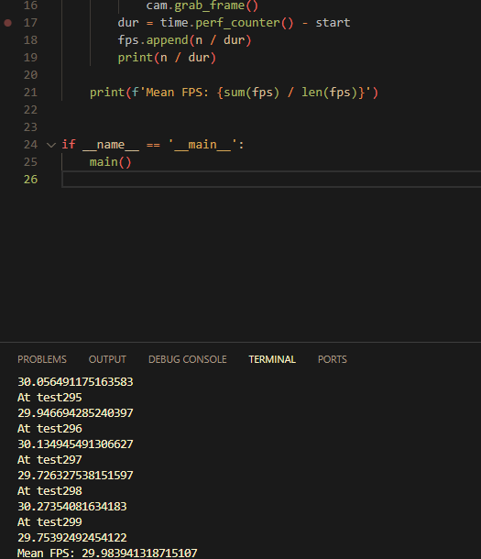
This confirms that the camera grabs frames at 30fps.

Camera function test
This test confirms that the camera object can grab and return frames from the webcam.
from camera import Camera
import cv2 as cv

def main():
cam = Camera(1280, 720)
stop = 0

while True:
frame, stop = cam.grab_frame()

if stop != 0:
break

cv.imshow('capture', frame)
print(f'Stopped as stop returned value of: {stop}')

if __name__ == '__main__':
main()

Running the camera:
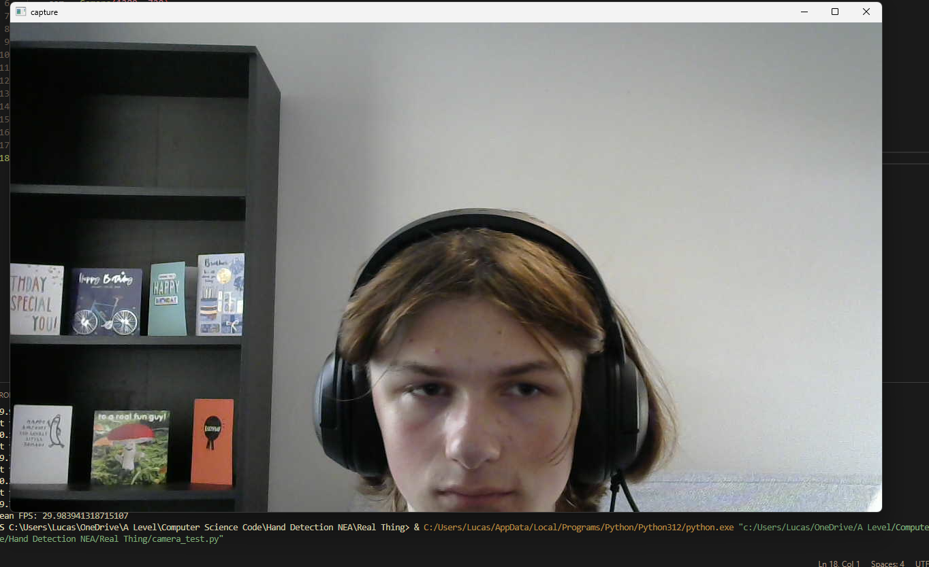
The camera does successfully grab frames.
Pressing ‘esc’ does return a value of 1:
When running without a webcam connected, the value of 2 is returned:

Day 2

Handfinder working test
This first test verifies that the HandFinder returns normalised landmarks between 0 and 1, doesn’t affect the value of stop, returns landmarks that are in a 1d array, it returns integer values for the centroid coordinates, and that the centroid is in the correct part of the hand.
Here is the code:
import cv2 as cv
import numpy as np
from hand_finder import HandFinder
from camera import Camera

def main():
cam = Camera(1280, 720)
hands = HandFinder(1280, 720)

while True:
frame, stop = cam.grab_frame()

if stop != 0:
break

prev_stop = stop

landmarks, c_x, c_y, stop = hands.find(frame, stop)

if landmarks is not None and c_x and c_y:
assert(all([l >= 0 and l <= 1 for l in landmarks]))
assert(stop == prev_stop)
assert(len(landmarks.shape) == 1)
assert(type(c_x) == int)
assert(type(c_y) == int)

frame = cv.circle(frame, (c_x, c_y), 15, (0, 255, 0), -1)

cv.imshow('frame with detected centroid', frame)

if __name__ == '__main__':
main()

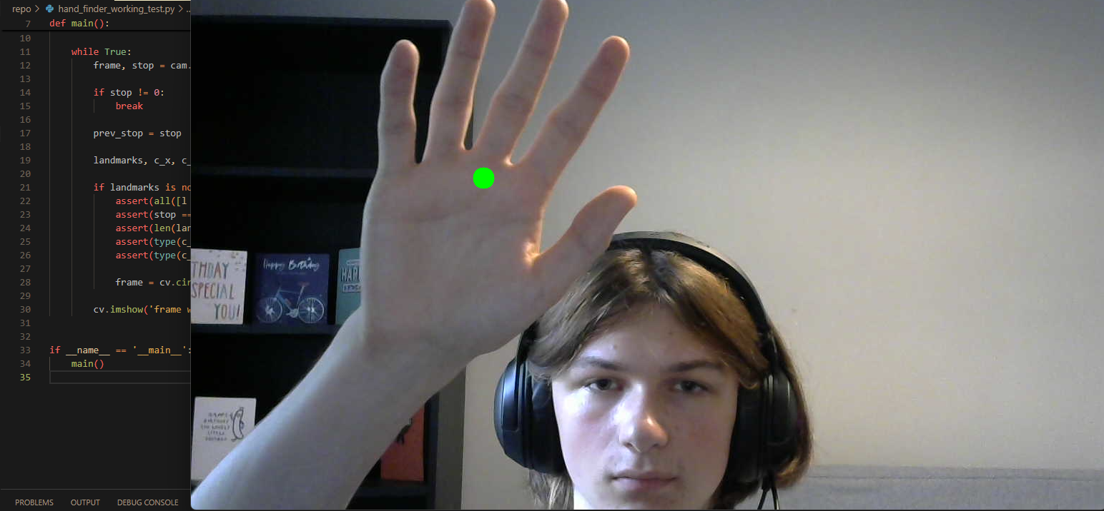
As can be seen, all the assertions pass, and the centroid is in the correct location

Handfinder time test
This test runs the handfinder 1000 times and calculates the mean amount of time (in ms) it takes to complete the detection and normalization. To ensure the worst case scenario, my hand is held in front of the camera the entire time to ensure it is detecting hands and having to carry out normalisation.
The code:
import cv2 as cv
import numpy as np
from hand_finder import HandFinder
from camera import Camera

def main():
cam = Camera(1280, 720)
hands = HandFinder(1280, 720)

while True:
frame, stop = cam.grab_frame()

if stop != 0:
break

prev_stop = stop

landmarks, c_x, c_y, stop = hands.find(frame, stop)

if landmarks is not None and c_x and c_y:
assert(all([l >= 0 and l <= 1 for l in landmarks]))
assert(stop == prev_stop)
assert(len(landmarks.shape) == 1)
assert(type(c_x) == int)
assert(type(c_y) == int)

frame = cv.circle(frame, (c_x, c_y), 15, (0, 255, 0), -1)

cv.imshow('frame with detected centroid', frame)

if __name__ == '__main__':
main()
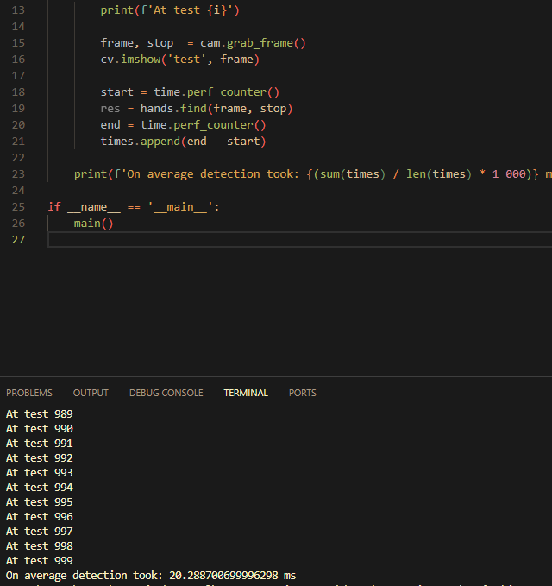

As can be seen, the detection takes just over 20ms, well within the maximum allowed time budget of 33.3ms.

Day 3
This part of the log contains tests for the csvHandle object

Add_row test:
This row tests that the add_row method correctly adds a row of random data to a test csv file
Code:
from csv_handle import csvHandle
import pandas as pd
import random

PATH = '.\\test_data.csv'

def main():
handle = csvHandle(PATH)
df = pd.read_csv(PATH)
print(df)
n = len(df)

data = [random.randint(0, 10)] + [random.choice([0, 1])] + [random.random() for _ in range(42)]
handle.add_row(data[0], data[1], data[2:])

print(pd.read_csv(PATH))
assert(len(pd.read_csv(PATH)) == n + 1)

if __name__ == '__main__':
main()

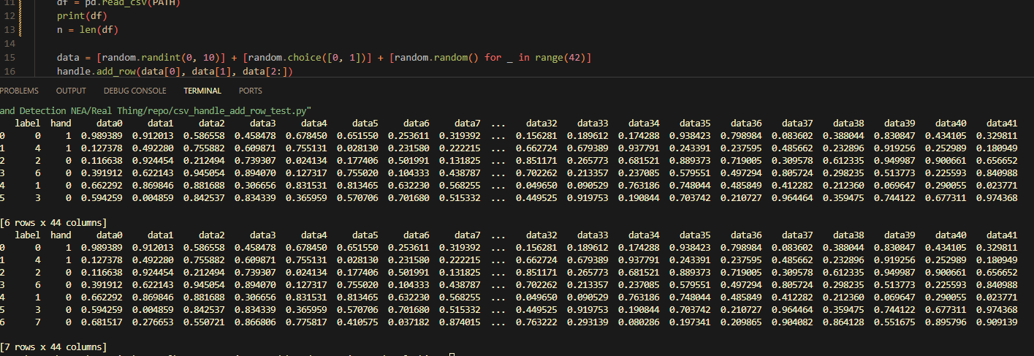
As can be seen, the assertion passes, and there is a new row in the csv file, with all correct data types in the correct columns.

Prepare_data test
This test tests that the prepare_data method returns the correct data in the X and Y variables, and are randomised in order.
Code:
import pandas as pd
from csv_handle import csvHandle

PATH = '.\\test_data.csv'

def main():
df = pd.read_csv(PATH)
print(df)
handle = csvHandle(PATH)

X, Y = handle.prepare_data()

print(X)
print(Y)

assert len(df) == len(X)

if __name__ == '__main__':
main()

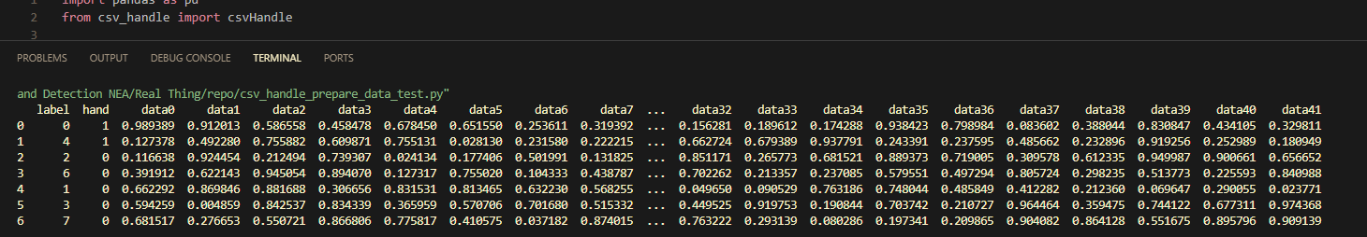
This is what the normal file looks like.
As seen on the next page, the X variable contains all the data from the data columns in a different order, and the Y variable is in the same order.
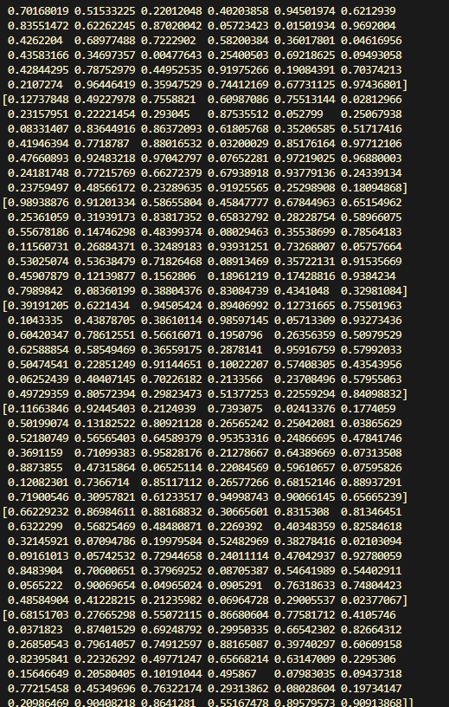

Model Retrain updates bar test
This code tests that running model.retrain with a progress bar successfully updates the progress bar.
Code:
import tkinter as tk
import threading
from tkinter import ttk
from model import Model
from csv_handle import csvHandle

def retrain_helper(bar, n):
model = Model('cuda', n, '.\\test_data.csv')
model.retrain(bar)

def retrain(bar, n):
t = threading.Thread(target=retrain_helper, args=(bar, n))
t.start()

def main():
root = tk.Tk()

bar = ttk.Progressbar(root)
bar.pack()

handle = csvHandle('.\\test_data.csv')
n = handle.count_labels()

b = tk.Button(root, command=lambda: retrain(bar, n))
b.pack()

root.mainloop()

if __name__ == '__main__':
main()

Results:
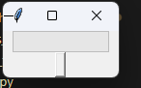
Before the button is pressed
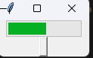
After the button is pressed

Day 4:

Model accuracy test:
After having generated the initial training data for the AI, I wrote a script that would use the retrain method to train it on the data created, and output the accuracy, to test whether the neural network architecture I decided to use is suitable.
I also generated some testing data to ensure that the model isn’t overfitting
Here is the code used:
import torch
import tkinter as tk
import threading
from tkinter import ttk
from model import Model
from csv_handle import csvHandle

PATH = '.\\data.csv'
TEST_PATH = ‘.\\test_data.csv’

def retrain_helper(bar, n, root):
model = Model('cuda', n, PATH)
model.retrain(bar)
root.destroy()

def retrain(bar, n, root):
t = threading.Thread(target=retrain_helper, args=(bar, n, root))
t.start()

def main_2():
root = tk.Tk()

bar = ttk.Progressbar(root)
bar.pack()

handle = csvHandle(PATH)
n = handle.count_labels()

b = tk.Button(root, command=lambda: retrain(bar, n, root))
b.pack()

root.mainloop()

def main():
main_2()

handle = csvHandle(TEST_PATH)
n = handle.count_labels()
model = Model('cuda', n, PATH)

X, Y = handle.prepare_data()

accuracies = []

for points, label in zip(X, Y):
points = torch.tensor(points, dtype=torch.float, device='cuda')
label = torch.tensor(label, dtype=torch.int64, device='cuda')
Y_hat, centroid, stop = model.predict(points.tolist(), [0, 0], 0)
accuracies.append(int(Y_hat == label))

print(f'Accuracy: {sum(accuracies) / len(accuracies)}')
exit()

if __name__ == '__main__':
main()

Day 5:

Config test:
I wrote a test that checks valid error codes are returned when trying to load different valid or invalid json files.
These are the files used:
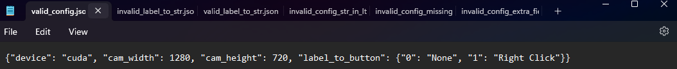
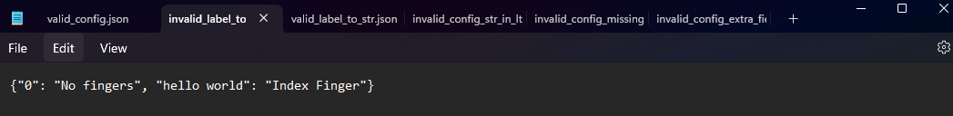
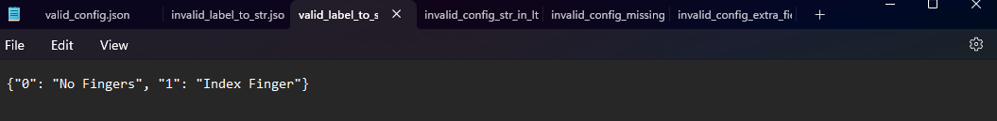
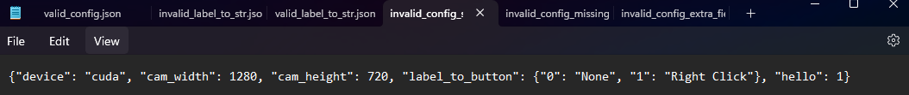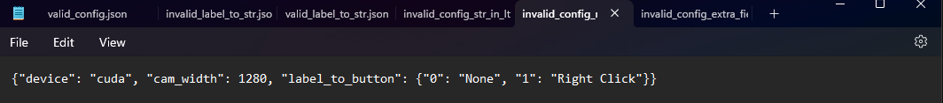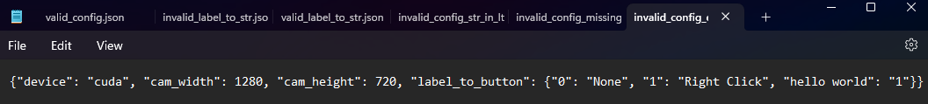
And this is the test used:
from config import Config

SOURCE = '.\\json_test_files\\'
V_CONFIG = SOURCE + 'valid_config.json'
INV_CONFIG_EXTRA = SOURCE + 'invalid_config_extra_field.json'
INV_CONFIG_MISSING = SOURCE + 'invalid_config_missing_field.json'
INV_CONFIG_STR_IN_LTB = SOURCE + 'invalid_config_str_in_ltb.json'
V_LTS = SOURCE + 'valid_label_to_str.json'
INV_LTS = SOURCE + 'invalid_label_to_str.json'
INV_NAME = SOURCE + 'valid_config.jso'

def main():
config = Config()

assert(config.load(V_CONFIG) == 2)
assert(config.load(INV_CONFIG_EXTRA) == 0)
assert(config.load(INV_CONFIG_MISSING) == 0)
assert(config.load(INV_CONFIG_STR_IN_LTB) == 0)
assert(config.load(V_LTS) == 1)
assert(config.load(INV_LTS) == 0)
assert(config.load(INV_NAME) == 0)

print('All assertions passed')

if __name__ == '__main__':
main()

When being run, all the assertions passed, confirming it functions correctly:

Day 6:

Commander test:
I wrote a script that goes through 7 example gestures chosen to test all of the cases when creating the int to function map in the commander’s constructor. On screen keyboard and None as those are custom functions, all the mouse clicks to test the match-case statement works, and windows to check the string to button map works.
Here is the json file used:
I had the script input each gesture 20 times, and checked that it only executed once, confirming my queue algorithm is functioning correctly.
This is the test:
import time
from commander import Commander
from config import Config

def main():
comm = Commander(1280, 720)
con = Config()
con.load('.\\label_to_str.json')

for i in range(7):
input(f"Press enter to test input {con.json_dict[str(i)]} 5 seconds from now")
time.sleep(5)
for j in range(20):
comm.run(i, [500, 200])

if __name__ == '__main__':
main()

Day 7:
Before coding the final version of the edit config screen, I created a prototype using dummy data, which worked as intended as can be seen here:
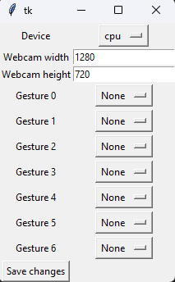
I decided to reuse this code in the final version, only changing the data that was inputted as the default values. No extra dependencies were added, and everything in the gui performs its logical functions, i.e. values can be selected/entered, and saved correctly to the config file.
However, in this code, the default values do not show, whether before or after selecting one.
This is what appears:
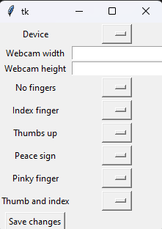
While it still functions, it would be extremely inconvenient to the user, as they would be unable to see what they have selected.
I am unsure as to what is causing the issue, as I imported the function from the prototype, and made my main program call that function, and the same issue occurs.
The only way I managed to get it to work, is by using the os module to run a shell command to run it in a separate file, which resolves the issue.

Day 8:

Performance issue with commander:
When testing the main loop, it ran smoothly for the first few seconds, but soon built up extreme, and worsening lag. I modified my code to write the size of each queue at each step, and the queue that sent data to the commander object was only increasing in size over time. This suggested that the commander’s run method was taking too long to execute.
I looked over the algorithm and my first thought was to make the execute_gesture method return early if the conditions to execute a gesture were not met.
Here is the edited part of the code:
# The first element in the queue cannot be same as the other 10, to ensure it only gets executed once after the first 10 frames
if self._gesture_queue[0] == self._gesture_queue[1]:
valid = False
return

for i in range(2, len(self._gesture_queue)):
if self._gesture_queue[i] != self._gesture_queue[i - 1]:
valid = False
return

if valid:
self._label_to_func[label]()
The 2 return statements could theoretically be hit early by an invalid state, which are the majority of states, reducing their execution time.
While this did improve the issue slightly, the lag was still present.
I realised that I was running the move_mouse and execute_gesture methods in serial, and none of the other objects were running methods in serial, so I figured this could be the problem. I tried modifying the run method to spawn 2 threads that would execute each method in parallel. This solved the issue, and made it run smoothly.
Below is the modified code:
def run(self, label: int, centroid: list[int, int]) -> None:
"""
Takes the label and centroid information
Moves the mouse to the new coordinate
Executes the gesture if it has been held for exactly 10 frames
"""
move_thread = threading.Thread(target=self._move_mouse, args=(centroid,))
execute_thread = threading.Thread(target=self._execute_gesture, args=(label,))
move_thread.start()
execute_thread.start()

Issue with model accuracy:
When testing the mainloop, I found that it was not executing gestures correctly, or at all. I added a print statement in the commander to see what label was being executed, and it was only ever being fed the label 3.
I found the cause for the issue quite quickly. In the model’s initialiser, there was a try except block that would create an FFNN with no trained weights if there was an error when loading from the saved file. I found that this exception was being triggered every time. This was due to how the GUI object computed how many labels there were. It takes the maximum value of the keys in the label_to_str.json file. However, that file is 0-indexed, so the file with 7 labels was producing a count of 6. Since the model file contained a model with 7 neurones, but the FFNN object was expecting 7, it triggered the exception, loading an untrained model. I have changed the code to add 1 to the max label to prevent this.
I have decided to remove the try-except block as I cannot find a scenario in which the user would make any actions that would lead to its triggering.

Day 9

Webcam issue discovered during final testing:
When doing final testing, I discovered that pressing ‘esc’ to halt the program would not halt the program.
I found that this was due to the use of cv.waitKey to read key inputs. This function only works when a cv.imShow window is open, which there is not during the mainloop.
I had to explore other potential solutions. I found online (https://pastebin.com/Bj0JmmD3) a table that maps from every key to the integer code it maps to in the win32api.
I used the GetKeyState function from the win32api to check if the ‘esc’ key is currently being pressed. It toggles between -127 and -128 when pressed, so the program now checks the value of GetKeyState(27) against -127 and -128.
Below is the modified code:
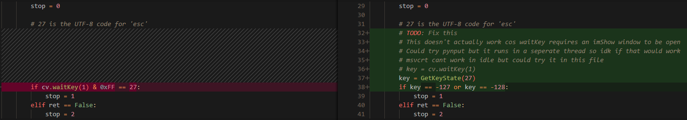

Final testing

Issue with calling functions
When testing the entire program, I found that when changing what commands each gesture should correspond to, when using any that were initialised using a lambda function, when called, instead of executing the correct command using pyautogui.click, they would only ever press the windows key.
I found that within the function that the lambda functions were created, they executed perfectly, but when returned into another function, then the issue occurred. Due to this, I believe that the issue was due to the passing of a local function to be used globally.
To fix this, I created a new file called funcs.py that contains all the functions that can be called as a command from a gesture, and a function that would return one of these functions when given the string. I then modified commander.py to instead of initialising local functions, to importing these functions and using these. After this, the issue was fixed.
Below is the modification that was made, and funcs.py:
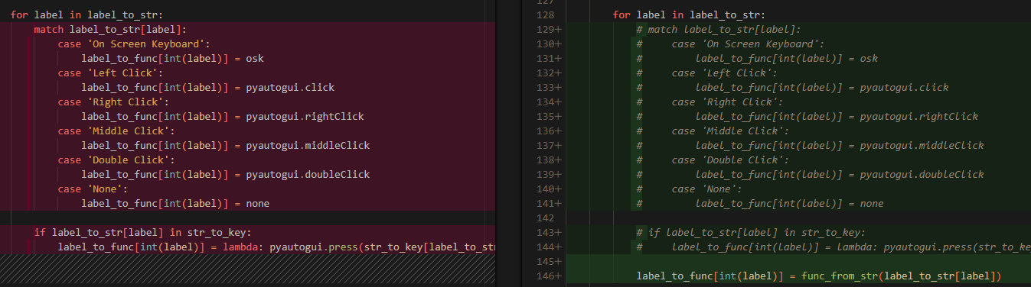
import pyautogui

def osk():
pyautogui.hotkey('win', 'ctrl', 'o')

def click():
pyautogui.click()

def right_click():
pyautogui.rightClick()

def middle_click():
pyautogui.middleClick()

def double_click():
pyautogui.doubleClick()

def none():
pass

def nexttrack():
pyautogui.press('nexttrack')

def prevtrack():
pyautogui.press('prevtrack')

def printscr():
pyautogui.press('printscr')

def win():
pyautogui.press('win')

def delete():
pyautogui.press('Delete')

def browserback():
pyautogui.press('browserback')

def browserforward():
pyautogui.press('browserforward')

def browserrefresh():
pyautogui.press('browserrefresh')

def pageup():
pyautogui.press('pageup')

def pagedown():
pyautogui.press('pagedown')

def volumeup():
pyautogui.press('volumeup')

def volumedown():
pyautogui.press('volumedown')

def volumemute():
pyautogui.press('volumemute')

def esc():
pyautogui.press('esc')

def func_from_str(s: str):
str_to_key = {'Next Track': nexttrack, 'Prev Track': prevtrack, 'Print Screen': printscr, 'Windows': win, 'Delete': delete, 'Browser Back': browserback,
'Browser Forward': browserforward, 'Browser Refresh': browserrefresh, 'Page Up': pageup, 'Page Down': pagedown, 'Volume Up': volumeup,
'Volume Down': volumedown, 'Mute': volumemute, 'Escape': esc, 'On Screen Keyboard': osk, 'Left Click': click, 'Right Click': right_click,
'Middle Click': middle_click, 'Double Click': double_click, 'None': none}
return str_to_key[s]

Testing against requirements

Below I have repeated the requirements as listed in the analysis, as I am going to test my program against the requirements.
Essential requirements:
- Must grab frames from client’s webcam
- Must identify what gesture each hand is making accurately enough to where the user doesn’t notice incorrect classification very frequently, an inaccuracy should be considered a rare occurrence
- Must translate the gesture(s) into a keyboard or mouse command
- Must calculate an appropriate mouse position given the hand’s position, and move the mouse there
- Must have a GUI
- Must have a gesture to deactivate the program
- Must be able to change what command each gesture corresponds to
- Must be able to save/load configuration files from within the GUI
- Must be able to activate an on-screen keyboard
- Run at a framerate good enough to seem smooth. For 24FPS, if everything is done sequentially, processing one frame must take at most 8.375 MS. If done in parallel, it can take up to 33.3 MS, as the webcam grabs frames at 30fps
Non-essential requirements:
- Have the ability to add extra gestures in case the user runs out
- Have the GUI be easy to use (if not I will provide a README containing all the information on how to use it)
- Report errors to the user when they incorrectly use the GUI
The test IDs are created by if they are an essential requirement or not (E/N), what number within that list it is, and a letter of the alphabet to indicate what iteration of this test it is. E.g. testing the third essential requirement for the second time would have the ID E3b
Test ID | Test Description | Data type | Data type | Expected Result | Actual Result | P/F | Changes made
E1a | Intialise a Camera object and repeatedly grab frames, and display them to make sure they are correct | N/A | N/A | The object grabs frames in real time | The object grabs frames in real time | P | N/A
E1b | Initialise a camera object and try to grab frames while another program is already using the webcam | N/A | N/A | Unexpected behaviour | Instead of returning a frame, the camera returns False, and a windows popup says ‘need help with your camera?’ | N/A | N/A
E2a | Train the model on the training dataset and then test its accuracy on a testing dataset and output the accuracy. | N/A | N/A | An accuracy above industry standard (96%) | 97-98% accuracy depending on the run | P | N/A
E2b | Call commander.run with the same gesture 10 times | [0]*10 | Normal | Command executes once | Command executes once | P | N/A
E2c | Call commander.run with the same gesture 11 times | [0] * 11 | Boundary | Command executes once | Command executes once | P | N/A
E2d | Call commander.run with the same gesture 9 times | [0] * 9 | Boundary | Command doesnt execute | Command doesnt execute | P | N/A
E2e | Call commander.run with a random gesture 10 times | List of random numbers length 10 | Normal | No command executes | No command executes | P | N/A
E3a | Press the start program button, and make hand gestures that are held for at least 10 frames | N/A | N/A | The command each gesture maps to executes | The command each gesture maps to executes | P | N/A
E4a | Press the start program button, and move my hand around in front of the webcam | N/A | N/A | The mouse is moved to a place on the screen that corresponds to where my hand is | The mouse is moved to a place on the screen that corresponds to where my hand is | P | N/A
E5a | Run the program | N/A | N/A | A working GUI is present | A working GUI is present | P | N/A
E6a | Bind a gesture to ‘esc’, and make that gesture after pressing start program | N/A | N/A | The main loop of the program stops | The main loop of the program stops, but the program stalls after closing | N | Set all the processes in the main loop to be daemons
E6b | Bind a gesture to ‘esc’, and make that gesture after pressing start program | N/A | N/A | The main loop of the program stops | The main loop of the program stops | P | N/A
E7a | Run the main loop as is, close it, open the ‘edit config’ page and change the bindings for each gesture, then rerun main loop and check it executes the new gestures | Right click -> next track | Normal | The first bindings run in the first run, and the new bindings run in the second run | The first bindings run in the first run, and the new bindings run in the second run | P | N/A
E8a | Change settings in ‘edit config’ screen, and run the program again to check the new settings are used | Cpu->cuda  Left click -> prev track | Normal | The new settings work correctly after changing | RuntimeError. A model created on the GPU cant be run on the CPU without changes to the code | N | Specify the map_location argument to be the device the user selected
E8b | Change settings in ‘edit config’ screen, and run the program again to check the new settings are used | Cpu->cuda  Left click -> prev track | Normal | The new settings work correctly after changing | The new settings work correctly after changing | P | N/A
E8c | Change settings in the ‘edit config’ screen, then click save as and enter a unique name for that file | ‘test_save_as’ | Normal | A new json file is created containing the new settings | A new json file is created containing the new settings | P | N/A
E8d | Load a different json file contaning different settings to what is currently loaded and check that those settings are relfected in the ‘edit config’ window | ‘test_load.json’ | Normal | The new settings are displayed as currently selected in the ‘edit config’ window | The new settings are displayed as currently selected in the ‘edit config’ window | P | N/A
E8e | Load a different json file containing different settings to what is currently loaded and check that the correct settings are used at runtime | ‘config.json’ | Normal | The correct commands are executed for each gesture, and it runs on the right device | The correct commands are executed for each gesture, and it runs on the right device | P | N/A
E9a | Bind a gesture to the on screen keyboard, start the program and make that gesture | N/A | Normal | An on screen keyboard opens when that gesture is made, and closes when it is made again | An on screen keyboard opens when that gesture is made, and closes when it is made again | P | N/A
E10a | Run the function ran by each process in the main loop and time how long it takes 5000 times and take the average, and test the model on both the CPU and GPU | N/A | N/A | Each function takes less than 33.3MS to run | Camera function took 33.3MS  HandFinder took 21.7S  Model on CPU took 0.189MS  Model on GPU took 0.572MS  Commander took 0.443MS | P | N/A
N1a | Press the add gesture button, enter a name for the gesture, take the 500 required pictures, bind it to a command and run the program | ‘Pinky finger’ | Normal | Once retraining takes place, the option to bind that gesture appears in the ‘edit config’ screen, and will execute that command when that gesture is made while running the main loop | Once retraining takes place, a KeyError is thrown when opening the ‘edit config’ window | N | When setting the currently selected values, wrap selecting the current setting for each gesture in a try except block. If a KeyError is thrown, then the value for that gesture is set to None
N1b | Press the add gesture button, enter a name for the gesture, take the 500 required pictures, bind it to a command and run the program | ‘Pinky finger’ | Normal | Once retraining takes place, the option to bind that gesture appears in the ‘edit config’ screen, and will execute that command when that gesture is made while running the main loop | Once retraining takes place, the option to bind that gesture appears in the ‘edit config’ screen, and will execute that command when that gesture is made while running the main loop | P | N/A
N2a | Show the GUI and the help page to my client, and ask what he thinks of the ease of use | N/A | N/A | N/A | Says the buttons are clear on what they are supposed to do. The tooltip given when starting the program is clear. The help document is detailed enough to know what to do. However can be hard to remember what gesture does what without the settings being constantly visible | N/  A | N/A
N3a | Try to enter an integer into the webcam width/height field and save changes | 1280 | Normal | Changes save successfully with no errors | Changes save successfully with no errors | P | N/A
N3b | Try to enter a string into the webcam width/height field and save changes | ‘hello world’ | Erroneous | Changes don't save and an error message pops up saying ‘enter a valid positive integer’ | Changes don't save and an error message pops up saying ‘enter a valid positive integer’ | P | N/A
N3c | Try to enter a negative integer into the webcam width/height field and save changes | -1280 | Erroneous | Changes don't save and an error message pops up saying ‘enter a valid positive integer’ | Changes don't save and an error message pops up saying ‘enter a valid positive integer’ | P | N/A
N3d | Try to enter a number with a decimal point into the webcam width/height field | 1280.0 | Erroneous | Changes don't save and an error message pops up saying ‘enter a valid positive integer’ | Changes don't save and an error message pops up saying ‘enter a valid positive integer’ | P | N/A

Evaluation

Evaluation against requirements
In this section I will discuss each requirement one by one and see how well my project met this requirement.
Essential requirements:
- Must grab frames from client’s webcam
- Must identify what gesture each hand is making accurately enough to where the user doesn’t notice incorrect classification very frequently, an inaccuracy should be considered a rare occurrence
- Must translate the gesture(s) into a keyboard or mouse command
- Must calculate an appropriate mouse position given the hand’s position, and move the mouse there
- Must have a GUI
- Must have a gesture to deactivate the program
- Must be able to change what command each gesture corresponds to
- Must be able to save/load configuration files from within the GUI
- Must be able to activate an on-screen keyboard
- Run at a framerate good enough to seem smooth. For 24FPS, if everything is done sequentially, processing one frame must take at most 8.375 MS. If done in parallel, it can take up to 33.3 MS, as the webcam grabs frames at 30fps
Non-essential requirements:
- Have the ability to add extra gestures in case the user runs out
- Have the GUI be easy to use (if not I will provide a README containing all the information on how to use it)
- Report errors to the user when they incorrectly use the GUI

Essential requirements

Must grab frames from the client’s webcam
The program does do this when running the main loop, however, as only 1 program can use the webcam at a time, trying to run it while another program is already using it, the program does not run. I still consider this requirement to be met as this is an issue that could not be circumvented by any program using the webcam, the only workaround is to use multiple webcams.

Must identify each gesture accurately to where the user doesn’t notice an incorrect classification
The neural network has an accuracy of 97-98%. Also, with the queue logic when deciding whether or not to execute a command, the neural network would have to misclassify the same gesture 10 frames in a row, which is exceedingly unlikely, so I consider this requirement met very well.

Must translate gestures into a keyboard or mouse command
The program does this and has a wide selection of commands that can be bound to a gesture. It does not have the full functionality that a standard keyboard and mouse would have, but does simulate most of the use, so I consider this requirement met.

Must move the mouse depending on where the hand is
The program will use the user’s hand’s location to decide where to move the mouse, and where it moves it makes sense and feels natural during use.

Must have a GUI
The program does have a GUI that enables use of all the functionality of the program

Must have a gesture to deactivate the program
By default, there is no gesture that is automatically set to ‘esc’, which is used to deactivate the program, but a gesture can be bound to this command in settings, as since the ‘esc’ button also works, my client may choose to use that gesture for something else

Must be able to change which command each gesture is bound to
This can be done in the ‘edit config’ screen in the GUI

Must be able to save/load configuration files in the GUI
Settings must be saved when changed. A given configuration of the settings can be saved using the ‘save as’ window under a unique name. An already existing config file can be loaded using the ‘load config’ button, which is very easy to use as it opens a file explorer window.

Must be able to open an on-screen keyboard
This is an option that a gesture can be bound to in the settings

Must run at a smooth framerate
On either the CPU or GPU of my home computer, it runs smoothly and doesn’t stutter. My client’s computer has similar specifications to mine, so should deliver a similar experience.

Non-essential requirements

Must have the ability to add extra gestures
The program has the ability to do this without leaving the GUI, however, does take a decent amount of time, as my client would need to take 250 frames of each hand making that gesture, however, there is no other way to collect the training data needed.

Have the GUI be easy to use
Each button on the GUI doesn’t have complicated functionality and clearly displays what it does. In case my client gets confused, there is a ‘help’ button which opens a Microsoft word document with a description on how the program works and what each button does

Report errors if the user incorrectly uses the GUI
Due to the nature of the project, there isn’t much they could do to try and break the program. The only time they need to enter data is for the name when saving a config file, and the width and height of their webcam. A filename can be anything, so there are no checks for this, but if they try to input anything other than a positive integer into the webcam dimensions, an error message will appear saying that they have to enter a positive integer.

Client and user feedback
For feedback, I had my client test out the program and give his opinion on what was good about it, and what could be improved. I also gave the program to a few of my friends, described the purpose of the program and had them do the same.

Positive feedback
Of those who tested out the program, they thought the program was very clear and easy to use, although some did get confused when trying to use the functionality to add a new gesture, the help document explained everything well enough for them to understand what to do. My client said that this would fulfil his needs for when he needs to control the computer from a distance.

Potential improvements
My client and other testers gave recommendations on what they consider to be useful improvements.
My client found it difficult to remember what gesture was bound to what, and so a way to display to the user the settings during use would be useful. If the user has multiple monitors, this is easy to circumvent by having the ‘edit config’ screen open on the other monitor, but with one monitor, I don’t think it would be too difficult to implement some kind of overlay that displays the settings.
One tester found the lack of click and drag functionality potentially limiting. This could be implemented with a bit of change to the queue logic in the Commander object, where if a click an drag gesture is made, once it has been held for 10 frames, or even before, continue checking for that gesture after, and only stop holding once a different one is made.
Another felt that the program would benefit from being able to map a gesture to a keyboard, program or website shortcut. This could be implemented by having a page for custom commands, where the users could create any of these 3, and then bind them to a gesture the usual way.
Most felt that non-static gestures, such as swiping to the side would feel more natural than static gestures, however, this would require a dramatic overhaul to how the program works, such as collecting videos of gesture movements as training data and using a recurrent neural network to predict based on a sequence of frames.

Overall evaluation
This project was a significant challenge, but was also very fun to work on, and tested my skill as a programmer. I think that given the amount of time available, I was able to produce an effective solution to my client’s problem. Given more time, I definitely could’ve produced a solution that felt more natural to use and had more functionality. However, it met all the requirements, so I am very happy with how it went.

Demonstration video
Here is a link to a video where I demonstrate the functionality of the program:
https://youtu.be/1rnbCTO_M1c

References
[1]: Source for frametimes for different FPS values - https://fpstoms.com
[2]: GitHub page for the GestIA solution - https://github.com/PaburoTC/GestIA
[3]: Page with information on Myo Mouse solution - https://www.instructables.com/Add-Gesture-Control-to-Your-Computer/
[4]: Ebay page to display price of Myo Mouse - https://www.ebay.co.uk/itm/295393659317?chn=ps&_ul=GB&mkevt=1&mkcid=28&google_free_listing_action=view_item
[5]: Human Computer Interaction using Hand Gesture - https://www.sciencedirect.com/science/article/pii/S187705091501409X/pdf?md5=2119be3f70afc8ac88a61364716d8a49&pid=1-s2.0-S187705091501409X-main.pdf&_valck=1
[6]: A real-time Hand Gesture Recognition and Human-Computer Interaction System - https://arxiv.org/pdf/1704.07296
[7]: Vision-Based Interpretation of Hand Gestures for Remote Control of a Computer Mouse - https://users.ics.forth.gr/~lourakis/publ/2006_hci.pdf
[8]: Mediapipe documentation - https://mediapipe.readthedocs.io/en/latest/solutions/hands.html
[9]: OpenCV documentation - https://docs.opencv.org/4.x/index.html
[10]: PyTorch docs - https://pytorch.org/docs/stable/index.html
[11]: Tkinter docs: https://docs.python.org/3/library/tk.html
[12]: Pytorch neural networks - https://pytorch.org/tutorials/beginner/basics/buildmodel_tutorial.html
[13]: Pyautogui cheat sheet - https://pyautogui.readthedocs.io/en/latest/quickstart.html
[14]: Multiprocessing documentation - https://docs.python.org/3/library/multiprocessing.html
[15]: Threading documentation - https://docs.python.org/3/library/threading.html
[16]: JSON documentation - https://docs.python.org/3/library/json.html
[17]: Pandas documentation - https://pandas.pydata.org/docs/
[18]: Tkinter dialog documentation - https://docs.python.org/3/library/dialog.html
[19]: Mediapipe docs with performance information: https://ai.google.dev/edge/mediapipe/solutions/vision/hand_landmarker

