Contents
Getting started 1
Save config as 1
Load config 2
Edit config 2
Start program 2
Add new gesture 3
Reset 3

Getting started
When you open the application, this is the screen you will be greeted with:
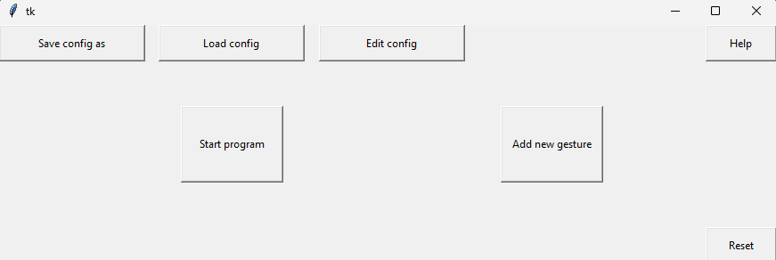
Each button has a very important function:
- Save config as: Allows you to save your current settings under a unique file name
- Load config: Allows you to load an already existing config file to reuse previous settings
- Edit config: Allows you to change the settings, such as which gesture corresponds to which command, and which device you want the neural network to run on
- Start program: Starts the main program, where you control the computer using gesture control
- Add new gesture: Allows you to take pictures of your hand in a specific gesture, and retrains the neural network to be able to detect it
- Reset: Resets all settings to their default

Save config as
Opens this screen:
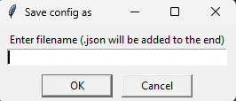
Enter a filename without any file extensions, and it will be saved with.json at the end. Press cancel if you have decided not to save

Load config
Opens a file explorer window. Selecting and opening a valid config file will load all of the settings saved in it. Opening an invalid file will leave the current settings.

Edit config
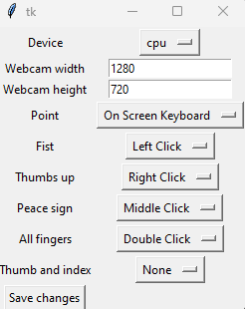
This is the screen for editing the config settings.
The device is set to cpu as default, if you have a discrete nvidia gpu, it is recommended to change it to cuda, if not then leave as cpu.
If you know what resolution your webcam is, then change the width and height to that, otherwise leave it at the default values.

Start program
Will open a window saying that the program is starting. The program does take quite a while to start, if your webcam has a light to indicate if it is on, then wait until the light is on, and then it will start. Otherwise, wait a minute or two and keep trying to see if it is on.

Add new gesture
First, it will open a window similar to one for save conifg as, where you need to input a name for the gesture.
Then it will open a window mirroring the view of your webcam, with a count of how many pictures have been taken for the left and right hand. The program will terminate when the count for each reaches 250.
Press ‘enteir’ to take a picture, it is recommended to hold down eter for the fastest results.
After this is done, a window with a loading bar saying ‘retrain’ will open. Do not close this window until the main window closes and the loading bar finishes.

Reset
Resets the settings, model, and data to their default values. You will have default settings, with only the default gestures. If you close the program or power cycle your computer while adding a gesture, this will likely be the only way to recover the program and make it usable again.

