GUIFE

Introduction
GUIFE is an alternative front end for Flora Europaea on CD-ROM. Flora Europaea on CD-ROM is edited by The Flora Europaea Editorial Committee, prepared for publication by Siebe Jorna, published June 2001 (CD-ROM, ISBN-13: 9780521778114 | ISBN-10: 0521778115, Cambridge University Press).

The original software is implemented in VB4 and uses a window of 800x600 pixels on the screen. It doesn’t run on some systems with more than 500MB RAM (as on my system). I decided therefore to write another GUI based on new technology (NET 4.6, VB.NET). GUIFE only works with the original data and software distributed by Cambridge University Press.

Feature Overview of GUIFE:
- Text browser (with taxon index)
- Full text search (only simple search for a single word)
- Search within page
- Key browser
- Glossary browser

The following features of the original software are not implemented:
- Boolean search
- Possible outcome of key

For context-sensitive help, drag ‘?’ from the top right corner of the current windows over the GUI element you need help for and click on it.

To show the definition of a term in a text page double click on it. If there is an entry in the glossary, the definition appears in the small text box on the left side of the window. You can also select a term in the text window and click on the “Glossary” button to get the definition of it.

If you double click on the name of a taxon for which there is a determination key in the database, the key browser window opens. The same happens if you select a taxons name in the text box and click the “Key” button.

If you click on the “Key” button and there is no active selection, the program looks for the key of the selected taxon in the index panel.

On the lower left part, you can see messages showing you what happens behind the scene.

Menu Reference

File

Page Setup
Define page orientation, page format and printer

Print preview
Shows a preview of print on screen

Print
Print the text page shown in the main text box

Edit

Copy
Copies the select text to the clipboard

Paste
Paste the content of the clipboard

Select all
Select whole content

Configuration
Starts configuration dialog

Data

Introduction
Introduction, abbreviations, maps and general information about the Flora Europaea project

Browse Key
Key browser

Browse Glossary
Glossary browser

Help
Help Information

Form Reference

Text Browser
Main form of application.
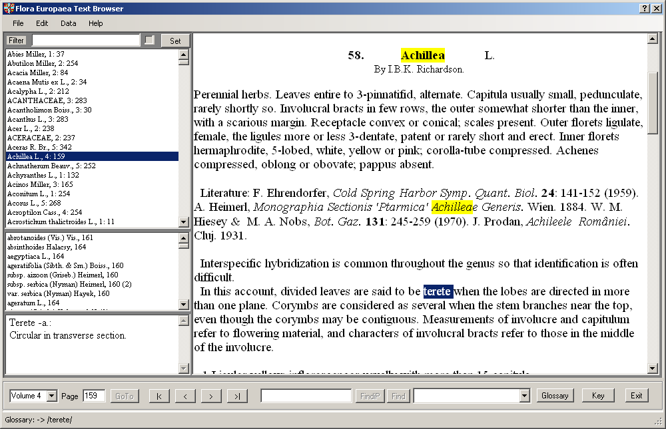

The large textbox on the left side contains the current page. On the right side there is the index on family and genus level. If you select an entry in the family and genus index, the corresponding page of flora Europaea is shown in the main textbox. If your selected entry is a genus, all species belonging to that genus are shown below the index. If you click on a species the according text is shown in the textbox.

In the upper left part of the main window you can set a filter for the family and genus index. If the checkbox beside the filter text is on, the filter is active, otherwise it is inactive. To set a new filter, enter the filter text in the textbox and click the “Set” button.

Found text is marked with yellow background color.

The command buttons at the bottom of the form allows you to navigate through the text of Flora Europaea: (from left to right)
- Selection of a volume of Flora Europaea (Volume 1 – 5)
- Page number (show current number of current page, go to a page)
- Navigation control (go to first page, to previous page, to next page and to last page within a volume)
- Search text
- Button “FindiP”: locate search text within current page
- Button “Find”: do a full text search
- Result of full text search (list of pages found)
- “Glossary” button: look up of glossary text
- “Key” button: opens the key browser
- “Exit” button: exit application

Key Browser
Browser for navigating through the determination keys.
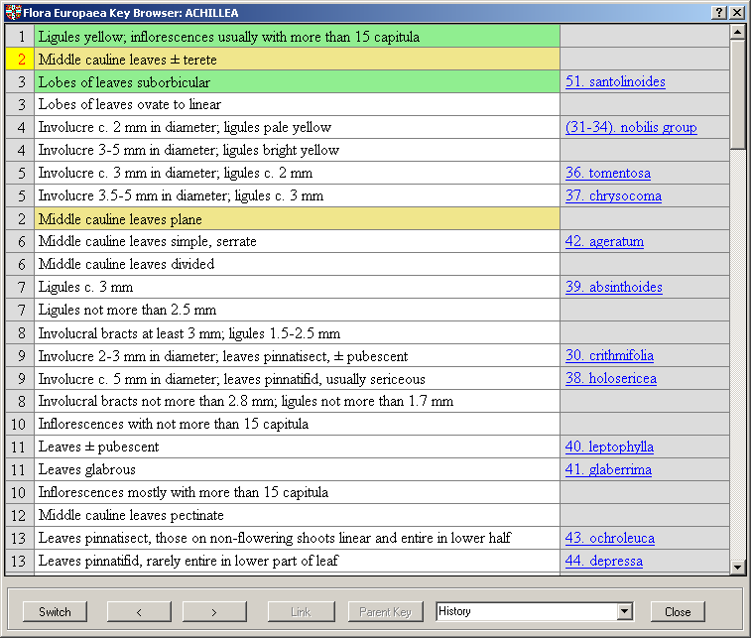

In the main part of the window you see the determination key. The left column contains the id number of the key entry. The column on the right side is the link column containing links to text search function or sub keys. The current entry is marked using yellow background color, the previous and next one with green background.

For navigation you can use the mouse, the keyboard or command buttons at the bottom of the form: (from left to right)
- “Switch” button: switch between alternate states at the same level
- “<>”: Move to previous or next level
- “Link” button: show sub key
- “Search” button: got to corresponding text in the main form
- “Parent Key”: go back to last used parent key
- “History”: list or key elements used in the past
- “Close” button: close form

If the active key line links to a sub key, you see a button named “Link” at the bottom of the form, if there is another link, the same button will be named “Search”.

Glossary Browser
Browser for navigating through the glossary.
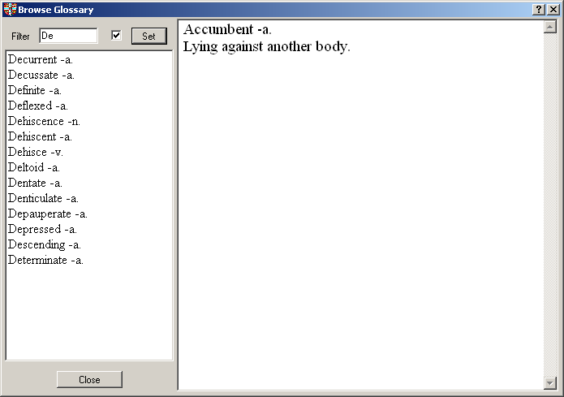

The Glossary browser window contains the glossary index with filter function and the glossary text.
In the upper left part of the main window you can set a filter for the glossary index. If the checkbox beside the filter text is on, the filter is active, otherwise it is inactive. To set a new filter, enter the filter text in the textbox and click the "Set" button.

Settings
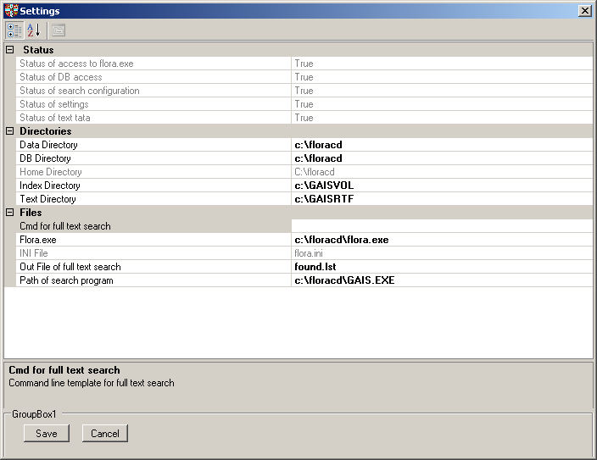
Here you can change the configuration of the application. If there are errors on the configuration this form is shown at startup for correcting configuration errors (mostly wrong paths of directories of files).

Settings
Settings are defined in file flora.ini

Overview of most important parameters:
Parameter | Default value | Description | Remarks
TEXTDIR | c:\GAISRTF | Text directory | If changed, .gais_inc and .gais_directorylist have to be changed accordingly
GAISVOL | c:\GAISVOL | Index directory
DATADIR | c:\floracd | Main Directory of original application
MDBDIR | c:\floracd | Directory containing the data base files with extension MDB of original application
FLORAEXE | c:\floracd\flora.exe | Path to executable of original application
GAISEXE | c:\floracd\GAIS.EXE | Path to executable of search tool
USERCMD | user.ini | Path to control file with user defined command | Example:  GOOGLE = http://www.google.ch/search  #STARTPRG  ATLASFE = C:\floracd\AFE99.EXE, LABEL(Altas)

Search configuration
Location of text and full text index are defined in the settings (parameter Text Directory, TEXTDIR and Index Directory, GAISVOL). Parameter GAISEXE contains the path of the search program GAIS.EXE. The file name of the search result file is defined in the parameter OUTFILE.
If location of GAISRTF is changed, the path in following files must be adjusted accordingly:
- .gais_directorylist
- .gais_inc

Each executed search command first stored in ffind.bat before it is executed. The search result is written to the output file defined in setting parameter OUTFILE (default: found.lst).

Help Reference
You can access help in the menu help on the main form, by pressing F1 or by using the context sensitive help (“?” button in the upper left corner of the form).

