GAS Architecture Implementation
For the implementation of the Gameplay Ability System, the architecture was structured to remain organized, scalable, and easy to extend for future gameplay features. The AbilitySystemComponent was added directly to the character class, making the character the central holder of abilities, gameplay effects, and attribute-related interactions. This setup allows the character to manage ability activation, effect application, and communication with other gameplay systems in a clear and consistent way.
The attribute system was implemented through a dedicated AttributeSet, containing the core player attributes required for the test, such as Health, Mana, and AttackSpeed. This approach keeps gameplay data centralized and follows the standard GAS structure, making it easier to maintain, replicate, and expand later if new attributes or mechanics are added.
Overall, the implementation was designed to follow Unreal’s intended GAS workflow while keeping the system modular and suitable for future ARPG-style expansion.
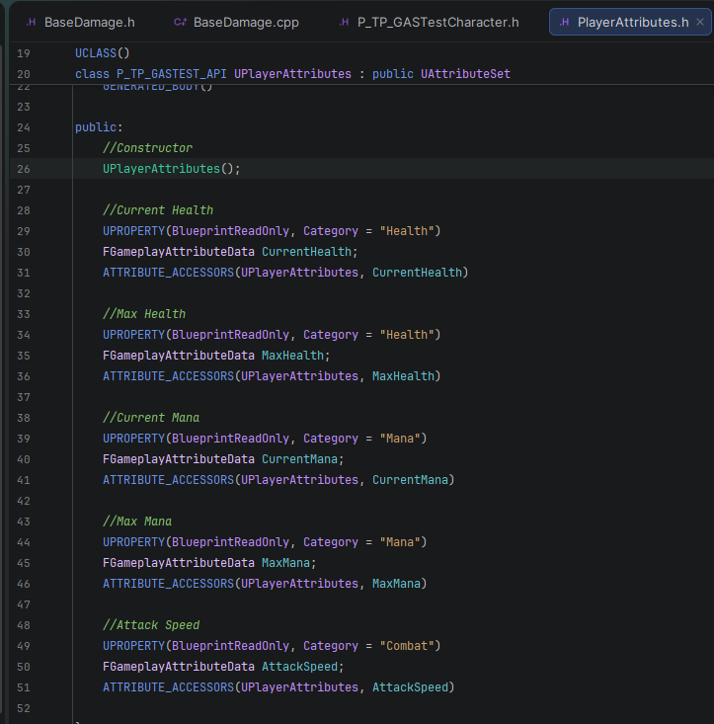
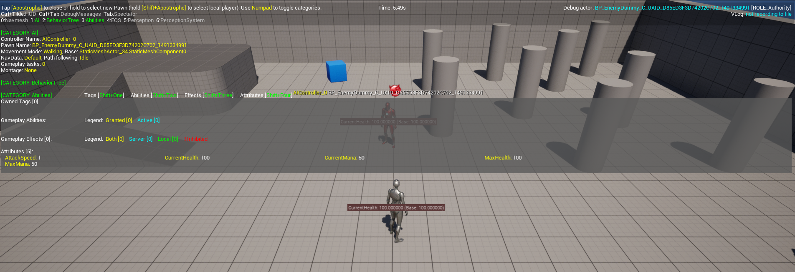

A Data Asset was used to store and reference the animation used by the ability instead of placing the animation directly inside the ability class. This approach allows designers to easily change the animation or adjust the ability behavior in the future without modifying the ability logic itself, making the system more flexible and easier to maintain.

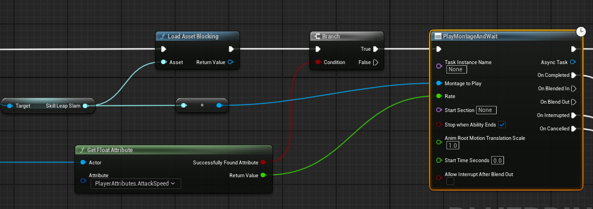
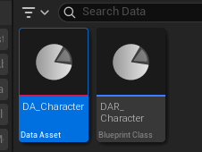
Movement Control During Ability Animations
A small control was implemented to allow player movement input to be processed near the end of the montage animation (e.g., an attack). This allows the character to start moving before the montage fully finishes, improving gameplay fluidity and responsiveness. The behavior is controlled through a notify or logic placed at the end of the montage animation.
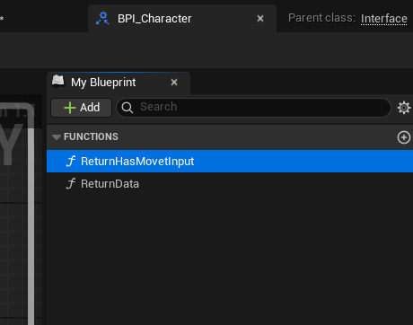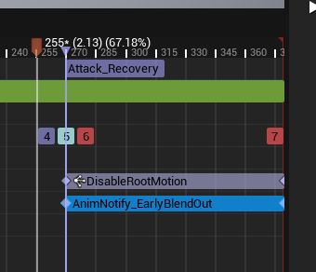

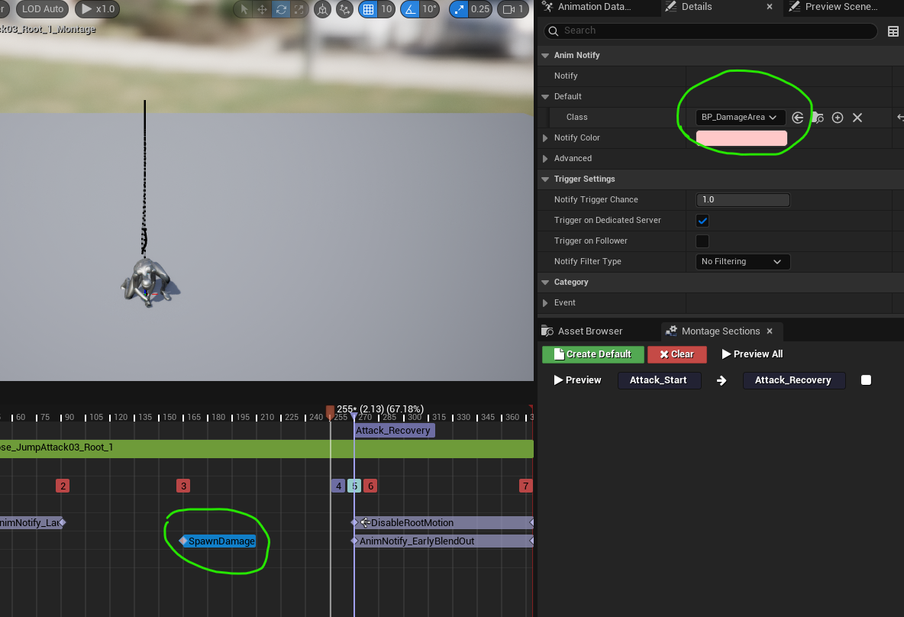
Damage Setup Through Animation Blueprint
The damage setup was handled through the animation system. A base C++ class was created to store core parameters such as the damage type tag and damage amount, keeping the structure simple for now but ready to be expanded with more complexity if needed. This approach keeps the system modular, since changing the damage type can be done directly in the animation montage without requiring changes to the main gameplay logic. It could also be moved to a Data Asset or Data Table depending on the project’s needs, while still allowing the damage spawn or damage call to be triggered through montage notifies independently of where the montage is being used.

