**IRIS Dark Model Modification 2022**

Due to a continued overestimation by the model starting in 2021, a new methodology for the IRIS dark model was explored. The solution was determined to be that the model was be separated at a given time. Previously, a set of time dependent parameters covered the entirety of the model timeframe. This meant that adjusting a parameter for recent data also modified the fit for older data. It was determined that the model would work better if parameters for early mission data were locked in and never changed again while parameters describing more current data would be free to be adjusted. This would improve overall model fit as well as reduce inconsistencies in the database.

Testing showed that the most optimal time for this separation was July 9th, 2020. This time was selected for multiple reasons. First, this was the time period were the model became the most stable. Following this time period, the year to year increase was seen to level out. This was especially obvious in ports FUV1,2, and 4. Because the model from 2020 looked incredibly similar to the model from 2022, it made sense to separate it from the more volatile model pre-2020. Secondly, this date was chosen since it was in the middle of the yearly cycle at the central local minimum. This made sense to not separate at an arbitrary point in the cycle. Third, this time produced the best overall model fit for both sides of the separated model. Finally, this exact date was chosen since it was right at the time of a set of IRIS darks.

The model (Model A) covering data from the start of the mission through July 8th, 2020 was optimized for that data set excluding any data beyond that point. This improved the fit during this time. These parameters were then locked in and should not be changed again in the future. A new model (Model B) was generated for data from July 9th, 2020 forward. This model had the same form as the first model but removed some of the time dependent modifier variables. Below is a table comparing the previous version of the model to the separated version. (Version 29 is the first implementation of this separated model).

|  |  |
| --- | --- |
| Standard Model Refit | Separated Model Refit |
| FUV1: **0.92**with **0.2884 sigma**  FUV2: **1.16**with **0.2981 sigma**  FUV3: **1.39** with **0.5863 sigma**  FUV4: **1.09** with **0.3566 sigma**  NUV1: **0.25** with **0.1572 sigma**  NUV2: **0.29** with **0.1861 sigma**  NUV3: **0.50** with **0.1567 sigma**  NUV4: **0.42** with **0.1609 sigma** | FUV1: **0.07**with **0.2139 sigma**  FUV2: **0.12**with **0.1530 sigma**  FUV3: **0.84** with **0.5219 sigma**  FUV4: **0.19** with **0.2555 sigma**  NUV1: **0.11** with **0.1439 sigma**  NUV2: **0.07** with **0.1749 sigma**  NUV3: **0.10** with **0.1054 sigma**  NUV4: **0.06** with **0.1256 sigma** |
| Average FUV: **1.14**  Average FUV sigma: **0.3823**  Average NUV: **0.37**  Average NUV sigma: **0.1652** | Average FUV: **0.31**  Average FUV sigma: **0.2860**  Average NUV: **0.09**  Average NUV sigma: **0.1375** |

Below are images showing the current separated model in both ports. The first set shows the full model. The second set shows only Model B post July 9th, 2020. And the third set shows the point at which Model A meets Model B to show the level of discontinuity.

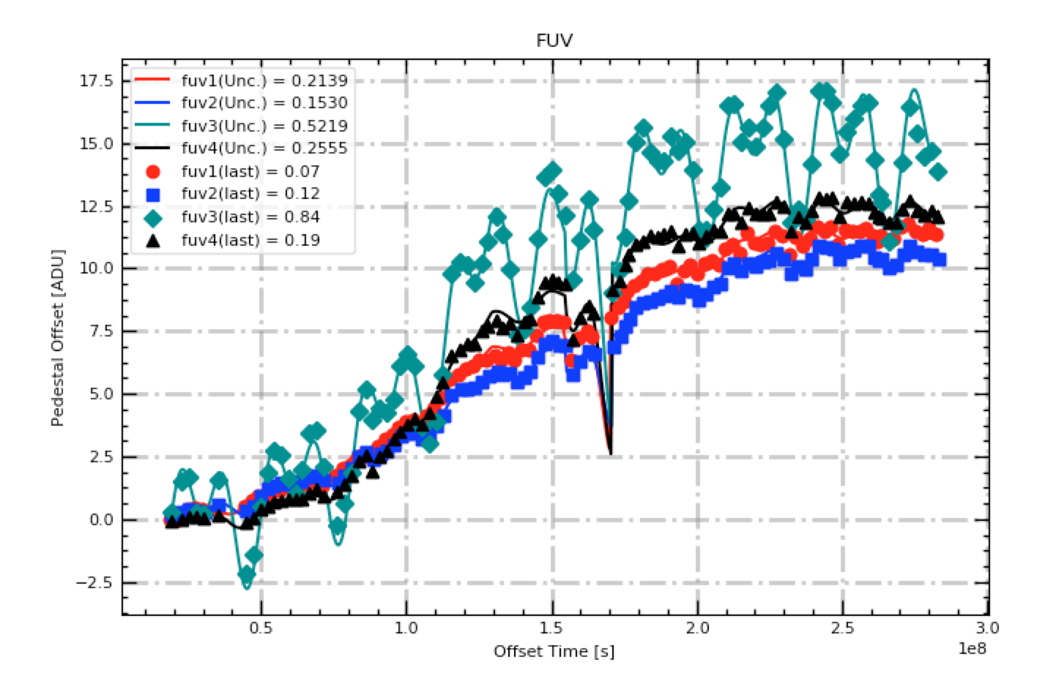

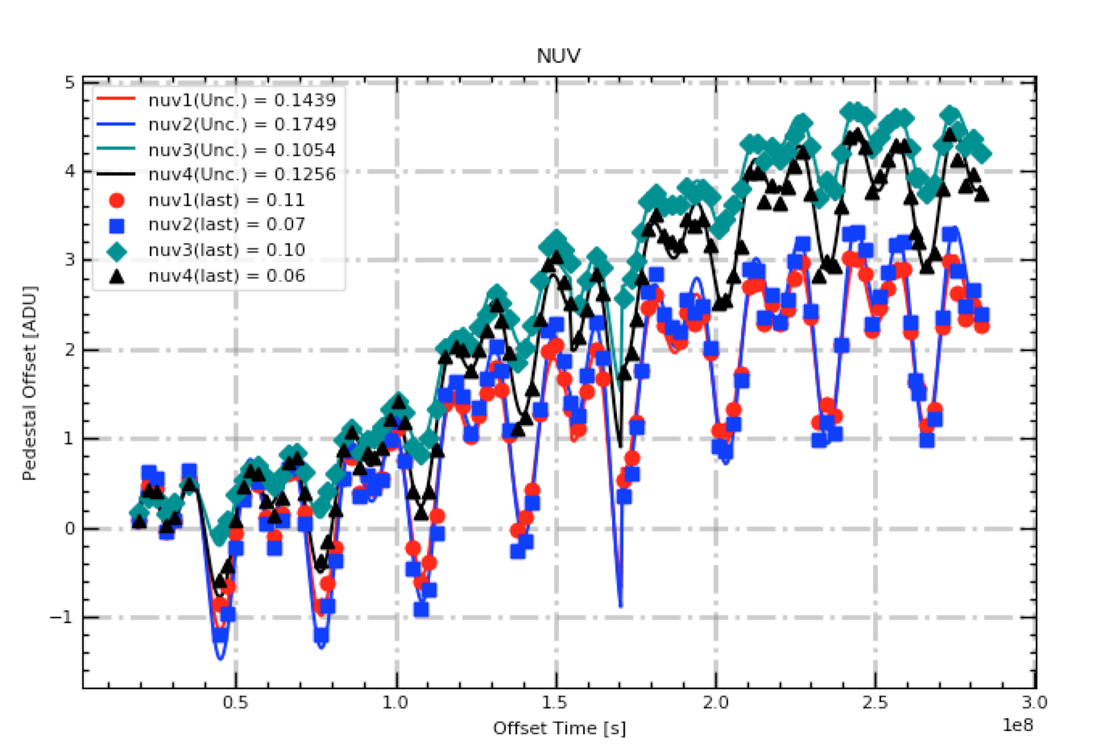

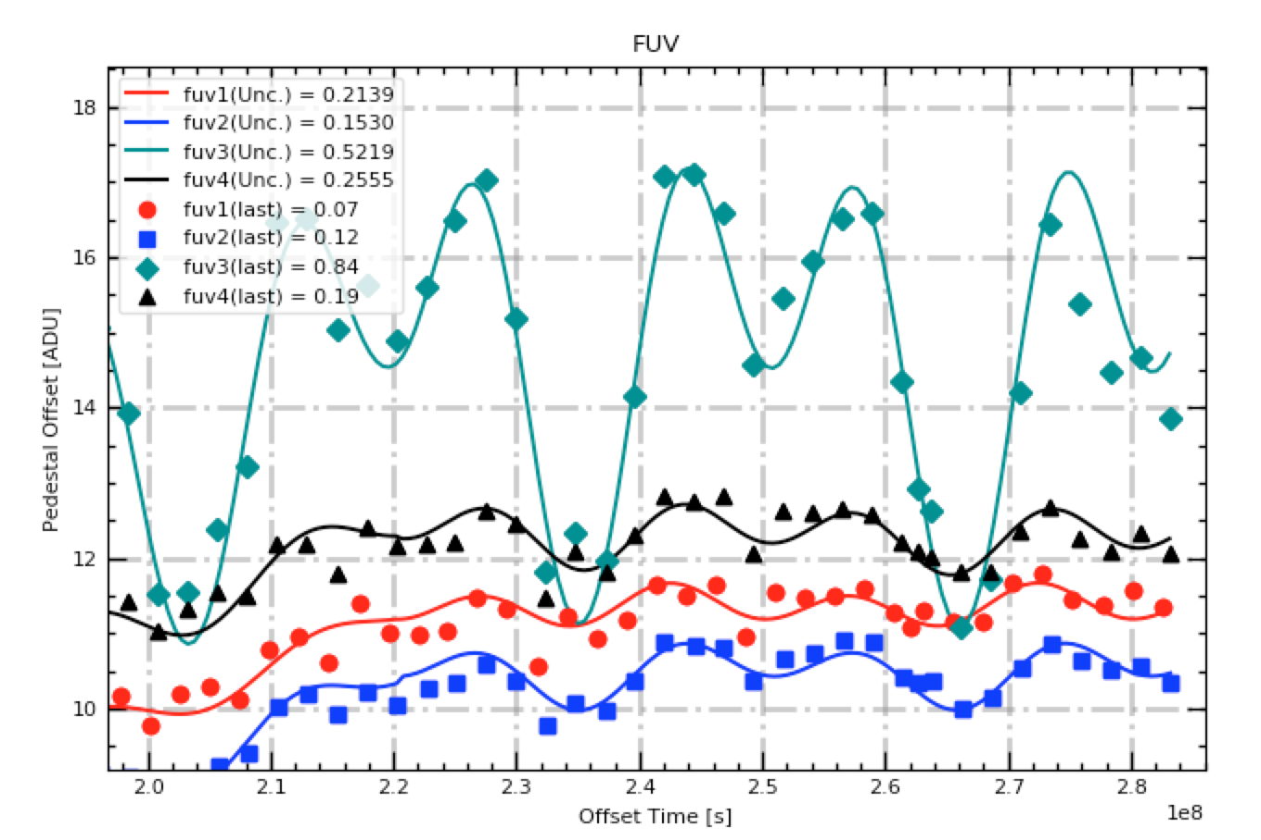

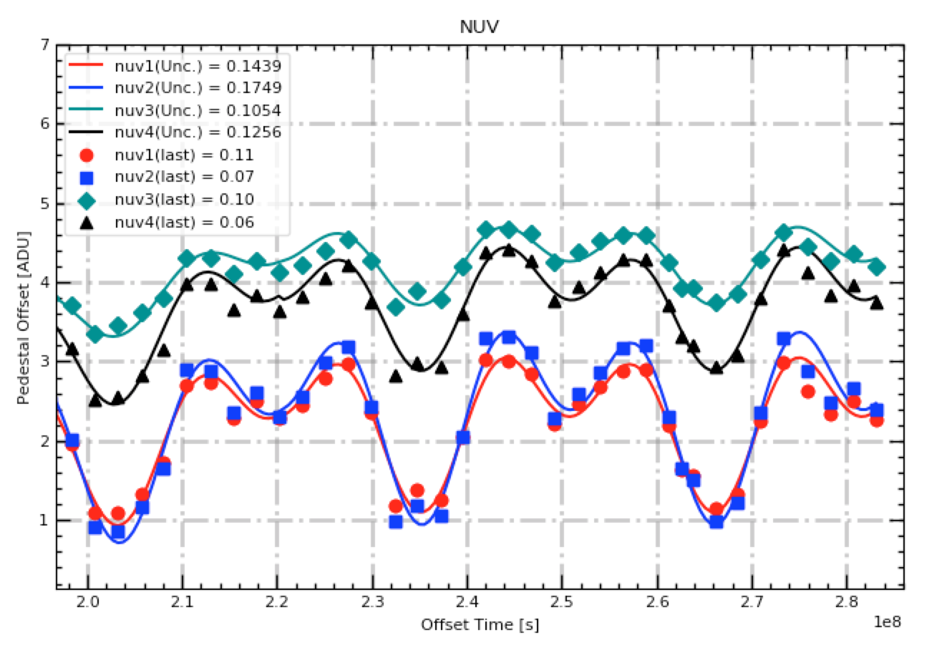

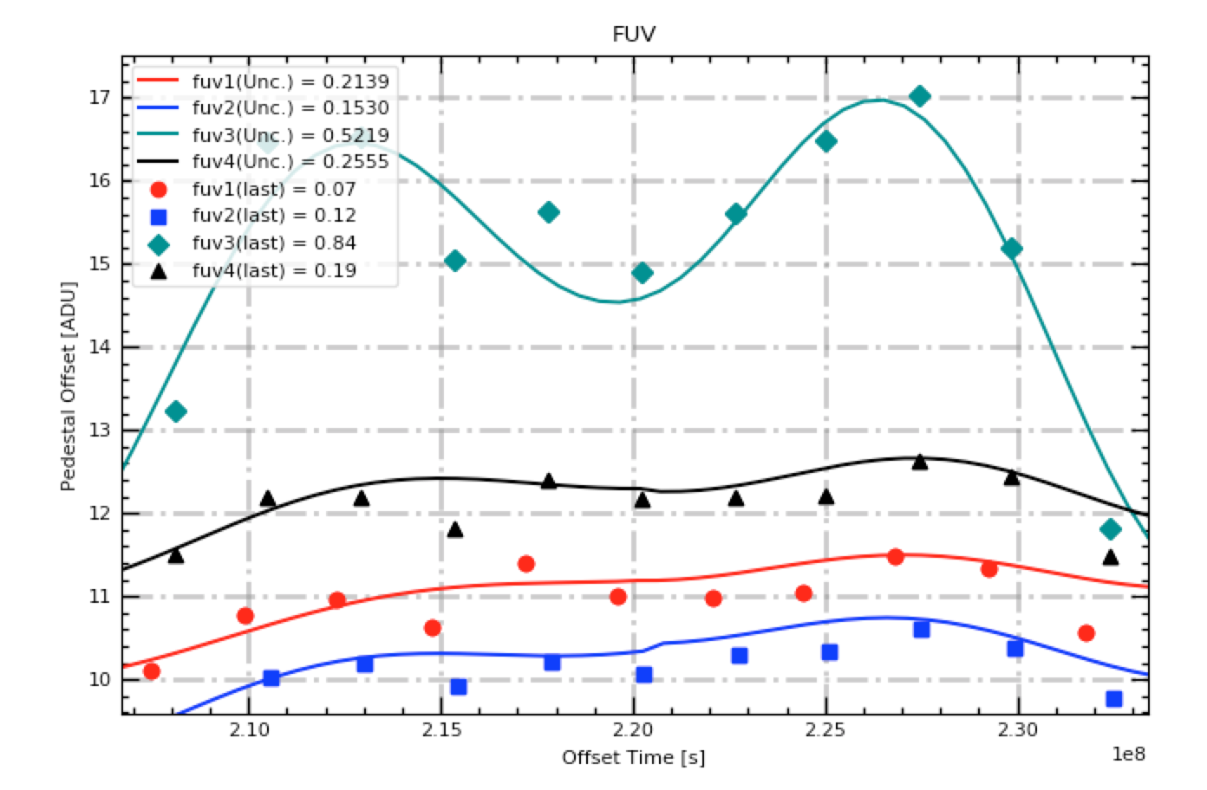

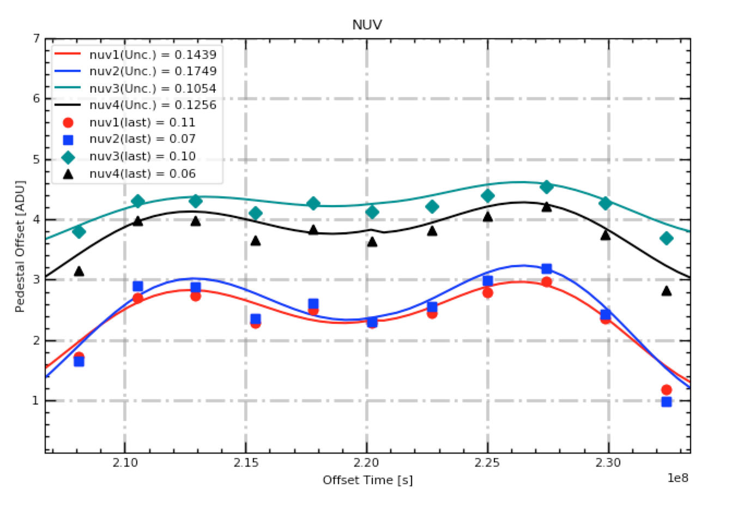

It was important to minimize the discontinuity that occurs at the point of model. Model B was constructed in such a way that there is no large jump between the end of Model A and the start of Model B. The following table shows the offset values at the exact end of Model A (2020/07/08T23:59:59) and the exact start of Model B (2020/07/09T00:00:00)

|  |  |  |
| --- | --- | --- |
| Port | Offset value at  2020/07/08T23:59:59 | Offset value at  2020/07/09T00:00:00 |
| FUV1 | 11.178152 | 11.197462 |
| FUV2 | 10.339919 | 10.428080 |
| FUV3 | 14.583322 | 14.590489 |
| FUV4 | 12.295879 | 12.270469 |
| NUV1 | 2.3279461 | 2.3059647 |
| NUV2 | 2.3684471 | 2.3888450 |
| NUV3 | 4.2529728 | 4.2627078 |
| NUV4 | 3.8285541 | 3.7719689 |

While the models are not exactly smooth at the point of discontinuity, this is a small enough discrepancy that it is acceptable.

**Model A Parameters**

Below are the final model parameters for model A covering the start of the mission through July 8th, 2020. These parameters are described in both the GUI refit text files and in all version of IRIS_Dark_Trend_fix.pro moving forward. These should never again be adjusted.

Amp1 ,Amp2 ,P1 ,Phi1 ,Phi2 ,Lin

Quad ,Offset ,Scale ,OffDrop ,AmpInc ,OffNSop

fuv1=[ 0.22504 , 0.14123 , 3.2876e+07 , 0.57710 , 1.27583 , 2.688194354e-08 , 6.027637770e-16 , -0.51376 , 0.21860, 0.27468, 11.12696, 0.79547]

fuv2=[ 0.28405 , 0.22782 , 3.1761e+07 , 0.39463 , 0.91922 , 2.726109985e-08 , 4.380741231e-16 , -0.52228 , 0.32913, 0.30626, 4.28409, 0.45041]

fuv3=[ 1.65115 , 1.63702 , 3.1643e+07 , 0.34131 , 0.88297 , 2.648864226e-08 , 1.274301392e-15 , -0.70601 , 0.05882, 0.17961, 0.96134, 1.94921]

fuv4=[ 0.32979 , 0.23508 , 3.2168e+07 , 0.48204 , 1.03840 , 1.540202648e-08 , 1.049035742e-15 , -0.47445 , 0.12195, 0.22495, 9.10567, 1.01930]

nuv1=[ 0.58894 , 0.55962 , 3.1648e+07 , 0.32813 , -0.09963 , 4.898462163e-09 , 2.070366876e-16 , -0.22547 , 0.17021, 0.41487, 0.58865, 0.37707]

nuv2=[ 0.72862 , 0.68366 , 3.1665e+07 , 0.32753 , 0.89597 , 3.518766768e-09 , 2.866893629e-16 , -0.22624 , 0.12186, 0.33818, 0.56151, 0.34956]

nuv3=[ 0.27157 , 0.24522 , 3.1635e+07 , 0.34720 , 0.89485 , 9.403417868e-09 , 3.724874287e-16 , -0.10939 , 0.19875, 0.18738, 1.25642, 0.21802]

nuv4=[ 0.45593 , 0.45128 , 3.1626e+07 , 0.33509 , 0.90171 , 8.337784755e-09 , 3.418901087e-16 , -0.25099 , 0.23615, 0.28125, 0.53626, 0.03761]