**IRIS Dark Report 03/2022**

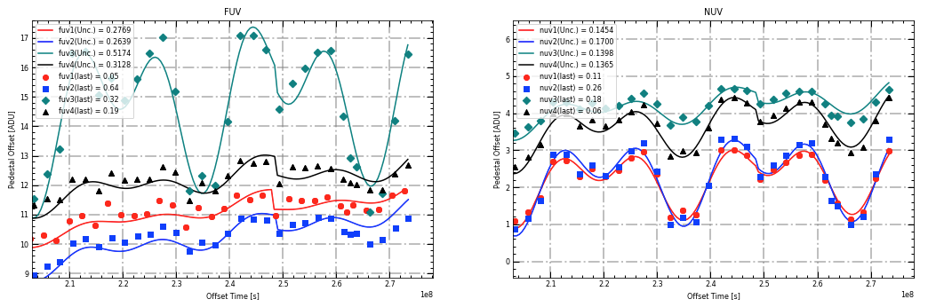**No Model Refit:** This is the current accepted state of the model as of March 2022. We see good alignment utilizing the new *lower* parameter. This produces good alignment but does cause an obvious discontinuity at the point of implementation. This model has not been updated since January of 2022. One single model still describes the entire time period with all 13 parameters active for adjustment.

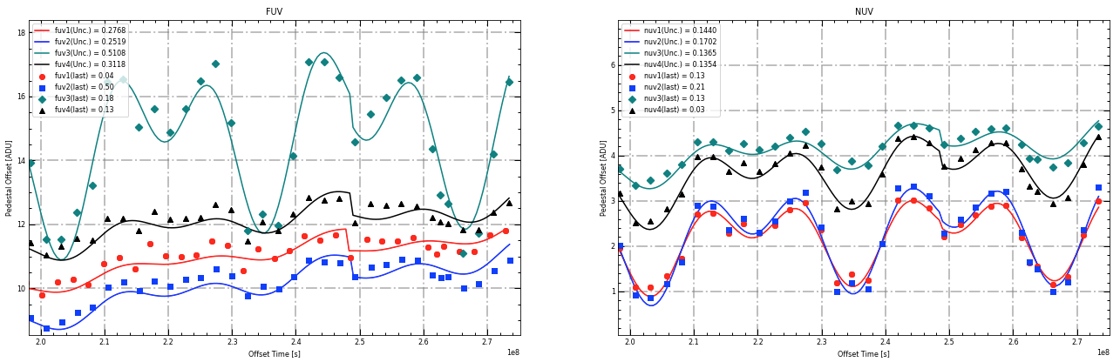**Model Refit with *lower* parameter:** This is the same as the current model (No Model Refit) with an adjustment to only *lower* parameter. We see slightly better alignment at the expense of a slightly larger discontinuity at the point of implementation. One continuous model still describes the entire time period with all 13 parameters active for adjustment.

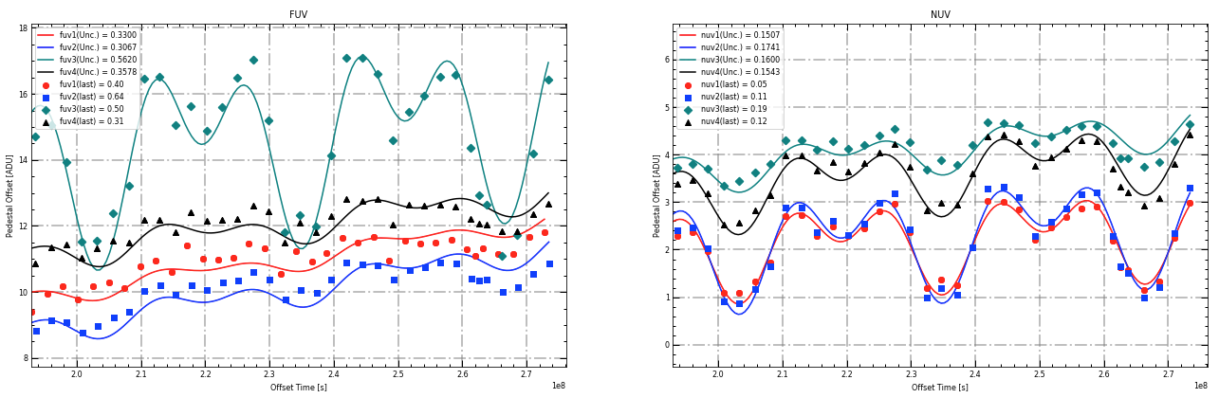**Model Refit without *lower* parameter:** An attempt to see what the model would look like if we hadn’t implemented the *lower* parameter. This parameter was removed and all other parameters were adjusted. Here we are obviously seeing the motivation for the *lower* parameter in the first place. The last 7 months show an overestimate by the model across the board. While the disparity does look better than it did a few months ago, it is still there and should be addressed. This model describes the entire time period continuously and uses 12 parameters.

The next 5 model refits utilize freezing the model before a certain time frame. A date was picked at a point in the cycle and all the data before then is locked in. That is, there is a distinct set of 12 variables (all of them except *lower)* that describe this time period that will not be changed in the future. The data for beyond this date is described by a simplified model utilizing only the main parameters that can be adjusted and updated separately from the locked in parameters. This offers improvements to both parts of the split model, allows for easier adjustment going forward by not have to continuously carry forward extra modifier variables, and ensures that the model does not change for data taken long ago.

For 4 of the models below, the parameters describing the ‘frozen model’ from before the date were refit to optimize the model fit without concerns about the model beyond the date. These optimized parameters would describe the frozen model for all eternity and not require or be subjected to any future adjustments. The other model below (Frozen Model As-Is) shows the model improvement that optimizing these parameters before locking them in provides. The purple arrow in the plots below indicates the lock-in date. Model to the left of that is locked in and the model to the right in adjustable with the 8 new main parameters.

The process used was the same for all of the 5 models below for a fair comparison and utilized the following steps in the Python GUI:

1. Refit all parameters of the model from before the lock-in date to obtain the optimized parameters for the frozen model
2. Update just the *offset* parameter for the new model to bring it close to acceptable (this was need to avoid resulting in weird model shapes as it tried to adjust)
3. Update all of the 8 main parameters for the new model

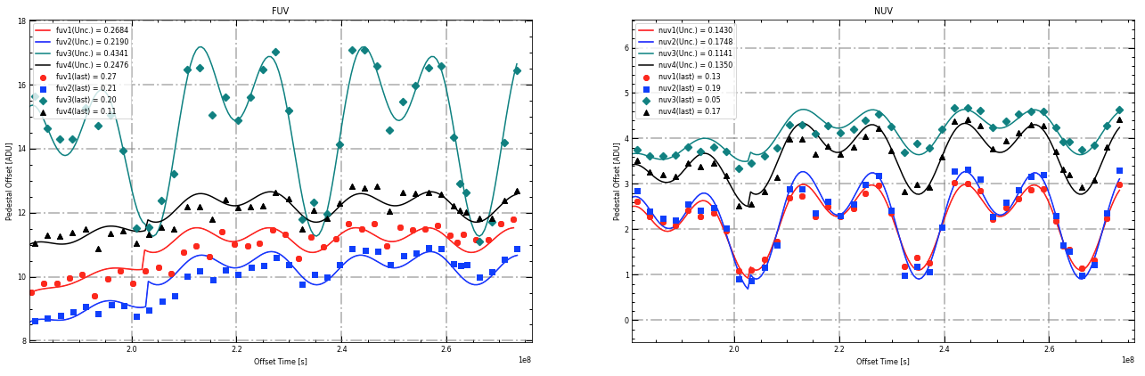**Model Refit from 12/22/2019 (Frozen Model Updated):** The lock-in date here is 12/22/2019, which is fully back at the start 2 cycles ago. Most obvious in the FUV2 channel at offset 2.0, this was at the start of the last big increase we see outside of normal cycle fluctuations. It produces poor alignment in the months following the lock-in date and has a large discontinuity in FUV channels. Would not suggest using; seems to be before the stability period.

**Model Refit from 07/06/2020 (Frozen Model Updated):** This was my preferred model out of all of them. This sets the lock-in date as 07/06/2020, which is the middle cycle point going back 2 cycles. This puts the lock-in date right after we start to really see stability in the model, again most visible here in FUV2 at an offset time of 2.1. This model produced the best numerical results in most categories and also introduced the least discontinuity. It also has the best reasoning for being used, with the period of stability beginning around this time. A subtler adjustment approach could improve the discontinuity that we are seeing, especially in FUV3. This would be my recommended approach to improving our model.

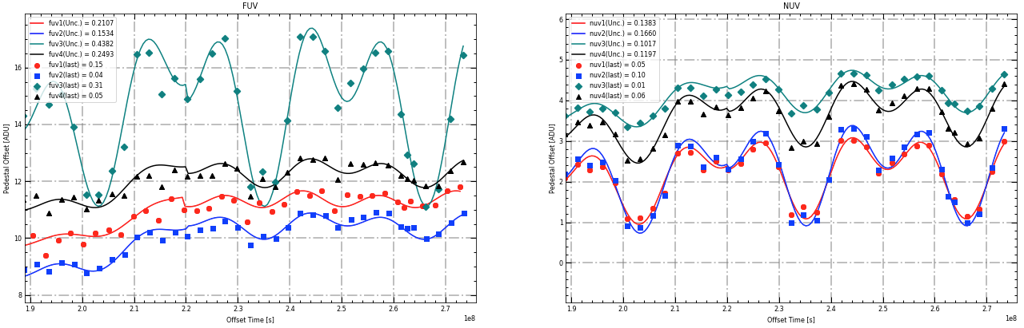

**Model Refit from 07/06/2020 (Frozen Model As-is):** This is included to demonstrate the improvement gained by optimizing the model parameters before locking them in. This model has the same lock in date (07/06/2020) but the parameters for the locked in model are the same as for the No Refit Model; not optimized. The results show how much improvement is gained by optimizing the parameters before locking them in. With optimization, the earlier model is free to improve itself without needing to be concerned with the data to the right of it. This results in overall better fit and would allow us to lock the model in with confidence that we are locking in the best possible model description and never look back again.

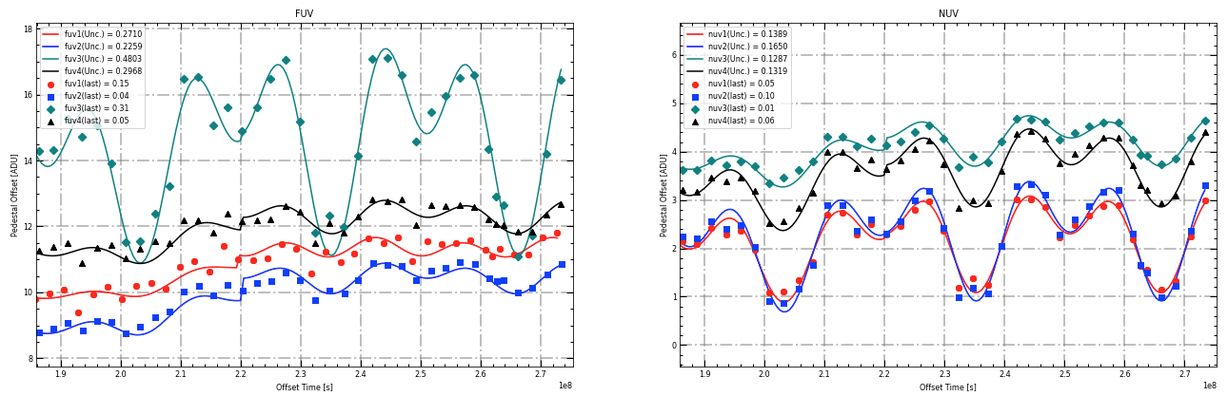

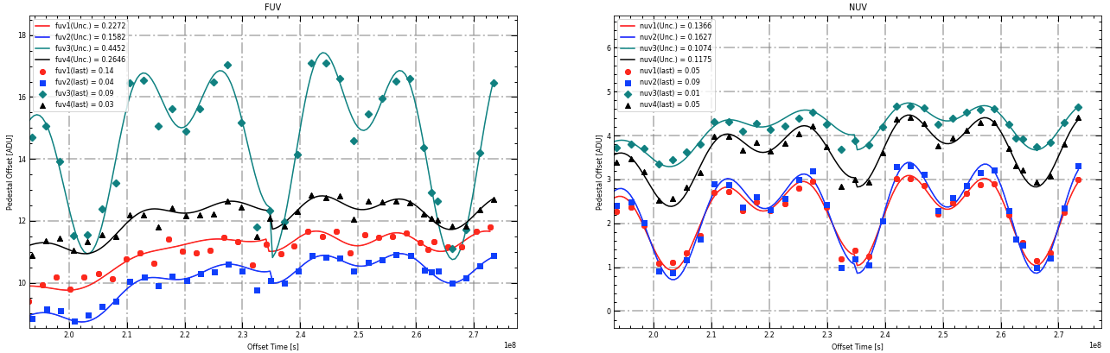**Model Refit from 12/26/2020 (Frozen Model Updated):** The runner up in terms of overall performance. Implementing at 12/26/2020 puts this at the start of the cycle 1 cycle back. There is a large amount of discontinuity at the point of implementation, but could again be minimized with a subtler approach at the expense of pure agreement. This makes sense to start exactly from a cycle ago. In most areas it performs as well as the 07/06 model and, in some places, better, but it is implemented well after we start to really see the stability of the model.

**Model refit from 07/11/2021 (Frozen Model Updated):** This is the most recent lock-in date that I tried. It starts midway through the last cycle at 07/11/2021. This produced a lot of discontinuity and not the best overall values. It was the best for the most recent data points, but that makes sense because it’s trying to create a model for only the most recent points.

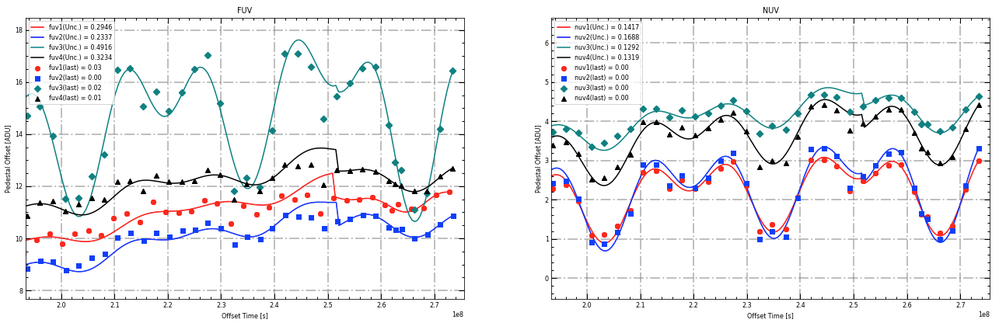

Here is a chart to quickly compare the most interesting of the above models. I excluded the two locked-in dates that produced obviously inferior results. Again, it is clear optimizing before locking in produces a great improvement. Just by the numbers 12/22/2020 and 07/06/2020 seem very comparable, but 07/06/2020 makes more sense logically and produced significantly less discontinuity, so would likely be my suggestion.

|  |  |  |  |  |  |  |  |  |  |  |
| --- | --- | --- | --- | --- | --- | --- | --- | --- | --- | --- |
| **Port** | **Current Model** | | **Refit without Lower** | | **12/26/2020** | | **07/06/2020** | | **07/06/2020 Not Optimized** | |
| *Sigma* | *Last* | *Sigma* | *Last* | *Sigma* | *Last* | *Sigma* | *Last* | *Sigma* | *Last* |
| *FUV1* | 0.2769 | 0.05 | 0.3300 | 0.41 | 0.2272 | 0.14 | 0.2107 | 0.15 | 0.2710 | 0.15 |
| *FUV2* | 0.2639 | 0.64 | 0.3067 | 0.64 | 0.1582 | 0.04 | 0.1534 | 0.04 | 0.2259 | 0.04 |
| *FUV3* | 0.5174 | 0.32 | 0.5620 | 0.50 | 0.4452 | 0.09 | 0.4382 | 0.31 | 0.4803 | 0.31 |
| *FUV4* | 0.3128 | 0.19 | 0.3578 | 0.31 | 0.2646 | 0.03 | 0.2493 | 0.05 | 0.2968 | 0.05 |
| *NUV1* | 0.1454 | 0.11 | 0.1507 | 0.05 | 0.1366 | 0.05 | 0.1383 | 0.05 | 0.1389 | 0.05 |
| *NUV2* | 0.1700 | 0.26 | 0.1741 | 0.11 | 0.1627 | 0.09 | 0.1660 | 0.10 | 0.1650 | 0.10 |
| *NUV3* | 0.1398 | 0.18 | 0.1600 | 0.19 | 0.1074 | 0.01 | 0.1017 | 0.01 | 0.1287 | 0.01 |
| *NUV3* | 0.1365 | 0.06 | 0.1543 | 0.12 | 0.1175 | 0.05 | 0.1197 | 0.06 | 0.1319 | 0.06 |

|  |  |
| --- | --- |
| Main Parameters | |
| Amp1 | The amplitude of the approximately 1 year sine function. |
| Amp1 | The amplitude of the approximately 1/2 year sine function. |
| P1 | Time dependent phase shift |
| Phi1 | The phase of the approximately 1 year sine function in radians. |
| Phi2 | The phase of the approximately 1/2 year sine function in radians. |
| Trend | The linear coefficient explaining the increase in the pedestal level. |
| Quad | The quadratic coefficient explaining the increase in the pedestal level. |
| Offset | The intercept for the quadratic and linear function |

|  |  |
| --- | --- |
| Modifier Parameters | |
| Qscale | The flattening of the linear and quadratic term after August 2017 |
| BO_Drop | The fractional drop in the offset (intercept term) due to the bake out on June 13-15, 2018 |
| SC_amp | The amplifier fraction in the in the sine function amplitudes due to the bake out on June 13-15, 2018. |
| Ns_incr | The fractional increase in the offset (intercept term) due to non-standard IRIS operations from October 27th to December 15th, 2018. |
| Lower | Term to improve alignment after consistent overestimate seen starting June 2021 |