**IRIS Darks 2021 (2nd half)**

This is a summary of the improvement made to the IRIS dark model following the disagreement seen in the 2nd half of 2021. During that period, the model consistently overestimated the darks. This was due to a larger similarity seen between the 2020 cycle and the 2021 cycle than had been seen in previous years. The model attempts to capture the periodicity of the IRIS darks throughout the yearly cycle. Year to year, the overall value has trended upwards and that increase is captured by the model. This cycle was not seen to be significantly increased from the previous year, especially in the back half, resulting in the consistent overestimate.

Here is a look at the last few years with model version 27, before introducing a new variable to the model:

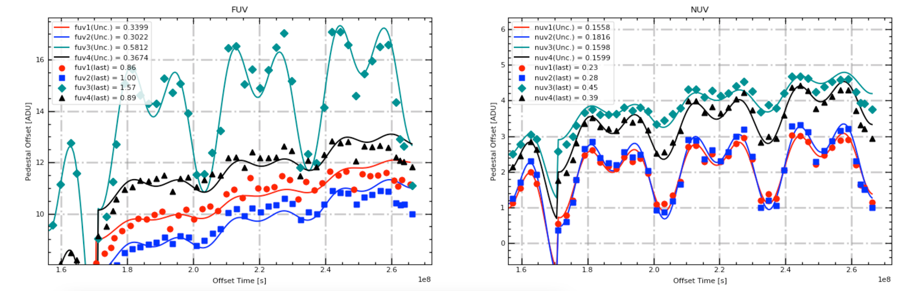

Below is a refit of the model without introducing any new parameters and adjusting all parameters. This adjustment improves model agreement across the board and significantly improves agreement of recent data points. However, it still shows consistent overestimation back to June 2021. This is pronounced in the FUV 1,2, and 4 ports. While NUV does still appear good, the consistency observed in those ports means that better agreement is possible.

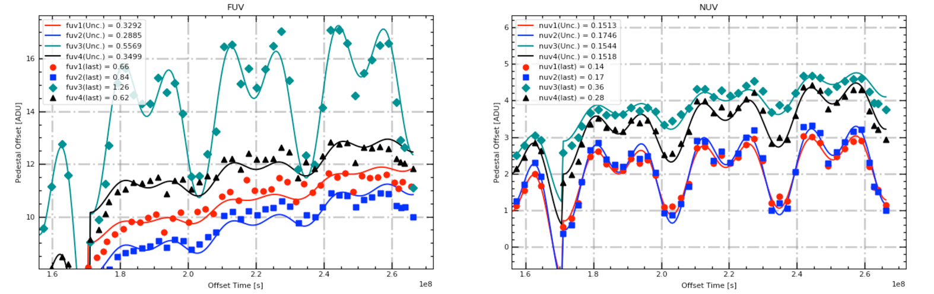

To achieve that goal, an additional parameter was added starting in June 2021. That parameter represented a distinct shift in each port, with that shift occurring in the negative direction. The model was updated with this new parameter. Only adjustments to the ‘trend’ parameter and 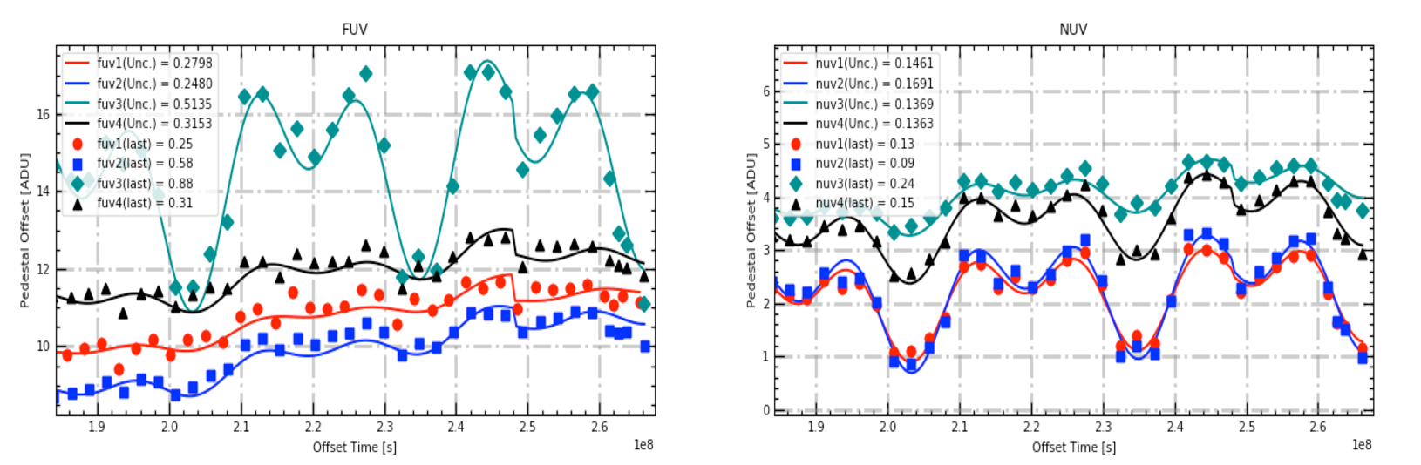the ‘lower’ parameter were made to achieve this improvement.

|  |  |  |
| --- | --- | --- |
| With no refit | Standard Model Refit | Refit with New Parameter |
| FUV1: **0.86**with **0.3399 sigma**  FUV2: **1.00**with **0.3022 sigma**  FUV3: **1.57** with **0.5812 sigma**  FUV4: **0.89** with **0.3674 sigma**  NUV1: **0.23** with **0.1558 sigma**  NUV2: **0.28** with **0.1816 sigma**  NUV3: **0.45** with **0.1598 sigma**  NUV4: **0.39** with **0.1599 sigma** | FUV1: **0.66**with **0.3292 sigma**  FUV2: **0.84**with **0.2885 sigma**  FUV3: **1.26** with **0.5569 sigma**  FUV4: **0.62** with **0.3499 sigma**  NUV1: **0.14** with **0.1513 sigma**  NUV2: **0.17** with **0.1746 sigma**  NUV3: **0.36** with **0.1544 sigma**  NUV4: **0.28** with **0.1518 sigma** | FUV1: **0.25**with **0.2798 sigma**  FUV2: **0.58**with **0.2480 sigma**  FUV3: **0.88** with **0.5135 sigma**  FUV4: **0.31** with **0.3153 sigma**  NUV1: **0.13** with **0.1461 sigma**  NUV2: **0.09** with **0.1691 sigma**  NUV3: **0.24** with **0.1369 sigma**  NUV4: **0.15** with **0.1363 sigma** |
| Average FUV: **1.08**  Average FUV sigma: **0.3977**  Average NUV: **0.34**  Average NUV sigma: **0.1643** | Average FUV: **0.85**  Average FUV sigma: **0.3811**  Average NUV: **0.24**  Average NUV sigma: **0.1580** | Average FUV: **0.51**  Average FUV sigma: **0.3392**  Average NUV: **0.15**  Average NUV sigma: **0.1471** |

It will need to be monitored moving forward if the second half of 2021 was an isolated lower period or if the consistency from cycle to cycle will remain moving forward. If the consistency does remain moving forward, the model will continually try to increase at a rate faster than the actual data. If 2022 shows a similar overestimation by the model, additional and more complex adjustments may need to be implemented.

========================================================================

*Emails from IRIS Dark refit from November 2021. Before the implementation of the ‘lower’ parameter.*

We will not really understand if this model overestimation will be a long-term trend until we get some data points on how low eclipse season will go or on the other side of eclipse season. Because of that, it is difficult to determine if implementing a new variable is an overreaction to capture a short-term trend or necessary to describe the model moving forward. There are valid arguments for both cases, so it has been difficult to determine what ultimately makes the most sense. As I stated before, any model adjustments including a new parameter introduces discontinuity into the model at the time of implementation, so we would like to avoid that option unless it is truly necessary. For now, our decision is to send out a model refit without an additional parameter**.**And we have outlined moving forward exactly what criteria we will be looking for in adding an additional parameter.

 A continued overestimation would be more obvious with the data from the low of eclipse season or the rise out of it. If this trend continued to that point, I would have no issue introducing a change to the model without an obvious physical explanation. CCD cameras settling into greater consistency after some time period would be a plenty adequate explanation for me at that point. Ultimately, we are looking to determine if this is a small error over a few months or truly a long-term issue. The following would trigger an additional variable:

* The low of eclipse season (should be in about a month or so) is significantly lower than the model predicts. This would indicate that it wasn't just a single section of a cycle that was incorrectly captured by the model, but indicative of a broader error in the model that requires adjustment through an additional variable.
* The cycle immediately after eclipse season is underestimated. Even if eclipse season was captured well with the refit, this would indicate that the model no longer explains data outside of eclipse season well.

I am happy with utilizing this parameter refit only model for now and keeping a close watch over the next 1-2 months if a new variable is really needed. The next set of darks was taken yesterday so I should be able to get those processed soon. I would guess that after the darks taken on the 24th we will have a much clearer picture about the overall trends of the model, since we should be getting close to the lower portion of eclipse season by then.

For now, here is model refit version 27. Please use it to process all data going back to June 1st, 2021.If the next few sets reveal that a more drastic change is required, this data may need to be reprocessed. But for now, please use model version 27. The fits are below and aren't great, but the drop into eclipse season does tend to exaggerate model disagreements.

FUV1: **0.80**with a **0.3079 sigma**

FUV2: **0.85**with a **0.2653 sigma**

FUV3: **1.33** with a **0.5261 sigma**

FUV4: **0.86** with a **0.3378 sigma**

NUV1: **0.28** with a **0.1473 sigma**

NUV2: **0.33** with a **0.1722 sigma**

NUV3: **0.33** with a **0.1409 sigma**

NUV4: **0.38** with a **0.1432 sigma**