**[Titans]**

Titans are a race of giant man-eating humanoids that serve as catalysts for the events in the series.

**Types**

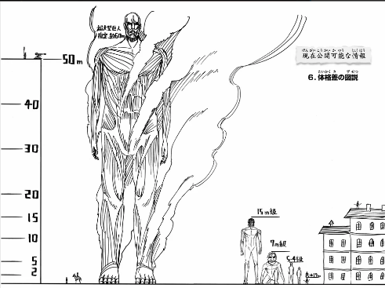 Different types of titans that appear are: Normal, Crawlers, Abnormal, Humanoid. The size of the titans varies from between 4 and 15 meters except for the special humanoid ‘Colossal Titan’ which is 60m.

**States**

Different states the titans can go into: Wandering, Chasing, Searching, Attacking and death.

**Movement**

Every titan type has its own various skill sets.

* **Normal titans** will only walk in the wandering/chasing state. They will also go after the player which is the closest in their sight.
* **Crawlers** move and attack like a four-legged creature. They can perform the same attacks as normal titans (except for kicking and belly flop). All the animations will be different from the normal titans.
* **Abnormal titans** will walk in their wandering state but will start to run when chasing a player. They will lock on to the first player they saw until he/she is out of their sight. This titan is a lot more intelligent which enables him to maneuver smarter towards the player and throw objects.

**Weak spots**

The weak spot of a titan is the nape, this must be cut (exactly 1m and 10cm) to successfully kill it. The player is also able to slash the joints of the titan to disable the slashed limb.

**Attacks**

Killing the player must be done with caution and reduce motion sickness as much as possible. Possible ways to do this are:

* Moving the player to 3rd person
  + Keep the player on the spot in 3rd person in spectator mode if he/she was standing still.
  + Keep the velocity of the player but go into spectator mode then slowly black out and set the players position to the desired position. Add a ‘you died’ label to show that they died while blacking out.
* Moving the head of the titan to the hand which grabbed the player

Attacks would be:

* Grabbing the player out of the air with its hands or mouth
* Smashing the player out of the air.
* Crushing the player with a belly flop.
* Kicking the player.
* Throwing an object (Abnormal)

A nice feature would also be a replay state where you can watch your death.