Regressão

Lucas Gessner da Silva
Unviersidade Federal de Santa Catarina
Daniel Augusto S. Porto
Unviersidade Federal de Santa Catarina)
Lucas Dantas Igarashi
Unviersidade Federal de Santa Catarina

Pré-Processamento dos Dados

Analisando os Atributos
Deletamos os seguintes atributos porque…..

Arrumando as Sintaxes
Entre os atributos restantes foi preciso arrumar a sintaxe na coluna “Combustível” e “Km”. Na característica combustível foi padronizado as diferentes formas que estavam escrito “Gasolina” e “Diesel”. Já na coluna Km, os dados foram mudados de string para float.

Linhas com Lacunas
Tentando manter a consistêcia dos dados, as lacunas de varíaveis contínuas foram preenchidas com a média da coluna. Porém, as linhas com lacunas em atributos discretos foram eliminadas para não serem preenchidas de forma inviesada.

Discreta para Contínua
Para os atributos discretos ordinários, como a faixa de preço, foram atribuitos valores inteiros crescentes dada sua ordem.
Entretanto, o mesmo não pdoe ser feito para atributos nominais, não havendo uma hierarquia intrínseca. Nesses casos, levando em conta que o número de categorias em cada coluna nominal era baixa, foi usado o método One Hot Encoding, transformando cada categoria em uma atributo diferente.

Padronizando e Tirando Outliers
Para melhorar o desempenho dos modelos e a retirada dos outliers, todos os atributos foram padronizados. Após esse processo a indentificação de dados anomalôs pelo método One Class SVM foi mais eficaz.

Modelos e Avaliações
Três modelos de regressão foram usados, progressão linear, Random Forest Regressor e Gradient Boosting Regressor. Utilizando validação cruzada com 5 pastas, as métricas avaliadas foram a Média do Erro Absoluto(MAE), para compreender o quanto de erro médio o modelo tinha, e o R², comprendendo a próximidade do valores do modelo com os valores reais. Obtendo assim, os seguintes resultados:

Regressão Linear:

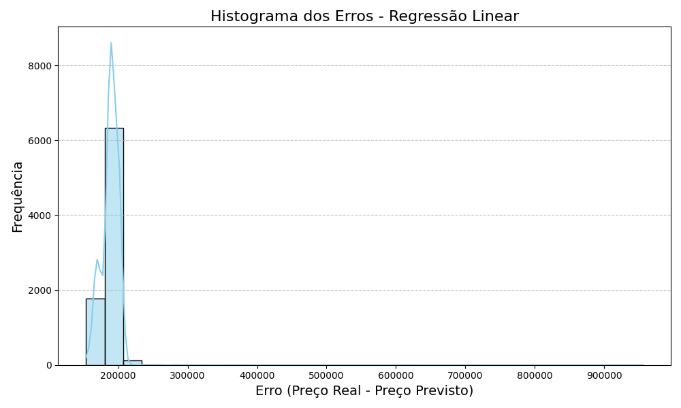
dddddddddddd
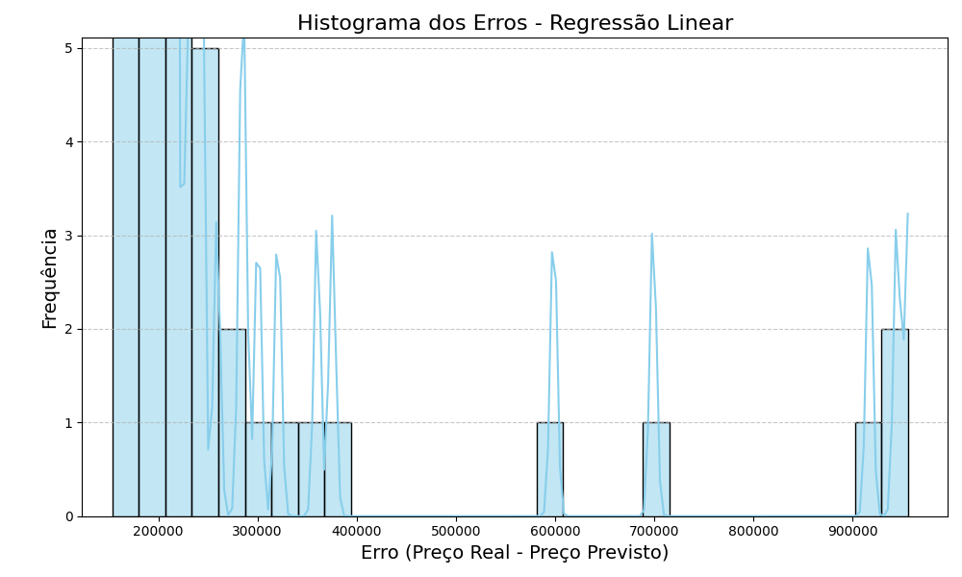
dddd
R2 Médio: 0.7682 (±0.0094)
MAE Médio: 6146.2630 (±115.0881)

Random Forest Regressor

R2 Médio: 0.8100 (±0.0128)
MAE Médio: 4751.6641 (±131.1732)
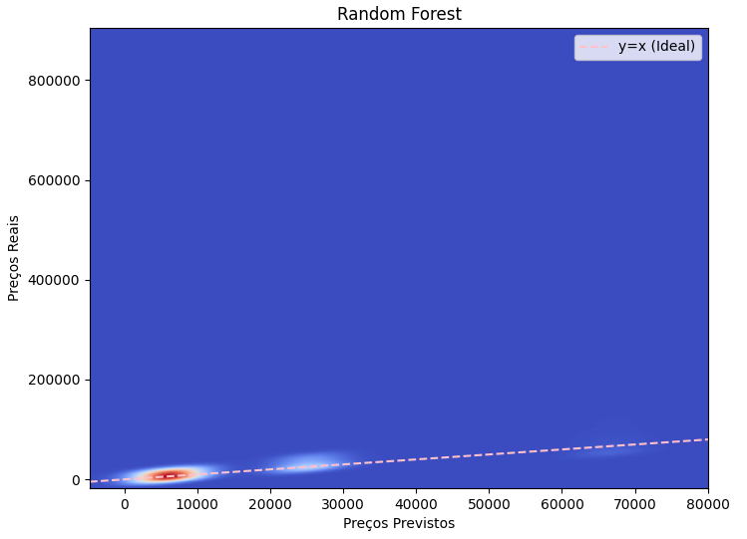
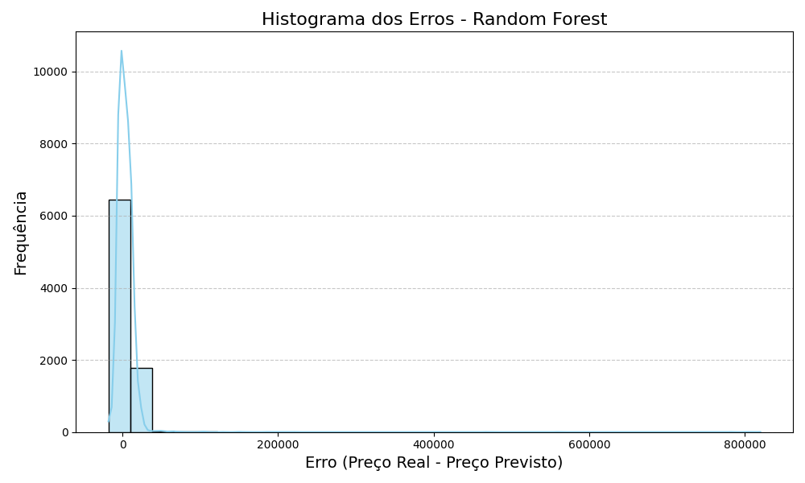
ddddddddddd
ddddddddddd

Gradient Boosting Regressor:

R2 Médio: 0.8185 (±0.0092)
MAE Médio: 5285.7522 (±128.5068) and Acronyms
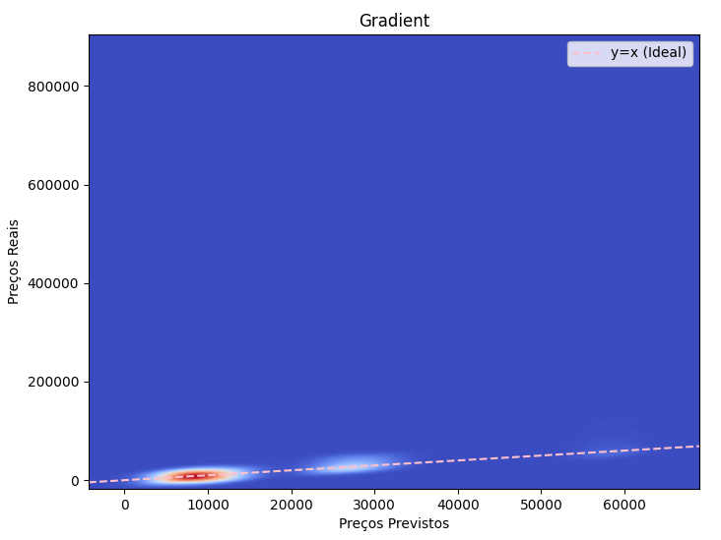

ddddd
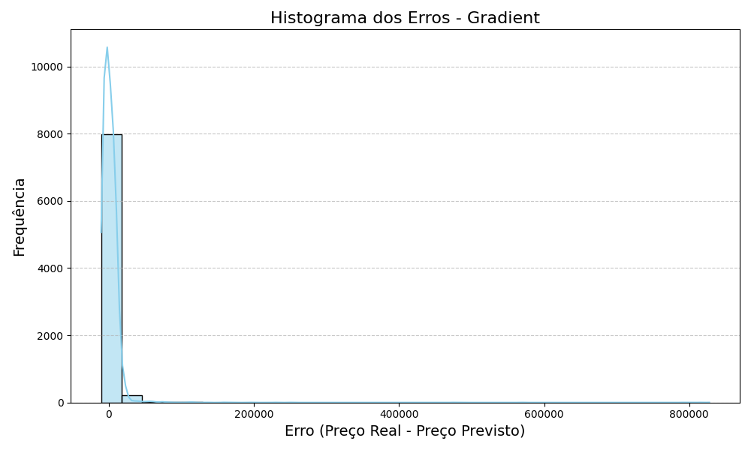
ddd

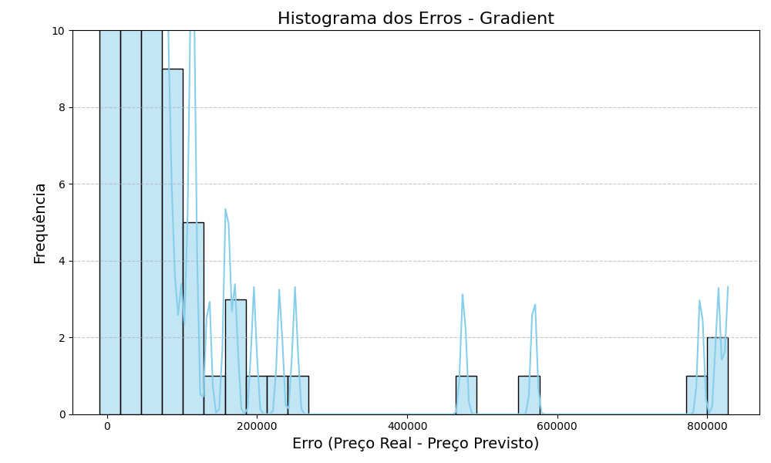

Equations
The equations are an exception to the prescribed specifications of this template. You will need to determine whether or not your equation should be typed using either the Times New Roman or the Symbol font (please no other font). To create multileveled equations, it may be necessary to treat the equation as a graphic and insert it into the text after your paper is styled.
Number equations consecutively. Equation numbers, within parentheses, are to position flush right, as in (1), using a right tab stop. To make your equations more compact, you may use the solidus ( / ), the exp function, or appropriate exponents. Italicize Roman symbols for quantities and variables, but not Greek symbols. Use a long dash rather than a hyphen for a minus sign. Punctuate equations with commas or periods when they are part of a sentence, as in:
a  b    
Note that the equation is centered using a center tab stop. Be sure that the symbols in your equation have been defined before or immediately following the equation. Use “(1)”, not “Eq. (1)” or “equation (1)”, except at the beginning of a sentence: “Equation (1) is . . .”

Some Common Mistakes
- The word “data” is plural, not singular.
- The subscript for the permeability of vacuum μ₀, and other common scientific constants, is zero with subscript formatting, not a lowercase letter “o”.
- In American English, commas, semicolons, periods, question and exclamation marks are located within quotation marks only when a complete thought or name is cited, such as a title or full quotation. When quotation marks are used, instead of a bold or italic typeface, to highlight a word or phrase, punctuation should appear outside of the quotation marks. A parenthetical phrase or statement at the end of a sentence is punctuated outside of the closing parenthesis (like this). (A parenthetical sentence is punctuated within the parentheses.)
- A graph within a graph is an “inset”, not an “insert”. The word alternatively is preferred to the word “alternately” (unless you really mean something that alternates).
- Do not use the word “essentially” to mean “approximately” or “effectively”.
- In your paper title, if the words “that uses” can accurately replace the word “using”, capitalize the “u”; if not, keep using lower-cased.
- Be aware of the different meanings of the homophones “affect” and “effect”, “complement” and “compliment”, “discreet” and “discrete”, “principal” and “principle”.
- Do not confuse “imply” and “infer”.
- The prefix “non” is not a word; it should be joined to the word it modifies, usually without a hyphen.
- There is no period after the “et” in the Latin abbreviation “et al.”.
- The abbreviation “i.e.” means “that is”, and the abbreviation “e.g.” means “for example”.
An excellent style manual for science writers is [7].

Using the Template
After the text edit has been completed, the paper is ready for the template. Duplicate the template file by using the Save As command, and use the naming convention prescribed by your conference for the name of your paper. In this newly created file, highlight all of the contents and import your prepared text file. You are now ready to style your paper; use the scroll down window on the left of the MS Word Formatting toolbar.

Authors and Affiliations
The template is designed for, but not limited to, six authors. A minimum of one author is required for all conference articles. Author names should be listed starting from left to right and then moving down to the next line. This is the author sequence that will be used in future citations and by indexing services. Names should not be listed in columns nor group by affiliation. Please keep your affiliations as succinct as possible (for example, do not differentiate among departments of the same organization).

For papers with more than six authors: Add author names horizontally, moving to a third row if needed for more than 8 authors.

For papers with less than six authors: To change the default, adjust the template as follows.

Selection: Highlight all author and affiliation lines.

Change number of columns: Select the Columns icon from the MS Word Standard toolbar and then select the correct number of columns from the selection palette.

Deletion: Delete the author and affiliation lines for the extra authors.

Identify the Headings
Headings, or heads, are organizational devices that guide the reader through your paper. There are two types: component heads and text heads.
Component heads identify the different components of your paper and are not topically subordinate to each other. Examples include Acknowledgments and References and, for these, the correct style to use is “Heading 5”. Use “figure caption” for your Figure captions, and “table head” for your table title. Run-in heads, such as “Abstract”, will require you to apply a style (in this case, italic) in addition to the style provided by the drop down menu to differentiate the head from the text.
Text heads organize the topics on a relational, hierarchical basis. For example, the paper title is the primary text head because all subsequent material relates and elaborates on this one topic. If there are two or more sub-topics, the next level head (uppercase Roman numerals) should be used and, conversely, if there are not at least two sub-topics, then no subheads should be introduced. Styles named “Heading 1”, “Heading 2”, “Heading 3”, and “Heading 4” are prescribed.

Figures and Tables

Positioning Figures and Tables: Place figures and tables at the top and bottom of columns. Avoid placing them in the middle of columns. Large figures and tables may span across both columns. Figure captions should be below the figures; table heads should appear above the tables. Insert figures and tables after they are cited in the text. Use the abbreviation “Fig. 1”, even at the beginning of a sentence.
- Table Type Styles
Table Head | Table Column Head
Table Head | Table column subhead | Subhead | Subhead
copy | More table copyª
- Sample of a Table footnote. (Table footnote)
- Example of a figure caption. (figure caption)
Figure Labels: Use 8 point Times New Roman for Figure labels. Use words rather than symbols or abbreviations when writing Figure axis labels to avoid confusing the reader. As an example, write the quantity “Magnetization”, or “Magnetization, M”, not just “M”. If including units in the label, present them within parentheses. Do not label axes only with units. In the example, write “Magnetization (A/m)” or “Magnetization {A[m(1)]}”, not just “A/m”. Do not label axes with a ratio of quantities and units. For example, write “Temperature (K)”, not “Temperature/K”.

Acknowledgment (Heading 5)
The preferred spelling of the word “acknowledgment” in America is without an “e” after the “g”. Avoid the stilted expression “one of us (R. B. G.) thanks ...”. Instead, try “R. B. G. thanks...”. Put sponsor acknowledgments in the unnumbered footnote on the first page.

References

- Medium: Read and write stories.
- scikit-learn: machine learning in Python — scikit-learn 1.5.2 documentation
- pandas documentation — pandas 2.2.3 documentation
- Matplotlib — Visualization with Python
- seaborn: statistical data visualization — seaborn 0.13.2 documentation

