CE/CS/SE 3354 · Software Engineering · Fall 2026
Project Milestone P2

Analysis and High-Level Design
Sprinkler Tracking System
Team | Team 02, section .010
Document version | 1.0
Date | 11/08/2026
Repository URL | https://github.com/LucasIgl/CS3354.010_FALL26_TEAM02
Git tag for this milestone | p2 (points at the commit that contains this exact PDF)
Submitted on Canvas by | [one member only]

Team member | NetID | GitHub username
Mujtaba Altameemi
Eric Dantas
Lucas Igl
Owen Shen
Ash Thanickel | Dat200003 | dthanickel

HOW TO USE THIS TEMPLATE
This is not a new document. P2 continues the document you baselined at P1. Copy your P1 sections 1 to 3 into this file (updated under change control), then fill in the new sections 4 to 9. Your P1 project plan, open questions and baseline move to the end and are renumbered:
P1 section 4 (project plan) becomes section 10. P1 section 5 (open questions) becomes 11. P1 section 6 (baseline) becomes 12.
Delete every guidance, example and warning box (blue, amber and red) and the two marking pages at the end before you submit. They are instructions, not content. Boxes or placeholders such as "[TBD]", "PR #[n]" or "[Member 3]" left in the submitted document lose document-quality points.
Length: sections 4 to 9 should add roughly 12 to 18 pages, diagrams included. Every section below carries a budget. A longer document is not a better one.
Diagrams: draw them in any tool (draw.io, Lucid, PlantUML, or a tidy hand drawing that is scanned). Export each as an image for this document and commit the source file to /docs/p2/diagrams. A diagram that cannot be read cannot be credited for its content.
Required structure: using this file is optional, but its section numbering is required, because the rubric refers to it.
Rubric: the marking pages at the end show where the 60 points sit. Read them before you divide the work.

WHAT P2 DOES NOT ASK FOR (DELETE THIS BOX BEFORE SUBMITTING)
P2 is analysis and high-level design. At this milestone we are NOT asking for:
design class diagrams with operations, parameter types or visibility, and design-level sequence diagrams with operation signatures (Chapter 9 detailed design; they enter the document during P3 work)
production code (the only code in P2 is the small architecture spike in section 8)
a test plan (P3, after Chapter 11)
screen mock-ups or a visual design (not graded at this milestone; add them only if they settle an open question)
design patterns from the Gang of Four catalog, ATAM or utility trees (not required; do not spend your time there)
Work placed in the wrong milestone is not credited. Spend the time on sections 4 to 9.

0 Revision History, Contribution Record and Changes Since P1
All three tables below are graded. The contribution record carries the individual 20% of this milestone and must agree with your repository history.
Version | Date | Author | Summary of change
0.1 | 10/18/2026 | All | P1 baseline
1.0 | 11/08/2026 | All | P2 baseline: analysis and high-level design added

0.1 Individual contribution record (P2)
Team member | Sections and artifacts this person produced for P2 | Evidence in the repository (commit hashes, PR numbers) | Reviews given (PR numbers)
Mujtaba Altameemi | Section 6 | PR #8
Eric Dantas
Lucas Igl | Section 4 | PR #7
Owen Shen | None
Ash Thanickel | Section 5 | Commit fc16c9e | PR #7, PR #8

GUIDANCE: DELETE THIS BOX BEFORE SUBMITTING
Evidence means something a reader can open and that existed before the deadline: a commit hash, a pull request, a file in the repository. Issues you own count as indirect evidence; link the commits that close them for full credit.
Commit your own work from your own GitHub account. If one person uploads everyone's text from a shared document, the history shows one author and the other members have no verifiable evidence. A shared drafting document is fine; the final text of each section is committed by its owner.
Cite only what exists. Every commit, pull request, branch and file named in this table is checked. Citing evidence that is not in the repository is an academic-honesty matter, not a formatting slip.
Every member appears with a distinguishable contribution. Two rows with identical wording are marked as vague claims. If a member did not contribute, write that plainly in their row rather than leaving it blank or covering for them.

0.2 Changes since the P1 baseline
Change ID | What changed (IDs affected) | Why (P1 feedback, new finding, spike result) | Knock-on effect | Agreed on
CH-01
CH-02
CH-03

GUIDANCE: DELETE THIS BOX BEFORE SUBMITTING
Start with your P1 feedback. Every point raised in your P1 comment should appear here as a change, or with one sentence explaining why you kept the original. This table is where the baseline-and-change-control idea from Chapter 5 becomes real.
Requirement IDs are never reused. A removed requirement stays in section 3 marked "Withdrawn (CH-nn)" so the traceability matrix does not silently lose it.
Budget: half a page.

EXAMPLE (COMETPARK): DELETE BEFORE SUBMITTING
CH-02 · QR-02 rewritten as quality-attribute scenario QAS-01 · Why: P1 feedback said "fast enough" had no response measure · Knock-on: ADR-02 now cites QAS-01 · Agreed 30 Oct.

1 to 3 Introduction, Overall Description and Requirements (carried forward)
GUIDANCE: DELETE THIS BOX BEFORE SUBMITTING
Paste your P1 sections 1, 2 and 3 here and bring them up to date. Keep their numbering and IDs.
Fix before you build on it: any requirement that is still untestable, any source that still says "pending", any open question your P1 feedback flagged. Analysis and design inherit every ambiguity you leave in section 3.
Use cases: section 3.4 keeps the use-case diagram and the list at actor-goal level. The detailed expansion now lives in section 4; do not copy it twice.
Traceability: replace the P1 matrix in section 3.5 with a one-line pointer to section 9.1, where it is extended.
If nothing in a subsection changed, keep it and say so in one line under its heading ("Unchanged since v0.x").

1 Introduction
1.1 Purpose of this document and of the system

This document acts as the proposal and baseline for Section 010, Team 02’s project Sprinkler Tracking System. It contains a description of the system, its scope, context, stakeholders, requirements, and constraints. This document is used by the course instructor/grader for grading and reference, and by the team members for building, designing, and testing the system. Once signed and submitted, it becomes the baseline and additional changes must go through change control.
The Sprinkler Tracking System (STS) addresses an issue at UT Dallas where the campus wide sprinkler watering system activates on a fixed schedule regardless of the weather conditions, as observed by Team 02 members throughout the Fall 2026 semester. This results in sprinklers activating during or immediately after rain showers, causing wasted water, funds, and potentially damaging plants due to overwatering. The problem affects UT Dallas Facilities Management, since the unnecessary watering costs money and additional wear on the watering system, requiring additional upkeep. Additionally, because UT Dallas is a large campus, reducing unnecessary water use also lowers its demand on the surrounding community’s water supply. The STS will provide a dashboard for the Facilities team, allowing them to easily determine when to disable the watering system’s scheduled activations.

1.2 Scope
In scope — we will build this | Out of scope — we will not, and why
Dashboard to quickly view watering schedules and zones. | Actual rain measurement. This requires an additional hardware system with its own development and test cycle and manufacturing constraints.
Utilize weather APIs to determine when watering schedules should be disabled. | Modify the existing sprinkler system. This requires a large cost to replace a system that is not broken on its own.
Display cost and water savings from the disabled waterings. | Monitor for failing irrigation. This requires a network of additional sensors, and the goal of this project is to reduce water usage on available hardware.
Communication with the Primary Sprinkler Irrigation Controller. | Create a public-facing interface. The data collected is intended solely for UT Dallas staff and maintenance contractors.

Why the exclusions were excluded:
The exclusions are chosen since they require either a large increase in scope or cost for little gain. The goal of this project is to exist in harmony with current systems.

1.3 Definitions, acronyms and abbreviations
Term or abbreviation | Meaning as used in this project
STS | Sprinkler Tracking System, the name of the project being proposed in this document

1.4 References
[NA]

2 Overall Description
2.1 Product perspective and context
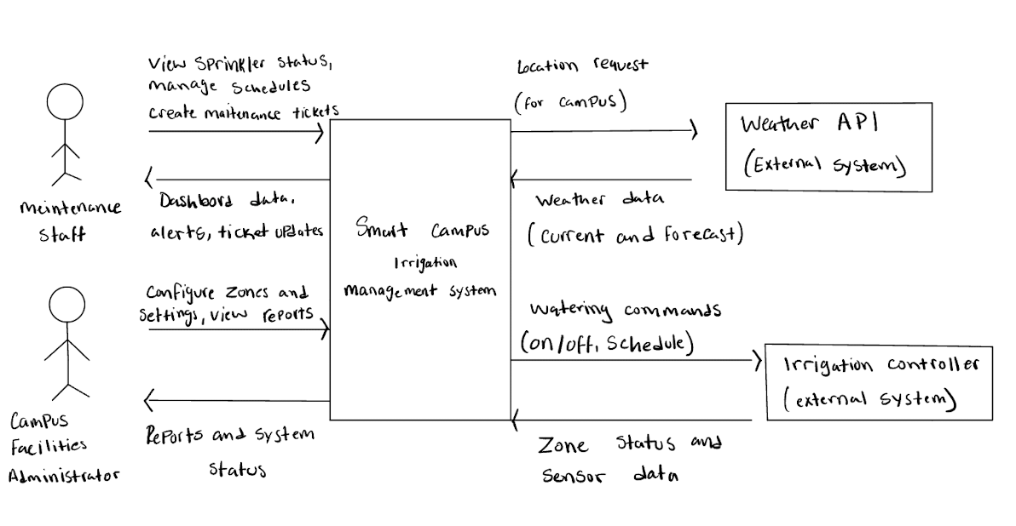
The Sprinkler Tracking System is designed to help campus maintenance staff keep track of the sprinklers, change watering schedules, and report any problems. It also uses weather data to check if watering is needed or not, especially when it rains. Our system will focus on the dashboard, watering schedules, and maintenance reports. The Weather API and sprinkler controller will be outside the system since we are not building those ourselves.

2.2 Stakeholders and how you reached them
Stakeholder | Role in relation to the system | What they need from it | How you learned this
Maintenance Staff | Maintain the sprinklers | Check sprinkler status, change schedules, and report problems | Assumed based on their job
Campus Facilities | Manage the sprinkler system | Control watering schedules and check water usage | Assumed based on their responsibilities
University Management | Manage campus expenses | Reduce water waste and save money | Assumed based on campus needs
Students and Staff | Use campus areas | Avoid sprinklers running when they are not needed | Based on our observations on campus
IT Staff | Support the system | Keep the system secure and running properly | Assumed based on their responsibilities

2.3 User characteristics
Maintenance Staff: They know how the sprinklers work but might not be familiar with the dashboard. The system should be easy to use on phones and computers so they can check sprinkler status and report issues.
Campus Facilities Admin: They are familiar with how to manage campus operations but might not be familiar with the new system. The dashboard should be simple so they can quickly check water usage and manage watering schedules.

2.4 Constraints
- The system will use weather APIs to determine whether watering is needed, rather than adding new sensors.
- The system will work with the existing sprinkler system on campus without making any changes to the hardware.
- The dashboard will only be accessible to campus maintenance staff and other authorized workers.
Source: Section 1.2 (Project Scope)

2.5 Assumptions and dependencies
# | Assumption or dependency | What breaks if it does not hold
A1 | We are assuming we can connect our system to the sprinklers on campus. | If it doesn't work we won't be able to control the sprinklers from the dashboard.
A2 | We will use a Weather API to get weather updates. | If the API doesn't work we won't be able to adjust the watering schedules based on the weather.
A3 | We assume maintenance staff will be able to use the dashboard. | If they can't use it, they won't be able to check the sprinklers or change the schedules.

2.6 Feasibility summary
Feasibility gate | Verdict | Evidence behind the verdict
Technical | Feasible, needs testing | We can use a weather API, but we haven't yet checked whether we can connect to the campus sprinklers.
Operational | Feasible, needs confirmation | Maintenance staff can use the dashboard to check the sprinklers and change the watering schedules.
Schedule | Feasible, needs planning | There are five of us in the group, so we can each work on different parts of the project.
Economic / resource | Feasible for a prototype | We are using the sprinklers already on campus, so we don't need new sensors. We still need to check the API cost.

3 Specific Requirements
3.1 Functional requirements
ID | Requirement — one “shall” sentence | Priority | Source | Acceptance criterion
FR-01 | The system shall retrieve weather data for the UT Dallas campus from the weather API at least once hourly | MUST | University Management (2.2) | A tester can confirm this by checking the retrieval log
FR-02 | The system shall activate the sprinklers based on the set watering schedule | MUST | Campus Facilities (2.2) | A tester can confirm this by comparing the activation of the sprinklers to the set watering schedule
FR-03 | The system shall send a skip recommendation to the dashboard for the scheduled watering time if the weather forecast provides adequate precipitation | MUST | Campus Facilities (2.2) | A tester can confirm this by simulating an acceptable forecast and approving the skip recommendation sent
FR-04 | The system shall allow an administrator to make modifications to the watering schedule for each watering zone | MUST | Campus Facilities (2.2) | A tester can confirm this by creating, editing, and deactivating zones and confirm the changes on the dashboard
FR-05 | The system shall display the watering schedules, status, and alerts for each zone | MUST | Maintenance Staff (2.2) | A tester can confirm this by simulating alert triggers and checking the dashboard
FR-06 | The system shall require a user to sign in before displaying the dashboard | MUST | IT Staff (2.2) | A tester can confirm this by requesting the dashboard and ensuring that the dashboard redirects and verifies sign in data appropriately
FR-07 | The system shall allow maintenance staff to report problems with zones that will be displayed on the dashboard | SHOULD | Maintenance Staff (2.2) | A tester can confirm this by submitting a report and ensuring that it appears on the dashboard
FR-08 | The system shall export watering history and skipped watering as a CSV for a user-selected range of dates | COULD | University Management (2.2) | A tester can confirm this by attempting an export with a set of known records to ensure all incidents are exported correctly

3.2 Quality requirements
ID | Requirement — with threshold, condition and method | Priority | Source | How it will be verified
QR-01 | Ninety percent of dashboard loads shall occur within 3 seconds, measured over a 30-minute load test with up to 20 concurrent users | MUST | Maintenance Staff, Campus Facilities (2.2) | Load test scripted against the dashboard and report the 90th percentile load time
QR-02 | The dashboard shall be available for ninety-five percent of 5-minute checks between 6 AM and 10 PM over a 24-hour period | MUST | Campus Facilities (2.2) | Test script to ping the dashboard every five minutes during the period and report the successful checks
QR-03 | At least 4 of 5 first-time users shall approve a rain-skip recommendation within 2 minutes without help, using only the dashboard | MUST | User Characteristics (2.3) | Timed usability session with 5 new participants
QR-04 | A signed-in session shall expire after 30 minutes of inactivity and 100% of data endpoints shall reject unauthenticated requests | MUST | IT Staff (2.2) | Automated test that calls all endpoints without a session and with a session idle for 31 minutes

3.3 Constraint requirements
ID | Constraint — one sentence | Source | Why it cannot be negotiated
CON-01 | The system shall obtain all weather and rainfall data from an external weather API | Scope 1.2 | New rain-measurement hardware is out of scope
CON-02 | The system shall be accessible only to authenticated UT Dallas Facilities staff and authorized maintenance contractors with no public-facing interface | Scope 1.2 | Zone locations and schedules are operational data only for campus staff, a public interface is out of scope

3.4 Initial use cases
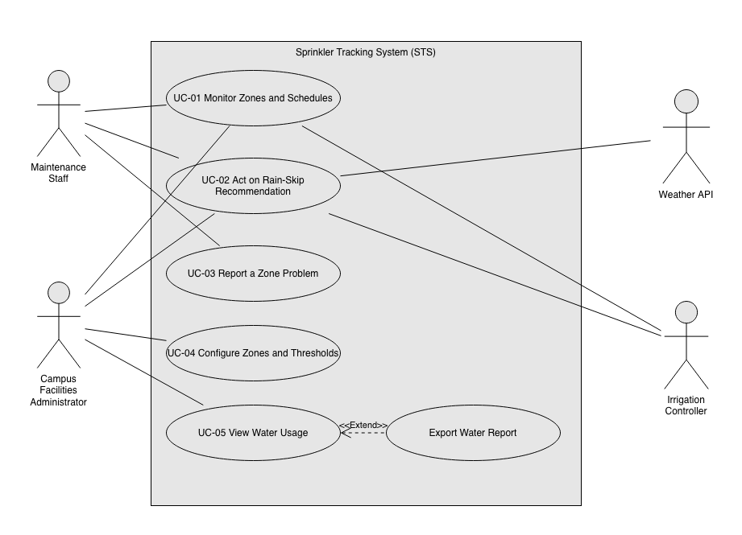

Expanded use cases
Field | Content
Identifier and name | UC-01 Monitor Zones and Schedules
Primary actor | Maintenance Staff
Supporting actors | Irrigation Controller, Weather API
Preconditions — what must be true before it starts | The staff member is signed in, and at least one active zone is configured.
Trigger — what starts it | A staff member opens the dashboard.
Main success scenario — numbered steps | - The staff member opens the dashboard  - The system shows every active zone with its name, location, next scheduling watering, and rain-skip status, plus the time of the last weather retrieval  - The staff member selects the zone  - The system requests that zone’s status from the Irrigation Controller  - The Irrigation Controller returns the status  - The system shows the zone’s status (idle, watering, or offline) with the time received, next week’s watering schedule, and open problem reports  - The staff member now knows all status of active zones, use case ends
Alternative and exception flows | 2a. No zones are active: The system shows “No active zones” and the use case ends.  2b. The last weather retrieval was over two hours old: System shows stale weather warning and marks status as out of date.  5a. The controller does not respond within 10 seconds: the system shows last known status with timestamp with label “controller unreachable” and continues to step 6  6a. The staff member sees a fault in the zone: they may start UC-03 Report a Zone Problem for that zone
Postconditions — what is true when it succeeds | The staff member has seen the zone’s status and schedule. No data in the system has changed
Requirements realized | FR-01, FR-05, FR-06, FR-07

Field | Content
Identifier and name | UC-02 Act on Rain-Skip Recommendation
Primary actor | Campus Facilities Administrator
Supporting actors | Weather API, Irrigation Controller, Maintenance Staff
Preconditions — what must be true before it starts | The administrator is signed in. At least one active zone has a flow rate, a rain threshold, and scheduled watering. Weather retrieval has been successful within the last 2 hours.
Trigger — what starts it | The system generates a rain-skip recommendation, and the administrator sees it on the dashboard
Main success scenario — numbered steps | - The administrator opens the recommendation on the dashboard  - The system shows the zone, the scheduled watering time, the observed and forecast rainfall, and the zone’s threshold  - The administrator approves the skip  - The system sends a skip command for that watering to the irrigation controller  - The irrigation controller acknowledges the command  - The system records the skip with approver and time  - The system marks the watering as skipped on the dashboard for all users
Alternative and exception flows | 3a. The administrator rejects the recommendation: the system records the rejection and leaves scheduled watering; use case ends.  3b. Watering begins before the administrator acts: the system marks the recommendation expired and use case ends.  5a. The controller does not acknowledge within 60 seconds: the system retries once; if it still fails, it shows a “skip not confirmed – disable manually” alert and records the watering as not skipped
Postconditions — what is true when it succeeds | The controller has accepted the skip; the skip is recorded with approver, time; dashboard shows the watering as skipped.
Requirements realized | FR-01, FR-03, FR-04, FR-05, FR-06

3.5 Requirements to use case traceability
View section 9.1 to see full use case traceability.

4 Use-Case Analysis
Chapter 7, first half. Here you take the use cases from section 3.4 and write the most important of them out turn by turn, still with the technology switched off.

4.1 Use cases selected for analysis
Use case | Name | Why it was selected | Non-trivial steps
UC-01 | Monitor Zones and Schedules | Primary use case for most actors. The reason the system exists. | Old data, or no response from controller.
UC-02 | Act on Rain-Skip Notification | Human in the loop control, allows the system to make actions. | Scheduled time occurs before recommendation is processed; controller doesn't respond.
UC-04 | Configure Zones and Thresholds | Step involves many possible outcomes and changes the state of the system. | What happens when invalid configurations are input.

GUIDANCE: DELETE THIS BOX BEFORE SUBMITTING
Analyze at least three use cases, including the two you specified in full at P1. We recommend that one of them involves an external system or a failure that the actor can see.
Choose by risk and value, not by ease: the use case that carries most of the product, the one that touches most of your quality requirements, the one you are least sure you can build.
Budget: a quarter of a page.

4.2 Expanded use cases
Copy the block below once for each use case in 4.1.

UC-01 Monitor Zones and Schedules
Primary actor | Maintenance Staff
Supporting actors and external systems | Irrigation Controller, Weather API
TUCBW (this use case begins when) | A staff member opens the dashboard.
TUCEW (this use case ends when) | The dashboard displays to the user the current zone status, schedules, and rain skip notifications.
Preconditions | The staff member is signed in and authenticated, and at least one zone is configured.
Postconditions | The zone data, schedules, and notifications are shown to the user, without any modified data.
Traces to requirements | FR-03, FR-05, FR-07, QR- 01, QR-02, CON-02

Actor input / action | System response
 | (0) System displays main menu
(1) Authenticated Actor opens the dashboard page
 | (2) System displays zones with name, location, next scheduled watering, rain skip notification, and last weather retrieval time
(3) Actor selects a zone
 | (4) System requests zone status from Irrigation Controller.
(5) Irrigation controller sends zone data
 | (6) System displays zone status from irrigation controller, including problem reporting and watering state. Also shows schedules and notifications.
(7) Authenticated actor reads dashboard.

Alternate flow | At step | Condition | What happens | Ends or rejoins at
A1 | (5) | Dashboard page is unable to retrieve irrigation controller data. | Display a connection error to user | Return to main screen (2)
A2 | (2) | Last weather retrieval time is >2 hours old. | Highlight old data, encourage the user to request a refresh of the weather data. | (2)

UC-02 Act On Rain Skip Notification
Primary actor | Campus Facilities Administrator
Supporting actors and external systems | Weather API, Irrigation Controller
TUCBW (this use case begins when) | Admin views a rain skip notification.
TUCEW (this use case ends when) | Controller removes a scheduled watering, and confirmation is displayed to the admin.
Preconditions | Admin signed in, at least one zone configured with flow rate, rain threshold, and watering schedule.
Postconditions | Controller accepted skip. Skip recorded with approver and time.
Traces to requirements | FR-01-03, FR- 05, QR-03, CON-02

Actor input / action | System response
 | (0) System displays dashboard with active rain-skip notification.
(1) Admin clicks onto rain-skip notification
 | (2) System calls Weather API to confirm rainfall.
(3) Weather API returns rainfall data
 | (4) System displays confirmed rainfall data and skip information.
(5) Admin views data and confirms rain skip
 | (6) System calls Irrigation Controller to skip scheduled watering
(7) Irrigation controller skips watering and sends confirmation
 | (8) System logs skip confirmation with timestamp and approver. Updates dashboard to show skipped watering.
(9) Admin sees confirmation acknowledgement.

Alternate flow | At step | Condition | What happens | Ends or rejoins at
A1 | (4) | Confirmed data no longer meets threshold to skip watering | Rain skip notification cancels, and ends use case. Return to dashboard. | Ends use case
A2 | (5) | Admin does not confirm rain skip before schedule or rejects. | Scheduled watering is not skipped, rain skip notification marked as missed. | Ends use case

UC-04 Configure Zones and Thresholds
Primary actor | Administrator staff
Supporting actors and external systems | Irrigation controller
TUCBW (this use case begins when) | Actor clicks into configuration settings on dashboard
TUCEW (this use case ends when) | Configuration settings are validated and saved
Preconditions | Actor is authenticated.
Postconditions | Valid configuration settings are saved and implemented in the system.
Traces to requirements | FR-02, FR-04

Actor input / action | System response
 | (0) System dashboard is open
(1) Staff opens configuration settings.
 | (2) System displays current zones and configuration settings.
(3) Staff edits settings and presses save. (flow rate, rain threshold, watering schedule)
 | (4) System validates settings, and calls irrigation controller with updated configurations. Calls weather API to update information based on new thresholds.
(5) Irrigation control receives new configurations and confirms successful configuration.
 | (6) System saves the new settings to the zone and its watering schedule, logs the change, and shows a save acknowledgement
(7) Staff sees the configuration save acknowledgement.

Alternate flow | At step | Condition | What happens | Ends or rejoins at
A1 | (4) | Invalid configuration is input | No settings are actually changed, and the user is notified | Redo (3)
A2 | (5) | Irrigation controller does not confirm updated configuration. | Settings are not saved, and the User is notified that the irrigation controller was not able to be configured. | Use case ends.

GUIDANCE: DELETE THIS BOX BEFORE SUBMITTING
The rules from Lesson 13, all of which are checked:
Step (0) is what the actor sees before touching anything. It is often skipped, and it is where many missing requirements are found.
One turn per row. An actor action on the left, the system response on the right. Two steps merged into one row become a missing message on your sequence diagram in section 5.
End with an acknowledgment the actor can perceive. No acknowledgment, no TUCEW, no use case.
No background processing. If the actor neither sees it nor waits for it, it belongs to another use case.
Precondition or alternate flow? If it can be false while the system works normally, it is a flow you must handle, not an assumption.
No technology yet. No screen widgets, no database, no framework names. "Taps the green button" and "queries the PostgreSQL table" both fail the analysis check.
Every item the actor column names should already be an attribute in your domain model (5.1). Where it is not, you have found one.
Budget: about one page per use case.

EXAMPLE (COMETPARK): DELETE BEFORE SUBMITTING
UC-02 Find an Open Space · Primary actor: Driver · External system: Lot Sensor Network · TUCBW the driver asks for parking near a destination building · TUCEW the driver sees the recommended lot with its number of open spaces.
(0) The system shows the campus lots with the time of the latest occupancy update. (1) The driver chooses a destination building and permit type. (2) The system shows the three nearest lots the permit allows, each with open spaces and walking time. (3) The driver selects a lot. (4) The system shows the lot entrance and confirms the count is no older than 60 seconds.
A1 at step (2): no permitted lot has an open space · the system shows the nearest lot with expected turnover and the visitor option · ends.

4.3 Self-review log
Use case | Check from the Lesson 13 review checklist | Defect found | How it was fixed
UC-01 | Use case ends with acknowledgement | No acknowledgement with the authenticated actor. | Added a new step for the authenticated actor to read the dashboard.
UC-02 | Use case ends with acknowledgement | No acknowledgement with the admin actor. | Added a new step at the end to send confirmation for the admin to acknowledgment.
UC-04 | Step 0 should be the first thing an actor sees before any action. | Step 0 wasn't really the screen before the actor. | A new step was inserted with the screen before the use case.
UC-04 | No background processing | Steps (7)-(8) aren’t seen or waited for by admin. | Merged (7) and (8) with (6). Step (7) acknowledges
UC-04 | Alternate flows attach when condition detected | A1 and A2 were attached to (3) | Moved A1 to (4) and A2 to (5)

GUIDANCE: DELETE THIS BOX BEFORE SUBMITTING
Run the review checklist from Lesson 13 on each expanded use case before anyone draws a diagram, and record what each check found, including any defects you fixed. Report honestly; a clean result is acceptable when it is true. Budget: a quarter of a page.

5 Analysis Models
Chapter 7, second half. What has to exist inside the system for the use cases in section 4 to happen, and how those parts talk to each other.

5.1 Domain model
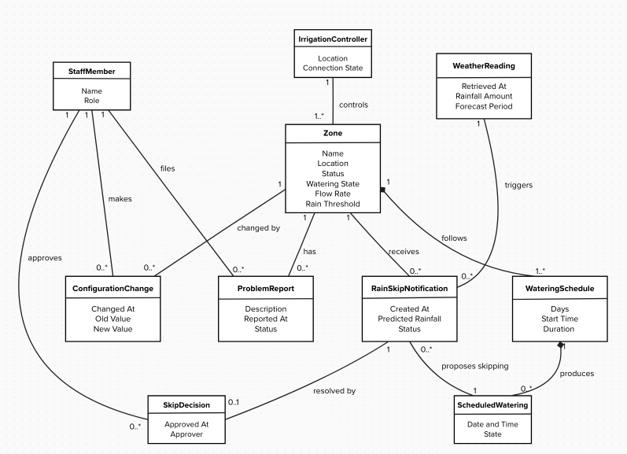
Figure 5.1 Domain model (conceptual classes, attributes, associations with multiplicities)
Class | What it represents (one line) | Key attributes | Associations (with multiplicity)
Zone | An area that is watered as a unit | Name, Location, Status, Watering State, Flow Rate, Rain Threshold | Controlled by 1 IrrigationController; Follows 1..* WateringSchedule; Receives 0..* RainSkipNotification; Has 0..* ProblemReport; Changed by 0..* ConfigurationChange
IrrigationController | The on-site controller that runs the sprinklers | Location, Connection State | Controls 1..* Zone
WateringSchedule | The recurring plan for when a zone is watered | Days, Start Time, Duration | Belongs to 1 Zone; Produces 0..* ScheduledWatering
ScheduledWatering | One planned watering on a specific date | Date and Time, State (planned / skipped / done) | From 1 WateringSchedule; Targeted by 0..* RainSkipNotification
WeatherReading | Rainfall data retrieved from the weather service | Retrieved at, Rainfall Amount, Forecast Period | Triggers 0..* RainSkipNotification
RainSkipNotification | A recommendation to skip a watering because of rain | Created At, Predicted Rainfall, Status (Active / Confirmed / Cancelled / Missed) | For 1 Zone; From 1 WeatherReading; Proposes skipping 1 ScheduledWatering; Resolved by 0..1 SkipDecision
SkipDecision | The record that a staff member approved a skip | Approved at, Approver | Resolves 1 RainSkipNotification; Made by 1 StaffMember
StaffMember | A signed-in user of the system | Name, Role (Maintenance / Administrator) | Approves 0..* SkipDecision; Files 0..* ProblemReport; Makes 0..* ConfigurationChange
ProblemReport | A fault reported for a zone | Description, Reported at, Status | About 1 Zone; Filed by 1 StaffMember
ConfigurationChange | A record of one change to a zone’s settings | Changed at, Old Value, New Value | To 1 Zone, Made by 1 StaffMember

5.2 Object interaction models
Copy the block below for at least two of the use cases in 4.1; preferably including your riskiest.

5.2.1 UC-02 Act on Rain-Skip Notification
(a) Non-trivial steps. List the steps from 4.2 that need objects inside the system, and say in one line why each of the others is trivial.
(2) Asks the Weather API for rainfall.
(4) Gets the zone’s threshold and checks it, then displays.
(6) Tells the Irrigation Controller to skip.
(8) Records the decision and updates the scheduled watering and notification.

(0) is trivial since the notification is already on screen. (1) and (5) are inputs from the admin and each a message from the actor (case A). (3) and (7) are replies to (2) and (6), drawn as return arrows. (9) is trivial because the admin only reads the screen.
(b) Scenario table.
Step | Subject (who acts) | Subject action (what it does) | Other data / objects (what is used) | Object acted upon (who receives)
1 | Administrator | Opens the rain-skip notification | Notification | DashboardView
2a | DashboardView | Asks for the skip to be verified | Notification | SkipCoordinator
2b | SkipCoordinator | Asks for current rainfall at zone | Zone Location | Weather API
4a | SkipCoordinator | Asks for the rain threshold | Zone | Zone
4b | SkipCoordinator | Checks rainfall still meets the threshold | Rainfall, Rain Threshold | SkipCoordinator
4c | DashboardView | Shows rainfall and the watering to be skipped | Rainfall, ScheduledWatering | Administrator
5 | Administrator | Confirms the skip | Notification | DashboardView
6a | DashboardView | Passes the confirmation and approver | Approver | SkipCoordinator
6b | SkipCoordinator | Tells the controller to skip the watering | Zone, Date and Time | IrrigationController
8a | SkipCoordinator | Records the skip with approver and time | Approver, Time | SkipDecision
8b | SkipCoordinator | Marks the watering skipped | - | ScheduledWatering
8c | SkipCoordinator | Marks notification confirmed | - | RainSkipNotification
8d | DashboardView | Shows skip confirmation | SkipDecision | Administrator

Interaction Objects:
- DashboardView: the boundary through which the administrator sees the rain-skip notification and confirms the skip
- SkipCoordinator: controls the interaction. It gets the rainfall and threshold, checks the rule, tells the Irrigation Controller to skip, and records the decision
(c) Analysis sequence diagram.
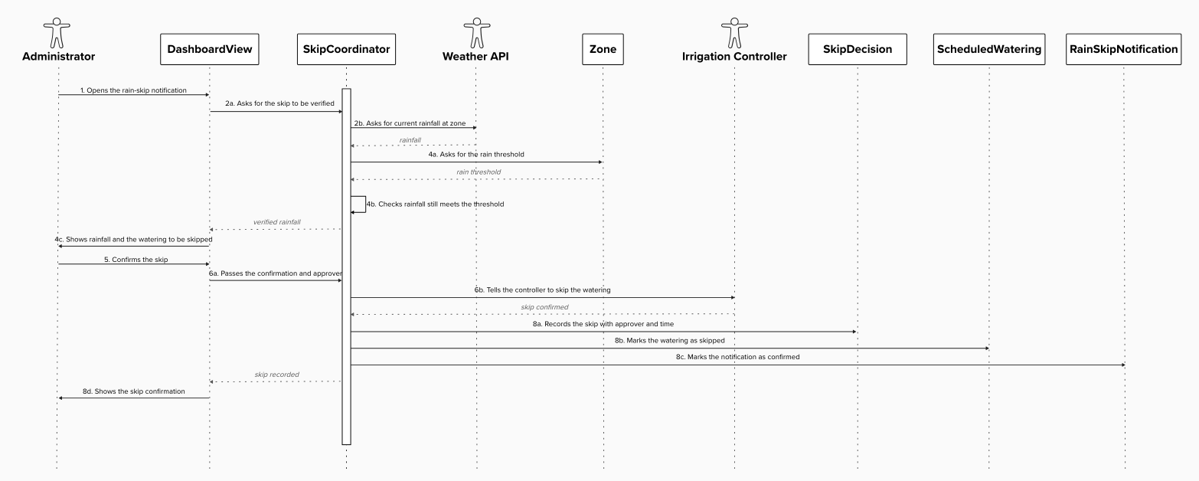
Figure 5.2.1 Analysis sequence diagram for UC-02; message numbers match the scenario table

5.2.2 UC-04 Configure Zones and Thresholds
(a) Non-trivial steps. List the steps from 4.2 that need objects inside the system and say in one line why each of the others is trivial.
(2) Gets the current zones and their settings.
(4) Checks the new settings are valid and sends them to the Irrigation Controller.
(6) Saves the zone settings and watering schedule, records the change, and shows the acknowledgement.

(0) is trivial because the dashboard is already on screen. (1) and (3) are inputs from admin and are messages from the actor (case A). (5) is the controller’s reply to (4), draw as a return arrow. (7) is trivial because the admin only reads the screen.
(b) Scenario table.
Step | Subject (who acts) | Subject action (what it does) | Other data / objects (what is used) | Object acted upon (who receives)
1 | Administrator | Opens configuration | - | ConfigView
2a | ConfigView | Asks for the current zones and settings | - | ConfigCoordinator
2b | ConfigCoordinator | Asks for each zone’s settings and schedules | - | Zone
2c | ConfigView | Shows zones and settings | Zones, Settings | Administrator
3 | Administrator | Edits flow rate, rain threshold and schedule, and saves | New Settings | ConfigView
4a | ConfigView | Passes the new settings | New Settings | ConfigCoordinator
4b | ConfigCoordinator | Checks the settings are valid | New Settings | ConfigCoordinator
4c | ConfigCoordinator | Sends the updated settings | New Settings | IrrigationController
6a | ConfigCoordinator | Updates flow rate and rain threshold | New Settings | Zone
6b | ConfigCoordinator | Updates the watering schedule | Days, Start Time, Duration | WateringSchedule
6c | ConfigCoordinator | Records the change with admin and time | Old and New Values | ConfigurationChange
6d | ConfigView | Shows the save acknowledgement | - | Administrator
Interaction Objects:
- ConfigView: the boundary through which the administrator sees and edits zone settings
- ConfigCoordinator: controls the interaction. It gets the current settings, validates the new ones, contacts the Irrigation Controller, and saves and records the change
(c) Analysis sequence diagram.
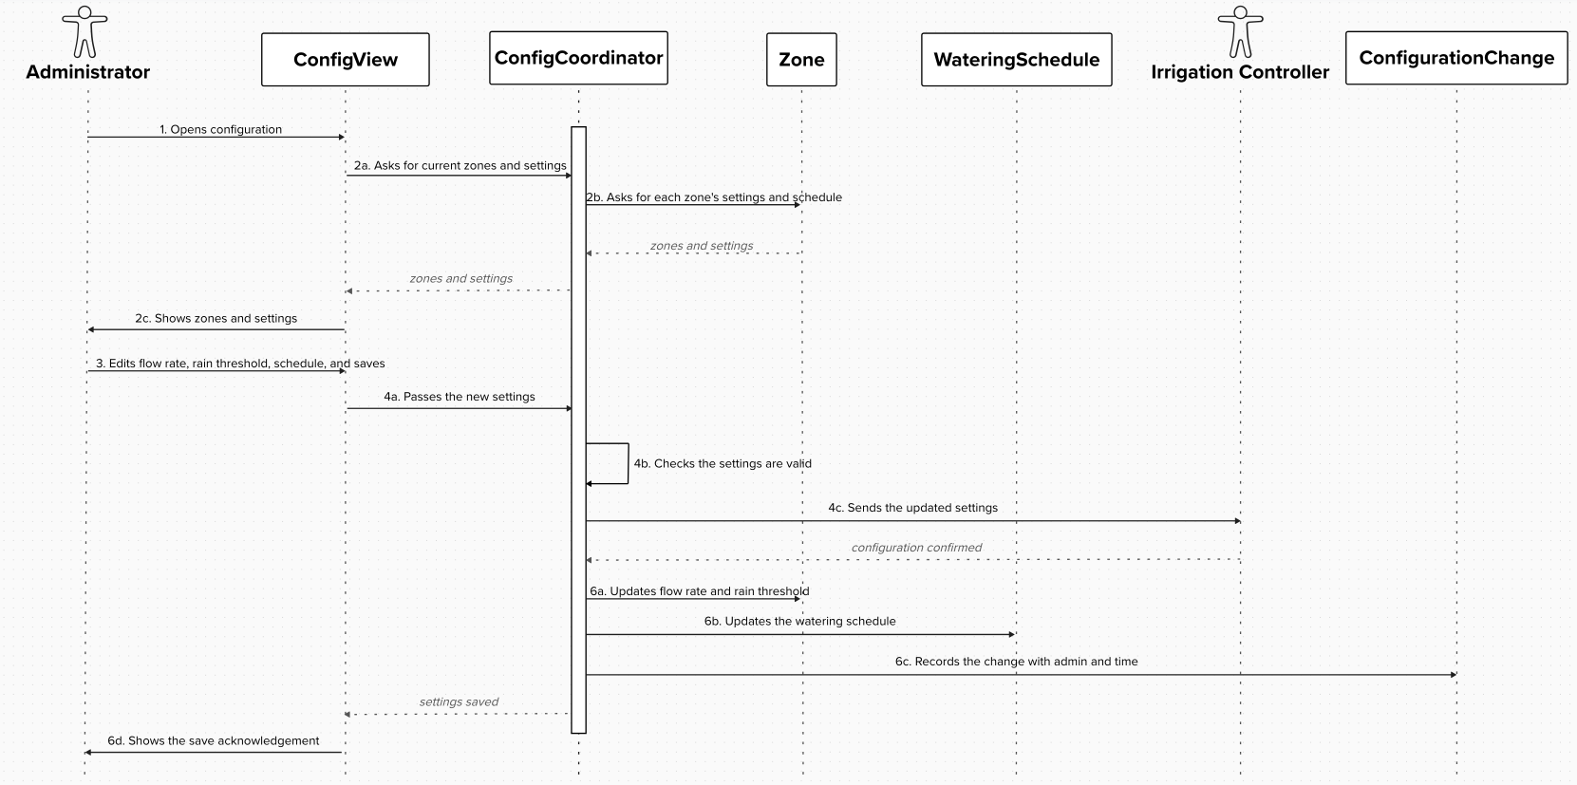
Figure 5.2.2 Analysis sequence diagram for UC-04; message numbers match the scenario table

GUIDANCE: DELETE THIS BOX BEFORE SUBMITTING
Write each step as a declarative sentence first, subject, verb, object, then fill the columns. Tables filled directly produce rows with no subject.
One message per table row, same numbers. Use the four translation cases from Lesson 14; the diagram is a conversion of the table, not a new drawing.
Messages are verb phrases, not operation signatures. "asks for the routes calling at the stop" is analysis; "getRoutes(stopId: int): List<Route>" is Chapter 9 and is not credited here.
Every object on the diagram is a class in 5.1 or an interaction object you name and explain in one line. One object is clearly in control of the interaction.
Budget: one to one and a half pages per use case.

EXAMPLE (COMETPARK): DELETE BEFORE SUBMITTING
Step 2 · Subject: LotFinder · Action: asks for the lots the permit allows · Data: permit type, destination · Object acted upon: PermitRules.

5.3 Consistency cross-check
Check | Result (pass, or what failed) | Fixed in
K1 Every item in an actor column (4.2) is an attribute in the domain model (5.1) | Failed: “last weather retrieval time”, “problem reporting” and “approver” were missing. Added to the model | 5.1
K2 Every object on a sequence diagram is a domain class or a declared interaction object | Failed: DashboardView, SkipCoordinator, ConfigView, and ConfigCoordinator were undeclared. Now declared as interaction objects. | 5.2.1, 5.2.2
K3 Every message on a sequence diagram corresponds to exactly one scenario-table row | Failed: replies in UC-02 (3), (7) and UC-04(5) had no rows. Now drawn as unnumbered returns. | 5.2.1(a), 5.2.2(a), Figure 5.2.2
K4 Every non-trivial step in 5.2 (a) has at least one scenario-table row | Pass | -
K5 Every analyzed use case traces to at least one functional requirement | Failed: UC-04 omitted FR-02 and UC-02 omitted FR-01-03 against the P1 matrix. Traces added. | 4.2 (UC-02, UC-04)
K6 The last messages of each diagram make the use case postcondition true | Failed for UC-04: nothing saved the settings. Added rows 6a-6b. UC-02 passes. | 4.2 (UC-04 step 6), 5.2.2

GUIDANCE: DELETE THIS BOX BEFORE SUBMITTING
Run the six checks across the work of different authors; they are designed to catch the seams between people. A failed check that you found and fixed is more convincing than a column of passes. Budget: a quarter of a page.

6 High-Level Design (Architecture)
Chapter 8. The rule now reverses: a high-level design that does not say where things run, what they are built from and what that choice cost has not been done.

6.1 Architectural drivers: quality-attribute scenarios
QAS | Quality attribute | Stimulus | Artifact | Response | Response measure | From
QAS-01 | Performance | Maintenance staff open the dashboard to check sprinkler zones | Dashboard | The system loads the dashboard and shows the sprinkler information | Ninety percent of dashboard loads shall occur within 3 seconds, measured over a 30-minute load test with up to 20 concurrent users. | QR-  01
QAS-02 | Availability | Maintenance staff try to access the dashboard between 6 AM and 10 PM | Dashboard | The system is available for staff to use | 95% of 5-minute checks succeed between 6 AM and 10 PM over 24 hours | QR-  02
QAS-03 | Security | Someone without a valid session tries to access system data | Authentication service | The system rejects the request and prevents access to the data | 100 percent of unauthenticated requests are rejected, and signed-in sessions expire after 30 minutes of not being active | QR-  04

CON-01: The system will use an external weather API to get weather and rainfall data instead of adding new sensors.
CON-02: Only UT Dallas Facilities staff and authorized maintenance contractors can use and view the system. Users must be logged in, and the system will not be open to the public.

6.2 Architectural style and alternatives
Style considered | Drivers it serves | What it costs | Verdict
Layered (N-tier) | Performance, availability, and security (QAS-01, QAS-02, and QAS-03) | It may take more time for requests to go through each layer | Chosen
Microservices | Performance and availability (QAS-01, QAS-02) | It needs more services to manage and maintain | Rejected
Event-driven | Performance and availability (QAS-01, QAS-02) | It complicates the system because it needs to handle different events. | Rejected

We chose the layered architecture because it separates the dashboard, system functions, and data. This makes the system easier to manage and helps limit of who can control and gain access. It also helps us meet the performance, availability, and security requirements from Section 6.1. We did not choose microservices or event-driven architecture because they would make the system more complicated than it actually is.

6.3 Component view
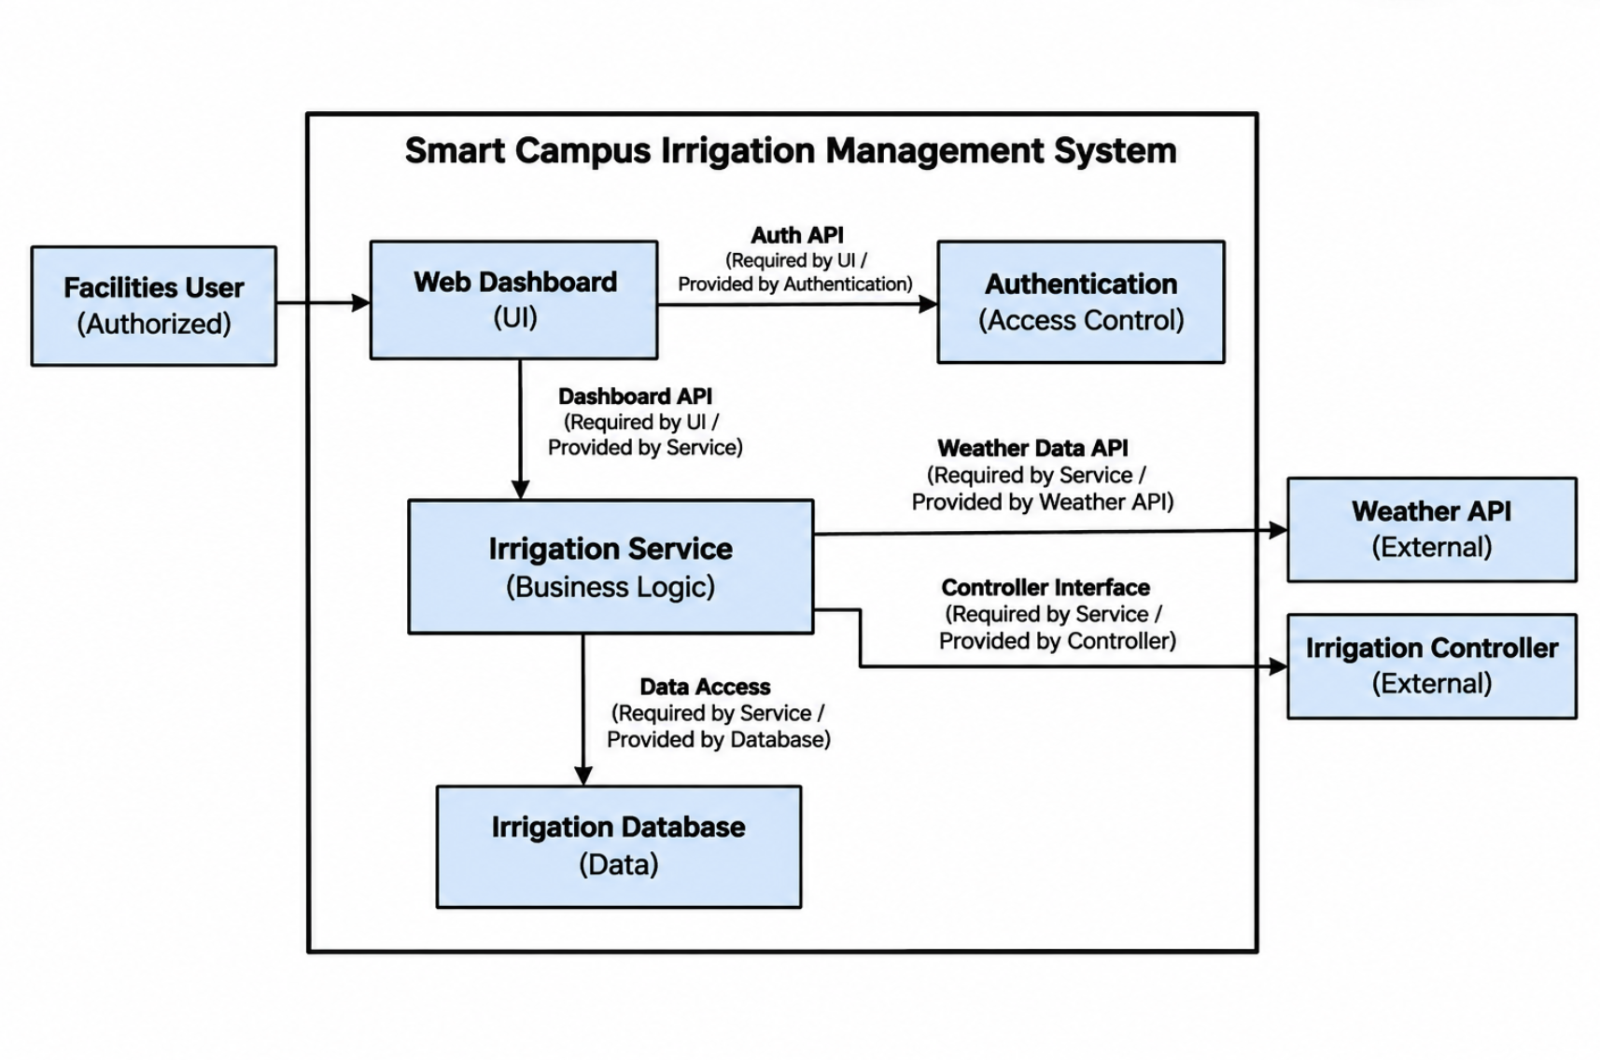
Figure 6.3 Component diagram: components, provided and required interfaces, external systems

Component | Responsibility (one sentence) | Provides | Requires | Answers to (UC / QAS / ADR)
Web Dashboard | Displays sprinkler information and allows staff to check and change schedules | User Interface | Dashboard API, Auth API | UC-01, UC-02, UC-04, QAS-01, ADR-01
Authentication | Checks if users are logged in and allowed to use the system. | Auth API | User login information | UC-01, UC-02, QAS-03
Irrigation Service | Manages sprinkler schedules and gets weather data from the external API | Dashboard API | Weather Data API, Data Access | UC-01, UC-02, UC-04, ADR-01
Irrigation Database | Stores sprinkler information and schedules | Data Access | N/A | UC-01, UC-02, UC-04, ADR-01

6.4 Deployment view
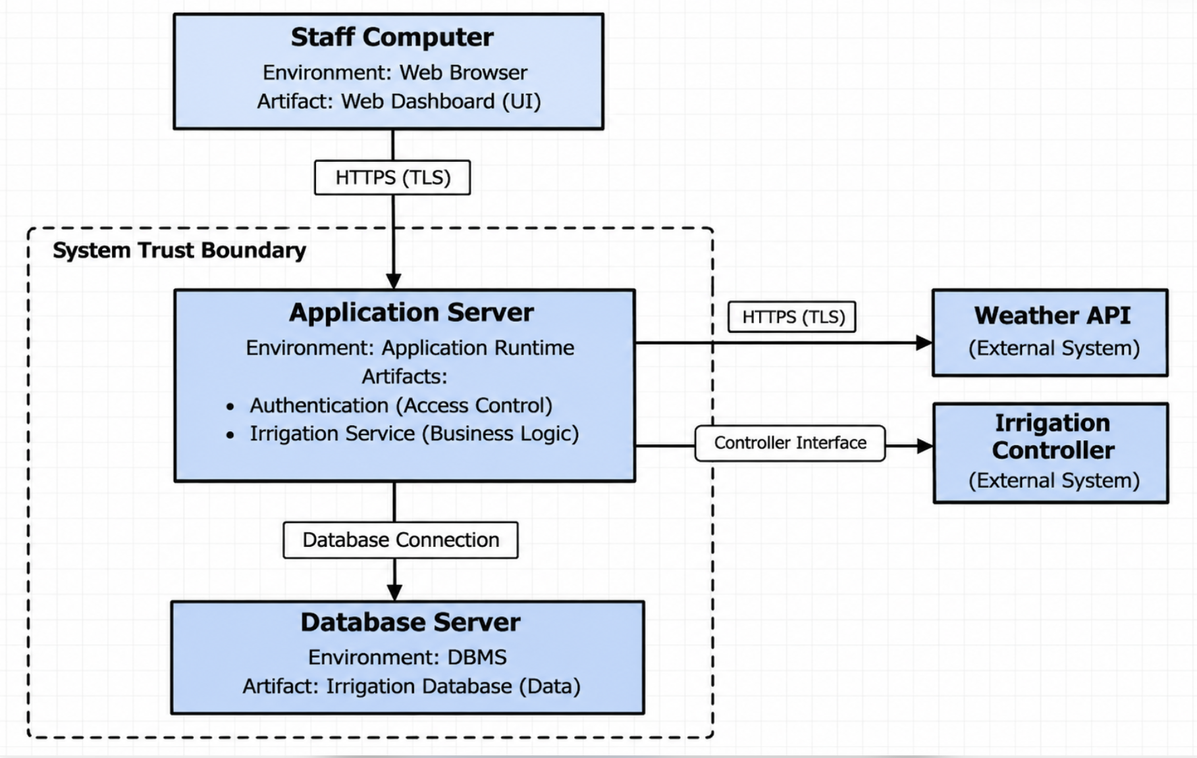
Figure 6.4 UML deployment diagram: nodes, execution environments, deployed artifacts, communication paths with protocols, trust boundaries
Node | What runs on it (artifacts, components) | Communicates with (protocol) | Trust zone
Staff Computer | Web browser and dashboard | Application Server (HTTPS) | User Device
Application Server | Login system and irrigation service | Staff Computer and Weather API (HTTPS), Database Server (Database Connection), Irrigation Controller (Controller Interface) | System
Database Server | Stores sprinkler zones and schedules | Application Server (Database Connection) | System

6.5 From analysis to architecture
Analysis object (from 5.1 and 5.2) | Component that owns it (6.3) | Note (split, merged, external)
StaffMember | Authentication | Handles staff login and access
DashboardView, ConfigView | Web Dashboard | Both are part of the dashboard
SkipCoordinator, ConfigCoordinator | Irrigation Service | Both use the same service
Zone, WateringSchedule, ScheduledWatering | Irrigation Service | Handles zones and schedules
RainSkipNotification, SkipDecision, WeatherReading | Irrigation Service | Handles rain data and skip decisions
ProblemReport, ConfigurationChange | Irrigation Service | Handles reports and changes
IrrigationController | External System | Existing controller outside our system

6.6 Design principles applied
Principle | Where it shows in your design | Evidence (component, interface, ADR)
Separation of concerns | Dashboard, login, and irrigation are separate | Web Dashboard, Authentication, Irrigation Service
Information hiding | Dashboard doesn't access the database directly | Dashboard API, Data Access
Low coupling | Components connect through interfaces | Dashboard API, Auth API
High cohesion | Each component has its own job | Authentication, Irrigation Service
Design for change | We can change the weather API if needed | Weather Data API
Keep it simple (KISS) | We use layers instead of more services | ADR-01

7 Design Rationale

7.1 Architecture decision records
At least three. ADR-01 records the style decision from 6.2. Use the format you practiced in the Lesson 16 workshop, written about your own project. Copy the block for each decision.

ADR-xx [Decision title]
Status | Accepted / Superseded by ADR-
Date and owner
Context (drivers) | Which QAS, use cases and constraints force a decision here
Options considered | At least two, each in one line
Decision
Consequences | Name the quality it favors, the move, and the cost you accept
Evidence | Spike result (section 8), measurement, documentation, or "none yet" with an open question
Related | ADR-, QAS-, R- (risk), CH- (change)

GUIDANCE: DELETE THIS BOX BEFORE SUBMITTING
A decision without a cost is a preference. If you cannot say what you gave up, you have not finished the record.
Options must be real alternatives the team discussed, not a straw man added to fill the row.
Budget: about a third of a page per ADR.

EXAMPLE (COMETPARK): DELETE BEFORE SUBMITTING
ADR-02 · Push occupancy changes to clients rather than polling · Context: QAS-01, CON-02 (campus Wi-Fi limits) · Options: client polling every 10 s; server push over a persistent connection · Decision: server push · Consequences: favors performance and freshness; costs connection management on the occupancy service and a fallback when push fails (A2 in UC-02) · Evidence: spike S-01.

7.2 Trade-off summary
Quality favored | Architectural move | Cost accepted | Recorded in
 |  |  | ADR-
 |  |  | ADR-
 |  |  | ADR-

GUIDANCE: DELETE THIS BOX BEFORE SUBMITTING
One row per real trade-off. This is the table a reviewer reads first. Budget: a quarter of a page.

8 Prototype Evidence: Architecture Spike
Spike ID and title | S-01: Weather API Test
Risk or decision it addresses | ADR-TBD (CON-01: External Weather API)
Question (answerable yes or no)
Set-up | Stack, data, what was simulated; folder in the repository
How it was measured
Result (numbers)
What it changed or confirmed | Which ADR, QAS or requirement
Where to see it | Commit hash, /spikes/S-01/, screenshot or log file

GUIDANCE: DELETE THIS BOX BEFORE SUBMITTING
Build the smallest thing that answers your riskiest architectural question, run it, and measure it. Time-box it to a few hours. It may be thrown away afterwards; it is not the product.
Good spikes answer questions such as: can we read the external data source, and is it fresh to within 60 seconds? Does the chosen hosting meet QAS-01 under a simulated peak? Does the authentication provider fit our trust boundary?
Never commit passwords, API keys or other credentials; keep them in local configuration excluded from the repository.
The code, the measurement and a short README are committed to /spikes before the deadline. A spike described but not in the repository is not evidence.
Budget: half a page.

9 Traceability

9.1 Extended traceability matrix
Requirement | Use case | Analysis classes | Component(s) | QAS / ADR | Evidence
FR-01 | UC-01, UC-02 | WeatherReading, SkipCoordinator | Irrigation Service (Weather Data API) | CON-01, ADR-01 | S-01 (section 8); Figure 5.2.1 message 2b
FR-02 | UC-02, UC-04 | Zone, WateringSchedule, ScheduledWatering, ConfigCoordinator | Irrigation Service, Irrigation Controller (external) | ADR-01 | Figure 5.2.2 messages 4c, 6b
FR-03 | UC-01, UC-02 | RainSkipNotification, WeatherReading, SkipCoordinator, DashboardView | Irrigation Service, Web Dashboard | QAS-01, ADR-01 | Figure 5.2.1 messages 2b to 4c
FR-04 | UC-04 | Zone, WateringSchedule, ConfigurationChange, ConfigView, ConfigCoordinator | Web Dashboard, Irrigation Service, Irrigation Database | ADR-01 | Figure 5.2.2 messages 3 to 6d
FR-05 | UC-01, UC-02 | Zone, WateringSchedule, RainSkipNotification, ProblemReport, DashboardView | Web Dashboard, Irrigation Service | QAS-01, QAS-02, ADR-01 | Figure 5.2.1 messages 4c, 8d
FR-06 | All (Precondition) | StaffMember | Authentication | QAS-03 | None yet; tested in P3
FR-07 | UC-03 | ProblemReport, StaffMember | Web Dashboard, Irrigation Service | - | None yet; see 9.2
FR-08 | UC-05 | ScheduledWatering, SkipDecision | Irrigation Service, Irrigation Database | - | None yet; see 9.2
QR-01 | UC-01 | - | Web Dashboard, Irrigation Service, Irrigation Database | QAS-01, ADR-01 | None yet; load test in P3 (R7)
QR-02 | UC-01 | - | Web Dashboard, Irrigation Service, Irrigation Database | QAS-02, ADR-01 | None yet; health checks in P3 (R6)
QR-03 | UC-02 | DashboardView | Web Dashboard | No QAS; see 9.2 | None yet; usability session in P3 (R3)
QR-04 | All | StaffMember | Authentication | QAS-03 | None yet; tested in P3
CON-01 | UC-01, UC-02 | WeatherReading | Irrigation Service (Weather Data API) | ADR-01 | S-01 (section 8)
CON-02 | All | StaffMember | Authentication; trust zones in 6.4 | QAS-03 | Figure 6.4

GUIDANCE: DELETE THIS BOX BEFORE SUBMITTING
Extend the P1 matrix one column at a time: from each requirement to the use case, to the analysis classes that realize it, to the component that will own it, to the decision or scenario that shaped it, and to whatever evidence exists (spike, measurement).
Requirements realized by the use cases you analyzed need the full chain. Every other MUST requirement needs at least its component. Withdrawn requirements stay in the matrix, marked as such.
Budget: one page.

9.2 Gap analysis
Gap | Items | What you did about it
Requirements with no component | None | N/A
Components with no requirement, QAS or ADR | None | N/A
Use cases not analyzed (and why that is acceptable) | UC-03 Report a Zone Problem (FR-07, SHOULD); UC-05 View Water History (FR-08, COULD) | UC-03 creates on ProblemReport, which is already in the domain model, so an interaction doesn’t add any new objects. UC-05 serves the lowest-priority requirement and can be deferred after P3. Both still reach a component. UC-01 is expanded in 4.2, but it doesn’t have an interaction model because it only reads data that UC-02 and UC-04 write.

GUIDANCE: DELETE THIS BOX BEFORE SUBMITTING
An empty gap table is believable only if the matrix above is complete. Say what each gap means and what you did. Budget: a quarter of a page.

10 Project Plan (updated; was P1 section 4)

10.1 Roles and working agreement
The team roles and the decision rule set at P1 (section 4.1 of version 0.1) are carried forward. Each member keeps the responsibility listed below, and when the team disagrees the question is settled by majority vote among the members taking part in the discussion.
Team member | Role (unchanged from P1)
Mujtaba Altameemi | Use cases and traceability; class and sequence diagrams
Owen Shen | Description lead; Weather API and controller research
Lucas Igl | Document owner, repository administrator, document integration
Eric Dantas | Project planner and risks; architecture drafts
Ash Thanickel | Requirements lead; state models

What changed since P1. The P2 project plan (this section) was drafted by Owen Shen. Eric Dantas remains the project planner and keeps the risk mitigations assigned to him in 10.3. No other role moved between members; the sections each member actually produced for P2 are recorded with their commits in section 0.1, and this change is logged in section 0.2.
How the team works. Plan items are opened as GitHub issues with one assignee each, as at P1. A member writes their sections on a branch separate from main, commits from their own GitHub account, and opens a pull request into main. The pull request is merged only after a member other than its author has reviewed it; the reviewer checks that the section keeps the requirement, use-case and risk identifiers from the P1 baseline and the section numbering required by the template, and leaves the review as pull-request comments so that it is visible in the repository history and can be cited in section 0.1. The document owner integrates the merged sections into the single document, exports the PDF and handles the tag as described in 10.4. Progress against the dates in 10.2 is checked by the team at each check-in, and an item whose owner has not started it is reassigned rather than left to slip (see R5).

10.2 Plan to P3
P3 covers detailed design (design class and sequence diagrams with operations), implementation of the layered architecture baselined in section 6 (Web Dashboard, Authentication, Irrigation Service and Irrigation Database, with the Irrigation Controller and Weather API outside the boundary), a test plan and tests against the acceptance criteria in section 3, and the final document. The dates below are internal targets set by the team to sequence the work; the official P3 due date posted on Canvas governs the final submission, and any target that conflicts with it is adjusted under change control.
Milestone | Date | Owner | Done when
P2 feedback reviewed and answered in section 0.2; requirement IDs preserved, withdrawn items marked | Within 3 days of P2 feedback | Lucas, Eric | Every point of the P2 feedback has a CH row or a one-sentence reason for keeping the original
Detailed design: design class diagram for the ten classes in 5.1 and the four interaction objects in 5.2 (operations, types, visibility); design-level sequence diagrams for UC-01, UC-02 and UC-04 | Nov 20 | Mujtaba | Diagram sources committed; every scenario-table row in 5.2.1 and 5.2.2 maps to an operation on a design class
State models for ScheduledWatering (planned, skipped, done) and RainSkipNotification (active, confirmed, cancelled, missed) from 5.1 | Nov 20 | Ash | Every state and transition traces to a step or alternate flow of UC-01, UC-02 or UC-04 in section 4.2
Irrigation Database schema realizing the 5.1 classes and the Data Access interface required by the Irrigation Service (6.3) | Nov 22 | Eric | Every attribute and association in 5.1 has a column or relation; the Irrigation Service reads and writes zones and schedules only through Data Access
Weather Data API client in the Irrigation Service: hourly retrieval into WeatherReading (FR-01, CON-01), cached last reading with its retrieval time, stale marking after two hours (UC-01 A2), and the on-demand rainfall confirmation used at UC-02 step (2) | Nov 25 | Owen | Retrieval log shows 24 consecutive hourly readings for the campus location; forcing the reading older than two hours shows the UC-01 A2 stale highlight; the UC-02 confirmation call returns rainfall for a zone location; no API key in the repository
Controller Interface (6.4): adapter in the Irrigation Service plus a simulated Irrigation Controller that returns zone status, accepts configuration, and skips or declines to confirm a watering (UC-01 A1, UC-02 step 7, UC-04 A2) | Nov 25 | Eric | Simulator returns zone status and connection state on demand and can confirm, decline or not answer a skip or a configuration; UC-01 A1 and UC-04 A2 are reproduced against it
Authentication component: sign-in before the Web Dashboard, session expiry, Auth API (FR-06, QR-04, QAS-03, CON-02) | Nov 25 | Lucas | Unauthenticated dashboard requests redirect to sign-in; automated test shows 100% of Dashboard API endpoints reject requests with no session or a session idle for 31 minutes
Zone and schedule configuration through ConfigView and ConfigCoordinator: flow rate, rain threshold, WateringSchedule, validation, ConfigurationChange record, controller update (FR-02, FR-04, UC-04) | Nov 29 | Ash | UC-04 main flow and A1 (invalid input) and A2 (controller does not confirm) walk end to end against the simulator; a ScheduledWatering is sent to the simulator at its planned time
Rain-skip notification and skip approval through DashboardView and SkipCoordinator: notification generation from WeatherReading against zone thresholds, confirmation, SkipDecision record, controller skip (FR-03, UC-02) | Nov 29 | Owen, Eric | With a simulated rainfall above a zone threshold a notification appears; UC-02 main flow, A1 (threshold no longer met) and A2 (missed or rejected) each produce the SkipDecision, ScheduledWatering and notification states in 5.1
Web Dashboard: zone list (name, location, next watering, rain-skip notification, last weather retrieval time), zone detail (status, schedule, open ProblemReports) and problem reporting (FR-05, FR-07, UC-01, UC-03) | Dec 2 | Mujtaba | UC-01 main flow and A1, A2 walk end to end against the simulator; a submitted ProblemReport appears on the zone detail
Test plan and execution: one test case per acceptance criterion in section 3; QAS-01 load test (20 users, 30 minutes), QAS-02 availability check and QAS-03 endpoint test run and recorded | Dec 4 | Ash (plan); component owners (execution) | Every MUST requirement has an executed test with a recorded result; QAS-01 90th-percentile load time and QAS-02 availability are reported as numbers against their response measures
Usability session for QR-03 (R3): five first-time users confirm a rain-skip notification unassisted | Dec 4 | Owen | Timings recorded; at least 4 of 5 finish within 2 minutes, or each failure is filed as an issue with a fix or a reason
P3 document: traceability extended to code modules and test cases, contribution record with commit hashes and PR numbers, AI-use declaration, all guidance boxes removed | Dec 6 | Lucas (integration); all members (own sections) | Every member has merged their own sections through a reviewed pull request; every cited commit and PR exists in the repository
Final submission: PDF committed to the folder named in the P3 instructions, tag pushed, one member uploads the same PDF to Canvas | Official P3 due date (Canvas) | Lucas | Tagged PDF and Canvas PDF are the same file; the tag is visible on GitHub before the deadline

10.3 Risks (updated)
The five P1 risks are carried forward with their identifiers and P1 ratings. Status entries record what this document gives evidence for: an action assigned at P1 whose outcome is not recorded in sections 7, 8 or 11 is shown as open rather than as done, and a rating is changed only where the row gives the reason. R6 to R9 are new risks created by the design in sections 5 and 6; R6 and R7 are the risks section 9.1 refers to for QR-02 and QR-01.
Risk | Status since P1 | Likelihood / impact | Mitigation and owner
R1 Unable to connect to the campus irrigation controller (A1, Q3) | Open. The controller interface documentation requested at P1 is not recorded as received. The design commits only to a Controller Interface between the Application Server and the controller (6.4); no decision record or spike at P2 addresses how that interface is realized. The simulated controller from the P1 mitigation is the working assumption for P3. | High / High (unchanged) | (Mujtaba) keeps the documentation request open with UTD Facilities and records the answer against Q3 in section 11. (Eric) builds the simulated controller behind the Controller Interface so that P3 development does not wait on the real controller, and records the integration choice as a decision record when the interface is known.
R2 Weather API is too costly, rate-limited or unreliable (A2, CON-01) | Open. Spike S-01 (section 8, Weather API Test) addresses CON-01, but its set-up, measurement and result, and the chosen API, cost and rate limit (P1 target Oct 25), are not yet recorded in this document. | Medium / High (unchanged) | (Mujtaba) records the chosen API, its free-tier limit and cost in section 11 once S-01 is complete. (Owen) designs the Weather Data API client as one scheduled call per hour plus the on-demand confirmation at UC-02 step (2), with the last WeatherReading cached, so hourly polling (FR-01) stays within a free tier and the dashboard shows the UC-01 A2 stale highlight when a retrieval fails.
R3 Maintenance staff or administrators find the dashboard hard to use (A3, QR-03) | Open. The three-person layout test planned at P1 is not recorded. Mock-ups are not graded at P2, so the test moves to the QR-03 usability session in 10.2. | Medium / Medium (unchanged) | (Owen) runs the QR-03 session with five first-time users during P3 and files each failure as a GitHub issue before the final build.
R4 Stakeholder needs are wrong because they were assumed (section 2.2) | Open. Every source in section 2.2 is still an assumption; no contact with UTD Facilities is recorded, and Q1 to Q3 in section 11 depend on it. | Medium / High (unchanged) | (Eric) puts Q1 to Q3 to UTD Facilities. Any changed need enters section 3 through a CH row in section 0.2 under its existing or a new ID, not by editing a requirement in place.
R5 Uneven workload leaves sections incomplete | Materialized at P1: the P1 contribution record shows one member with no credited contribution. Likelihood raised from Medium to High. | High / Medium (likelihood raised) | (Lucas) opens one GitHub issue per 10.2 milestone with a single assignee. Each member commits their own sections through pull requests from their own account so that section 0.1 can cite them. Open issues are checked against the 10.2 dates at each check-in, and an item not started within a week of its target is reassigned.
R6 (new) Dashboard availability: the deployment in 6.4 runs Authentication and the Irrigation Service on a single Application Server with a single Database Server, so one host or process failure takes the dashboard below the 95% availability in QAS-02 (QR-02) | New at P2, created by the single-server deployment in 6.4. Cited by section 9.1 for QR-02. | Medium / Medium (the system is used in working hours; QAS-02 measures 6 AM to 10 PM only) | (Eric) adds a health check on the Application Server and the Database Server during P3 and runs the QAS-02 5-minute check over a 24-hour window before the P3 deadline; a failed run is logged with the outage cause and the fix. (Lucas) keeps the deployment steps in the repository so the server can be rebuilt quickly.
R7 (new) Dashboard performance: the layered style accepted in 6.2 adds a hop for every request (Web Dashboard to Irrigation Service to Irrigation Database), and the zone list in UC-01 step (2) assembles data from several classes, so the 3-second load in QAS-01 (QR-01) may be missed under 20 concurrent users | New at P2, created by the cost named for the layered style in 6.2. Cited by section 9.1 for QR-01. | Medium / Medium (20 concurrent users is small; the cost is in the number of hops, not the volume) | (Mujtaba) builds the zone list as one Dashboard API call rather than one call per zone, and (Ash) runs the QAS-01 load test (20 users, 30 minutes) in the P3 test milestone; if the 90th percentile exceeds 3 seconds the Irrigation Service caches the zone list between weather retrievals and the test is repeated.
R8 (new) Simulator-to-controller mismatch: the simulated controller used for P3 development (R1 mitigation) differs from the real controller in command set, timing or protocol, so code that passes against the simulator fails against the controller | New at P2, created by developing against a simulated controller while the real Controller Interface (6.4) is unspecified. | High / High (unknown real interface; FR-02, FR-03, UC-02 step 6 and UC-04 step 4 depend on it) | (Eric) confines all controller communication to the Controller Interface inside the Irrigation Service, so that only that adapter changes when the real interface is known; UC-01 A1, UC-02 A2 and UC-04 A2 are implemented as responses of the adapter, not of the Web Dashboard. (Mujtaba) attaches the controller documentation, once received, to the adapter issue. No decision record covers controller integration at P2; the risk is tracked against the Controller Interface in 6.4 until one does.
R9 (new) Stale weather data: the cached WeatherReading introduced to stay within the API rate limit (R2) is older than two hours, so a RainSkipNotification (FR-03) is raised or missed on outdated data | New at P2, created by the caching decision. | Medium / Low (UC-02 step (2) re-confirms rainfall before a skip is approved, and UC-01 A2 flags readings older than two hours, so the worst case is a spurious notification cancelled at UC-02 A1) | (Owen) stores the retrieval time with every WeatherReading, raises notifications only from readings less than two hours old, and keeps the UC-02 step (2) confirmation call mandatory before a SkipDecision is recorded; the weather milestone in 10.2 tests this by forcing a stale reading.

10.4 Repository
Repository. https://github.com/LucasIgl/CS3354.010_FALL26_TEAM02, administered by Lucas Igl. All five team members have write access. The repository is kept readable for grading either by being public or by granting read access to the instructor account announced on Canvas before the deadline; the repository administrator confirms this before the tag is pushed.
Layout. /docs/p2 holds the submitted P2 PDF. /docs/p2/diagrams holds the editable source file of every diagram in this document. /spikes/S-01 holds the section 8 spike with its code, its measurement output and a short README. Credentials such as weather API keys are kept in local configuration files that are excluded from the repository and are never committed.
Branch and pull-request rule. Work is tracked as GitHub issues with one assignee each. A member writes their section on a branch, commits from their own GitHub account and opens a pull request into main. The pull request is merged only after review by a member other than its author, given as pull-request comments so that the review appears in the repository history and can be cited in section 0.1.
Submission and tag. The final PDF of this document is committed to /docs/p2 by the document owner, and the Git tag p2 is placed on that commit and pushed (git push origin p2) before the deadline, so that the tag points at the commit containing this exact PDF. The same file is then uploaded to Canvas by one member. If the document changes after tagging, the tag is moved to the new commit and pushed again and the Canvas upload is replaced, because the Canvas file and the tagged file must be identical.

10.5 Use of AI tools in P2
Each row below is written by the member it names; a member who used no tool enters None.
Member | Tool | What it was used for | What you checked or changed
Owen Shen | ChatGPT (OpenAI) | Reviewing the P2 project description, rubric and template against the P1 plan to list what section 10 must contain; drafting a first version of 10.1 to 10.5. | Checked every role, risk identifier and likelihood/impact rating against P1 section 4; removed suggested text that claimed completed stakeholder contact, a chosen API or a resolved controller connection; replaced generic milestones with ones tied to FR, QR and UC identifiers.
Owen Shen | Claude (Anthropic) | Revising section 10 and placing it in the P2 template; proposing the P3 milestone table and the new risks R6 to R9. | Compared the result with P1 section 4, the rubric row for sections 10 to 12, and the team draft of sections 4 to 6 and 8; aligned component, interface and class names with 5.1 and 6.3 to 6.5 and the risk numbers with the references in 9.1; confirmed that no ADR is cited by number because section 7 was not yet written and that spike S-01 is cited only by its stated question; confirmed that the repository, access and tag statements describe the agreed procedure rather than completed actions.

11 Open Questions (updated; was P1 section 5)
ID | Question | Raised by | Owner and due date | Status or answer | Assumption meanwhile
Q
Q

GUIDANCE: DELETE THIS BOX BEFORE SUBMITTING
Close the P1 questions you answered and say how. Add the questions analysis and design raised: a step whose triviality was unclear, a scenario with no agreed response measure. If no questions remain open, say how the earlier ones were resolved.

12 Baseline v1.0 Declaration (was P1 section 6)
We declare this document, version 1.0, the baseline for P2. Sections 1 to 9 describe what we will build in P3. Any later change to them is recorded in section 0.2 with its reason.
Team member | Signature or initials | Date
How P2 Is Marked
Delete this page and the next before submitting. 60 points: 48 for the shared team artifact (80%) and 12 for individual contribution evidence (20%).
Criterion | Points | What full marks look like
Baseline, change control, plan and repository (sections 0.2, 1 to 3, 10 to 12) | 6 | Every point of the P1 feedback is answered in 0.2. Requirement IDs are preserved and withdrawn items marked. The plan to P3, risks, AI-use declaration, open questions and signed v1.0 baseline are up to date. The repository is accessible and, before the deadline, holds this PDF, the diagram sources and the spike, with the tag p2 on that commit.
Use-case analysis (section 4) | 8 | At least three use cases expanded turn by turn with step (0), one turn per row, an acknowledgment at the end, real alternate flows, and no technology. Preconditions are true assumptions, not hidden alternate flows. The self-review log records what each check found, including any defects fixed.
Domain model and object interaction (section 5) | 10 | A conceptual domain model with attributes and multiplicities that contains every item the actor columns mention. At least two use cases carried through non-trivial steps, a five-column scenario table and an analysis sequence diagram whose messages match the table row for row. The six cross-checks are run honestly.
High-level design (section 6) | 10 | At least three quality-attribute scenarios with response measures. A named style chosen over at least two alternatives for reasons tied to those scenarios. A component view in which every component answers to a use case, scenario or decision; a UML deployment view with protocols and trust boundaries; every analysis object mapped to a component; design principles pointed out in the design itself.
Design rationale (section 7) | 6 | At least three decision records, each with real alternatives, a decision and a stated cost. The trade-off summary agrees with them.
Prototype evidence (section 8) | 4 | One spike that answers a real architectural question with a measured result, committed with its README before the deadline, and linked to the decision it changed or confirmed.
Traceability (section 9) | 4 | Every requirement realized by the analyzed use cases is traced through analysis classes to a component, and to the scenario or decision that shaped it where one exists. Every other MUST requirement reaches at least a component. Gaps are named, explained and acted on.
Document quality | up to −3 | Deducted from the team points, not awarded: guidance, example or warning boxes left in, placeholders, sections out of order or renumbered, unreadable diagrams, or a document far beyond its length budget.
Individual contribution evidence (section 0.1) | 12 each | 12: owns specific sections or artifacts, with own commits or pull requests before the deadline and at least one review of a teammate's pull request. 9: specific ownership and own commits, but thin or no review evidence. 6: specific claim with indirect evidence only (issues owned, or work uploaded explicitly on the member's behalf). 4: specific claim with no repository evidence. 2: vague or duplicated claim. 0: no credited work. A member with no credited work at all (absent from the contribution record and with no commits) may also lose the team portion, because the syllabus does not allow credit for work completed by others. This applies to individual non-participation only, never to a whole team.

WHERE P1 MARKS WERE LOST (DELETE THIS BOX BEFORE SUBMITTING)
Repositories that were empty, unreachable, or held a single upload from one account at the deadline. Repository and contribution credit could not be given, however good the document was.
Contribution records that cited commits, pull requests or files that were not in the repository. Everything cited is checked.
Guidance boxes, placeholders and unconfirmed draft text left in the submitted document.
Several members uploading different versions to Canvas. One member submits. If more than one file is uploaded, the latest upload is the one graded.
Quality requirements with no number in them, and requirements whose source was still "pending".
Work committed after the deadline. It is not counted, even a few minutes after.

