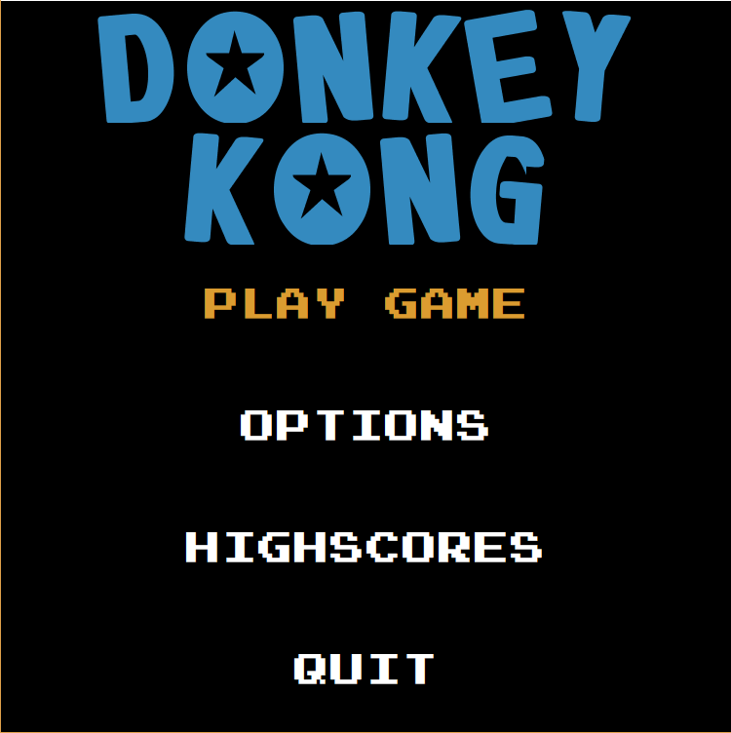

Figure 3.5.6.1: Screen shot of Main Menu

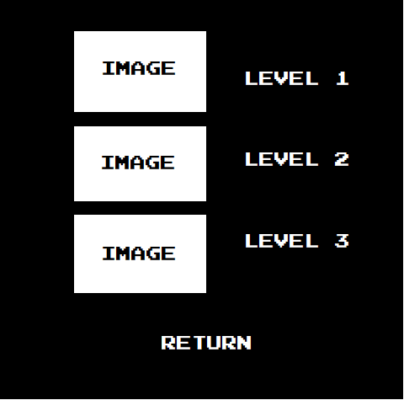

Figure 3.5.6.2: Screen shot of Level Selection Menu

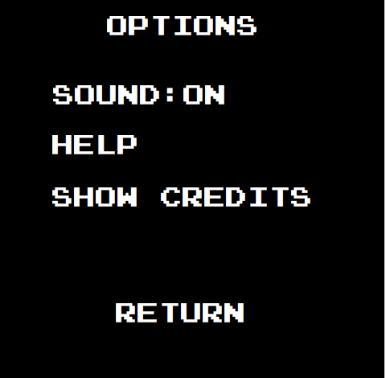

Figure 3.5.6.3: Screen shot of Options Menu

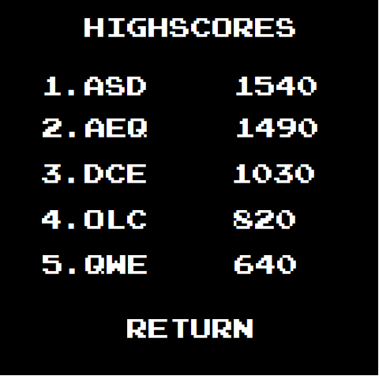

Figure 3.5.6.4: Screen shot of Highscores Menu