**2. Software Architecture**

2.1. Subsystem Decomposition

We chose the three-tier architectural style as a basis for our design because it is the most convenient architectural style to integrate with our system. The three-tier architectural style mainly consist of three layers: an interface layer, an application logic layer, and a storage layer. In the figure shown below, the high-level representation of our system decomposition is found.

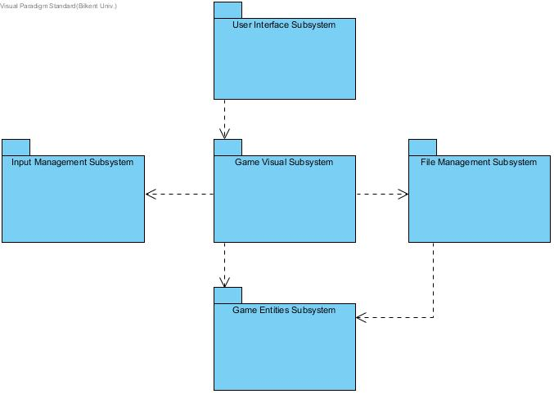Figure 2.1.1: High-level Representation of Subsystem Decomposition

The interface layer contains all boundary objects which interacts with the user. Therefore, we placed "User Interface Subsystem" package in the interface layer. Inside this package, we put "mainFrame" class, which contains main menu in it. When user wants to start game, first he/she should select "Play Game" option and then select the desired level to start. The chosen level number will be transferred to "Game Visual 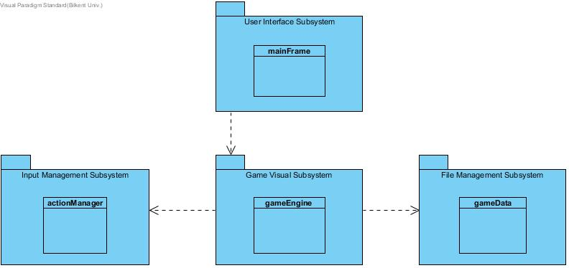Subsystem" package.

Figure 2.1.2: Interaction between Interface Layer and Application Logic Layer

The application logic layer contains all control objects. Thus, inside this layer, user's selection will interpreted and the "gameEngine" class will create the game map with cooperating "gameData" class which placed in "File Management Subsystem" package. Also during the game, "gameEngine" class will recieve inputs from "actionManager" class placed in "Input Management Subsystem" package.

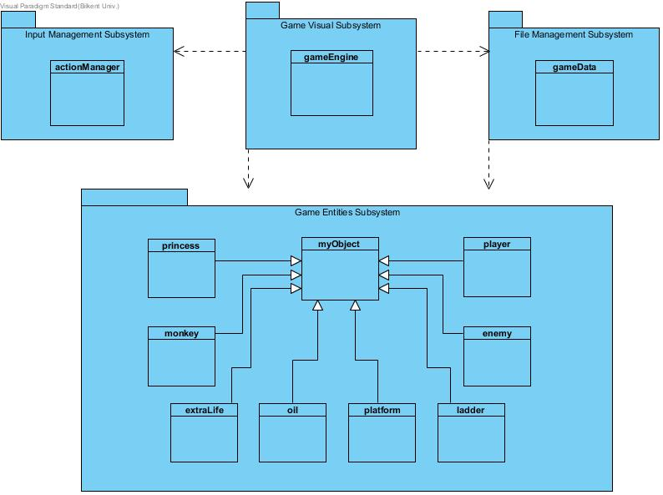

Figure 2.1.3: Interaction between Application Logic Layer and Storage Layer

The storage layer contains realizes the storage and retrieval of persistent objects. So, we placed "myObject" super class and subclasses into "Game Entities Subsystem" package. These objects will be used by both "gameEngine" and "gameData" classes during rendering operations and gameplay.

2.2. Hardware / Software Mapping

Our game will be implemented in Java so, in order to run it, the latest version of Java Runtime Environment will be required. In terms of hardware configuration, the game only requires a keyboard to make selections in the menu's and to play game. As system requirements, an average computer with basic softwares will be enough to support our game.