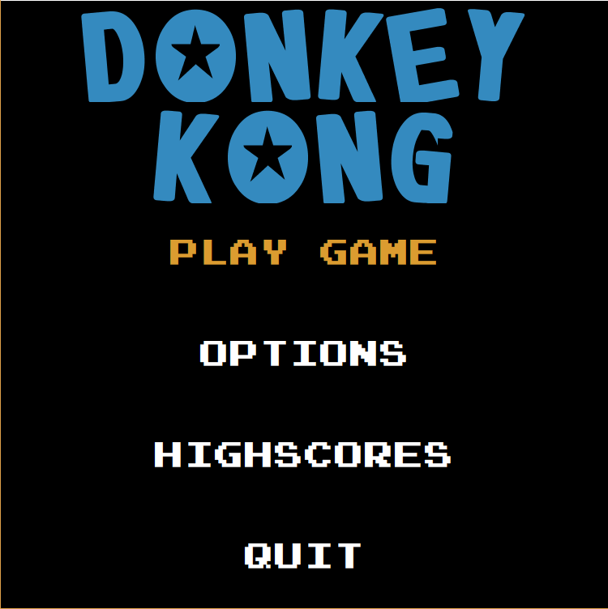

Figure 3.5.6.1: Screen shot of Main Menu

From the Main Menu user will be able to choose one of the options to continue. “Play Game” choice wlll lead to following “Level selection” page.

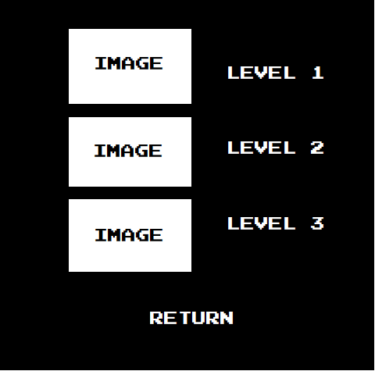

Figure 3.5.6.2: Screen shot of Level Selection Menu

User will choose from which level user wants to start. Everylevel has it is own difficulty level and own structure.

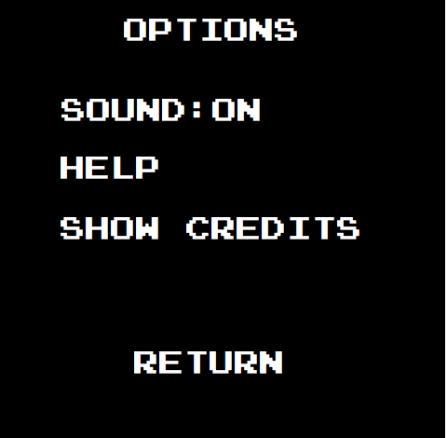

Figure 3.5.6.3: Screen shot of Options Menu

After user choses “Options” from “Main Menu” page, this is the page that will shoe up. As demonstrated in this mock-up user will be able to turn on and off from this page. From this page user will be able to go to “Help” and “Show Credits” page. “Show Credits” is shown in the following mock-up.

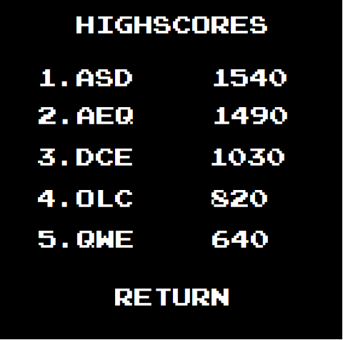

Figure 3.5.6.4: Screen shot of Highscores Menu

This is the page for the “Highscoe”, which from this page user will be able to learn top scorers of the game, with their name and score. If any user exceeds scores in the highscore, these table will be changed.