EDA

Lucas Cardoso Polak

17/10/2021

# EDA dos dados

## Libraries

library(tidyr)  
library(dplyr)

##   
## Attaching package: 'dplyr'

## The following objects are masked from 'package:stats':  
##   
## filter, lag

## The following objects are masked from 'package:base':  
##   
## intersect, setdiff, setequal, union

library(reshape2)

##   
## Attaching package: 'reshape2'

## The following object is masked from 'package:tidyr':  
##   
## smiths

library(factoextra) # visualização de clusters

## Carregando pacotes exigidos: ggplot2

## Welcome! Want to learn more? See two factoextra-related books at https://goo.gl/ve3WBa

library(dbscan)  
library(cluster)  
source("functions.R") # minhas funções definidas em um arquivo a parte

summary(cars)

## speed dist   
## Min. : 4.0 Min. : 2.00   
## 1st Qu.:12.0 1st Qu.: 26.00   
## Median :15.0 Median : 36.00   
## Mean :15.4 Mean : 42.98   
## 3rd Qu.:19.0 3rd Qu.: 56.00   
## Max. :25.0 Max. :120.00

## Including Plots

You can also embed plots, for example:

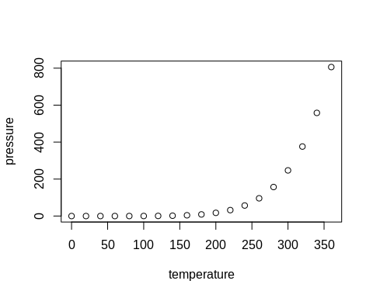

Note that the echo = FALSE parameter was added to the code chunk to prevent printing of the R code that generated the plot.