HTML vs. CSS vs. JavaScript:

What’s the Difference?

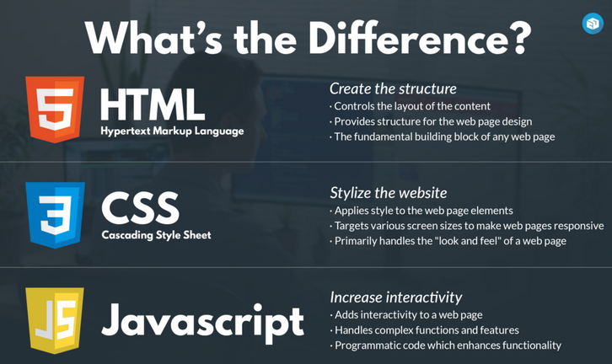

What Can You Do With Each Programming Language?
- With HTML, you will be able to create the structure of your website.
- CSS gives you the ability to make the website look more visually appealing.
- As for JavaScript, this is a robust programming language that allows you to effectively change the HTML and CSS components of your website to match your specifications precisely

What is HTML?
- HTML is a programming language that stands for Hypertext Markup Language. This is a relatively simplistic yet powerful programming language that allows web developers and website owners to create the structure of their website.
- The main reason why it’s important to know HTML is because it allows you as a website owner to create the basic structure of you website, from which you can use any other coding language to enhance the design.

What is CSS?
- CSS is a style sheet language that’s focused almost entirely on improving the presentation of HTML elements. While CSS is a static programming language, it can be used to make your website appear visually pleasing and modern.

What is JavaScript?
- JavaScript is among the most important programming languages for website owners who want to make their site more interactive, which makes this the most complex of the three standard programming languages in this article.
- JavaScript programming language gives you the tools that you need to alter the behavior of different elements that are found on a website page.

