CSS Foundations

Basic Syntax
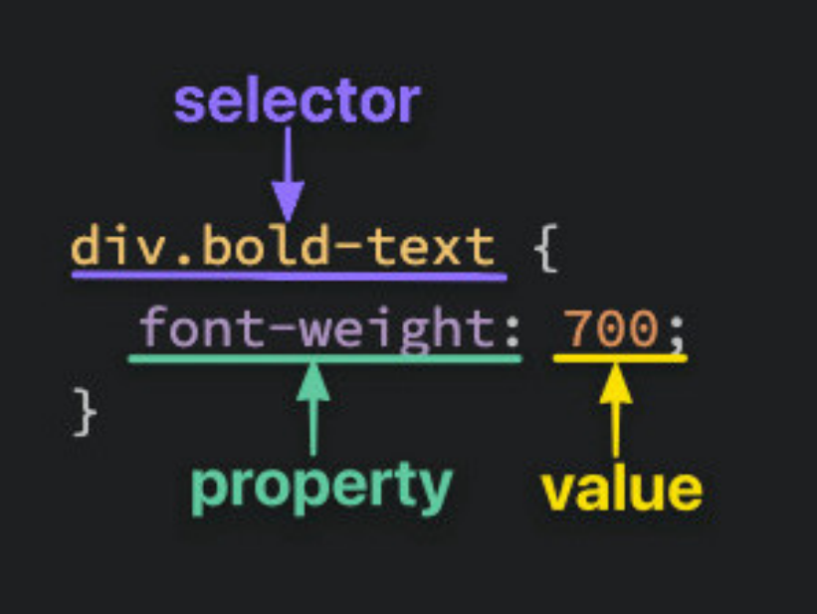

Selectors
- Selectors simply refer to the HTML elements to which CSS rules apply

Universal Selector
- The universal selector will select elements of any type, hence the name “universal”, and the syntax for it is a simple asterisk.
- In the example below, every element would have the color: purple; style applied to it.
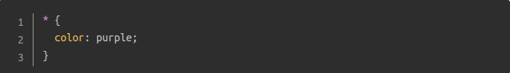

Type Selectors
- A type selector (or element selector) will select all elements of the given element type, and the syntax is just the name of the element.
- Here, all the <div> elements would be selected, while the <p> element wouldn’t be.
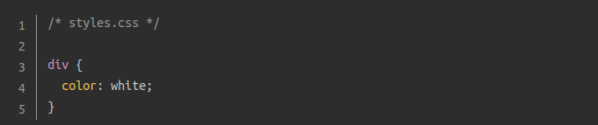

Class Selectors
- Class selectors will select all elements with the given class, which is just an attribute you place on an HTML element. Here’s how you add a class to an HTML tag and select it in CSS:
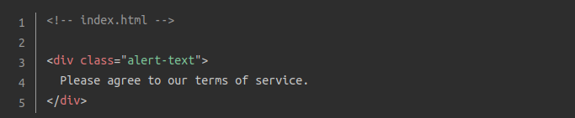
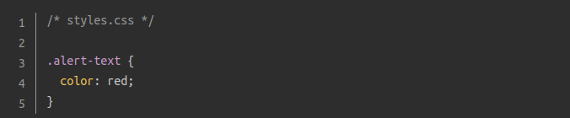
- Note the syntax for class selectors: a period immediately followed by the case-sensitive value of the class attribute.
- Another thing you can do with the class attribute is add multiple classes to a single element as a space-separated list, such as class="alert-text severe-alert".

ID Selectors
- ID selectors are similar to class selectors. They select an element with the given ID, which is another attribute you place on an HTML element:
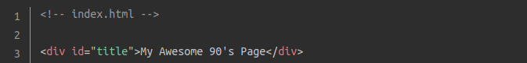
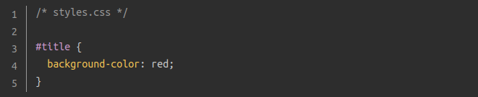
- Instead of a period, we use a hashtag immediately followed by the case-sensitive value of the ID attribute.
- A common pitfall is people overusing the ID attribute when they don’t necessarily need to, and when classes will suffice.
- The major difference between classes and IDs is that an element can only have one ID

Grouping Selector
- What if we have two groups of elements that share some of their style declarations?
- Both our .read and .unread selectors share the color: white; and background-color: black; declarations, but otherwise have several of their own unique declarations
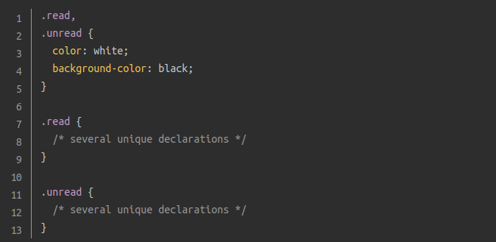
- To cut down on the repetition, we can group these two selectors together as a comma-separated list:

Chaining Selectors
- Another way to use selectors is to chain them as a list without any separation.
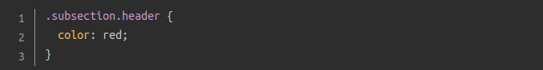
- What .subsection.header does is it selects any element that has both the subsection and header classes.
- This basically works with any combination of selectors except multiple type selectors (since an element can’t be two different types at once)

Descendant Combinator
- Combinators allow us to combine multiple selectors differently than grouping or chaining them, as they show a relationship between the selectors.
- The descendant combinator is represented in CSS by a single space between selectors.
- A descendant combinator will only cause elements that match the last selector to be selected if they also have an ancestor (parent, grandparent, etc) that matches the previous selector. So something like .ancestor .child would select an element with the class child if it is nested inside of ancestor, no matter how deeply.
- In the example below, the first two elements with the contents class (B and C) would be selected, but that last element (D) won’t be.

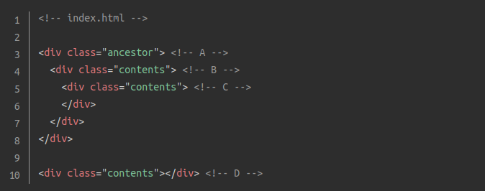
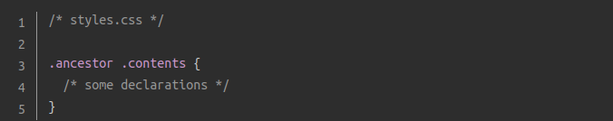

Properties to Get Started With

color and background-color:

The color property sets an element’s text color, while background-color sets, well, the background color of an element.
- They accept one of several kinds of values, such as an actual color name like red or the transparent keyword. They also accept HEX, RGB, and HSL values

Typography Basics and text-align:
- font-family can be a single value or a comma-separated list of values that determine what font an element uses. It’s best practice to include a list of values for this property, starting with the font you want to be used most and ending with a generic font family as a fallback, e.g. font-family: "Times New Roman", sans-serif;
- font-size will, as the property name suggests, set the size of the font.
- font-weight affects the boldness of text, assuming the font supports the specified weight. This value can be a keyword, e.g. font-weight: bold, or a number between 1 and 1000, e.g. font-weight: 700.
- text-align will align text horizontally within an element, and you can use the common keywords you may have come across in word processors as the value for this property, e.g. text-align: center.

Image Height and Width
Images aren’t the only elements that we can adjust the height and width on, but we want to focus on them specifically in this case.
- If you wanted to adjust the size of the image without causing it to lose its proportions, you would use a value of “auto” for the height property and adjust the width value:
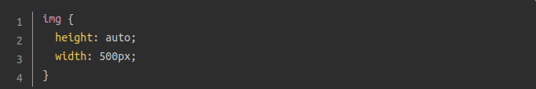
- It’s best to include both of these properties for <img> elements, even if you don’t plan on adjusting the values, to prevent problems when loading the image in your page.

The Cascade of CSS
“But I wanted these paragraphs to be blue, why are they red like these other paragraphs?!”
- The cascade is what determines which rules actually get applied to our HTML.
- There are different factors that the cascade uses to determine this, three of which we’ll go over to hopefully help you avoid (as many of) those frustrating “I hate CSS” moments.

Specificity
- A CSS declaration that is more specific will take precedence over ones that are less specific.
- Each type of selector has its own specificity level
  - ID selectors (most specific selector)
  - Class selectors
  - Type selectors
  - Universal selector and combinators (no specificity)
Examples:
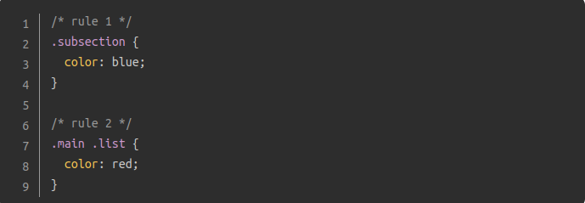
Both rules are using only class selectors, but rule 2 is more specific because it is using more class selectors, so the color: red; declaration would take precedence.
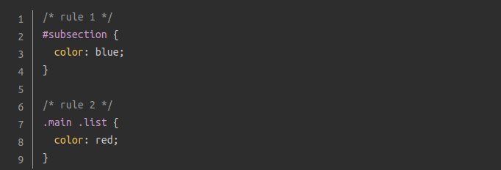
Despite rule 2 having more class selectors than ID selectors, rule 1 is more specific because ID beats class. In this case, the color: blue; declaration would take precedence.

Inheritance
- Inheritance refers to certain CSS properties that, when applied to an element, are inherited by that element’s descendants, even if we don’t explicitly write a rule for those descendants.
- Typography based properties (color, font-size, font-family, etc.) are usually inherited, while most other properties aren’t.
- The exception to this is when directly targeting an element, as this always beats inheritance

Rule Order
- The final factor, the end of the line, the tie-breaker of the tie-breaker.
- Lets say that after every other factor has been taken into account, there are still multiple conflicting rules targeting an element. Really simply, actually. Whichever rule was last defined is the winner.
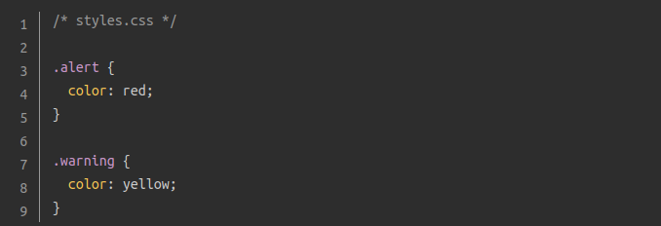
For an element that has both the alert and warning classes, the cascade would run through every other factor, including inheritance (none here) and specificity (neither rule is more specific than the other). Since the .warning rule was the last one defined, and no other factor was able to determine which rule to apply, it’s the one that gets applied to the element.

Adding CSS to HTML
The only thing left for now is to go over how to add all of this CSS to our HTML. There are three methods to do so.

External CSS
- External CSS is the most common method you will come across, and it involves creating a separate file for the CSS and linking it inside of an HTML’s opening and closing <head> tags with a self-closing <link> element:
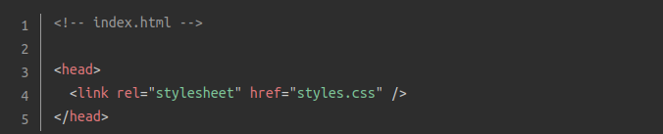
- A note on file name. You can name the file whatever you want as long as the file type is .css, though “style” or “styles” is most commonly used.
- Pros to this method
  - It keeps our HTML and CSS separated, which results in the HTML file being smaller and makes things look cleaner.
  - We only need to edit the CSS in one place, which is especially handy for websites with multiple pages that all share similar styles.

Internal CSS
- Internal CSS (or embedded CSS) involves adding the CSS within the HTML file itself instead of creating a completely separate file.
- You place all of the rules inside of a pair <style> tags, placed inside the <head> tags of your HTML file.
- This method can be useful for adding unique styles to a single page of a website, but it doesn’t keep things separated like the external method
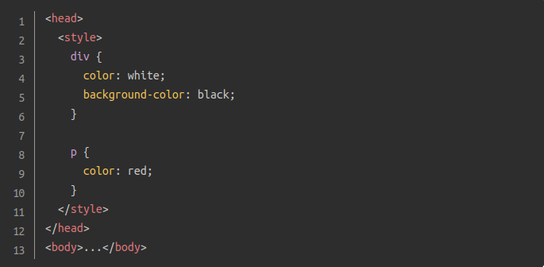

Inline CSS
Inline CSS makes it possible to add styles directly to HTML elements, though this method isn’t as recommended:
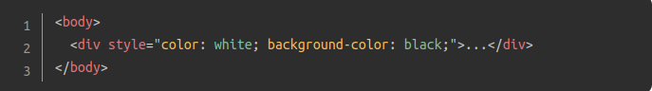
- If you need to add a unique style for a single element, this method can work just fine.
- It can get pretty messy pretty quickly once you start adding a lot of declarations to a single element.
- Any inline CSS will override the other two methods, which can cause unexpected results.

