HTML Foundations

Introduction
HTML(Hypertext markup language) defines the structure and content of webpages. We use HTML elements to create all of the paragraphs, headings, lists, images, and links that make up a typical webpage. In this lesson, we will explore how HTML elements work.

Elements and Tags
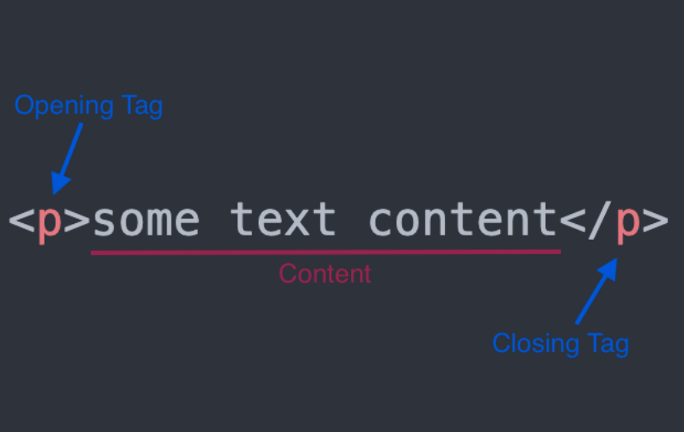
- You can think of elements as containers for content. The opening and closing tags tell the browser what content the element contains. The browser can then use that information to determine how it should interpret and format the content.

- There are some HTML elements that do not have a closing tag. These are known as empty elements because they don’t wrap any content.
- HTML has a vast list of predefined tags that you can use to create all kinds of different elements.
- Using the correct tags can have a big impact on two aspects of your sites: how they are ranked in search engines; and how accessible they are to users who rely on assistive technologies, like screen readers, to use the internet.
- Using the correct elements for content is called semantic HTML.

Creating a HTML File
- We should always name the HTML file that will contain the homepage of our websites index.html. This is because web servers will by default look for an index.html page when users land on our websites - and not having one will cause big problems.
- To let the computer know we want to create an HTML file, we need to append the filename with the .html extension as we have done when creating the index.html file.
- VSCode has a built-in shortcut you can use for generating all the boilerplate in one go. To trigger the shortcut just enter ! on the first line. This will bring up a couple of options. Press the enter key to choose the first one, and voila, you should have all the boilerplate populated for you.

The DOCTYPE
- Every HTML page starts with a doctype declaration. The doctype’s purpose is to tell the browser what version of HTML it should use to render the document. The latest version of HTML is HTML5, and the doctype for that version is simply <!DOCTYPE html>.

HTML Element
- After we declare the doctype, we need to provide an <html> element. This is what’s known as the root element of the document, meaning that every other element in the document will be a descendant of it.

Head Element
- The <head> element is where we put important meta-information about our webpages, and stuff required for our webpages to render correctly in the browser. Anything included within the head element will not be displayed to the user.
- The head element goes within the HTML element and should always be the first element under the opening <html> tag
- Title Element
  - One element we should always include in the head of an HTML document is the title element: <title>My First Webpage</title>
  - The title element is used to give webpages a human-readable title which is displayed in our webpage’s browser tab.
- The Charset Meta Element
  - Another important element we should always have in the head element is the meta tag for the charset encoding of the webpage: <meta charset="utf-8"/>.
  - Setting the encoding is very important because it ensures that the webpage will display special symbols and characters from different languages correctly in the browser.

Body Element
- The final element needed to complete the HTML boilerplate is the <body> element. This is where all the content that will be displayed to users will go - the text, images, lists, links, and so on.

Paragraphs
- A paragraph element is defined by wrapping text content with a <p> tag.

Headings
- There are 6 different levels of headings starting from <h1> to <h6>. The number within a heading tag represents that heading’s level.
- Using the correct level of heading is important as levels provide a hierarchy to the content.

Strong Element
- The <strong> element makes text bold. It also semantically marks text as important; this affects tools, like screen readers, that users with visual impairments will rely on to use your website.
- But you will probably find yourself using the strong element much more in combination with other text elements

Em Element
- The em element makes text italic. It also semantically places emphasis on the text, which again affects things like screen readers.
- To define an emphasized element we wrap text content in a <em> tag.
- Like the strong element, you will find yourself mostly using the em element with other text elements:

Nesting and Indentation
- When we nest elements within other elements, we create a parent and child relationship between them.
- Elements at the same level of nesting are considered to be siblings.
- We use indentation to make the level of nesting clear and readable for ourselves and other developers who will work with our HTML in the future.

HTML Comments
- HTML comments are not visible to the browser; they allow us to comment on our code so that other developers or our future selves can read them.
- Writing an HTML comment is simple: we just put <!-- and --> at either end of the comment.

Unordered Lists
- Unordered lists are created using the <ul> element, and each item within the list is created using the list item element <li>.
- Each list item in an unordered list begins with a bullet point.
- Used if you want to have a list of items where the order doesn’t matter, like a shopping list of items that can be bought in any order.

Ordered Lists
- If you instead want to create a list of items where the order does matter, like step-by-step instructions for a recipe, or your top 10 favorite TV shows, then you can use an ordered list.
- Ordered lists are created using the <ol> element. Each individual item in them is again created using the list item element <li>
- Each list item in an ordered list begins with a number instead.

Anchor Elements
- To create a link in HTML, we use the anchor element. An anchor element is defined by wrapping the text or another HTML element we want to be a link with a <a> tag.
- An anchor tag on its own won’t know where we want to link to. We do this by using an HTML attribute. In our case, we need to add a href (hyperlink reference) attribute to the opening anchor tag.
- An HTML attribute gives additional information to an HTML element and always goes in the element’s opening tag.
- It’s worth noting you can use anchor tags link to any kind of resource on the internet, not just other HTML documents.

Absolute Links
- Links to pages on other websites on the internet are called absolute links.
- A typical absolute link will be made up of the following parts: protocol://domain/path.

Relative Links
- Links to other pages within our own website are called relative links.
- Relative links only include the file path to the other page, relative to the page you are creating the link on.
- We will usually want to organize our website directories a little better. Normally we would only have the index.html at the root directory and all other HTML files in their own directory.

Images
- To create an image in HTML we use the <img> element.
- Unlike the other elements we have encountered so far, the <img> element is empty. Which means it doesn’t have a closing tag.
- The src attribute works much like the href attribute for anchor tags. It can embed an image using both absolute and relative paths.
- Besides the src attribute, every image element should also have an alt(alternative text) attribute. The alt attribute is used to describe an image, it will be used in place of the image if it cannot be loaded. It is also used with screen readers to describe what the image is to visually impaired users.

