CSS Box Model

The most important skills you need to master with CSS are positioning and layout. Changing fonts and colors is a crucial skill, but being able to put things exactly where you want them on a webpage is even more crucial.

Every single thing on a webpage is a rectangular box.
These boxes can have other boxes in them and can sit alongside one another.
To see how it works you can add this style to all elements of the webpage:
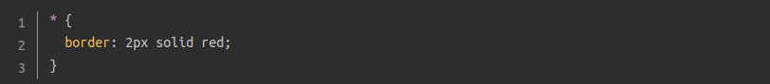
There are many ways to manipulate the size of these boxes, and the space between them, using padding, margin, and border.
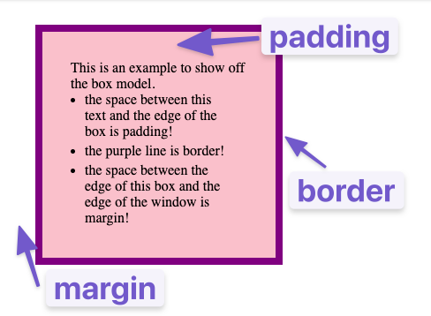

Padding:
- increases the space between the edge of a box and the content inside of it.
- Unlike margins, you cannot have negative amounts of padding, so the value must be 0 or a positive value.
- We can control the padding on all sides of an element using the padding property, or on each side individually using the equivalent longhand properties: padding-left, padding-right, padding-top, padding-bottom.
Margin:
- increases the space between a box and any others that sit next to it.
- Margin collapses between two elements that are next to each other. If two elements are next to each other, whichever margin is the largest is the one used (this only works vertically). If one margin is negative, its value will be subtracted from the total. Where both are negative, the margins will collapse and the smallest (furthest from zero) value will be used.
- Margins can have positive or negative values. Setting a negative margin on one side of your box can cause it to overlap other things on the page.
- We can control all margins of an element at once using the margin property, or each side individually using the equivalent longhand properties: margin-top, margin-left, margin-bottom, margin-right.
- Each of the margin properties can also accept a value of auto.
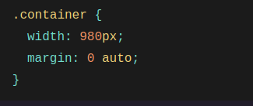
- auto is handy for horizontal centering: In this example, two things are done to center this element horizontally within the available space: The element is given a specified width The left and right margins are set to auto.Without the specified width, the auto values would essentially have no effect, setting the left and right margins to 0 or else to whatever is the available space inside the parent element.
- auto is useful only for horizontal centering, and so using auto for top and bottom margins will not center an element vertically.
Border:
- adds space (even if it’s only a pixel or two) between the margin and the padding.
- You can set the width, style, or color of all four borders at once using the border property. To set the properties of each side individually, you can use: border-top, border-bottom, border-left, border-right.
- To set the width, style, or color of all sides, use the following: border-width, border-style,border-color. To set the width, style, or color of a single side, you can use one of the more granular longhand properties: border-top-width, border-top-style, etc

Height and Width of a box
- We can specify the height and width that we want for a box.
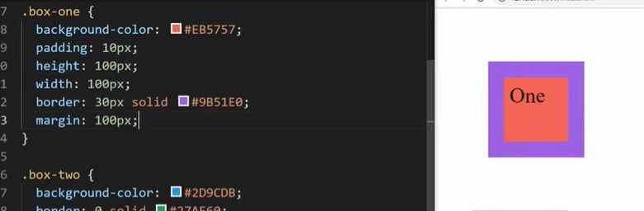
- However, the total height and width for an element in CSS is calculated adding the padding on the top and bottom, border on the top and bottom, and the height and width. In the example above the total height would be 100+10+10+30+30 = 180px
- If we want the height and width to be the one we specified, we can use the property box-sizing : border-box. Instead of adding padding and border it just uses the width and height specified.
- Many times the property border-box is used in the universal selector so that all boxes sizes are calculated just with the height and width.

Use browser DevTools to view the box model
Your browser developer tools can make understanding the box model far easier. If you inspect an element in Firefox's DevTools, you can see the size of the element plus its margin, padding, and border. Inspecting an element in this way is a great way to find out if your box is really the size you think it is!
