**Bake Shop System**

Bake Shop System is a system that manages all orders and inventory.

**Installation Guidelines:**

Before you install the Bake Shop System, please make sure that your system environment is the same as the below.

|  |  |
| --- | --- |
| Technology | Version |
| Windows/ Mac/ Linux | Window 7+ / Mac / Linux |
| Memory | 4GB or higher |
| Java | JDK 1.8 or higher |
| IntelliJ | 2018.x or higher |

1. Open the IntelliJ IDEA and click “Open or Import”. Select the file directory that you download the Bake Shop System, then click ”open”.

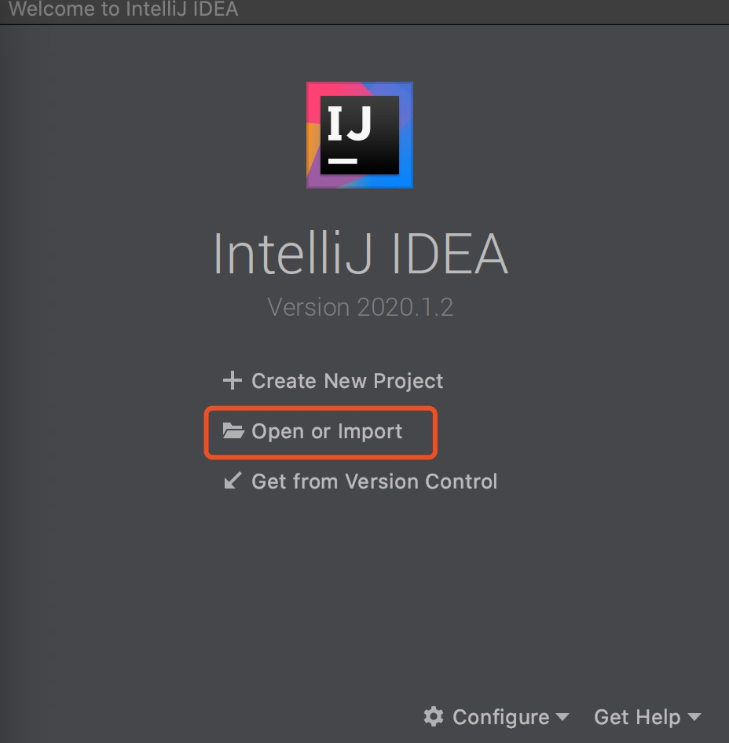

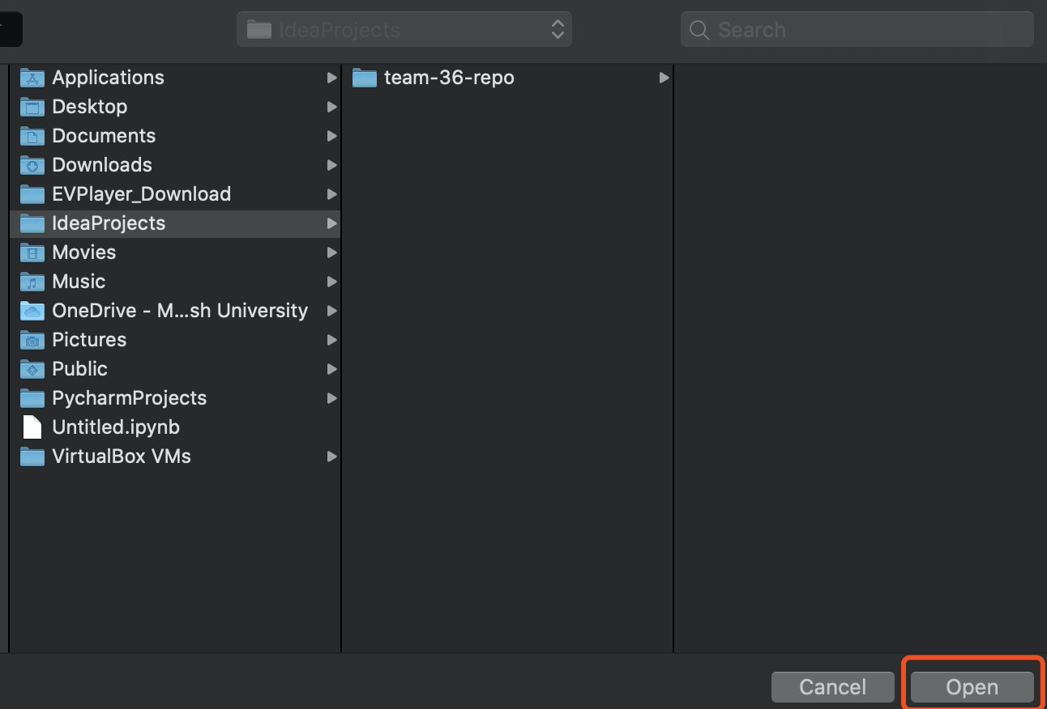

1. Click the open folder to find the main program. Click “main“.

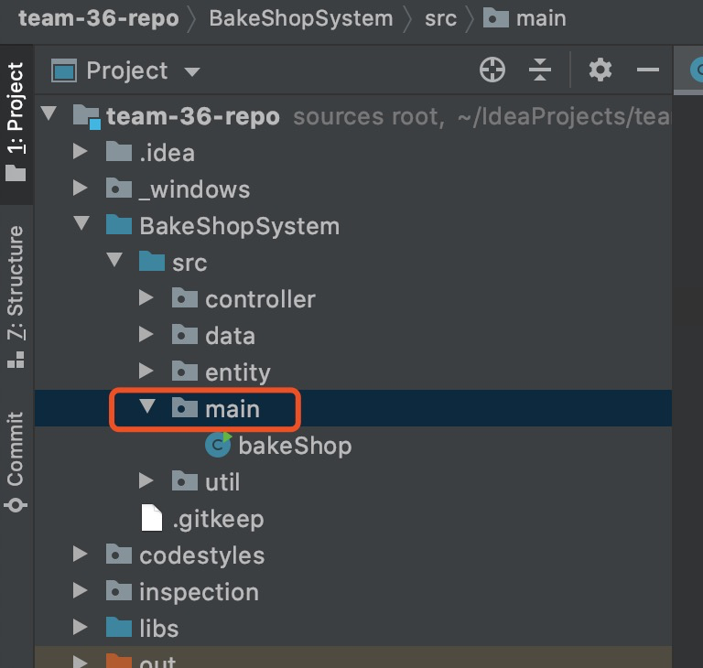

1. Right click “bakeShop”, then choose the option “Run ‘bakeShop’.main()”.

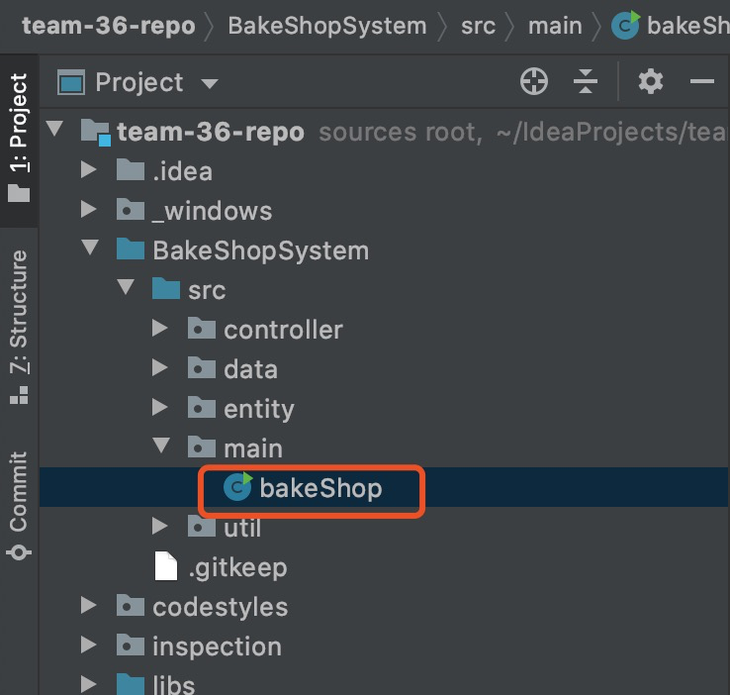

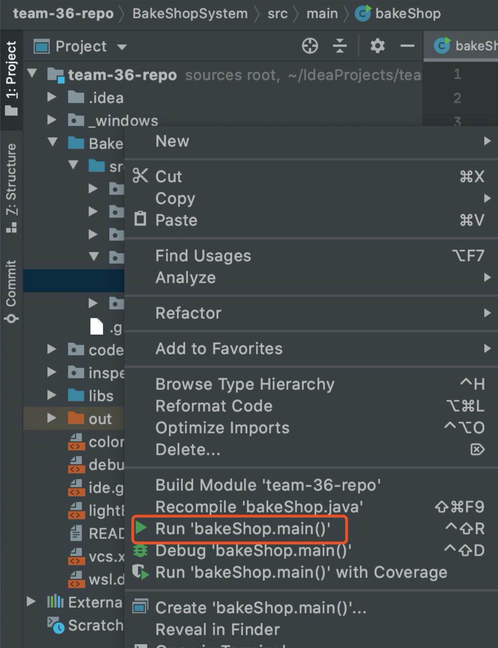

**Troubleshooting:**

1. Make sure that the file “Sample Data.xlsx” is closed when you run the program.
2. Make sure that the email you enter follows the format: xxx@xxx.xxx when you log in.
3. Make sure that the phone number you enter follows the format: (0x)xxxxxxxx when you create an order.
4. The street, city, and state must be letters.
5. The postal must be numbers.
6. The input in menus should be limited in the options and ‘back’.
7. The input in update order, update staff, create staff, create order should be limited in the options, ‘submit’, and ‘back’.
8. The input of add items should follow format ‘itemName,quantity’, e.g. ’milk,2’.