Ticket Grabbing

**Follow below steps to execute TicketGrabbing:**

1. Download the latest version for Windows Python  
   <https://www.python.org/downloads/>

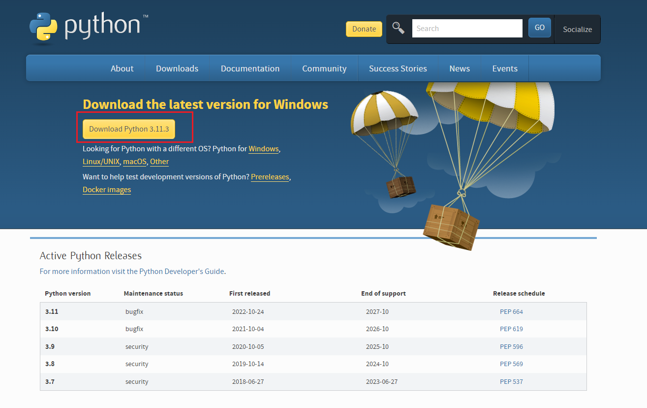

1. Download the chromedriver according to your chrome browser version  
   <https://chromedriver.chromium.org/downloads>

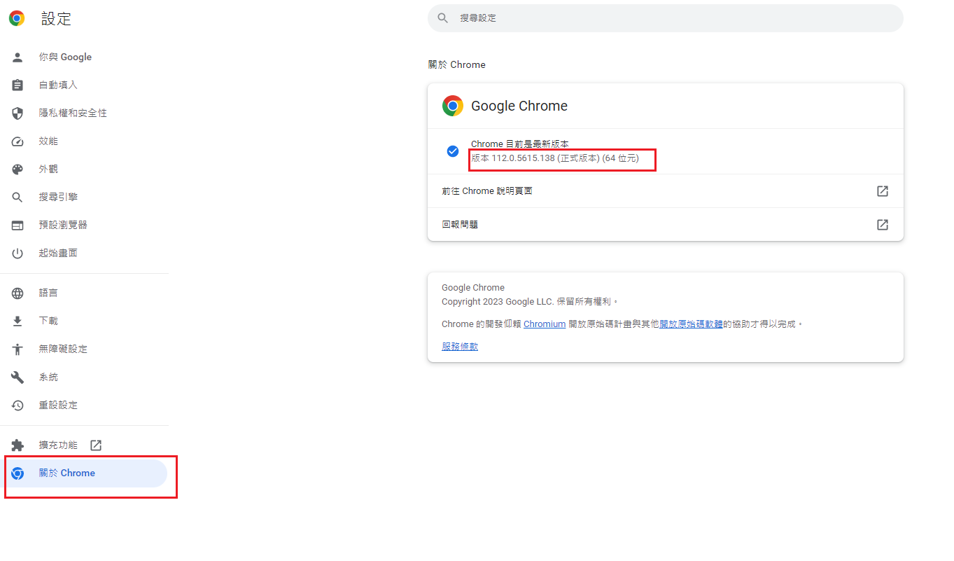

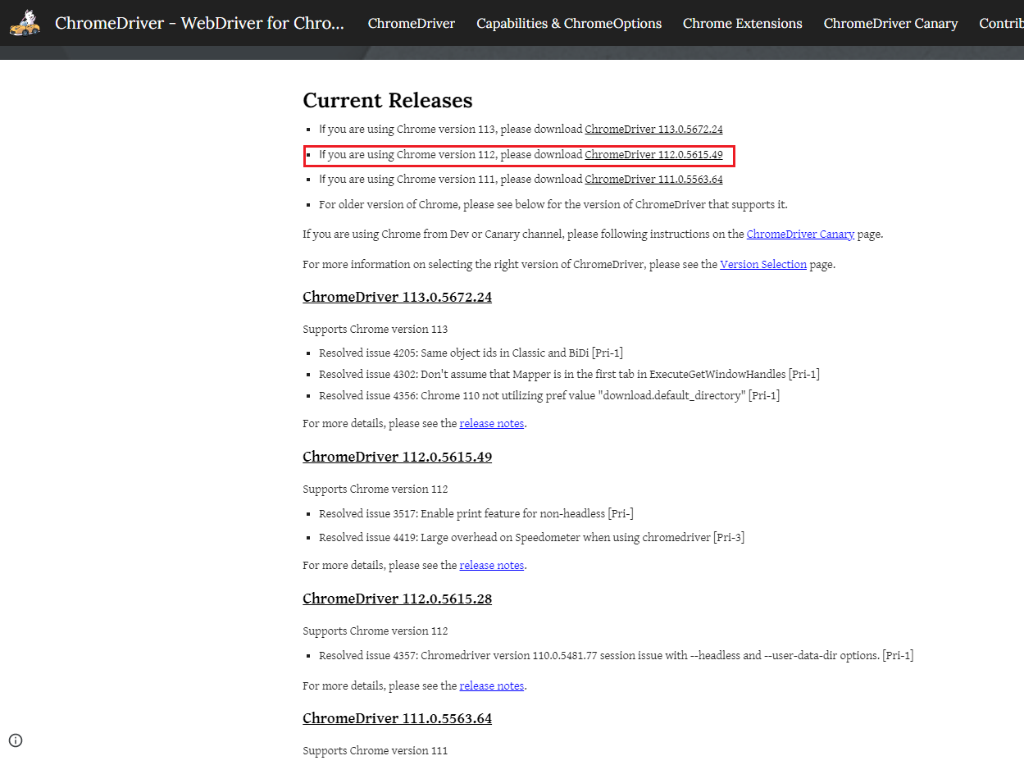

1. Enter command line to check related packages
   * python --version
   * pip install selenium
   * python -m pip install --user --upgrade pip
   * pip install ddddocr
   * pip install requests

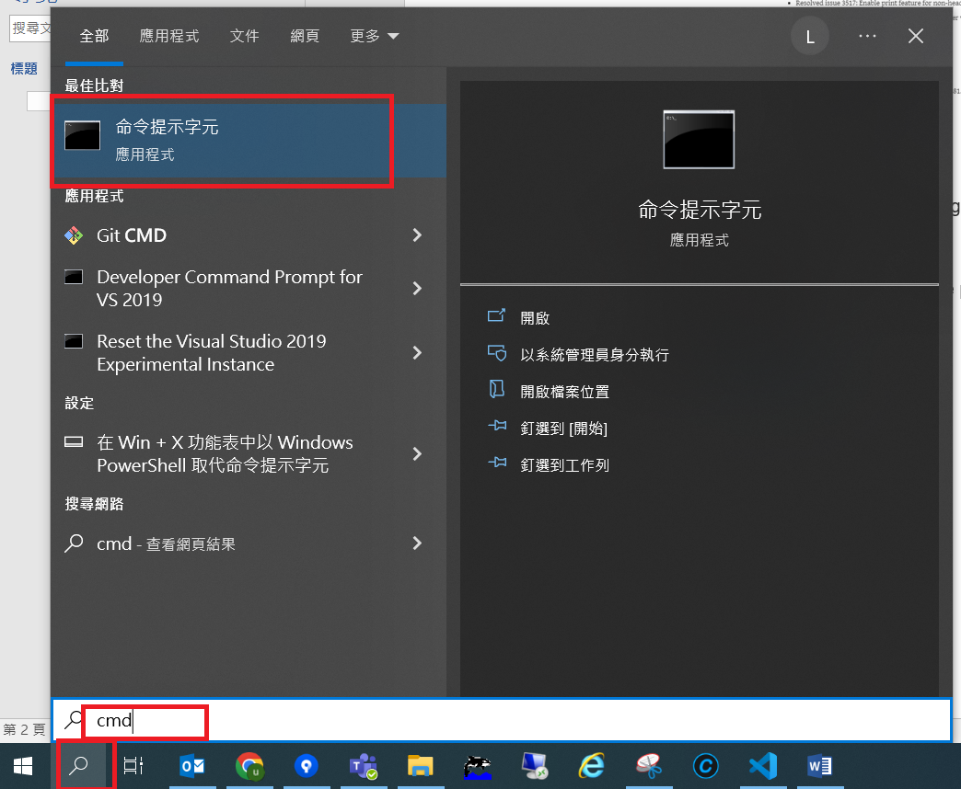

1. Update config.json url value depend on your PLG game

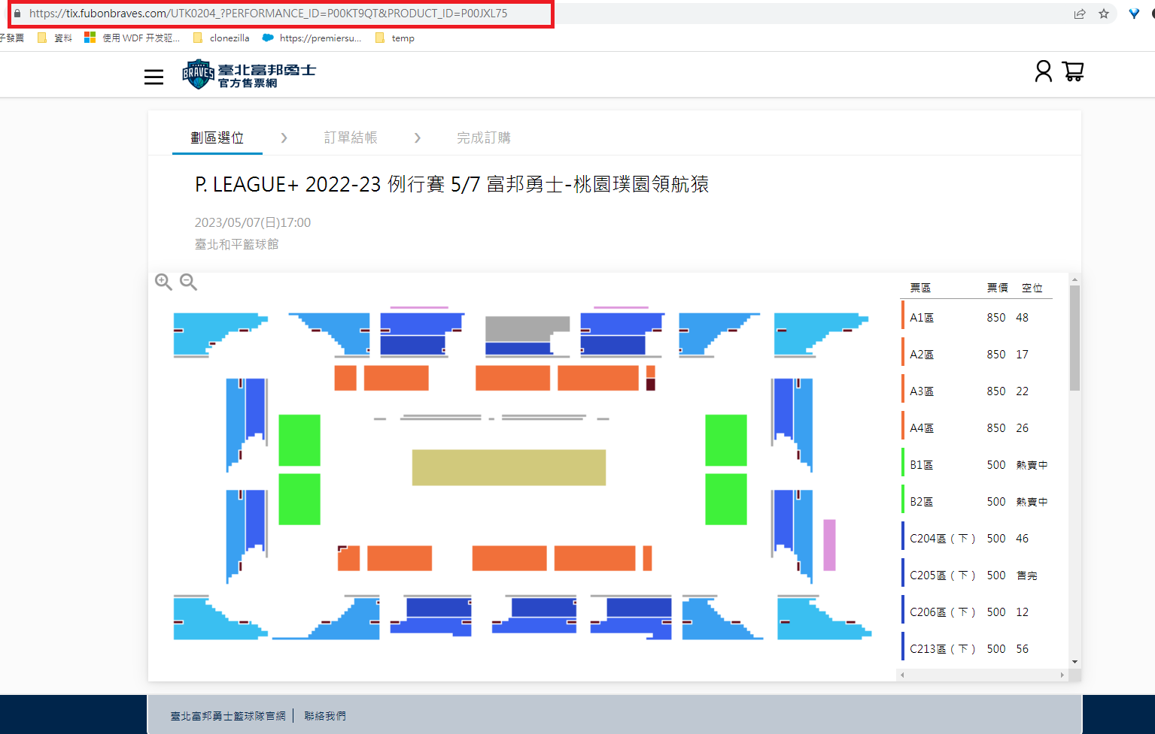

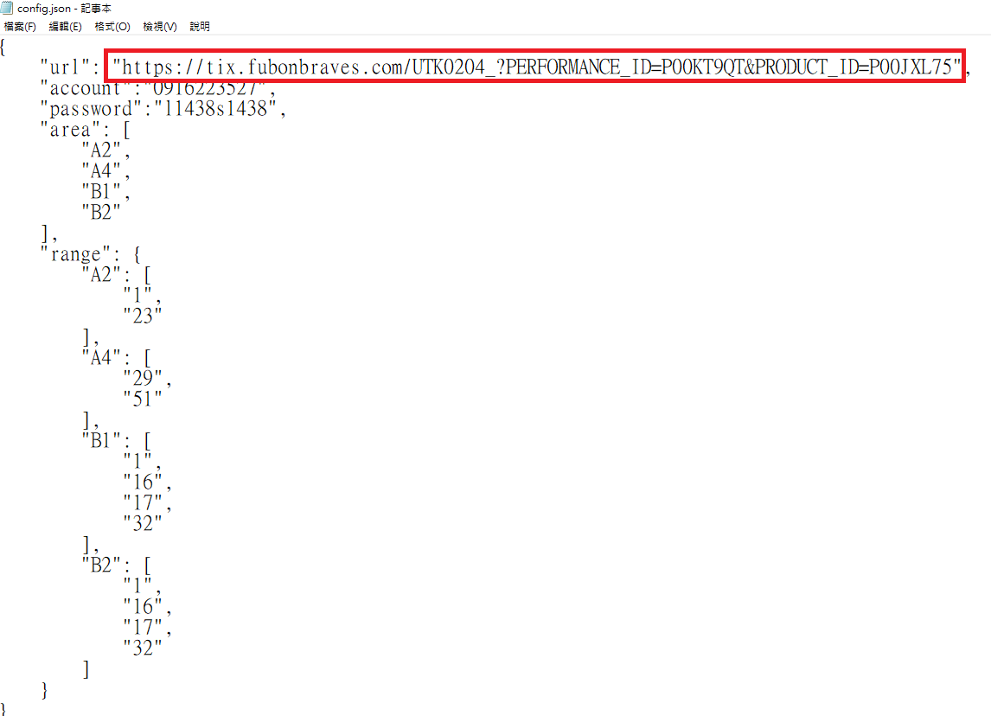

1. Execute py .\[TicketGrabing.py](http://ticketgrabing.py/)

