**aaeonFramework Installation Guide**

***Document History***

|  |  |  |  |
| --- | --- | --- | --- |
| ***Version*** | ***Date*** | ***Author*** | ***Description*** |
| 1.00 |  | Tim Lin | First Release |
| 1.06 | 2017.10.26 | Tim Lin | Modify some typo |
| 1.07 | 2017.11.10 | Jerry Liao | Adjust some format incorrect |
| 1.08 | 2017.11.21 | Jerry Liao | Add uninstall error part |
| 1.09 | 2019.03.19 | Hsiuyang Chien | Add install error part |

# Install aaeonFramework

**Note:** The below install instructions are for Windows 7, Windows 8 and Windows 10.

Navigate to the folder that contains the aaeonFrameworkSetup.msi file.

Double click “**aaeonFrameworkSetup.msi”**.

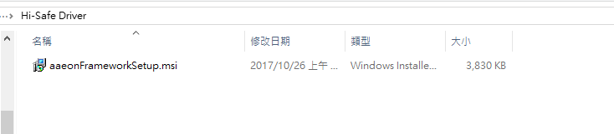

Press the **Next >**

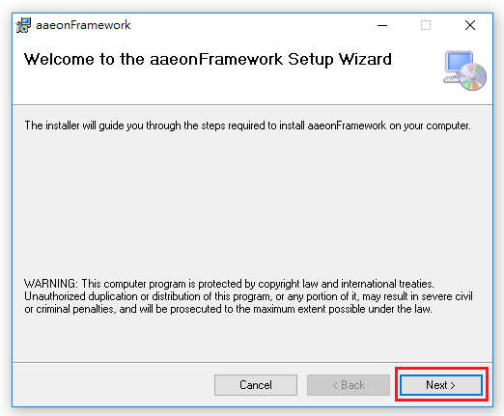

Press the **Next >**

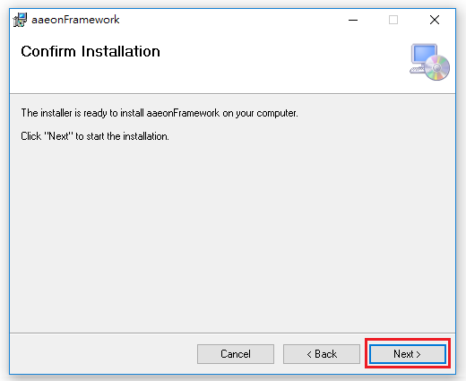

Press the **Yes**

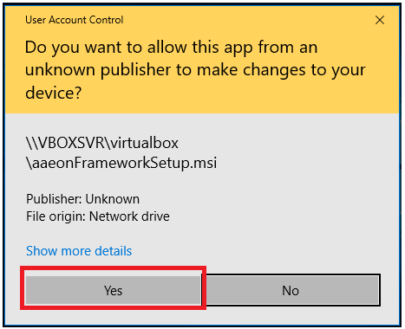

Press the **Install**

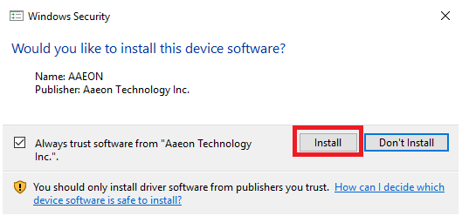

Press the **Close**

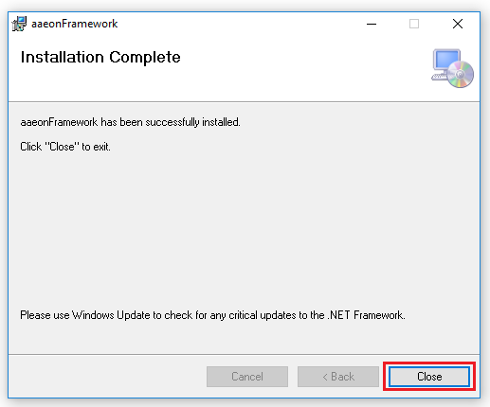

If you encounter error when installing aaeonFramework, please download

**“.NET Framework 4.0”** or up.

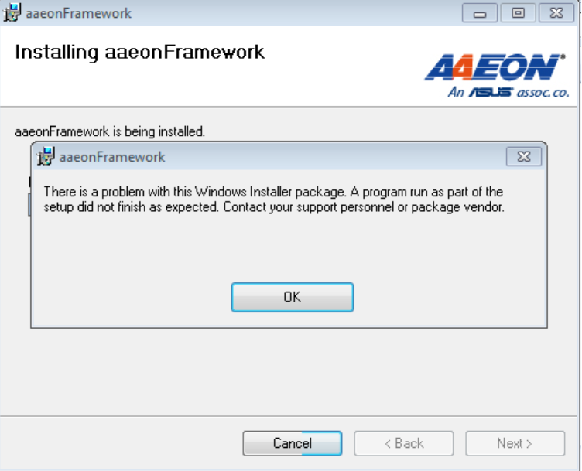

After you finished Installation, you will find “AAEON Framework” in Device Manager.

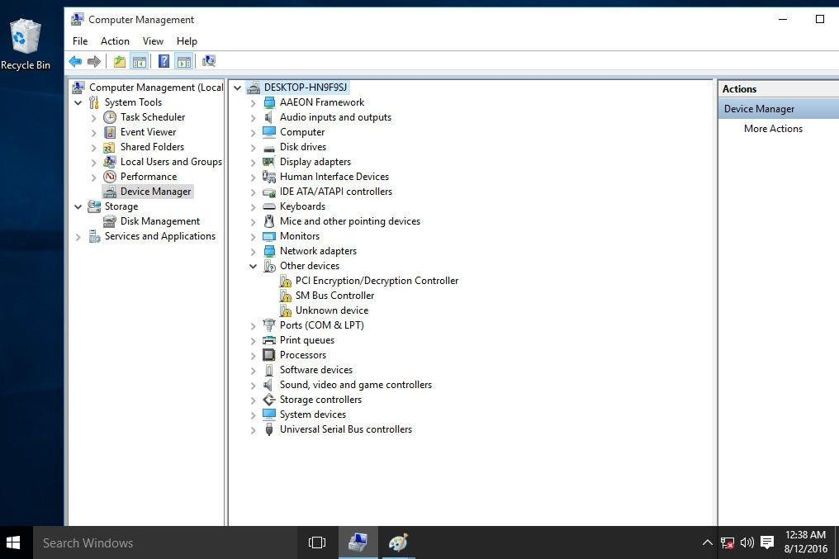

If your device is Windows 7 64 bit, please install Windows6.1-KB3033929- x64.msu from **C:\Program Files (x86)\AAEON\HiSafe\.**

If you cannot find the file mentioned above, please refer to this link: <https://www.microsoft.com/en-US/download/details.aspx?id=46148>

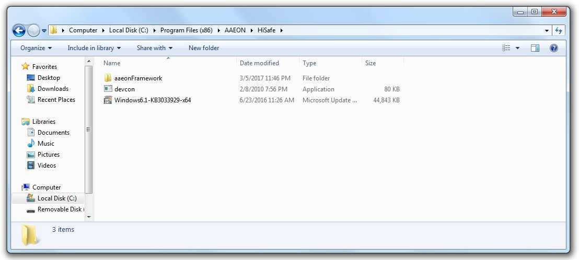

# Uninstall aaeonFramework

Double click **“aaeonFrameworkSetup.msi”**.



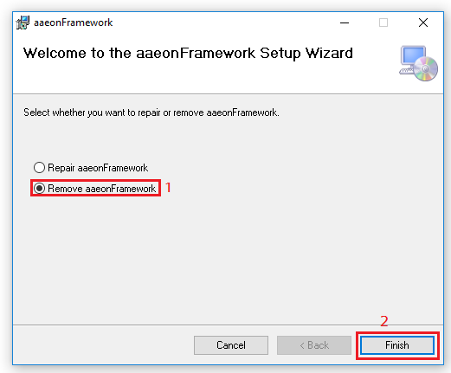Select **“Remove aaeonFramework”** and press **“Finish”.**

If you encounter error when uninstalling aaeonFramework, please repair it then remove again.

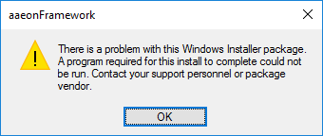

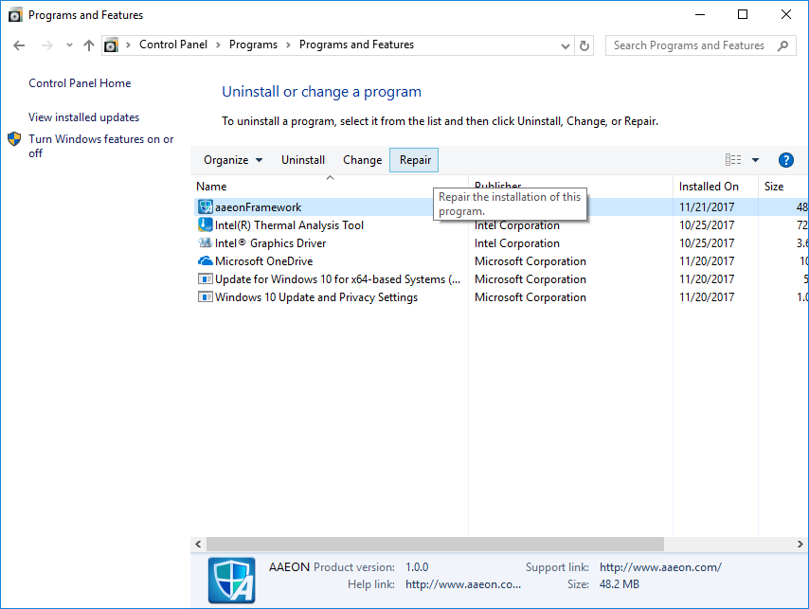

# Check aaeonFramework Version

You can check aaeonFramework build date by right clicking item in Device Manager.

