Radioactive Duck
Student's name : Morard Ambre, Tornare Lucas, Contat Sonny
Module : 64-31 Web Development
Submitted on 25.06.2026
Table of contents
1 Indications of the integrated competencies and their location in the code 2
2 Outcome 4
3 Links 4

Indications of the integrated competencies and their location in the code
Skills | Mandatory project implementation | Indicate file and line + screenshot
Forms HTML elements | x (form with HTML input and validation see optional JS) | Index.html (l. 42-43)  Js/setup.js (l. 14-22)
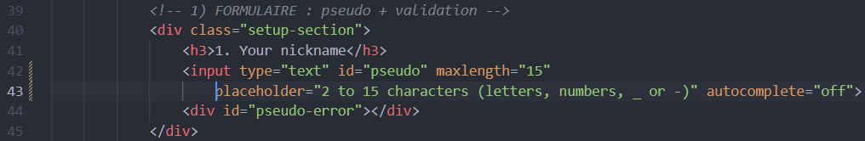
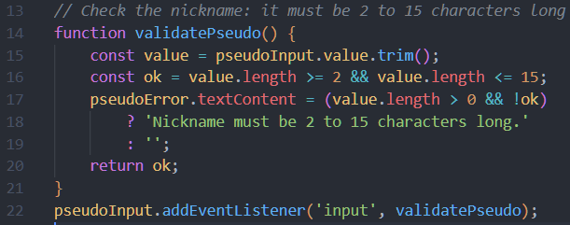
Medias & API | x (canvas AND audio or video e.g.: integrates a tutorial video of the game or application) | Game.html (l. 26)  js/audio.js (l.1-10)
 | 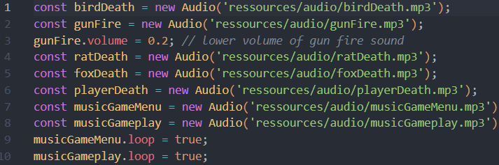
DOM handling functions | x (min. getElementById() or querySelector()) | js/setup.js (l.4-8, 31)
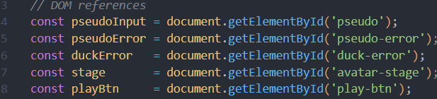
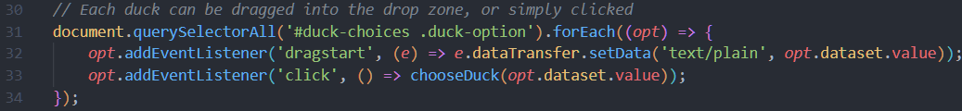
Several variable scopes in JS | x (implicit) | js/game.js (l. 2-4, 16-17)
global
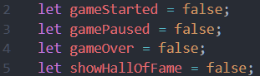
VS
local
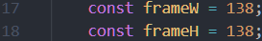
Natives Libraries | x (min. Math) | file.js  line: XXX
 | Your screenshot
Variable comparison operators | x (implicit) | file.js  line: XXX
 | Your screenshot
Loop & iterators | x (loop on object) | snake.js  line : 411
 | Your screenshot
Types of functions:  - standard,  - anonymous | x (standard function with parameters and method) | file.js  line: XXX
 | Your screenshot
Types de stockages (bonus) | x (local storage) | file.js  line: XXX
 | Your screenshot
Callback | x (either by use of API or own construction) | file.js  line: XXX
 | Your screenshot
Drag'n Drop | x (Building an avatar) | file.js  line: XXX
 | Your screenshot
Ajax | OPTIONAL  (Game setup) | file.js  line: XXX
 | Your screenshot
JSON | OPTION  (Game setup et React JS website) | file.js  line: XXX
 | Your screenshot
Geolocalisation | x (Implicit) | fichier.js  line: XX
 | Your screenshot

Links
- Link to source code: https://github.com/...
- Link to demo: https://www....

