Laboratory Sheet 1
1. Create a web page with your short CV. It should include:

a. a main page (index.html)
b. links to 3 websites (past schools, employers)

1 - https://www.totvs.com
2 - https://www.griffith.ie/
3 - http://www.dit.ie/

c. several paragraphs of text (summary, cover letter)
Summary

Bilingual professional (Portuguese and English) holding a Higher Diploma in Computing in Science, BSc in Business Management, and MSc in Marketing, over 10 years of experience in ERP/SaaS/PaaS/IaaS account management, customer relationship, and business management. Looking for opportunities as a Software Engineer, seeking IT improvement with a focus on career progression.

Cover letter

To whom it May concern
Upon review of your job posting for the Associate Software Engineer, I felt compelled to submit my resume for your consideration. As an experienced and tech-savvy professional with comprehensive {experience} and expertise in developing and implementing a variety of technical solutions to achieve goals, I have also a developed knowledge of new tools, languages and APIs, I am therefore confident that I would significantly contribute to the objectives of your company.
With a proven track record of analysing business processes, leading project management responsibilities and constantly developing software skills, I believe I am in a position to greatly exceed expectations for this role and substantially benefit your organization. I would be delighted to hear from you and look forward to discussing the position in further detail.
Thank you for your time and consideration.

Sincerely,

Lucas Maximo

d. nested lists (jobs and responsibilities, projects and technologies)

Subjects Studied
- Programming and Data Structures: Java EE.
- Data Communications and Networks.
- Software Engineering For Web Application: HTML, BOOTSTRAP, CSS, and PHP.
- Relational Databases: MY-SQL.
- Programming and Data Structures: Java 8 and 10.
- Operating System Design: Linux and Windows.
- Object Oriented Development: OOD by Java.
- Discrete Mathematics.
- Computer Architecture And Organization: Electronics basic and data circuits.
Academic Projects
- Project: Design Patterns |Technologies used: Java, Eclipse |Methodology used: Researched Methodology | Description: Creational Patterns, Structural Patterns, Behavioral Patterns, Patterns identified by Sun Java Centre (Stack, Naive Queue, Circular Queue, Sorting, Selection, Bubble, Big O, Trees, Quick Sort, Interact, Recursion and Graph.
- Project: Car Rental - Relational Database | Technologies used: MySQL, Java & Eclipse| Methodology Used: Research | Description: Normalization, Schema, Data Population, Queries and connection with front end system JavaFx.
- Project: English Schools - Web design | Technologies Used: Html, Css, PHP & MySQL| Methodology used: Research | Description: Design documentation(Market analyses, Content inventory, Sitemap, Organization of webpages, Wireframe), Website Code, including images, Videos and Database.
- Project: Object Oriented | Technologies Used: MySQL, Java & IntelliJ | Methodology used: Research Methodology | Description: Electronics Shop, UML Diagram, Databases creation, IO File Handling, Abstracts and interfaces, Immutable Objects, Comparable, Polymorphism, Singleton, Generics, Multithreading, etc.

e. a table with visible borders (education, years and grades)

- Master in Advanced Software Development | Dublin Institute of Technology |2019 - 2021
- Higher Diploma in Science in Computing |Griffith College Dublin| 2018 – 2019 – First Honours
- International Business Programme Erasmus - Marketing | EADA Business School, Spain | 2017
- Master in Marketing (Innovations) |ESPM (School of Advertising and Marketing), Brazil | 2017
- Bachelor in Business Administration | FECAP (Alvarez Penteado Foundation), Brazil | 2007

f. your photo at the top of the page


g. the TU Dublin logo, working as a hyperlink to www.dit.ie


2. Create two external style sheets: “Creative” and “Professional”, with a background, different text formatting, etc.
Define style sheet Creative
Define style sheet Professional

3. Change the webpage in ways to select the style (external CSS) by clicking a button.

Creating a button
Creating a link to the button

4. Create 3 questions about yourself on the page. There should be a hidden answer under each question. When the user clicks a “show answer” button, the answer should appear. The text on the button should change to “hide answer”. Clicking the button again at this point should hide the answer and change the button’s text back to “show answer”.

Question 1 – Which is the language that I have more familiarity
Answer 1 –
Question 2 – What is my target profession
Answer 2 –
Question 3 – How long time I am leaving in Ireland
Answer 3 –

Create an active button, where the user can click on it and it will see the answer. Click again the answer disappear.

5. Add an interactive image gallery with photos of yourself. At the top of the page there should be a large image. Under the image there should be a ribbon of small images (thumbnails). When the user clicks one of the thumbnails, the large image at the top should change to the full-size version of the clicked thumbnail.
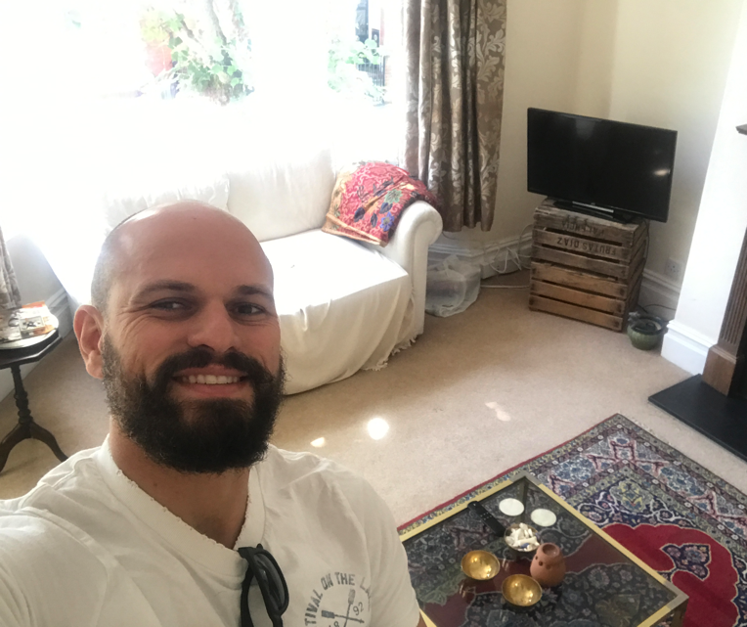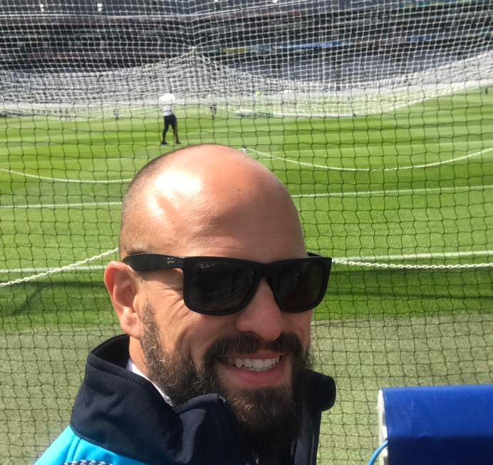

a. Try using plain JavaScript for this, no frameworks yet;

6. Clicking on any thumbnail in the interactive gallery will make it display a border around that thumbnail. Clicking another thumbnail will make the border disappear from the previous one and be displayed in the current one.

7. Make the webpage display the current time (hours:minutes:seconds) every 3 seconds, under the TU Dublin logo.
a. Get help here: http://www.w3schools.com/jsref/jsref_obj_date.asp
8. Hovering the mouse over the timer will make its background be assigned a random colour
a. Get help here: http://www.w3schools.com/jsref/jsref_obj_math.asp

