Tutorial 1.2

Question 1: What is a full wave rectifier? Discuss the construction and principle of operation of a typical centre tapped/bridge full wave rectifier.

Question 2: What is the ripple factor? Evaluate the ripple factor for both half-wave and full-wave rectifiers and discuss the performance.

Question 3: What is PIV? Why PIV is very important in diode circuits? Determine the PIV for the half-wave/full-wave/bridge rectifier circuit.

Question 4: What is a clipper/clamper circuit? How does a clipper/clamper circuit work? What are the applications of clipper/clamper circuits?

Question 5: What is a voltage doubler circuit? Illustrate the construction and principle of operation of a typical half-wave/full-wave voltage doubler circuit. What are their applications?

Question 6: What is the breakdown of a diode? How it occurs?

Question 7: What is a filter? How a filter reduces the ripple of a DC signal?

Question 8: What is a Voltage Regulator? How a DC signal can be regulated in a power supply circuit?

Question 9: What are the Zener effect and Avalanche effect?

Question 10: What is the difference between a crystal diode and a Zener diode?

Problem 1:
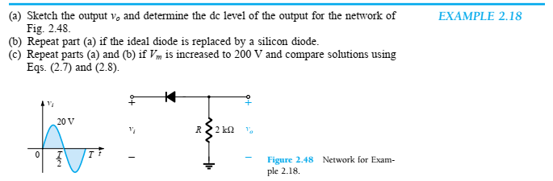

Problem 2:
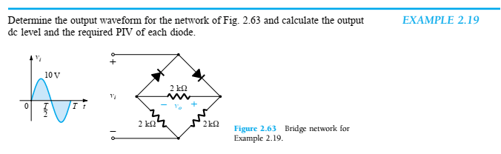

Problem 3:
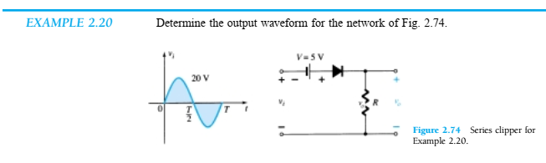

Problem 4:
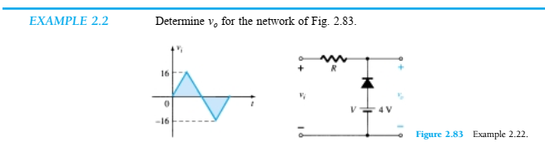

Problem 5:
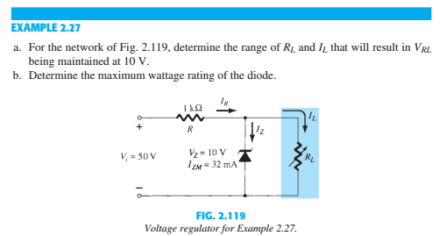

Problem 6:


