Tutorial 5
Question 1: What is a feedback in an amplifier? Discuss the considerations for an ideal feedback in an amplifier.

Question 2: Explain the advantages and disadvantages of negative feedback in an amplifier.

Question 3: Prove that the closed loop gain of an amplifier depends on its feedback transfer function (β) only.

Question 4: Show that the percent change in the closed loop gain of an amplifier is less than the percent change of its open loop gain.

Question 5: Show that the gain bandwidth product of an amplifier is independent of its feedback transfer function (β).

Question 6: Show that the negative feedback cannot improve the signal to noise ratio if the noise is a part of the input signal.

Question 7: What is series-shunt (series-series/ shunt-shunt/shunt-series) feedback? Draw the equivalent circuit of a voltage amplifier having series shunt feedback and evaluate the parameters.

Question 8: Compare the effect of different feedback processes on the amplifier circuit.

Problem 1:
Determine the voltage gain, input, and output impedance with feedback for series shunt feedback having gain
A = -100, input impedance Ri=10 k, output impedance Ro=20 k for feedback of (a) ᵦ=0.1 and (b) ᵦ=0.5.
Problem 2:
If an amplifier with gain of 1000 and feedback of ᵦ=0.1 has a gain change of 20% due to temperature, calculate the change in gain of the feedback amplifier.

Problem 3:
Calculate the gain without and with feedback for the FET amplifier circuit with series shunt feedback and the following circuit values: R1=80 k, R2=20 k, Ro=10 k, RD=10 k, and gm=4000 µS.
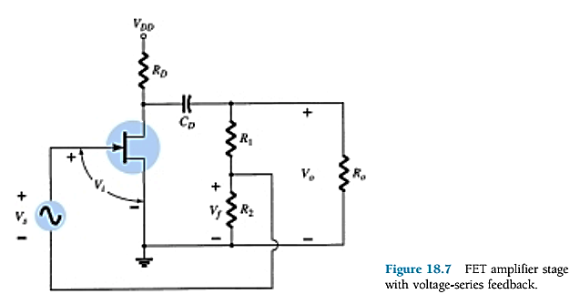

Problem 4:
Calculate the gain of the opamp amplifier circuit with series shunt feedback. Consider op-amp open loop gain A=100,000 and resistances R1=1.8 kΩ and R2=200Ω.


