EXPERIMENT 1: ERROR IN MEASUREMENT

OBJECTIVE
- To learn on type of measurement error
- To learn on method/technique of measurement process
- To investigate sources of error in measurement and to apply the equations provided to analyze the error.
INTRODUCTION
A: MEASUREMENT PROCESS
Measurement process is a process excluded all information, instrument and operation which related to all aspect of technique, principles, behavior, and quality value measurement standard.

The step taken before measure:
- Procedure of measurement- Identified the parameter/variable to be measured, how to record the result.
- Characteristic of parameter- Should know the parameter that to be measured ac, dc, frequency etc.
- Quality- Time and cost of equipment, the instrument ability; the measurement knowledge and suitable result.
- Instrument- Choose a suitable instrument; multimeter oscilloscope or etc.
During measurement:
- Quality- Make sure the chosen instrument is the best, the right position when taken result, the frequent of measurement.
- Safety first- Electric shock, overload effect, limitation of instrument.
- Sampling-See the changing of parameter during measurement, which value should be taken when the parameter keeps changing. Take the enough samples and it is accepted.
The step after measurement:
- Every data must be analyzed, statically, mathematically and the result must be accurately and complete.

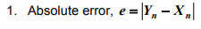
B. ERROR IN MEASUREMENT
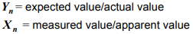

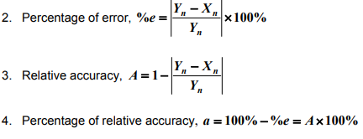
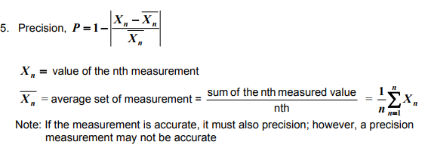

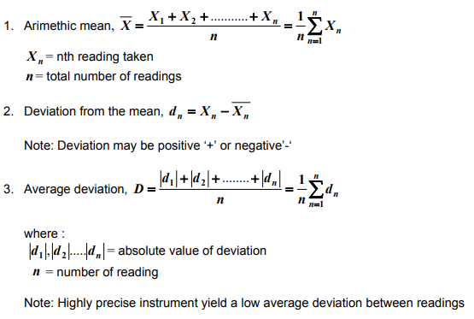
C. STATISTICAL ANALYSIS OF ERROR IN MEASUREMENT

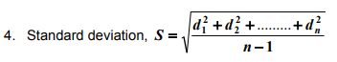

EQUIPMENT AND COMPONENT
- Digital Multimeter
- Composition resistors
- Resistor, 1kΩ
- DC power supply
- Breadboard

PROCEDURE
Part A – Error Caused by Component Tolerance
- Set up the experimental circuit as shown in Figure1.1
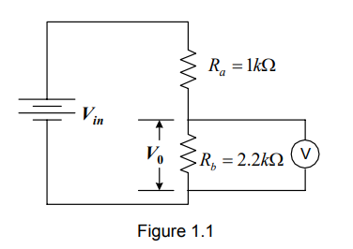
- Connect the voltmeter across R_{b} and adjust the input voltage, V_{in} until the output voltage, V_{o} is exactly 10V. Record the value of Vin in the table provided. Do not change Vin throughout the remainder of the experiment
- Replace the resistor with one of the 2.2kΩ composition resistors and again record the value of Vo in data table provided.
- Place each of the remaining 2.2kΩ resistors in the circuit, one at a time and record the value of Vo for each resistor. Repeat this step for 5 set of 2.2kΩ resistor.
- Using the voltage divider formula calculate the value of Rb for each of the 5 resistors. Record the calculation in the table.
- Calculate the average value of Rb. Enter in the data table.
- Calculate the range of error in the values for Rb. Enter in the data table.
- Calculate the percentage of error for the average value of Rb, against the colour-coded value of the resistors. Enter in the data table.
Part B – Error in reading
- Each student measures and records the value of the resistor provided, using the multimeter.
- Record all the data from the measurement in the table given.
- Calculate the average of the readings of resistance value measured. Record the data in the table.
- Calculate the range of errors in the readings for the resistance. Record the data.
- Calculate the percentage of error for the average resistance calculated compared to the actual value of the resistor as measured by the instructor on a resistance bridge. Record the data.
- Compute the: a) arimethic mean b) deviation from the mean c) average deviation in the statistical analysis.

RESULT
Prepare tables for all the recorded data in your experiments with proper parameter, column and row.

DISCUSSION
Based on your result and observation, comment on your result.

