Experiment 1: Modeling of Wind Turbine in MATLAB/Simulink

SOFTWARE
MATLAB Simulink

PROCEDURE
- Load Simulink by simply typing “simulink” at the MATLAB prompt. Once simulink has loaded, create a new model by going to File, New → Blank Model (or alternatively press CTRL+N). Next, begin placing components on the empty window.
- Click Library Browser
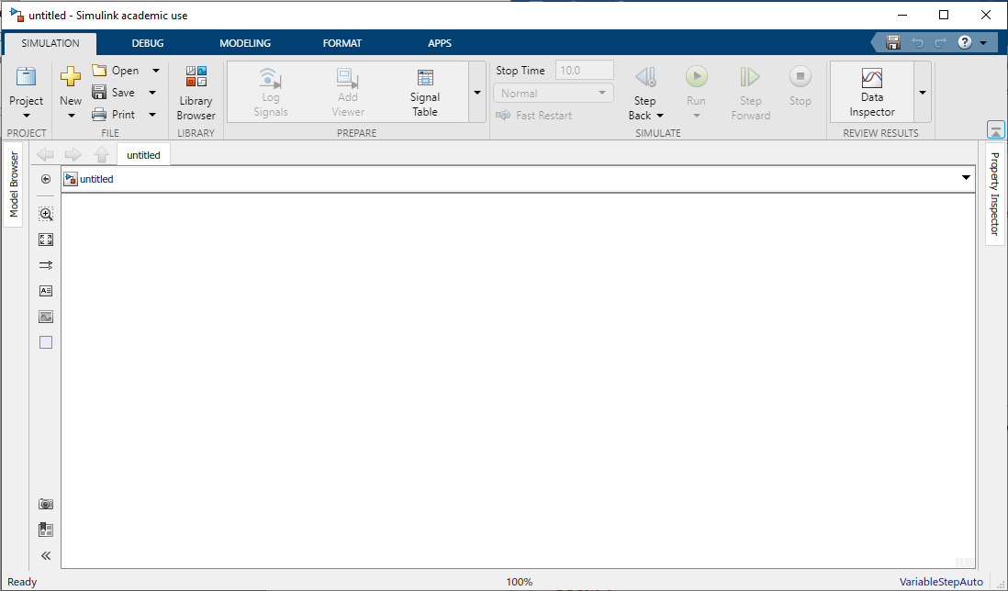
- Click Simscape > Electrical > Specialized Power Systems > Renewables > Wind Generation> Wind Turbine. Right click at Wind Turbine and select add block to model (or alternatively press CTRL+I)
- Click Library Browser >Commonly Used Blocks> Constant. Click Constant and add block to model.
- Rename the Constant block to ‘wind speed’ and connect it to wind speed (m/s) of Wind Turbine block. Change the constant value to 10m/s
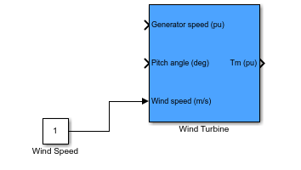
- Click Library Browser >Commonly Used Blocks> Constant. Right click Constant and add block to model.
- Rename the Constant block to ‘pitch angle’ and connect it to Pitch angle (deg) of Wind Turbine block. Change the constant value to 3deg.
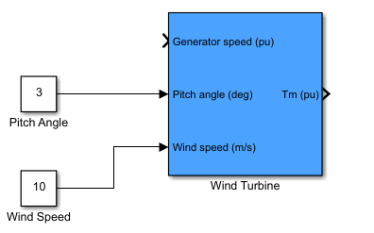
- Click Library Browser >Simscape>Electrical>Specialized Power Systens>Fundamental Blocks>Machines>Permanent Magnet Synchronous Machine. Right click Permanent Magnet Synchronous Machine and add block to model.
- Connect the mechanical torque (Tm) of Wind Turbine to Permanent Magnet Synchronous Machine mechanical torque (Tm).
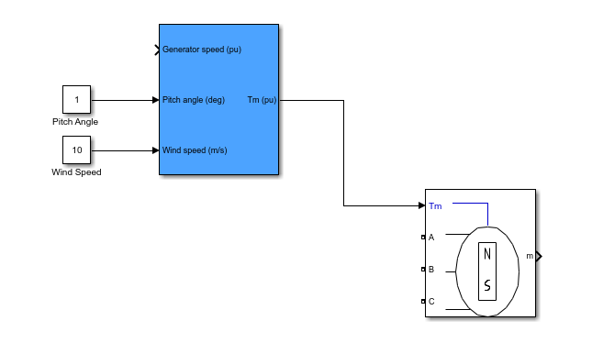
- Click Library Browser >Commonly Used Blocks> Bus Selector. Right click and add block to model.
- Connect Bus Selector to Permanent Magnet Synchronous Machine.
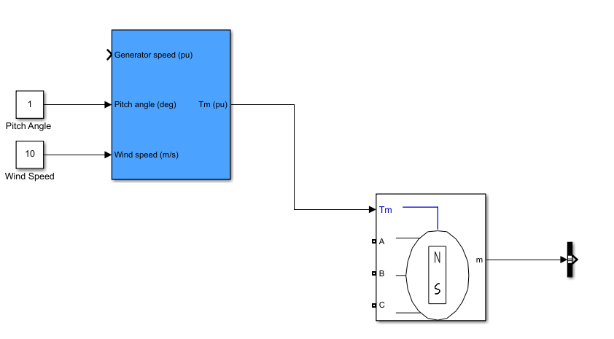
- Double click Bus Selector and select Rotor Speed wm (rad/s). Click Ok.
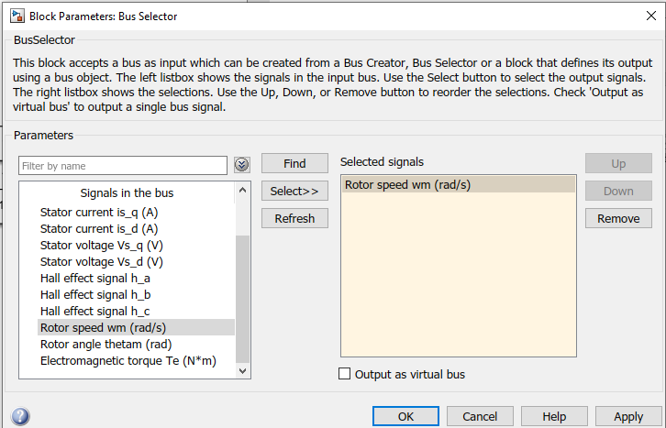
- Connect the Bus Selector to Wind Turbine Generator Speed
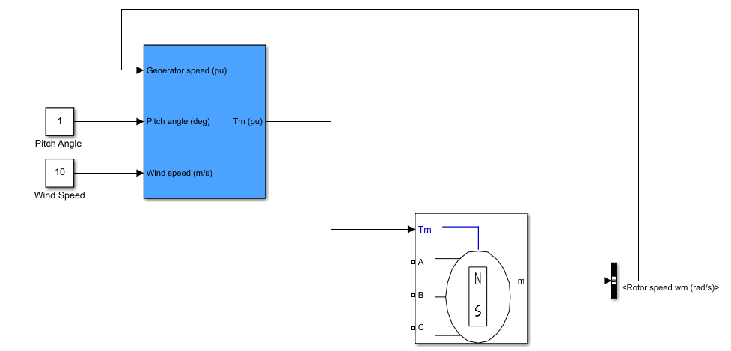

- Click Library Browser >Simscape>Electrical>Specialized Power Systems>Fundamental Blocks>Measurements>Three Phase V-I Measurement. Right click and add block to model.
- Connect the Three Phase V-I Measurement block to Permanent Magnet Synchronous Machine output.
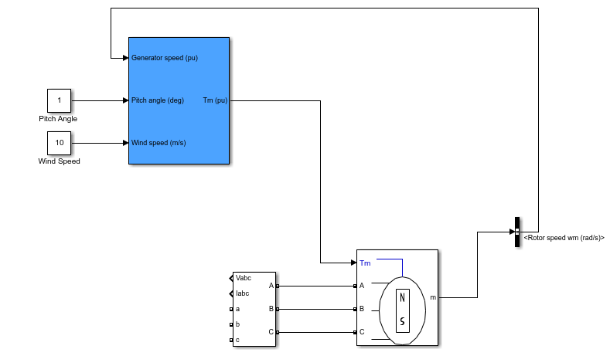
- Click Library Browser >Simscape>Electrical>Specialized Power Systems>Fundamental Blocks>Elements>Three-Phase Series RLC Branch. Right click and add block to model.
- Connect the Three-Phae Series RLC Branch to Three-Phase V-I Measurement Block.
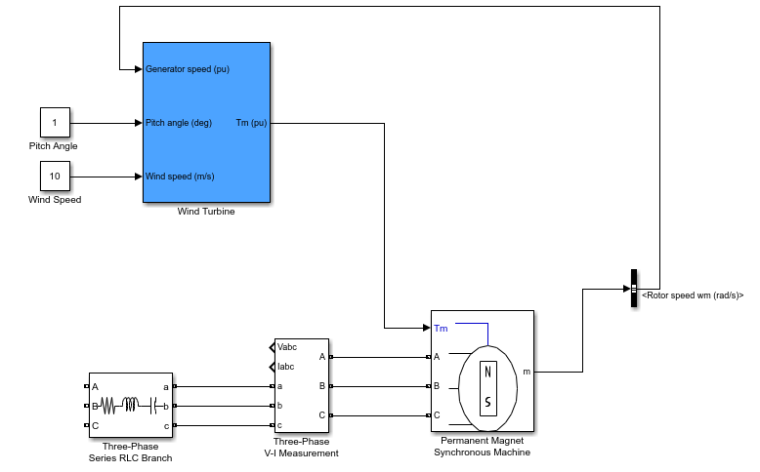
- Double click the Three-Phase Series RLC Branch block. Change branch type to R and Resistance value to 10ohm. Click OK.
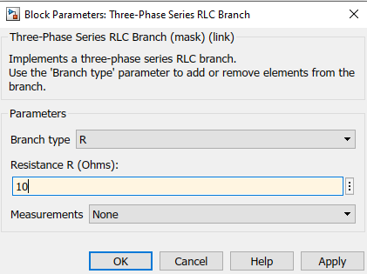
- Click Library Browser >Simscape>Electrical>Specialized Power Systems>Fundamental Blocks>Elements>Ground. Right click and add block to model. Connect Ground to the Three-Phase Series RLC Branch block.
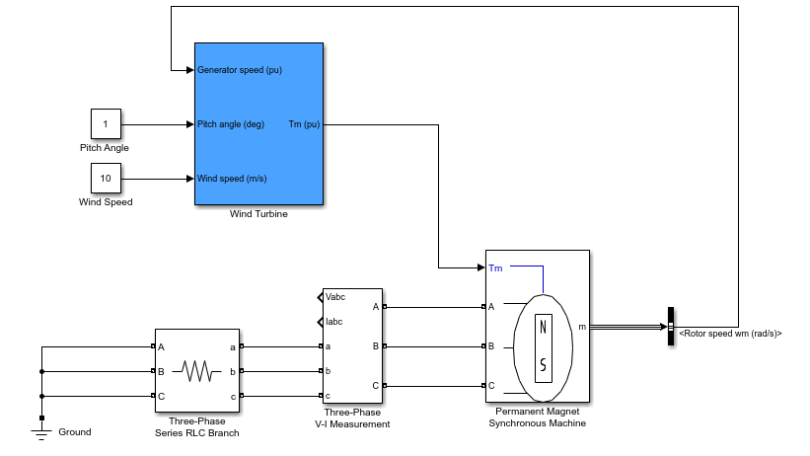
- Click Library Browser >Simulink>Sink>Scope. Right click and add block to model. Connect Scope to Vabc and Iabc.
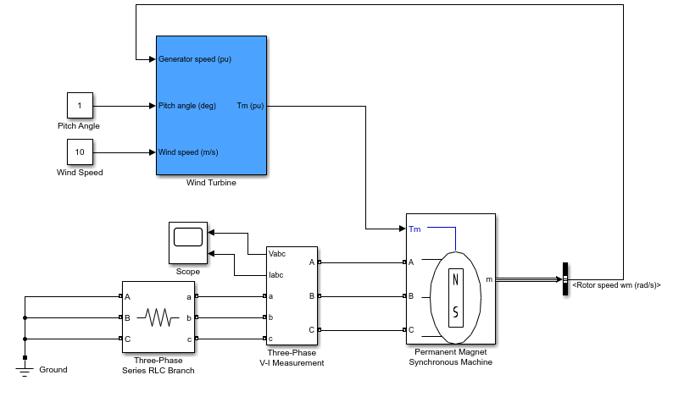
- Click Library Browser >Simscape>Electrical>Specialized Power Systems>Fundamental Blocks>powergui. Right click and add block to model.
- Double click powergui, change to Discrete. Click OK.
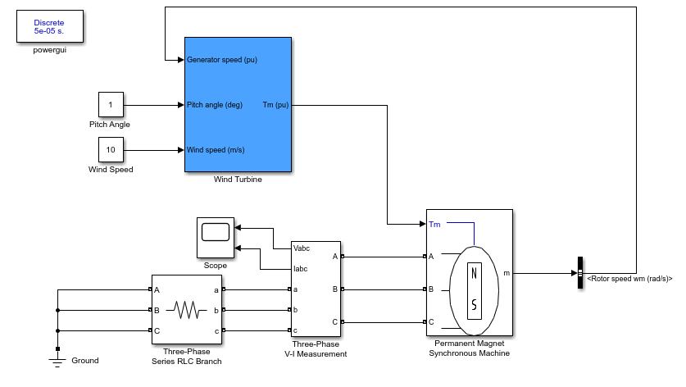
- Click run. Observe the output waveform.
- Change the wind speed to other value. Observe the output waveform.

