EXPERIMENT 1: STUDY OF NODE-VOLTAGE ANALYSIS

INTRODUCTION

Nodal analysis provides a general procedure for analyzing circuits using node voltages as the circuit variables. Choosing node voltages instead of element voltages as circuit variables is convenient and reduces the number of equations one must solve simultaneously.

In nodal analysis is selecting a node as the reference or datum node. The reference node is commonly called the ground since it is assumed to have zero potential. A reference node is indicated by any of the three symbols as below;

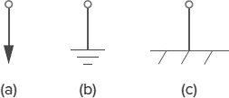

Figure 1: (a) Common ground (b) ground (c) chassis ground

It involves systematic steps with an objective to solve the node voltages with node voltages known, current in every branch can be calculated.
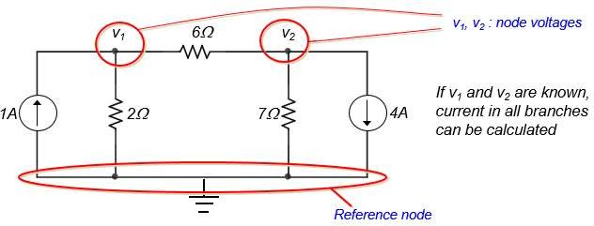

Figure 2: Node-voltage Analysis circuit

OBJECTIVE

- To measure the voltages and currents present in the circuit using Node-voltage Analysis with independent source.
- To measure the voltages and currents present in the circuit using Supernode Analysis with dependent source.

PART A: NODE-VOLTAGE ANALYSIS WITH INDEPENDENT SOURCE EQUIPMENT AND COMPONENT

- DC Power Source, 10V
- DC Current source,1A
- Resistor (5Ω x 2, 10Ω, 2Ω)
- Multimeter

PROCEDURE

Circuit diagram
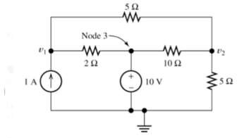
Figure 3: Nodal analysis circuit with independent source

  - Run Multisim 14.0 Software.
  - Click File > Save As > COM106_Experiment 1_YOUR ID_YOURNAME > Save.
  - Follow Step 4 until Step 12 to construct your forward biased circuit as shown in figure 3.
  - Click Place > Component > Group > Sources > POWER_SOURCES > DC_POWER > OK. Place it on the screen.
  - Double click DC_POWER, set 10V.
  - Click Place > Component > Group > Sources > SIGNAL_CURRENT_SOURCES > DC_CURRENT > OK. Place it on the screen.
  - Double click DC_CURRENT, set 1A.
  - Click Place > Component > Group > Basic > RESISTOR > OK. Place it on the screen.
  - Set your RESISTOR value to 5Ω. Double click on RESISTOR > Value > Resistance > 5 Ω > OK.
  - Repeat step 8 and step 9 for 5Ω, 2Ω, and 10Ω.
  - To rotate the SOURCES > POWER_SOURCES > GROUND > OK. Place it on the screen.
  - Connect all component as shown in Figure 3.
  - To simulate. Click > Simulate > Analyses and Simulation > DC Operating Point > add > V(1), V(2), I(R1), I(R2), I(R3) and I(R4).
  - Click > Save > Run.
  - Record the corresponding reading of V(1), V(2), I(R1), I(R2), I(R3) and I(R4) in Table 1.

RESULT

Table 1: Nodal Analysis with Independent Source

Parameter | Measured value | Calculated value
V(1)
V(2)
I(R1)
I(R2)
I(R3)
I(R4)

PART B: SUPERNODE ANALYSIS WITH DEPENDENT AND INDEPENDENT SOURCE

EQUIPMENT AND COMPONENT

- DC Power Source, 20V
- DC Current source, 10A
- Voltage controlled voltage source (VCVS), 3Vx
- Resistor (1Ω, 2Ω ,3Ω, 4Ω, 6Ω )

PROCEDURE

Circuit diagram

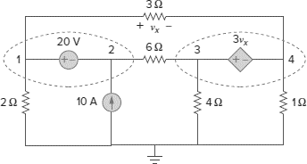

Figure 4: Supernode Analysis with Dependent Source

- Run Multisim 14.0 Software.
- Click File > Save As > COM106_Experiment 1_YOUR ID_YOURNAME > Save.
- Follow Step 4 until Step 13 to construct your forward biased circuit as shown in figure 3.
- Click Place > Component > Group > Sources > POWER_SOURCES > DC_POWER > OK. Place it on the screen.
- Double click DC_POWER, set 20V.
- Click Place > Component > Group > Sources > SIGNAL_CURRENT_SOURCES > DC_CURRENT > OK. Place it on the screen.
- Double click DC_CURRENT, set 10A.
8. Click Place > Component > Group > Basic > RESISTOR > OK. Place it on the screen.

- Set your RESISTOR value to 1Ω. Double click on RESISTOR > Value > Resistance > 5 Ω > OK.
- Repeat step 8 until 9 for 2Ω, 3Ω, 4Ω and 6Ω.
- Click Place > Component > Sources > CONTROLLED_VOLTAGE_SOURCE > VOLTAGE_CONTROLLED_VOLTAGE SOURCE > OK. Place it on the screen.
- To rotate the SOURCES > POWER_SOURCES > GROUND > OK. Place it on the screen.
- Connect all component as shown in Figure 4.
- To simulate. Click > Simulate > Analyses and Simulation > DC Operating Point > add > V(1), V(2), V(3), V(4), I(R1), I(R2), I(R3), I(R4) and I(R5).
- Click > Save > Run.
- Record the corresponding reading V(1), V(2), V(3), V(4), I(R1), I(R2), I(R3), I(R4) and I(R5) in Table 2.

RESULT

Table 2: Supernode Analysis with Independent and Dependent Source

Parameter | Measured value | Calculated value
V(1)
V(2)
V(3)
V(4)
I(R1)
I(R2)
I(R3)
I(R4)
I(R5)

DISCUSSION

- Elaborate your result and findings in this experiment.
- Show your working calculation for Table 1 and Table 2.

